European Union Risk Assessment Report

Voluntary Risk assessment of COPPER, COPPER II SULPHATE PENTAHYDRATE, COPPER(I)OXIDE, COPPER(II)OXIDE, DICOPPER CHLORIDE TRIHYDROXIDE
CAS No: 7440-50-8, 7758-98-7, 1317-3-1, 1317–38–0, 1332-65-6
EINECS No: 231–159–6, 231–847–6, 215-270-7, 215–269–1, 215-572-9

Responsible for this voluntary risk assessment : European Copper Institute (ECI)
Contact person: Dr. Katrien Delbeke, European Copper Institute, Brussels, Belgium
e-mail: kmd @eurocopper.org

Review country for this voluntary risk assessment : Italy
Contact person: Dr. Roberto Binetti , Istituto Superiore di Sanità, Rome, Italy
e-mail: binetti@iss.it

CHAPTER 3.2 – Environmental effects
3.2.1. General approach
3.2.2. Effects to Freshwater organisms
3.2.3. Effects to aquatic organisms from STP
Authors of this chapter : P. Van Sprang, M. Vangheluwe, A. Van Hyfte, D. Heijerick, M. Vandenbroele and F. Verdonck (ARCADIS – EURAS, Belgium), in co-operation with Katrien Delbeke (ECI), Bob Dwyer (ICA) and Bill Adams (Rio Tinto)

Date of Last Literature Search : | Full Ecotox search: 2004;  additional focussed searches :2007
Review of report by MS Technical Experts finalised: | April 2008
Final report: | June 2008

LEGAL NOTICE
Neither the European Commission nor any person acting on behalf of the Commission is responsible for the use which migh be made of the following information
A great deal of additional information on the European Union is available on the Internet.
It can be accessed through the Europa Server(http://europa.eu.int).
Foreword
In response to a request from the European Commission to “start preparing the initial assessments for substances on the EU working list as these were considered as Community priorities in the context of the industry voluntary initiatives for high production volume chemicals” the copper industry committed to undertake a Voluntary Risk Assessment (VRA) for copper and the copper compounds on the EU working list: Cu, CuO, Cu₂O, CuSO₄ and Cu₂Cl(OH)₃. This initiative was endorsed by the EU CAs in 2001. Yearly summaries on progress have been presented at the CA meeting.
This comprehensive VRA dossier has taken four years to complete, with the whole process managed by the European Copper Institute. It was compiled in co-operation with expert consultants from the University of Birmingham/ICON for human health toxicity, from BR. Stern and Associates for human health deficiency, and from Euras/Ecolas for the environment. It is based on the principles of Regulation 793/93, 1488/94 and the detailed methodology laid down in the revised Technical Guidance Document on Risk Assessment for New and Existing Substances. Methodological experiences gained through other metal Risk Assessments, e.g. the incorporation of bioavailability for zinc, were incorporated as appropriate. Additional up to date scientific information was integrated into the assessment where scientifically relevant (i.e. the use of bioavailability models for water, sediment and soil, plus information on copper as an essential nutrient). A broad cross section of the European copper industry has been fully involved in the process and has submitted a significant amount of proprietary data.

To ensure the transparency and quality of the dossier, the initial draft RA reports have been refined by incorporating inputs from the Review Country (Italy – Istituto Superiori di Sanità) and independent peer review panels.

For several of the substances under consideration, targeted risk assessments are required under the Biocidal Product Directive (98/8/EC) and the Plant Protection Products Directive (91/414). These dossiers, which have been/will be provided to the competent authorities (France) by the respective end user industry groups, contain confidential information not available to ECI. However, ECI has worked closely with both of these groups in incorporating relevant information to ensure consistency to the extent possible.
A single dossier covers the assessments for copper metal and the copper compounds, with substance specific aspects provided where relevant. For the base data compilation, extensive literature searches were performed for each substance. Data gaps were filled with analogous data, where relevant, or by additional testing where possible. Where the information was either unnecessary for the copper risk assessment, or impossible to obtain, waiving for testing and/or justification to support derogation is discussed. Some remaining data gaps were identified and will be tackled as a follow-up to this report.
Since the initial submission of the dossier on 15 May 2005, comments have been received from several Member States. The current version reflects comments made by the Member States in writing and during the TCNES meetings. To ensure the transparency and quality of the dossier, the current version and the responses to Member States comments have been refined in close co-oporation with the Review Country (Italy – Istituto Superiori di Sanità).

The human health and environmental sections of the report have been agreed by TCNES (see TCNES opinions) and sent to SCHER for final review.
This Draft Risk Assessment Report is the responsibility of the European Copper Insitute (ECI). The member companies of the copper industry risk assessment consortium are the owners of the assessment. These companies are listed below.
Industries/companies wishing to use all or part of the Risk Assessment Reports, and/or their appendices, for regulatory purposes such as for EU REACH registrations, EU Biocidal Products Directive Registrations, or EU Plant Protection Product Directive Registrations, are required to contact ECI to agree terms of access.

In order to avoid possible misinterpretations or misuse of the findings in this draft, anyone wishing to cite or quote any part of this report, or its related appendices, is advised to contact ECI beforehand.

Contact details of the responsible:
Dr. Katrien Delbeke, European Copper Insitute, Tervurenlaan 168, B-1150 Brussels, Belgium. Tel: +32 2 777 7083, e-mail: kmd @eurocopper.org
Ownership
The industry companies that are part of the industry consortium are listed here:
 | COPPER VOLUNTARY RISK ASSESSMENT - COMPANY MEMBERS IN INDUSTRY CONSORTIUM
SITE | ADDRESS | CITY | COUNTRY
ALCHEMA | East Ord Industrial Estate | Berwick Upon Tweed TD15 2XF | UK
ANGLO AMERICAN BASE METALS | 20 Carlton House Terrace | London SW1Y 5AN | UK
ANTOFAGASTA MINERALS S.A. | Ahumada 11 - Piso 6 | Santiago | CHILE
Atlantic Copper - Cordoba | Barriada Electromecanica, s/n | E-14005 CORDOBA | SPAIN
Atlantic Copper Barcelona | Ctra. Palaudaries, Km 0.4 | E-08185 Llica de Vall | SPAIN
ATLANTIC COPPER HOLDING S.A. -Huelva | Avda Francisco Montenegro, s/n | E-21001 HUELVA | SPAIN
B. MASON & SONS LTD. | WHARF STREET, ASTON | BIRMINGHAM B6 5SA | UK
BHP Billiton Plc | Avenida Americo Sur Nr. 100 - 8th Floor | Santiago | CHILE
BOLIDEN AB. | Smaltverket | S-93281 Skelleftehamm | SWEDEN
BOLIDEN CUIVRE ET ZINC | RUE DU FOURNEAU, 43 | B-4030 GRIVEGNEE (LIEGE) | BELGIUM
BOLIDEN LDM NEDERLAND B.V. | P.O. BOX 42 - LIPSSTRAAT 44 | NL-5150 AA DRUNEN | NETHERLANDS
BOLIDEN MINERAL AB | Klarabergsviadukten 90 | SE - 101 20 Stockholm | SWEDEN
BRAZE TEC GmbH | Rodenbacher Chaussee 4 | D-63457 Hanau-Wolfgang | GERMANY
BUNTMETALL AMSTETTEN GES.M.B.H. | FABRIKSTRASSE 4 | A-3300 AMSTETTEN | AUSTRIA
CODELCO-Chile | Huerfanos 1270, piso 11 | 650-0544 Santiago | CHILE
Compañia Minera Doña Ines Collahuasi | Av. Andres Bello 2687 Piso 11 | Las Condes, Santiago 6760276 | CHILE
Compañia Mineraria Zaldívar | 1125 Seventeenth Street, Suite 2310 | Denver, Colorado 80202 | USA
CUMERIO (was Umicore Copper) | Watertorenstraat 33 | B-2250 OLEN | BELGIUM
DEUTSCHE GIESSDRAHT GmbH | Kupferstraße 5 | D-46446 EMMERICH | GERMANY
ELMET S.L. | Barrio Arene 20 | E-48640 BERANGO (Vizcaya) | SPAIN
ENZESFELD-CARO METALLWERKE AG | Postfach 1, FABRIKSTRASSE 2 | A-2551 ENZESFELD/TRIESTING | AUSTRIA
Erachem Comilog SA | Rue du Bois | B-7334 Saint-Ghislain | BELGIUM
EUROPA METALLI S.P.A Fornaci | Via della Repubblica, 257 | I-55052 Fornaci di Barga (Lucca) | ITALY
EUROPA METALLI S.P.A. Serravalle | Via Cassano 113 | I-15069 Serravalle Scrivia (Alessaandria) | ITALY
EUROPA METALLI SpA Campo Tizzoro | Viale L. Orlando 325 | I-51023 Campo Tizzoro (Pistoia) | ITALY
HALCOR METAL WORKS S.A. | 16 Himaras Str. | Maroussi , GR 151 25 | GREECE
HALCOR METAL WORKS S.A. casting shapes | Foundry, Oinofyta (55th km) | GR | GREECE
HALCOR METAL WORKS S.A. rolling mill | Rolling Mill, 252 PIRAEUS STREET | GR-17778 ATHENS | GREECE
HALCOR METAL WORKS S.A. tube | Copper Tube Mill, Oinofyta (57th km) | GR | GREECE
HÜTTENWERKE KAYSER AG. | Postfach 15 60, Kupferstraße 23 | D-44505 LÜNEN | GERMANY
IBP Group Services Limited | Whitehall Road | Tipton, West Midland DY4 7JU | UK
ISAGRO (ex Caffaro) | Via Caldera, 21 | 20153 Milano | ITALY
KGHM Polska Miedz SA | ul. Sklodowsklej-Curie 48 | 59-301 Lubin | POLAND
KM EUROPA METAL AG | POSTFACH 3320, Klosterstraße 29 | D-49023 OSNABRUECK | GERMANY
KME - Berlin | Miraustraße 10-14 | D-13509 Berlin | GERMANY
KME - Menden | Carl-Benz-Straße 13 | D-58706 Menden | GERMANY
KME Group | P.O. Box 33 20 Klosterstrasse | D-49074 Osnabruck | GERMANY
LA FARGA LACAMBRA, SA | Ctra C-17, Km 73,5 COLONIA LACAMBRA | E-08509 LES MASIES DE VOLTREGA (BARCELONA) | SPAIN
MANICA | Via all'Adige,4 | 38068 ROVERETO (Trento) | ITALY
Méxicana de Cobre, S.A. de C.V. | Baja California No. 200 Sixth Floor | Mexico City 06760 | MEXICO D.F.
Minera Escondida Limitada | Avenida Americo Vespucio Sur Nr. 100 - 9th Floor | La Condes, Santiago | CHILE
Mitsubishi Materials Corporation | 20F OtemachiFirst Square West, 1-5-1, Ohtemachi, Chiyoda-KU | 100-8117 Tokyo | JAPAN
MKM MANSFELDER KUPFER UND MESSING GMBH | POSTFACH 1254, Lichtlöcherberg 40 | D-06323 HETTSTEDT, D-0ß6333 Hettstedt | GERMANY
MUELLER INDUSTRIES, Inc. | 8285 Tournament Drive, Suite 150 | Memphis, TN 38125 | USA
NEXANS | 4-10, rue Mozart | 92587 Clichy Cedex | FRANCE
NEXANS BOURG EN BRESSE | PO Box 101 | F-01003 Bourg en Bresse | FRANCE
Nexans IKO Sweden AB |  | S-514 81 Grimsas | SWEDEN
NEXANS MEHUN SUR YEVRE |  | F-18500 Mehun Sur Yevre | FRANCE
NEXANS WIRES CHAUNY | 128, avenue Jean Jaures, BP30 | F-02301 Chauny | FRANCE
NEXANS WIRES MÂCON | Rue du Port | F-71000 Macon | FRANCE
Nippon Mining & Metals Co., Ltd | Toranomon 2-chome, Minato, Ku | 105-0001 Tokyo | JAPAN
NORANDA Inc. | Avda Andrés Bello 2777 Oficina 801 | Las Condes, Santiago 6760276 | CHILE
NORDDEUTSCHE AFFINERIE AG. | Postfach 10 48 40, Hovestraße 50 | D-20033 HAMBURG, D-20539 Hamburg | GERMANY
NORDIC BRASS AB | Box 524 | S-721 09 Västeras | SWEDEN
Nordox Industries AS | Ostensjovn. 13, PB 6639 Etterstad | N-0607 Oslo | NORWAY
OK Tedi Mining Limited | P.O. Box 1, Dakon Road, Tabubil | Western Province, Papua | NEW GUINEA
OMG Kokkola Chemicals Oy | PO Box 286 | 67101 Kokkola | Finland
OUTOKUMPU American Brass | 70 Sayre Street, P.O. Box 981 | Buffalo, NY 14240 | USA
OUTOKUMPU COPPER Products AB | Box 510, Metallverksgatan 5 | S-721 88 VAESTERAS, S-721 09 Västeras | SWEDEN
OUTOKUMPU Copper Products Oyj | Riihitontuntie 7 A, P.O. Box 144 | Espoo FIN-02201 | FINLAND
OUTOKUMPU COPPER STRIP AB | Metallverksgatan 20-22 | S-721 88 VAESTERAS, S-721 10 Västeras | SWEDEN
Outokumpu Copper Strip AB- Finspang |  | S-612 81 Finspang | SWEDEN
OUTOKUMPU COPPER TUBES S.A. | Bº ARKOTXA S/N | E-48480 ZARATAMO | SPAIN
OUTOKUMPU HARJAVALTA METALS OY | P.O.Box 89 | FIN-29200 Harjavalta | FINLAND
OUTOKUMPU MKM LTD. (ex Boliden MKM) | MIDDLEMORE LANE - ALDRIDGE | WALSALL, West Midlands WS9 8DN | UK
Outokumpu Nordic Brass AB (was BOLIDEN GUSUM AB) | Gräsdalens Industrial site | S-610 40 GUSUM | SWEDEN
OUTOKUMPU PORICOPPER OY | P.O. Box 60 | FIN-28101 Pori | FINLAND
P.T. Freeport Indonesia Inc. | 1615 Poydras Street P.O. Box 51777 | New Orleans, Louisiana 70112 | USA
PALABORA Mining Company | P.O. Box 65 Phalaborwa, 1390 | Limpopo Province | SOUTH AFRICA
Phelps Dodge Corporation | One North Central Avenue | Phoenix, AZ 85004 | USA
PRYMETALL GMBH & CO. KG | Zweifaller Strasse 150 | D-52224 Stolberg | GERMANY
Revere Copper Products Inc. | One Revere Park | Rome, NY 13440-5561 | USA
RIO TINTO Plc | 6 St. James' Square | London SW1Y 4LD | UK
Sahna Kaimer GmbH/KG | Im Teelbruch 80 | D-45219 Essen-Kettwig | GERMANY
SCHWERMETALL HALBZEUGWERK GMBH | POSTFACH 6264, Breiniger Berg 165 | D-52211 STOLBERG, D-52223 STOLBERG | GERMANY
SOCIETE DE COULEE CONTINUE DE CUIVRE | 42 RUE FERDINAND-BUISSON - B.P. 105 | F-02301 CHAUNY CEDEX | FRANCE
SOCIETE LENSOISE DU CUIVRE | Boulevard du Marais | F-62300 LENS CEDEX | FRANCE
SPIESS URANIA | Heidenkampsweg 77 | D-20097 Hamburg | GERMANY
STOLBERGER METALLWERKE GMBH & CO. KG | POSTFACH 1929, Frankentalstraße 5 | D-52206 STOLBERG, D-52222 Stolberg | GERMANY
SUMITOMO Metal Mining Co., Ltd | 1 1-3, Shimbasi 5-Chome, Minato-KU | 105-871 6 Tokyo | JAPAN
Thyssen Krupp VDM | Plettenberger Strsse 2 | D-58791 Werdohl | GERMANY
TREFILERIES ET LAMINOIRS DE LA MEDITERRANEE | 35 RUE LE CHATELIER | F-13015 MARSEILLE CEDEX 15 | FRANCE
TREFIMETAUX - Givet Plant | Rue des Vieilles Forges | F-08600 Fromelennes | FRANCE
TREFIMETAUX - Niederbruck | 31, Rue Joseph Vogt | F-68290 Niederbruck | FRANCE
TREFIMETAUX - Serifontaine | Rue M. Thorez, BP3 | F-60590 Serifontaine | FRANCE
TREFIMETAUX --usine de Boisthorel |  | F-61270 Rai | FRANCE
UMICORE ITALIA SRL | nucleo industriale di Pianodardine (Avellino) | I-AVELLINO | ITALY
WEDNESBURY TUBE & FITTINGS - MUELLER EUROPE | OXFORD STREET | GB- BILSTON WEST MIDLANDS WV14 7DS | UK
WIELAND-WERKE AG Ulm Vöhringen | POSTFACH 42 40, Graf-Arco-Straße 36 | D-89070 ULM, D-89079 ULM | GERMANY
WIELAND-WERKE AG, WERK LANGENBERG | POSTFACH 110269, Ziegeleiweg 20 | D-42530 VELBERT, D-42555 VELBERT | GERMANY
WIELAND-WERKE AG, WERK VILLINGEN | POSTFACH 1780, Lantwattenstr 11 | D-78007 VILLINGEN, D-78050 VILLINGEN-SCHWENNINGEN | GERMANY
WILLIAM BLYTHE LIMITED | Church, Accrington | Lancashire, BB5 4PD | UK
WMC Copper uranium/WMC Resources Limited | IBM Tower 60 City Road | Southbank Vic 3006 | AUSTRALIA
Wolstenholme International | Springfield House, Lower Ecclesfield Road, Darwen | Lancashire BB3 0RP | UK
XSTRATA Copper | Level 9, Riverside Centre, 123 Eagle Street | Brisbane Q 4000 | AUSTRALIA
YORKSHIRE COPPER TUBE LTD. (KME) | East Lancashire Road, Kirby | LIVERPOOL L33 7TU | UK
YORKSHIRE Fittings Ltd | P.O. Box 166 | Leeds, LS10 1NA | UK
European Copper Institute - May 12th 2005
 | COPPER VOLUNTARY RISK ASSESSMENT - COMPANY MEMBERS IN INDUSTRY CONSORTIUM
SITE | ADDRESS | CITY | COUNTRY
ALCHEMA | East Ord Industrial Estate | Berwick Upon Tweed TD15 2XF | UK
ANGLO AMERICAN BASE METALS | 20 Carlton House Terrace | London SW1Y 5AN | UK
ANTOFAGASTA MINERALS S.A. | Ahumada 11 - Piso 6 | Santiago | CHILE
Atlantic Copper - Cordoba | Barriada Electromecanica, s/n | E-14005 CORDOBA | SPAIN
Atlantic Copper Barcelona | Ctra. Palaudaries, Km 0.4 | E-08185 Llica de Vall | SPAIN
ATLANTIC COPPER HOLDING S.A. -Huelva | Avda Francisco Montenegro, s/n | E-21001 HUELVA | SPAIN
B. MASON & SONS LTD. | WHARF STREET, ASTON | BIRMINGHAM B6 5SA | UK
BHP Billiton Plc | Avenida Americo Sur Nr. 100 - 8th Floor | Santiago | CHILE
BOLIDEN AB. | Smaltverket | S-93281 Skelleftehamm | SWEDEN
BOLIDEN CUIVRE ET ZINC | RUE DU FOURNEAU, 43 | B-4030 GRIVEGNEE (LIEGE) | BELGIUM
BOLIDEN LDM NEDERLAND B.V. | P.O. BOX 42 - LIPSSTRAAT 44 | NL-5150 AA DRUNEN | NETHERLANDS
BOLIDEN MINERAL AB | Klarabergsviadukten 90 | SE - 101 20 Stockholm | SWEDEN
BRAZE TEC GmbH | Rodenbacher Chaussee 4 | D-63457 Hanau-Wolfgang | GERMANY
BUNTMETALL AMSTETTEN GES.M.B.H. | FABRIKSTRASSE 4 | A-3300 AMSTETTEN | AUSTRIA
CODELCO-Chile | Huerfanos 1270, piso 11 | 650-0544 Santiago | CHILE
Compañia Minera Doña Ines Collahuasi | Av. Andres Bello 2687 Piso 11 | Las Condes, Santiago 6760276 | CHILE
Compañia Mineraria Zaldívar | 1125 Seventeenth Street, Suite 2310 | Denver, Colorado 80202 | USA
CUMERIO (was Umicore Copper) | Watertorenstraat 33 | B-2250 OLEN | BELGIUM
DEUTSCHE GIESSDRAHT GmbH | Kupferstraße 5 | D-46446 EMMERICH | GERMANY
ELMET S.L. | Barrio Arene 20 | E-48640 BERANGO (Vizcaya) | SPAIN
ENZESFELD-CARO METALLWERKE AG | Postfach 1, FABRIKSTRASSE 2 | A-2551 ENZESFELD/TRIESTING | AUSTRIA
Erachem Comilog SA | Rue du Bois | B-7334 Saint-Ghislain | BELGIUM
EUROPA METALLI S.P.A Fornaci | Via della Repubblica, 257 | I-55052 Fornaci di Barga (Lucca) | ITALY
EUROPA METALLI S.P.A. Serravalle | Via Cassano 113 | I-15069 Serravalle Scrivia (Alessaandria) | ITALY
EUROPA METALLI SpA Campo Tizzoro | Viale L. Orlando 325 | I-51023 Campo Tizzoro (Pistoia) | ITALY
HALCOR METAL WORKS S.A. | 16 Himaras Str. | Maroussi , GR 151 25 | GREECE
HALCOR METAL WORKS S.A. casting shapes | Foundry, Oinofyta (55th km) | GR | GREECE
HALCOR METAL WORKS S.A. rolling mill | Rolling Mill, 252 PIRAEUS STREET | GR-17778 ATHENS | GREECE
HALCOR METAL WORKS S.A. tube | Copper Tube Mill, Oinofyta (57th km) | GR | GREECE
HÜTTENWERKE KAYSER AG. | Postfach 15 60, Kupferstraße 23 | D-44505 LÜNEN | GERMANY
IBP Group Services Limited | Whitehall Road | Tipton, West Midland DY4 7JU | UK
ISAGRO (ex Caffaro) | Via Caldera, 21 | 20153 Milano | ITALY
KGHM Polska Miedz SA | ul. Sklodowsklej-Curie 48 | 59-301 Lubin | POLAND
KM EUROPA METAL AG | POSTFACH 3320, Klosterstraße 29 | D-49023 OSNABRUECK | GERMANY
KME - Berlin | Miraustraße 10-14 | D-13509 Berlin | GERMANY
KME - Menden | Carl-Benz-Straße 13 | D-58706 Menden | GERMANY
KME Group | P.O. Box 33 20 Klosterstrasse | D-49074 Osnabruck | GERMANY
LA FARGA LACAMBRA, SA | Ctra C-17, Km 73,5 COLONIA LACAMBRA | E-08509 LES MASIES DE VOLTREGA (BARCELONA) | SPAIN
MANICA | Via all'Adige,4 | 38068 ROVERETO (Trento) | ITALY
Méxicana de Cobre, S.A. de C.V. | Baja California No. 200 Sixth Floor | Mexico City 06760 | MEXICO D.F.
Minera Escondida Limitada | Avenida Americo Vespucio Sur Nr. 100 - 9th Floor | La Condes, Santiago | CHILE
Mitsubishi Materials Corporation | 20F OtemachiFirst Square West, 1-5-1, Ohtemachi, Chiyoda-KU | 100-8117 Tokyo | JAPAN
MKM MANSFELDER KUPFER UND MESSING GMBH | POSTFACH 1254, Lichtlöcherberg 40 | D-06323 HETTSTEDT, D-0ß6333 Hettstedt | GERMANY
MUELLER INDUSTRIES, Inc. | 8285 Tournament Drive, Suite 150 | Memphis, TN 38125 | USA
NEXANS | 4-10, rue Mozart | 92587 Clichy Cedex | FRANCE
NEXANS BOURG EN BRESSE | PO Box 101 | F-01003 Bourg en Bresse | FRANCE
Nexans IKO Sweden AB |  | S-514 81 Grimsas | SWEDEN
NEXANS MEHUN SUR YEVRE |  | F-18500 Mehun Sur Yevre | FRANCE
NEXANS WIRES CHAUNY | 128, avenue Jean Jaures, BP30 | F-02301 Chauny | FRANCE
NEXANS WIRES MÂCON | Rue du Port | F-71000 Macon | FRANCE
Nippon Mining & Metals Co., Ltd | Toranomon 2-chome, Minato, Ku | 105-0001 Tokyo | JAPAN
NORANDA Inc. | Avda Andrés Bello 2777 Oficina 801 | Las Condes, Santiago 6760276 | CHILE
NORDDEUTSCHE AFFINERIE AG. | Postfach 10 48 40, Hovestraße 50 | D-20033 HAMBURG, D-20539 Hamburg | GERMANY
NORDIC BRASS AB | Box 524 | S-721 09 Västeras | SWEDEN
Nordox Industries AS | Ostensjovn. 13, PB 6639 Etterstad | N-0607 Oslo | NORWAY
OK Tedi Mining Limited | P.O. Box 1, Dakon Road, Tabubil | Western Province, Papua | NEW GUINEA
OUTOKUMPU American Brass | 70 Sayre Street, P.O. Box 981 | Buffalo, NY 14240 | USA
OUTOKUMPU COPPER Products AB | Box 510, Metallverksgatan 5 | S-721 88 VAESTERAS, S-721 09 Västeras | SWEDEN
OUTOKUMPU Copper Products Oyj | Riihitontuntie 7 A, P.O. Box 144 | Espoo FIN-02201 | FINLAND
OUTOKUMPU COPPER STRIP AB | Metallverksgatan 20-22 | S-721 88 VAESTERAS, S-721 10 Västeras | SWEDEN
Outokumpu Copper Strip AB- Finspang |  | S-612 81 Finspang | SWEDEN
OUTOKUMPU COPPER TUBES S.A. | Bº ARKOTXA S/N | E-48480 ZARATAMO | SPAIN
OUTOKUMPU HARJAVALTA METALS OY | P.O.Box 89 | FIN-29200 Harjavalta | FINLAND
OUTOKUMPU MKM LTD. (ex Boliden MKM) | MIDDLEMORE LANE - ALDRIDGE | WALSALL, West Midlands WS9 8DN | UK
Outokumpu Nordic Brass AB (was BOLIDEN GUSUM AB) | Gräsdalens Industrial site | S-610 40 GUSUM | SWEDEN
OUTOKUMPU PORICOPPER OY | P.O. Box 60 | FIN-28101 Pori | FINLAND
P.T. Freeport Indonesia Inc. | 1615 Poydras Street P.O. Box 51777 | New Orleans, Louisiana 70112 | USA
PALABORA Mining Company | P.O. Box 65 Phalaborwa, 1390 | Limpopo Province | SOUTH AFRICA
Phelps Dodge Corporation | One North Central Avenue | Phoenix, AZ 85004 | USA
PRYMETALL GMBH & CO. KG | Zweifaller Strasse 150 | D-52224 Stolberg | GERMANY
Revere Copper Products Inc. | One Revere Park | Rome, NY 13440-5561 | USA
RIO TINTO Plc | 6 St. James' Square | London SW1Y 4LD | UK
Sahna Kaimer GmbH/KG | Im Teelbruch 80 | D-45219 Essen-Kettwig | GERMANY
SCHWERMETALL HALBZEUGWERK GMBH | POSTFACH 6264, Breiniger Berg 165 | D-52211 STOLBERG, D-52223 STOLBERG | GERMANY
SOCIETE DE COULEE CONTINUE DE CUIVRE | 42 RUE FERDINAND-BUISSON - B.P. 105 | F-02301 CHAUNY CEDEX | FRANCE
SOCIETE LENSOISE DU CUIVRE | Boulevard du Marais | F-62300 LENS CEDEX | FRANCE
SPIESS URANIA | Heidenkampsweg 77 | D-20097 Hamburg | GERMANY
STOLBERGER METALLWERKE GMBH & CO. KG | POSTFACH 1929, Frankentalstraße 5 | D-52206 STOLBERG, D-52222 Stolberg | GERMANY
SUMITOMO Metal Mining Co., Ltd | 1 1-3, Shimbasi 5-Chome, Minato-KU | 105-871 6 Tokyo | JAPAN
Thyssen Krupp VDM | Plettenberger Strsse 2 | D-58791 Werdohl | GERMANY
TREFILERIES ET LAMINOIRS DE LA MEDITERRANEE | 35 RUE LE CHATELIER | F-13015 MARSEILLE CEDEX 15 | FRANCE
TREFIMETAUX - Givet Plant | Rue des Vieilles Forges | F-08600 Fromelennes | FRANCE
TREFIMETAUX - Niederbruck | 31, Rue Joseph Vogt | F-68290 Niederbruck | FRANCE
TREFIMETAUX - Serifontaine | Rue M. Thorez, BP3 | F-60590 Serifontaine | FRANCE
TREFIMETAUX --usine de Boisthorel |  | F-61270 Rai | FRANCE
UMICORE ITALIA SRL | nucleo industriale di Pianodardine (Avellino) | I-AVELLINO | ITALY
WEDNESBURY TUBE & FITTINGS - MUELLER EUROPE | OXFORD STREET | GB- BILSTON WEST MIDLANDS WV14 7DS | UK
WIELAND-WERKE AG Ulm Vöhringen | POSTFACH 42 40, Graf-Arco-Straße 36 | D-89070 ULM, D-89079 ULM | GERMANY
WIELAND-WERKE AG, WERK LANGENBERG | POSTFACH 110269, Ziegeleiweg 20 | D-42530 VELBERT, D-42555 VELBERT | GERMANY
WIELAND-WERKE AG, WERK VILLINGEN | POSTFACH 1780, Lantwattenstr 11 | D-78007 VILLINGEN, D-78050 VILLINGEN-SCHWENNINGEN | GERMANY
WILLIAM BLYTHE LIMITED | Church, Accrington | Lancashire, BB5 4PD | UK
WMC Copper uranium/WMC Resources Limited | IBM Tower 60 City Road | Southbank Vic 3006 | AUSTRALIA
Wolstenholme International | Springfield House, Lower Ecclesfield Road, Darwen | Lancashire BB3 0RP | UK
XSTRATA Copper | Level 9, Riverside Centre, 123 Eagle Street | Brisbane Q 4000 | AUSTRALIA
YORKSHIRE COPPER TUBE LTD. (KME) | East Lancashire Road, Kirby | LIVERPOOL L33 7TU | UK
YORKSHIRE Fittings Ltd | P.O. Box 166 | Leeds, LS10 1NA | UK
European Copper Institute - May 12th 2005

CHAPTER 3.2 – Environmental effects
3.2.1. General approach
3.2.2. Effects to Freshwater organisms
3.3.3. Effects to aquatic organisms from STP
Authors of this chapter : P. Van Sprang, M. Vangheluwe, A. Van Hyfte, D. Heijerick, M. Vandenbroele and F. Verdonck (ARCADIS – EURAS, Belgium), in co-operation with Katrien Delbeke (ECI), Bob Dwyer (ICA) and Bill Adams (Rio Tinto)

contents
1 general substance information 0
2 gENERAL INFORMATION ON EXPOSURE 1
3 Environment 2
3.1 Exposure 2
3.2 Effects assessment 2
3.2.1 General Approach 2
3.2.1.1 Toxicity data sources on acute and chronic effects 2
3.2.1.2 Selection of data 4
3.2.1.3 Total versus added risk approach for the PNEC derivation 4
3.2.1.4 PNEC derivation 6
3.2.1.5 Copper specific characteristics 7
3.2.2 Approach toxicity assessment freshwater aquatic organisms 8
3.2.2.1 Selection of ecotoxicty data applicable to the PNEC derivation 8
3.2.2.1.1 Data relevancy 10
3.2.2.1.2 Method used for the aggregation of NOEC data 11
3.2.2.1.3 Approach for PNEC/ PNEC_{add} derivation 12
3.2.2.2 Results freshwater toxicity 14
3.2.2.2.1 General considerations 14
3.2.2.2.2 Abiotic factors influencing the aquatic toxicity of copper 14
3.2.2.2.3 Influence of individual abiotic factors on the aquatic toxicity of Cu 15
3.2.2.2.4 Background concentration 18
3.2.2.2.5 Mechanisms of copper toxicity in fish and invertebrates (from De Schamphelaere, 2003) 18
3.2.2.2.6 Biotic-ligand model (BLM) 22
3.2.2.2.7 Chronic toxicity to freshwater organisms 56
3.2.2.2.8 Derivation of HC5-50 values for surface waters 94
A. Non-normalised HC5-50 for surface waters 94
B. BLM-normalised HC5-50 for surface waters 96
C. Uncertainty analysis on the normalized HC5-50 119
D. Comparison of the HC5-50 with background and baseline levels 126
E. Comparison between the HC5-50 and essentiality and homeostasis levels 129
F. Comparison between the HC5-50 with model ecosystem and field studies 133
3.2.2.2.9 Derivation of the Predicted No Effect Concentration surface waters (PNEC_{freshwater}) 159
i. HC5 derived from statistical extrapolation 159
ii. PNEC derived from the assessment factor method 159
iii. Summary and final derivation of the PNEC freshwater 160
3.2.3 Effects assessment for aquatic micro-organisms in STP 168
3.2.3.1 Toxicity data for aquatic micro-organisms (STP) 169
3.2.3.2 PNEC for aquatic micro-organisms in STP (PNEC_{micro-organisms}) 175

EUSES Calculations can be viewed as part of the report at the website of the European Chemicals Bureau: http://ecb.jrc.it

TABLES
Table 3-1 Reliability index, according to USEPA (1995) and RIVM (1997) 8
Table 3-2 Evaluation of data relevancy 10
Table 3-3 : Summary of BLM constants of different Cu-BLMs 26
Table 3-4 : Summary of the physico-chemical characteristics of the waters used for the development and validations of the chronic algae, invertebrates and fish models. 35
Table 3-5 : Variations in test medium characteristics used for the validation of the chronic D.magna BLM for other invertebrate endpoints 48
Table 3-6: Normalised HC₅ values in µg/L (derived from log-normal SSD) for all selected eco-regions based on full cross species normalisation and most conservative bioavailability model (see above for the different approaches). 54
Table 3-7: Overview of the NOEC values and physico-chemical parameters for freshwater algae/higher plants. Selected high quality Q1 NOEC values are underlined selected for the effects assessment and bioavailability normalisation. Legend see table Table 3-9 56
Table 3-8 Overview of the NOEC values and physico-chemical parameters for freshwater invertebrates. Selected NOEC high quality Q1 values are underlined selected for the effects assessment and bioavailability normalisation. Legend see table Table 3-9 61
Table 3-9 Summary of the NOEC values and physico-chemical parameters for freshwater fish. Selected high quality Q1 NOEC values are underlined selected for the effects assessment and bioavailability normalisation 71
Table 3-10: Physico-chemical parameters of the selected toxicity studies (min-max values) and European freshwaters (reported as 10th , 50th and 90th %). 91
Table 3-11 :Summary of the “species mean” NOECs (total risk approach) in µg Cu/l (with most sensitive endpoint and number of datapoints) 93
Table 3-12: Non-normalised “species mean” NOECs (total risk approach) that are used as input values for deriving the HC₅ values as a basis for the freshwater. Median 5th percentile values with 90% confidence bound (HC5-50 with 5% and 95% CI) for freshwater ecosystem in case of statistical extrapolation and using the assessment factor approach. All values in µg/l. 94
Table 3-13: Summary of the phys.-chem. characteristics of the different selected scenarios. 96
Table 3-14 : Comparison of the phys.-chem. conditions of the different scenarios versus EU surface waters (Swad database). 96
Table 3-15 : Summary of the most sensitive endpoint and number of datapoints after normalisation using the BLM’s 103
Table 3-16: Overview of the individual BLM-normalised NOEC values for the different eco-regions 103
Table 3-17: Summary of the HC5-50 for the best fitting distributions using the A/D and the K/S Go-F approaches 106
Table 3-18: Summary of the HC5 and HC5-50 for the best fitting and log-normal distributions derived for the different selected scenarios 106
Table 3-19 : Goodness-of-fit statistics (according to Andersen-Darling (A/D) and Kolmogorov-Smirnov (K/S)) for the best fitting and log-normal frequency distributions. 107
Table 3-20: HC5-50 (i.e. at 50th % confidence limit together with 5th and 95th confidence limits) derived from the best fitting distribution and log normal distribuiotn.. All values in µg/l.. 107
Table 3-21: Comparison of the intra-species variability (expressed as max/min ratios,) before and after BLM normalisation of the NOEC data (n= number of individual datapoints, the variability includes the variability among endpoints) 109
Table 3-22: EPA Ecotox data on amphibian 117
Table 3-23 : Minimum taxonomic groups requirements for the extrapolation method 119
Table 3-24 Copper HC₅-50 values (i.e. at 50th % confidence limit together with 5th and 95th confidence limits) derived from the best fitting distribution of geometric mean NOECs (n=27), the log normal distribution of geometric mean NOECs (n=27) and the log normal distribution of individual NOEC. All values in µg/l. 121
Table 3-25: Evaluation of the uncertainty around the HC5 derived for a range of typical EU scenario’s. Comparison between the HC5 and its 50 % confidence limit. 121
Table 3-26: Evaluation of the uncertainty around the HC5 derived for a range of typical EU scenario’s. Comparison between the HC5 and 95th left side confidence limit (HC5-5) for the SSD calculated from the best fit of the species geometric mean NOEC values (n=27), the log normal distribution of the species geometric mean NOEC values (n=27) and the log normal distribution using all NOEC values (n=139). 122
Table 3-27 : Comparison between the HC5-50 and the lowest NOEC value as observed for Brachionus calyciflorus 123
Table 3-28: Number of Brachionus NOECs under the HC5-50 (Best fitting) 123
Table 3-29: Risk calculations on the FOREGS database with the copper BLM. Only sites within the BLM bounderies (pH 5.5-8.5; Hardness 10-500 mg CaCO3/L )are considered 126
Table 3-30 : Physico-chemistry, BLM calculated HC5-50 and risk characteristaion (using anAF 1 and AF 2) for the individual sites at risk within the Foregs database. Only sites within the BLM bounderies (pH 5.5-8.5; Hardness 10-500 mg CaCO3/L) are considered 127
Table 3-31 Measured copper concentrations using ICP for total and dissolved copper (Schäfers et al., 2001) 133
Table 3-32 Overview of the high quality mesocosm toxicity data (Q1) 133
Table 3-33: Taxonomic groups evaluated in Schaefers et al, 2001 137
Table 3-34: Geometric mean NOEC values for the most sensitive taxonomic groups, in Schaefers et al, 2001 137
Table 3-35: NOEC values for the most sensitive taxonomic groups in Hedtke, 1984 139
Table 3-36: Taxonomic groups evaluated in Roussel, 2002 141
Table 3-37: Geometric mean NOEC values for the most sensitive taxonomic groups in Roussel, 2006 142
Table 3-38 : Overview of the individual mesocosm NOEC values and the single species NOEC values and HC5-50 value with 5th and 95th confidence limit) normalised towards the conditions occurring in the respective mesocosms. 155
Table 3-39: HC5-50 normalised towards different phys-chem conditions occurring in the mesocosm studies (the other parameters were kept constant cfr -Table 3-32). 157
Table 3-40 Physico-chemistry of the EU sensitive scenario’s 164
Table 3-41 Overview of the toxicity data of copper (as total or nominal concentrations) for micro-organisms (heterotrophs and nitrifiers) 172
Table 3-42 Overview of the toxicity data of copper (as dissolved concentrations) for micro-organisms (heterotrophs and nitrifiers) 173
Table 3-43 Overview of the estimated or measured NOEC values for copper (as dissolved concentrations) - heterotrophs 173
Table 3-44 Overview of the toxicity data of copper for ciliated protozoans in STP 175

FIGURES
Figure 3-1 Schematic representation of a general model of acid-base, sodium, chloride and ammonia transport across the gill epithelium of freshwater organisms and the transport channels involved (after Grosell et al., 2002a) 20
Figure 3-2: Correlation between the observed acute and chronic Cu-toxicity to D. magna in six EU surface waters. 21
Figure 3-3: Predictive capacity of the chronic Daphnia magna biotic ligand model as shown by observed versus predicted 21-d no-observed-effect concentrations (NOECs) and 21-d 50% effective concentrations (EC50s). (De Schamphelaere and Janssen, 2004). DOC from three different surface waters was added to the artificial test media (circles : Behain, squaures: Ossekolk, triangles : Ankeveen; closed sympbols : NOECs; open symbols : EC50 values. 24
Figure 3-4 :Observed vs. predicted EC₆₀,Cu2+ for 30 days juvenile growth of O. mykis, using the developed chronic fish BLM parameters. Full line indicates perfect predictions. Dashed lines indicate a factor of 2 prediction. 25
Figure 3-5:Observed vs. predicted EC₆₀,Cu2+ for 7 days larval growth of P.promelas, using the developed chronic fish BLM parameters. Full line indicates perfect predictions. Dashed lines indicate a factor of 2 prediction. 26
Figure 3-6 : Predictive capacity as shown by observed vs. predicted effect levels (ECx, as dissolved Cu) of the species and endpoint specific models (A and B) and of the unified models (C and D) for P. subcapitata (A,C) and C. vulgaris (B,D) growth rate inhibition, and of the unified models for P. subcapitata biomass inhibition (in natural waters), and for C. reihardtii growth rate inhibition (E). 28
Figure 3-7 : Differences in pH sensitivity between algae and invertebrates for different DOC percentiles in EU surface waters. 29
Figure 3-8 : Comparison of observed and predicted Cu²⁺ concentrations in 15 natural UK surface water samples covering lakes, ponds, streams and rivers with varying physico-chemistry. The study considers that 65% of the DOC has copper bonding capacity (from Bryan et al., 2002) 31
Figure 3-9 : Measured versus predicted LC50 values for P.promelas early life stage mortality LC50s tested in laboratory waters and field surface waters (from Di Toro et al., 2001). 32
Figure 3-10 : Predicted versus measured copper acute LC₅₀ values D;magna tested in 6 Dutch natural surface waters (From Kramer et al., 2004. 32
Figure 3-11 : Relationship between observed and predicted chronic EbC₅₀ dissolved (closed symbols) and NOECdissolved (open symbols) of copper for Daphnia magna (figure left) and Pseudokircherniella subcapitata (figure right) in natural waters (De Schamphelaere, 2003) 34
Figure 3-12 : Relation between early life stage LC50 values for P; promelas and DOC levels (Data from Ryan et al, 2004). DOC was collectes form 9 different Norwegian surface waters and added to a US EPA articial medium at three concentrations (0, 2, 5 and 10 mg DOC./L) 35
Figure 3-13: Predicted versus observed LC50 values for P. promelas for test waters with added Natural Organic Matter. The test media consists of a US EPA articial medium, amended with DOC form 9 different Norwegian surface wates at 2, 5 and 10 mg DOC./L ((Data from Ryan et 2004). The chronic fish BLM parameters, average test water chemistry and default DOC assumptions (50% active DOC and 0.01% active HA) were used for the model predictions. 35
Figure 3-14 : relationship between observed and predicted 48-h mean effective concentration of copper to field collected cladoceran species (from Bossuyt et al., 2004). 39
Figure 3-15: MERAG Approach for read-across of bioavailability models. 40
Figure 3-16: UK.NL read-across approach and read-across criteria (from annex ZZZ) 41
Figure 3-17 : Relation between observed and BLM predicted ecotoxicity of Brachionus calyciflorus. The characteristics of the test media are provided in the text 44
Figure 3-18: Relation between observed and BLM predicted ecotoxicity of Lampsilis siliquoidea (n=28). The characteristics of the test media are provided in the text. Data from Kunz et al (2006). 46
Figure 3-19: Relation between observed and BLM predicted ecotoxicity of Hyridella depressa (n=11). The characteristics of the test media are provided in the text. Data from Markich et al. (2003). 46
Figure 3-20: Relation between observed and BLM predicted ecotoxicity of Hyalella azteca (n=42). Data from Borgmann et al, 2005. The toxicity data with control mortality >80% were not used (nr of datapoints used= 37). 47
Figure 3-21 : Acute species sensitivity distributions for copper. 48
Figure 3-22: Comparison of predicted and measured soil solution EC50s using the empirical algae regression and the terrestrial BLM for the higher plant barley and b) free Cu ion versus pH relationship based on speciation of soil solutions in barley tests, compared with the regression model developed for algae 50
Figure 3-23: Predicted versus measured copper acute LC₅₀ values for fish and invertebrates (from Santore et al., 2002) 51
Figure 3-24 : Comparison of the uncertainty of the predictive capacity of the chronic D. magna Cu-BLM versus the chronic fish Cu-BLM for predicting toxicity of the invertebrates Brachonus and Hyalella. 54
Figure 3-25: Sensitivity of aquatic organisms towards Cu 80
Figure 3-26 : Exposure time (days) observed in the toxicity tests from the copper database 82
Figure 3-27 Time course for the response of O. kisutch to copper exposure (Mudge et al., 1993) 84
Figure 3-28 Time course for the response of O. mykiss to copper exposure (Seim et al., 1984) 84
Figure 3-29 Time course for the response of D. magna to copper exposure ( data from Heijerick et al., 2001) 85
Figure 3-30 Distribution of the observed background Cu concentrations in the ecotoxicity tests 89
Figure 3-31 Distribution of the observed pHs in the ecotoxicity tests 89
Figure 3-32 Distribution of the observed DOC values in the ecotoxicity tests. 90
Figure 3-33 Distribution of the observed hardness values in the toxicity tests 91
Figure 3-34: Water parameters of the selected toxicity studies (min-max values), hardness, DOC and pH boundaries of the BLMs (min-max values for the broadest and narrowest BLMs), and European freshwaters (reported as 10th and 90th %). Ranges of the narrowest BLMs are shown by the vertical arrows. 92
Figure 3-35: The cumulative frequency distributions of the non-normalised species mean NOEC values from the Cu toxicity tests in the dataset of freshwater organisms. Observed data and Pearson V distribution curve (best fitting curve) for the dataset fitted on the data 94
Figure 3-36 : The cumulative frequency distributions of the normalised species mean NOEC or EC₁₀ values from the Cu toxicity tests in the dataset of freshwater organisms (scenario ditches in The Netherlands). Geochemical parameters for this scenario were: pH = 6.9, hardness = 350.1 mg/L CaCO₃, DOC = 12.0 mg/L. Observed data and Beta distribution curve (best fitting curve) for the dataset fitted on the data. 98
Figure 3-37 : The cumulative frequency distributions of the normalised species mean NOEC or EC₁₀ values from the Cu toxicity tests in the dataset of freshwater organisms (scenario ditches in The Netherlands). Geochemical parameters for this scenario were: pH = 6.9, hardness = 350.1 mg/L CaCO₃, DOC = 12.0 mg/L. Observed data and log-normal distribution curve for the dataset fitted on the data. 98
Figure 3-38 : The cumulative frequency distributions of the normalised species mean NOEC or EC₁₀ values from the Cu toxicity tests in the dataset of freshwater organisms (scenario River Otter in the United Kingdom). Geochemical parameters for this scenario were: pH = 8.1, hardness = 165 mg/L CaCO₃, DOC = 3.2 mg/L. Observed data and log-normal distribution distribution curve (best fitting curve) for the dataset fitted on the data. 98
Figure 3-39 : The cumulative frequency distributions of the normalised species mean NOEC or EC10 values from the Cui toxicity tests in the dataset of freshwater organisms (scenario River Teme in the United Kingdom). Geochemical parameters for this scenario were: pH = 7.6, hardness = 159 mg/L CaCO3, DOC = 8.0 mg/L. Observed data and Beta distribution curve (best fitting curve) for the dataset fitted on the data. 99
Figure 3-40 : The cumulative frequency distributions of the normalised species mean NOEC or EC₁₀ values from the Cu toxicity tests in the dataset of freshwater organisms (scenario River Teme in the United Kingdom). Geochemical parameters for this scenario were: pH = 7.6, hardness = 159 mg/L CaCO₃, DOC = 8.0 mg/L. Observed data and log-normal distribution curve for the dataset fitted on the data. 99
Figure 3-41: The cumulative frequency distributions of the normalised species mean NOEC or EC₁₀ values from the Cu toxicity tests in the dataset of freshwater organisms (scenario River Rhine in The Netherlands). Geochemical parameters for this scenario were: pH = 7.8, hardness = 217 mg/L CaCO₃, DOC = 2.8 mg/L. Observed data and log-normal distribution curve (best fitting curve) for the dataset fitted on the data. 100
Figure 3-42: The cumulative frequency distributions of the normalised species mean NOEC or EC₁₀ values from the Cu toxicity tests in the dataset of freshwater organisms (scenario River Ebro in Spain). Geochemical parameters for this scenario were: pH = 8.2, hardness = 273 mg/L CaCO₃, DOC = 3.7 mg/L. Observed data and Beta distribution curve (best fitting curve) for the dataset fitted on the data. 100
Figure 3-43 : The cumulative frequency distributions of the normalised species mean NOEC or EC₁₀ values from the Cu toxicity tests in the dataset of freshwater organisms (scenario River Ebro in Spain). Geochemical parameters for this scenario were: pH = 8.2, hardness = 273 mg/L CaCO₃, DOC = 3.7 mg/L. Observed data and log-normal distribution curve for the dataset fitted on the data. 101
Figure 3-44 : The cumulative frequency distributions of the normalised species mean NOEC or EC₁₀ values from the Cu toxicity tests in the dataset of freshwater organisms (scenario Lake Monate in Italy). Geochemical parameters for this scenario were: pH = 7.87; hardness = 48.3 mg/L CaCO₃, DOC = 2.5 mg/L. Observed data and log-normal distribution curve (best fitting curve) for the dataset fitted on the data. 102
Figure 3-45 : The cumulative frequency distributions of the normalised species mean NOEC or EC₁₀ values from the Cu toxicity tests in the dataset of freshwater organisms (scenario Swedish acidic lake). Geochemical parameters for this scenario were: pH = 6.7; hardness = 27.8 mg/L CaCO₃, DOC = 3.8 mg/L. Observed data and Beta distribution curve for the dataset fitted on the data. 102
Figure 3-46 : The cumulative frequency distributions of the normalised species mean NOEC or EC₁₀ values from the Cu toxicity tests in the dataset of freshwater organisms (scenario Swedish acidic lake). Geochemical parameters for this scenario were: pH = 6.7; hardness = 27.8 mg/L CaCO₃, DOC = 3.8 mg/L. Observed data and log-normal distribution curve for the dataset fitted on the data. 103
Figure 3-47 : Overview of the SSD for the different freshwater eco-regions as a function of the DOC/pH content. 105
Figure 3-48 : The intra-species variability (expressed as max/min ratios) of the NOECs expressed as dissolved µg Cu/l test medium and BLM-normalised to an EU typical case freshwater environment, using the chronic bioavailability models. 108
Figure 3-49 : Observed NOECs versus BLM predicted NOECs (by endpoint) at the physico-chemistry of the ecotoxicity tests. This graph includes all NOECs retained in the ecotox database. 110
Figure 3-50: Effect of incorporation of Q2 datapoints on the HC₅-50 derivation for the river Otter. 111
Figure 3-51 : Effect of incorporation of Q2 datapoints on the HC5-50 derivation for the river Teme. 112
Figure 3-52 :Effect of inclusion of datapoints with high pH variation on the HC₅-50 derivation for the river Otter 112
Figure 3-53 :Effect of inclusion of datapoints with high pH variation on the HC5-50 derivation for the river Teme 113
Figure 3-54 :Effect of exclusion of datapoints with default DOC assumptions for natural waters on the HC₅-50 derivation for the river Otter 114
Figure 3-55 :Effect of exclusion of datapoints with default DOC assumptions for natural waters on the HC₅-50 derivation for the river Teme 114
Figure 3-56 : Effect of incorporation of more conservative DOC assumptions on the HC5-50 derivation for the river Otter. Original DOC assumptions: 0.5 mg/l for reconstituted waters; DOC/TOC= 0.8; low DOC assumptions: 0.3 mg/l for reconstituted waters (cfr. University of Ghent) and 1.1 mg/l for well waters from the study of Nebeker et al. (1984); DOC/TOC= 0.5: High DOC assumptions: 1.0 mg/l for reconstituted waters (cfr. Santore et al., 2002); DOC/TOC= 1.0. 115
Figure 3-57 :Effect of incorporation of more conservative DOC assumptions on the HC5-50 derivation for the river Teme Original DOC assumptions: 0.5 mg/l for reconstituted waters; DOC/TOC= 0.8; low DOC assumptions: 0.3 mg/l for reconstituted waters (cfr. University of Ghent) and 1.1 mg/l for well waters from the study of Nebeker et al. (1984); DOC/TOC= 0.5: High DOC assumptions: 1.0 mg/l for reconstituted waters (cfr. Santore et al., 2002); DOC/TOC= 1.0. 115
Figure 3-58 :Effect of incorporation of long term NOEC for Dreissenia polymorpha on the HC₅-50 derivation for the river Otter 116
Figure 3-59 :Effect of incorporation of long term NOEC for Dreissenia polymorpha on the HC₅-50 derivation for the river Teme 116
Figure 3-60 : BLM predicted versus measured LC₅₀ values for fathead minnow in flow through toxicity exposures from Erickson et al. (1987) 125
Figure 3-61: Effects of copper diet on egg development and larvae malformations of Xenopus larvae (BBL= normal diet; Cu(+)= copper supplemented diet, Cu(-)=copper defiecinet diet) 129
Figure 3-62: Effect of copper concentrations on 4-days development of X. laevis. Adult X. laevis were maintained on beef liver and lung diet for 28days. 129
Figure 3-63 Energy reserves (Ea) of first (triangles) and 4th to 15th (squares) generation D. magna acclimated to different copper concentrations (error bars represent standard deviations. Mean levels for same letter are not significantly different at p<0.05). Ovals represent the optimal concentration range. 130
Figure 3-64 : Comparison between the chronic EC₅₀ values and the homeostatic range for D. magna 131
Figure 3-65 :Comparison between the BLM-normalised chronic EC50 values and the homeostatic range for D. magna 131
Figure 3-66 : Comparison of the log normal SSD obtained from the mesocosm (Schaefers et al., 2001, Table 3-34 with the SSD of the single species NOEC values, normalized to the average physico-chemistry of the study. The SSD curves allowed to calculate a HC5-50 for the multi-species mesocosm of 19.6 µg Cu/L and a single-species BLM predicted HC5-50 of 9.9 µg Cu/L (see text) 145
Figure 3-67: Comparison of the SSD obtained from the mesocosm (Hedtke, 1984,Table 3-35) with the SSD of the single species NOEC values, normalized to the average physico-chemistry study. The SSD curves allowed to calculate a HC5-50 for the multi-species mesocosm of 3.8 µg Cu/L and a single-species BLM predicted HC5-50 of 3.4 µg Cu/L (see text) 146
Figure 3-68: Comparison of the SSD obtained from the mesocosm (Roussel, 2006, Table 3-37) with the SSD of the single species NOEC values, normalized to the average physico-chemistry of the study. 148
Figure 3-69: Calculated fraction bound copper and estimated overprediction of toxicity in the Roussel 2006 study compared to a fully pre-equilibrated system. The kinetic model described by Ma et al., 1999 (see text) was used for the calculations. 148
Figure 3-70: Relative contribution of emission sources to the total copper emissions in natural surface waters, considering accumulations to steady steady and up till 100 years. 149
Figure 3-71: Abundance of Keratella quadrata as a function of concentration and time. 151
Figure 3-72: Abundance of Copepods as a function of concentration and time. 152
Figure 3-73: Abundance of Cryptophyta as a function of concentration and time. 153
Figure 3-74: Predicted BLM normalised HC5-50 values (mean + standard deviation) versus observed mesocoms No Observed Ecological Adverse Effects ( NOEAEC) and Lowest Observed Ecological Adverse Effects (LOEAEC), connected by a line. Rhomb:Roussel, 2006; Squares:Schaefers, 2001; Trangles:Hedtke, 1984 158
Figure 3-75: BLM predicted HC5-50 value, from single species NOECs versus observed mesocoms HC50 values. 158
Figure 3-76 : Sensitivity analysis of the HC5 for the most sensitive EU scenario versus the reasonable worst case for algae and invertebrates and the non-normalized data. 164
Figure 3-77 Effect of exposure time on copper inhibition of nitrifiers (graph on the left) and heterpotrophs (graph on the right). 170

general substance information

gENERAL INFORMATION ON EXPOSURE

Environment

Exposure

Effects assessment
    - General Approach
For copper a large amount of literature data that relate to the assessment of environmental effects of copper are available. These literature data encompass acute and chronic exposure scenarios and include basic test results on dose-response relations as well as defined scientific data that allow for the interpretation of the toxicity data.
Considering the availability of high quality information on chronic effects of copper for water, sediments and terrestrial environments as well as for micro-organisms of sewage treatment plants, chronic effects have been used as a basis for the derivation of PNECs for all compartments. The general approach followed for the effects assessment can be summarised as follows:
- available literature on chronic effects data was used as the basis of the effects assessment.
- all original papers were subsequently evaluated for quality and relevance in view of a RA, in accordance to TGD principles.
- high quality NOECs were retained and used for a PNEC derivation.
- for the derivation of the PNEC, copper specific characteristics related to bioavailability, essentiality and homeostasis are integrated in the assessment.
Information on acute effects of copper to freshwater organisms was used for the hazard assessment and for the derivation of a proposal for acute classification of copper and copper compounds. The full evaluation related to this classification is provided in Appendix Env K.
      - Toxicity data sources on acute and chronic effects
The ecotoxicological data in this report are derived from general literature searches aiming at obtaining relevant original papers on the subject as published in international journals. The searches have including the key citation indices outlined below and additional searches performed through the Copper Research Information Forum (B.Harrison, Univ. British Colombia, USA). Information from research activities initiated in the frame of this RA and agreed upon by the peer review panel was also included in this report.
- Biological Abstracts: Contains citations, with abstracts, to the world's biological and biomedical literature dealing with research in the life sciences. Covers articles from nearly 7000 periodicals from 1993-1999. Corresponds to the abstracts appearing in Biological Abstracts (BA), and in part to the online BIOSIS Previews database.
Abstract subject: Coverage: Life sciences dealing with animals (including humans), plants and micro-organisms, including aerospace and underwater biological effects, agronomy, allergy, anatomy and histology, animal production, bacteriology, behavioural biology, biochemistry, biophysics, blood and body fluids, botany (general and systematic), cardiovascular system, chemotherapy, Circadian rhythm and other life cycles, cytology and cytochemistry, dental and oral biology, developmental biology, digestive system, disinfection and sterilization, ecology, economic botany, economic entomology, endocrine system, enzymes, evolution, food and industrial microbiology, food technology, forestry and forest products, general biology, genetics and cytogenetics, gerontology, horticulture, immunology, integumentary system, invertebra (comparative and experimental), laboratory animals, mathematical biology and statistical methods, medical and clinical microbiology, metabolism, methods and materials, microbiological apparatus, morphology and anatomy of plants, morphology and cytology of bacteria, muscle, neoplasms and neoplastic agents, nervous system, nutrition, paleobiology, paleobotany, paleozoology, palynology, parasitology, pathology, pediatrics, pest control, pharmacognosy and pharmaceutical botany, pharmacology, physical anthropology (ethnobiology), physiology and biochemistry of bacteria, physiology (general), phytopathology, plant physiology (biochemistry and biophysics), poultry production, psychiatry, public health, radiation biology, reproductive system, sense organs, skeletal system, social biology, soil microbiology, soil science, temperature (measurements, effects, and regulation), tissue culture, toxicology, urinary system and external secretions, veterinary science, and virology (general).

- PolTox: Contains more than 100,000 citations, with abstracts, to international periodicals and other literature covering pollution and toxicology information relevant to agricultural issues worldwide from 1996 to 2001. Derived from CAB ABSTRACTS (described in a separate entry).
Abstract subject: Pollution and toxicology information relevant to agriculture and forestry, including environmental agrochemicals such as insecticides, fungicides, pesticides, and fertilizers; groundwater contamination, runoff, and leaching; heavy metals in soils, crops, and animals; reclamation and revegetation of polluted sites; environmental impact of farming; waste management, treatment, and disposal; all aspects of toxicology; health hazards of pesticides, drug residues, side effects of drugs, and steroids and hormones in animals.

- Science Citation Index: Provides complete bibliographic data plus citations to worldwide literature across a wide range of scientific and technological disciplines. Covers approximately 4600 journals from 1988-2001. Corresponds to the Science Citation Index publication and the online SciSearch database.
Abstract subject: Natural, physical, earth, environmental, biomedical, and life sciences; chemistry, agriculture, clinical medicine, engineering, technology and applied sciences, and computer and information science.

- The Meyer (1999) database is an extensive compilation of metal bibliography resulting from searches of (1) the collections of books and articles in the Fish Physiology and Toxicology Laboratory at the University of Wyoming, (2) the metal US EPA metals criteria (Cd, Cu, Ni, Pb and Zn) documents, (3) major printed bibliographies (International Copper Association, International Lead Zinc Research Association, Nickel Producers Environmental Research Association, National Technical Information Service (Water Pollution Effects of Metals on Fresh Water Fish), North American Benthological Society, Fourth Annoted Bibliography n Biological Effects of Metals in Aquatic Environments (US EPA), World Health Organization (Copper Environmental Health Criteria)), (4) electronic databases (Agricola, Applied Science and Technology Abstracts, AQUIRE, Article First, Biological Abstracts, Environment, Fish and Fisheries Worldwide, Papers First, Pollution Abstracts, Wildlife Worldwide, Wyoming Water Bibliography), (5) recent Tables of contents of toxicology journals (Aquatic Toxicology, Archives of Environmental Contamination and Toxicology, Bulletin of Fisheries and Aquatic Sciences, Canadian Journal of Fisheries and Aquatic Sciences, Environmental Pollution, Environmental Toxicology and Chemistry, Water Air and Soil Pollution and Water Research) and (6) major review articles or books. ("Metal bioaccumulation in fishes and aquatic invertebrates: a literature review” (US EPA, 1978), "Metal speciation and bioavailability in aquatic systems" (Campbell, 1995), "The effects of environmental acid on freshwater fish with particular reference to the softwater lakes in Ontario and the modifying effects of heavy metals: a literature review" (Spry et al., 1981)). This extensive database contains individual toxicity test results for freshwater organisms on the metals mentioned above. The chronic toxicity database contains a total of 208 articles and reports on fish, amphibians and aquatic invertebrates from which 620 separate chronic toxicity values were extracted for 97 different taxa. Moreover, the database contains information concerning the general test conditions, test endpoints, measured/nominal test concentration, test parameters and acclimation conditions.
      - Selection of data
According to the Guidelines set out in the Technical Guidance Document (TGD, 1996; TGD revisions, 2003), in support of Commission Directive 93/67/EEC on Risk Assessment for New Notified Substances and Commission Regulation (EC) No1488/94 on Risk Assessment for Existing Substances, it is very important to evaluate ecotoxicity data with regard to their adequacy and completeness. The assessment of data adequacy involves a review of individual data elements with respect to how the study is conducted and how the results are interpreted in order to accept (or reject) a study in accordance with the purpose of the assessment.
The term adequacy covers both the reliability of the available data and the relevance of the data for environmental hazard and risk assessment. These two basic elements have been defined by the TGD as follows:
Reliability: covering the inherent quality of a test relating to test methodology and the way that the performance and results of a test are described.
Relevance: covering the extent to which a test is appropriate for a particular hazard or risk assessment
Only ecotoxicity data that comply with all of the above-mentioned criteria can be considered valid and may be used in the risk assessment.
The experience gained within the data evaluation in the EU risk assessment process of metals, such as the data quality and reliability schemes used in the Zn and Cd risk assessment exercise, have been used as a framework for the present evaluation.
      - Total versus added risk approach for the PNEC derivation
Currently, the Technical Guidance Document (TGD, 2003) does not provide detailed information on how to deal with elements, such as copper, that have a natural background concentration in the environment. In the EU Risk Assessment for metals both the “added risk approach” (according to Struijs et al., 1997 and Crommentuijn et al., 1997) – cfr. Zn RAR - and the “total risk approach” – cfr. Cd RAR - have been applied.
In theory, the use of the added risk approach avoids the potential problem of deriving PNEC values below the natural background concentration, as could be the case when the total risk approach is used. In the added risk approach both the "Predicted Environmental Concentration"(PEC) and the "Predicted No Effect Concentration" (PNEC) are expressed as Cu added by man, resulting in an “added Predicted Environmental Concentration” (PECadd) and “added Predicted No Effect Concentration” (PNECadd), respectively. The use of the added risk approach (a method that in principle can be used for all naturally occurring substances) implies that only the anthropogenic amount of a substance, i.e. the amount added to the natural background concentration, is considered to be relevant for the effects assessment of that substance. Thus, a possible contribution of the natural background concentration to (adverse) effects to ecological systems is ignored.
The use of this approach requires the accurate establishment of the natural background of a particular location and/or a specific region. However, according to the CSTEE (2004), the current knowledge on the geographic distribution of metal background concentration (Cb) in ecological systems is insufficient to correctly implement the added risk approach. Further research on the development of standard methods for assessing background concentrations in soil, water and sediments and the establishment of the regional variability is therefore required. The CSTEE (2004) further suggests that the establishment of a “default background concentration” will not contribute to the correct assessment of the risks posed by metals.
Moreover, the original papers describe the added risk approach using the equation
MPC = MPA + ϕCb with ϕ being a bioavailability factor, Cb the background concentration, MPA the maximum permissible addition and MPC the maximum permissible concentration. Using the added risk assessment approach, the ϕ factor is usually set at 0, i.e. the background concentration is not bioavailable. In the total risk assessment approach this factor is usually set at 1, i.e. maximum bioavailability of the background. Numerous studies have shown that metal bioavailability is dependent on environmental characteristics (e.g. pH, hardness, dissolved organic matter, and others for surface water; sulfides, organic matter, and others for sediments & soils) and thus may vary from 0 to 100% depending on environmental factors. Thus neither ϕ = 1 nor ϕ = 0 are correct.
According to the CSTEE (2004), not accounting for ϕ in both the MPA and Cb fraction results in the incorrect assessment of the risks and thus prevents the establishment of science-based PNEC values. Furthermore, the opinion of the CSTEE (2004) was that the use of the Added Risk Approach may increase the overall uncertainty associated with PNEC values and risk characterisation of naturally occurring substances because of the lack of accurate information on background variability and on a number of biological/ecological processes (e.g. acclimation/adaptation, field community responses).
Based on the above considerations, the most accurate and ecologically relevant risk characterisation should be made by establishing - on a site-specific-, watershed/basin- or regional basis - both exposure and effects data sets expressed on the same level of bioavailability. This is the most straightforward and technically correct way to deal with bioavailability. It avoids the artificial distinction between added and background metal – a distinction that has no scientific bases – and it properly accounts for the water, sediment and soil quality parameters that affect bioavailability.
Information on background variability (in culture media and natural European environments (water, sediments, soils)) and its influence on a number of biological/ecological processes (e.g. optimal concentration ranges, acclimation/adaptation, field community responses) is nevertheless crucial for the derivation of ecological relevant PNEC values and will therefore be considered.
      - PNEC derivation
In the environmental risk assessment methodology, the Predicted Environmental Concentration (PEC) of a substance is compared with its "Predicted No Effect Concentration" (PNEC), the environmental level at which no adverse effect on ecosystem function is to be expected.
The PNEC is derived from ecotoxicity data obtained on distinct organisms belonging to different trophic levels under laboratory conditions. In spite of the artificial nature of such data and their lack of connection with the higher levels of ecosystem organization, this approach is widely used for assessing the multitude of man-made existing and new (organic) chemicals.
Current methods for PNEC determination include:
- the "safety factor" approach and
- the statistical extrapolation model approach.
These methods were initially developed for man-made organic chemicals, not naturally occurring in the environment. However, when applied to the natural essential elements like copper, several conceptual problems and inconsistencies with biological reality arise.
In general preference is given to the first mentioned safety factor method and it is recommended to use statistical extrapolation as a ‘supplementary approach’ (TGD, 1996; TGD revisions, 2003). As a general approach in risk assessment, a safety factor is applied to the lowest ecotoxicity values observed in a database on a given substance. The safety factor varies with the size of the database and the uncertainty of the ecotoxicity value that is referred to. As recommended in the EU risk assessment for zinc and cadmium, preference is given to the statistical extrapolation for the following reasons: these models uses all available NOECs as inputs thus deriving a PNEC that is less dependent on one single toxicity value and the large number of available chronic NOECs on copper allows the calculation of a reliable estimate of the distribution of species sensitivity by means of statistical extrapolation resulting in more reliable PNEC values. In addition, when in the total risk approach the ‘safety factor’ method is applied to the natural essential elements like copper, such approach often leads to PNECs well below the natural background concentration range. At the same time, such PNECs would also be situated at concentrations that are deficient for many organisms in the ecosystem. The application of this safety factor approach is thus considered as not biologically realistic and therefore not retained for PNEC derivation on essential elements.
Similar to the Zn and Cd EU risk assessments, the statistical extrapolation model (Aldenberg & Slob, 1993) has been preferred in the copper risk assessment. This model assumes a parametric distribution for the different chronic ecotoxicity data (no observed effect concentrations: NOECs) observed on a number of species, belonging to an ecosystem. In order to estimate the uncertainty associated with the use of a finite dataset, 95 % and 50 % confidence limits can be calculated for this HC₅ value. In analogy with the EU zinc risk assessment, the PNECs in this study is set at the level of the 50% lower confidence value of the HC₅.
      - Copper specific characteristics
The following copper specific characteristics may have important implications for the effects assessment of copper:
Essentiality
Copper is an essential nutrient and is therefore needed by biota to fulfil specific functions in the metabolism. Copper is known to be a component of more than 20 enzymes and notable the photosynthetic pigment phaetocyanin, the respiratory enzyme cytochrome oxidase and the anti-oxidant superoxide dismutase. Natural copper levels, available for plants, micro-organisms and animals, including man, living in a specific aquatic or terrestrial environment, depend on the natural geological and physico-chemical characteristics of the environment. Insufficient bioavailable concentrations of copper in soils have been shown to reduce agricultural yields and to produce metabolic copper deficiencies in animals. Copper deficiency has moreover been noted in a wide variety of soils world-wide (IPCS 1998). Indeed, it is common practice to add copper to soils to compensate for copper deficiency and similarly, copper supplements are also added in animal feeds (cattle, pigs, poultry) in order to avoid copper deficiency for livestock. For each species and for each essential metal, an ‘Optimal Concentration range for Essential Elements’ (OCEE) is required for normal metabolic functioning. Within this OCEE, the species can satisfy its metabolic requirements for the essential metals. This OCEE concept covers therefore two boundaries, i.e. one at the deficiency side and one at the toxicity side. This OCEE is determined by the natural (bioavailable) concentration range of that essential metal in the species' natural habitat and the species' homeostatic capacity which allows it to regulate its internal levels to an optimal level under varying external essential metal availabilities. An organism’s homeostatic regulation capacity has, however limits. When the external essential metal concentration gets too high or too low, homeostatic capacity will not be sufficient and toxicity or deficiency will occur. The occurrence of deficiency effects and shifts in tolerance caused by metal acclimation has not been considered in the environmental risk assessments of essential metals. However, when evaluating the impact of copper, effects from copper deficiency and effects from copper excess will be assessed where possible.

Bioavailability
For copper as well as for other metals, it is important to define the actual or bioavailable concentration, which is important for toxicity, both in the laboratory tests and in the real environment. Due to several physico-chemical processes, copper will exist in different chemical forms, some of which are more bioavailable than others. It is thus realised that the bioavailability of metals in both laboratory tests and in the environment may be affected by several abiotic factors, such as pH, alkalinity, hardness and DOC for the water compartment. It is therefore important to assess copper bioavailability when assessing copper effects from laboratory experiments (effects assessment) as well as when evaluating field exposures (exposure assessment). Indeed, the TGD (Annex VIII) emphasised on the importance of bioavailability for environmental risk assessment.
    - Approach toxicity assessment freshwater aquatic organisms
      - Selection of ecotoxicty data applicable to the PNEC derivation
A lot of information is available on the chronic toxicity of Cu towards aquatic organisms. Because the data quality of the extracted information can vary considerably between individual source documents, only the most reliable ecotoxicity data from standard and non-standardised tests were incorporated into this risk assessment. Similarly to the EU risk assessments for Cd and Zn, available copper toxicity data were re-evaluated and retained on the basis of reliability and relevance criteria. In the effect assessment chronic NOEC/L(E)C₁₀ values are used rather than acute L(E)C₅₀ values, to derive PNEC values. Acute effect values are therefore not assessed in this report.
Data reliability
Standardised tests, as prescribed by organisations such as OECD and USEPA, are used as a reference when test methodology, performance and data treatment/reporting are considered. Indeed, the thorough description of key requirements guarantees the (high) reliability of the reported ecotoxicity data. Non-standardised test data, however, may also have a high reliability, but require a more thorough check on their compliance with reliability criteria before being used in hazard identification and/or risk assessment. Typically, four different categories of reliability are identified (USEPA, 1995 and RIVM, 1997) for categorising toxicity data from aquatic organisms. These categories are defined in Table 3-1.
Table 3-1 Reliability index, according to USEPA (1995) and RIVM (1997)
Reliability index | USEPA 1995 | RIVM 1997
I (highly reliable) | high confidence | valid without restrictions
II (reliable) | moderate confidence | valid with restrictions
III (not reliable) | low confidence | invalid
IV (unknown reliability) | unknown confidence | not assignable

This classification system leads to a prioritisation of data, reflecting their level of reliability. For use in hazard identifications, PNEC-derivations, risk assessments or other analyses with legislative consequences, only data that are rated as I or II are considered. The highest possible ranking for non-standardised tests is RI-II., only standardised tests (cfr. OECD and accordingly) can be ranked as RI-I.
In the present study this level of detail is not considered meaningful since both classes can be used for hazard identification if these studies comply with the other two criteria (relevance and applicability). Therefore in this study selections have been made on a simple accept/reject basis and no further attempt for prioritisation within these categories has been made.
The specific items considered in this risk assessment report for data selection are the following:

Type of test
Standard OECD approved tests and non standardised tests have been considered as suitable. Preference is given to data extracted from peer reviewed publications, but data from national environment agencies (US EPA, RIVM, …) are also retained. In the present study only chronic tests are being considered. According to the Zn risk assessment, chronic exposure was defined as > 4 days for all invertebrates and fish. With respect to the chronic effect values it is noted that the fact whether or not a NOEC value is considered chronic is not determined exclusively by the above exposure limit of 4 days. For unicellular algae, other micro-organisms (bacteria, protozoa) and even invertebrates (e.g. rotifers), an exposure time of 4 days or less already covers one or more generations, thus for these organisms chronic NOEC values may be derived from experiments of less than 4 days. For algae, the minimum required exposure time is 24 h. The relevance of specific exposure times for the estimation of chronic effects for organisms with relative long life times (fish) will be evaluated in more details on a case by case basis considering sensitive life stages.
Description of test material and methods
Tests should be performed according standard operational procedures. A detailed description of methods employed in the study should be provided. Including, but not limited to preparation of the test solutions (environment), timing of administration and observations recorded, etc.
Chemical analysis
Since the chronic effect levels are often not far above reported copper background concentrations, only effect levels based on actual (measured) concentrations have been found reliable. The copper levels in the control (dilution) media may contribute to the overall available copper and may therefore contribute significantly to the toxicity profile. From the ecotoxicity database, the natural waters used as control medium (Table 3-7, Table 3-8 and Table 3-8) contain up to 7 µg Cu/L. Artificial media, are usually low in copper levels but may occasionally contain relative high copper levels (eg Bristol algae growth medium). The copper levels in these control/dilution media will thus influence the total dissolved copper level in the test medium and may therefore influence the real (measured) ecotoxicity profile. Measuring copper levels in the test media further excludes handling errors related to the preparation/addition of test substance solutions. In addition, measuring the substance concentration in the test solutions is a well agreed quality control used in all GLP studies
According to the EU Zn risk assessment, these results can be regarded as being dissolved copper concentrations, because under laboratory conditions it is assumed that almost all the copper is present in the dissolved fraction. However, the validity of this statement will be evaluated for toxicity tests performed with natural waters. In this RAR the results of the freshwater aquatic toxicity studies are expressed as actual (measured) concentration. The actual concentrations include the background concentration (Cb) of copper but the concentration of copper in the culture media (background concentrations) is however reported.
If it is not mentioned whether the NOEC/L(E)C₁₀ values are based on measured or nominal concentrations, they were considered as nominal concentrations.
Test acceptability
Minimal requirements for endpoints such as mortality, growth, reproduction (e.g. control mortality for chronic exposure < 20 %) are often given in standard procedures. Therefore chronic data were rejected if evidence is provided that such unacceptable control mortality is observed in the control. For algae, control division rate was checked for conformity with OECD (1983) and ASTM (2003) guidelines. These guidelines suggested a cell division rate of 1.33 for the OECD guideline (i.e. cell concentration in the control cultures should have increased by a factor of at least 16 within 3 days) and 1.0 for the ASTM (2003) guideline (i.e. cell concentration in the control cultures should have increased by a factor of at least 16 within 4 days). In addition there must be evidence that the concentration of the substance being tested has been satisfactorily maintained, and preferably it should be least 80% of the nominal concentration throughout the test (OECD, 1983). These criteria are accepted validity criteria which are inherent to the performance of ecotoxicity tests.
Concentration-effect relationships
Clear dose response relationships should be observed. Because effect concentrations are statistically derived values, information concerning the statistics should be used as a criterion for data selection. However, data that include, sufficient details to perform appropriate statistics have also been retained and appropriate statistics have been applied by the authors to derive reliable L(E)C₁₀/NOEC values. In that respect L(E)C₁₀ values are considered as equivalent to NOEC. If no methodology is reported or if values are ‘visually’ derived, the data were considered unreliable. Effect levels derived from toxicity tests using only 1 test concentration always results in unbounded and therefore unreliable data. Therefore, only the results from toxicity tests using 1 control and at least 2 Cu concentrations were retained.
Tests that do not comply with the above-mentioned stipulations are rated as not reliable and are not recommended for use in the risk assessment exercise.
        - Data relevancy
In accordance with the TGD, not all data that are rated as reliable can be used for risk assessment purposes. The relevancy of these data was therefore considered carefully in accordance to practices in the Zn RA and based on the items summarised in Table 3-2.
Table 3-2 Evaluation of data relevancy
Biological relevancy | The use of non-standardised endpoints (enzyme activity, morphological changes,...) should be done with caution. Preference is given to toxicological criteria that may affect the species population dynamics and thus influence at the population level (e.g. survival, growth and reproduction).
Relevancy of the test substance | Cu-only exposures are considered relevant for the effects assessment. Studies should be rejected if indications exist that impurities or other substances might have an effect on the toxic properties of the substance under investigation.
Relevancy of the test medium | Used media should be representative for the environmental compartment(s) studied.

Because of the potential difficulty of comparing NOECs generated from studies that use widely differing endpoints, only the chronic toxicity data from studies in which survival, filtration rate, reproduction, growth and per capita rate of increase (an index of population growth rate) were retained for the invertebrates and fish. For algae, the only relevant endpoint used for PNEC derivation is growth (rate and cell density).
Because abiotic factors can influence speciation, and therefore bioavailability and toxicity of copper, water characteristics of the test media have been taken into account for freshwater data selection. Both natural and artificial test waters are accepted provided that the major physico-chemical characteristics (in particular pH and hardness) are similar to the ranges that would be encountered in natural freshwaters.
According to the Zn risk assessment, the following values for pH and hardness have been used for data selection the pH values should be within 5.5 to 9 and the hardness should be reported (no boundaries were selected). The DOC level in the toxicity tests is not used as a criterion for data selection. However, because of its crucial role in the bioavailability of copper it should be estimated in every test media. If not reported, the DOC concentrations were estimated from available water surface databases or from scientific literature.
Cu background concentration in the culture media was not used as a criterion to select toxicity data as it is suggested by Bossuyt et al. (2003b) that this phenomenon is of less importance for copper compared to bioavailability.

Method used for the derivation of NOEC values
The methods that have been used for the derivation of NOEC values (No Observed Effect Concentrations), being “real” NOEC values or NOEC values derived from effect concentrations, are essentially the same as outlined in the TGD (1996; revisions 2003).
If possible, “real” NOEC values were derived from the data reported, i.e. the NOEC is one of the concentrations actually used in the test. In order of preference:
Statistical analysis: the NOEC is the highest concentration (in a series of test concentrations) showing no statistical significant effect (inhibition) compared to the control. Significance level: p = 0.05 (optional: the p = 0.01 level if reported instead of the p = 0.05 level). There has to be a clear concentration-effect relationship.
If the “real” NOEC could not be derived from the data reported, the following procedure was used to derive the NOEC. If L(E)C₁₀ values are available, the NOEC is set at this L(E)C₁₀ level, on condition that this value falls within the tested concentration range.
a) Especially in more recent references there is increasing preference for the L(E)Cx (where x is a low effect between 5 and 20%) approach. Hence, a benchmark dose (usually the L(E)C₁₀) was reported in a number of references instead of the NOEC. The L(E)C₁₀, which is calculated from the concentration-effect relationship, is used as NOEC equivalent, unless the “real” NOEC was also reported or could be derived from the data reported.
b) Furthermore, if the individual data are reported, a number of L(E)C₁₀ values were calculated by the consultant.
As enough reliable ‘true’ NOEC data could be extracted from literature, it was decided not to derive NOEC values from LOEC or MATC.
        - Method used for the aggregation of NOEC data
In addition, to avoid over-representation of ecotoxicological data from one particular species and as used in the above mentioned EU risk assessment, the chronic Cu toxicity data values used here were treated as following:

- If for one species several chronic NOEC values based on the same toxicological endpoint are available, these values are averaged by calculating the geometric mean, resulting in the “species mean” NOEC. With respect to this it is noted that the NOEC values should be from equivalent tests, for example from tests with similar exposure times (e.g. real chronic exposure time). However, NOEC values derived from tests with a relatively short exposure time may be used together with NOEC values derived from tests with a longer exposure time if the data indicate that a sensitive life stage was tested in the former tests.
- If for one species several chronic NOEC values based on different toxicological endpoints (e.g. mortality, reproduction, growth) are available, the lowest value is selected, i.e. the most sensitive endpoint. The lowest value is determined on the basis of the geometric mean if more than one value for the same endpoint is available (see above). The most sensitive endpoint per species is further used as input in the species sensitivity distribution.
- In some cases, NOEC values for different life stages of a specific organism are available in a specific publication. If from these data it becomes evident that a distinct life stage is more sensitive, the result for the most sensitive life stage is selected. The life stage of the organisms is indicated in the Tables as the life stage at start of the test (e.g. fish: yearlings) or as the life stage(s) during the test (e.g. eggs → larvae, which is a test including the egg and larval stage).
- The influence of the test water characteristics (pH, hardness, DOC) on the NOEC values is evaluated and accounted for prior to the derivation of species-specific geomean NOEC values.
        - Approach for PNEC/ PNEC_{add} derivation
The PNECs for the aquatic compartment (surface water, waste water treatment plant and sediment) are calculated from the chronic NOEC data extracted from the different databases described above. For deriving PNEC_{add}s the results of the toxicity tests based on measured concentrations should be corrected, if possible, for background copper concentration.
PNEC values were derived from the ecotoxicity data, using the two ecotoxicological extrapolation methods, both of which are described in the TGD:
- The PNEC is calculated from the lowest acute LC₅₀ or EC₅₀ or, preferably, from the lowest chronic NOEC/ L(E)C₁₀, using assessment factors that depend on the available toxicity data (TGD - Chapter 3).
- In case the chronic database is sufficiently large, the PNEC is calculated by means of statistical extrapolation, using all available chronic NOEC values as input (TGD - Chapter 3, Appendix V).
In the TGD preference is given to the first-mentioned extrapolation method and it is recommended to use statistical extrapolation as a “supplementary approach”. However, there is an increasing preference towards using statistical extrapolation for the derivation of PNEC values in case of data-rich substances (such as copper).
The London workshop on the use of statistical extrapolation for the derivation of PNEC values in case of data-rich substances was held in January 2001 in the framework of the EU Existing Substances programme. This workshop was specifically aimed at discussing the use of statistical extrapolation for the derivation of PNEC values for the metals zinc, cadmium and hexavalent chromium, since for these metals large chronic databases are available. The workshop recommended to include statistical extrapolation in the derivation of PNEC values for these metals, provided the chronic database meets certain requirements (EU, 2001).
The major recommendations that were made at the workshop were incorporated in the copper risk assessment and are the following (EU, 2001).
- General requirements for input data (chronic NOEC values): at least 10 values and preferably more than 15 values, for different species.
- Taxonomic requirements for input data for the aquatic (freshwater) database: at least 8 taxonomic groups, using the EPA list of 8 groups required for the derivation of the “final chronic value” (PNEC equivalent, also calculated by means of statistical extrapolation) as a starting point. It is noted that the EPA list may over represent fish species (the phylum Chordata is represented by 3 families of fish or by 2 families of fish and 1 amphibian species) and that primary producers (algae, higher plants) are not included in the list. There is therefore a need to include algae and higher plants.
- Distribution function: the log-normal distribution (e.g. the methods of Wagner & Løkke (1991) and Aldenberg & Jaworska (2000)) and the log-logistic distribution (Aldenberg & Slob, 1993) are pragmatic choices because of its mathematical properties (methods exist that allow for most in-depth analysis of various uncertainties). However, several other techniques could be used in order to derive variability distributions (i.e. species-sensitivity distributions, SSD) and percentiles from parametric (e.g. Log-normal, Weibull distributions,…) and non-parametric methods. Both statistical (e.g. Kolmogorov-Smirnov, Andersen-Darling tests) and visual (e.g. Q-Q plots) goodness-of-fit techniques were used in order to select the most appropriate distribution function for the compiled chronic data set. In order to select the most appropriate distribution for a given data set, goodness-of-fit statistics (software BestFit, Palisade Inc.) were used. Goodness-of-fit tests are formal statistical tests of the hypothesis that the data represent an independent sample from an assumed distribution. These tests involve a comparison between the actual data and the theoretical distribution under consideration. Preference is given to the Andersen-Darling (A-D) test because it places more emphasis on tail values. This test belongs to the wide class of quadratic statistics measuring vertical discrepancy in a cumulative distribution function-type probability plot and is sensitive to departures of the distributions in the tails (Stephens, 1982). The calculated goodness-of-fit statistic measures how good the fit is and is usually used in a relative sense by comparing the values to the goodness-of-fit of other distributions. In addition, critical values are calculated and used in order to determine whether a fitted distribution should be accepted or rejected at a specific level of confidence. Typically, these values depend on the type of distribution fit, the number of data points and the confidence interval. The level at which one distinguishes between likely and unlikely values of the test statistic is a matter of judgement. Typically a significance level of 0.05 is used, implying that a value of the test statistic below the 95th percentile of the distribution for the statistic is acceptable and leads to the inability to reject the hypothesis. A value of the calculated A-D statistic above the 95th percentile of the distribution leads to the rejection of the null hypothesis, i.e. the distribution is not a good fit (Cullen & Frey, 1999).
- Level of protection: Pragmatically, the 5th percentile value with 50% confidence should be used.
- Uncertainty considerations: Depending on the database and the confidence limits of the 5th percentile value derived from that database, an assessment factor (AF) should be applied on the 5th percentile value, thus PNEC = 5th percentile value/AF. The assessment factor should be between 1 and 5, to be judged on a case by case basis. In determining the size of the additional assessment factor to be applied, the following points were mentioned as a guide:
- The overall quality of the database and the end-points covered, e.g., if all the data are generated from “true” chronic studies (e.g., covering all sensitive life stages);
- The diversity and representativeness of the taxonomic groups covered by the database, including also the variation represented relating to differences in the life forms, feeding strategies and trophic levels of the organisms (see TGD);
- The mode of action of the chemical;
- Statistical uncertainties around the 5th percentile estimate, e.g., reflected in the goodness-of-fit or the size of confidence interval around the 5th percentile;
- Comparisons between field and mesocosm studies and the 5th percentile and mesocosm/field studies to evaluate the laboratory to field extrapolation.
      - Results freshwater toxicity
        - General considerations
The soluble test compounds used in both the freshwater and saltwater long-term studies (salt water effects evaluation not yet finalised) that are summarised below were copper sulfate or copper chloride. Occasionally other soluble copper compounds may have been used (unspecified Cu compound). The potential toxicity of the added chloride or sulphate ions is considered as negligible because the added anion concentrations are much lower (µg/l range) than the ones present in artificial or natural test media. For the same reason, the anion toxicity for the unspecified compounds is also considered as negligible.
There is a large database on the aquatic chronic toxicity of soluble copper for a variety of organisms, including the major taxonomic groups, i.e. algae, crustaceans and fish. In an effects assessment chronic NOEC or L(E)C₁₀ values are used rather than acute LC₅₀ or EC₅₀ values to derive PNEC values.
        - Abiotic factors influencing the aquatic toxicity of copper
Physico-chemical water characteristics such as hardness, ionic strength, pH and redox potential influence the chemical speciation of copper and other metals in water and thus may influence its bioavailability and toxicity. With respect to the abiotic factors influencing the toxicity of metals in freshwater, total hardness (determined by the calcium and magnesium content in the water) is usually considered as one of the main factors or as the main factor. The toxicity of metals is generally assumed to be inversely related to hardness. In some countries, for example the United States and Canada, the relevance of this factor is reflected in hardness-related Water Quality Criteria (WQC’s) for a number of metals. Possible effects of dissolved organic carbon (DOC), pH and hardness on the acute and chronic aquatic toxicity of copper towards freshwater organisms are nevertheless acknowledged. In order to fully account for all bioavailability factors, a Water Effect Ratio, characterised as the ratio of the L(E)C₅₀ receiving surface water/ L(E)C₅₀ standard medium, is currently commonly applied in the US site-specific permit system. Recently, the US EPA agreed on the incorporation of the acute copper Biotic Ligand Model as an alternative to the Water Effects Ratios. The rationale for the incorporation of bioavailability in the copper RA is outlined below.
        - Influence of individual abiotic factors on the aquatic toxicity of Cu
A review by Meyer, 1999
An extensive study on the potential effects of water quality parameters on acute and chronic toxicity of freshwater organisms towards copper was performed by Meyer (1999). For three individual species, i.e. the waterflea Daphnia magna, rainbow trout Oncorhynchus mykiss and fathead minnow Pimephales promelas, linear regression techniques were used to investigate the relationships of acute LC₅₀ values with water quality parameters (pH, hardness and alkalinity). Dissolved organic carbon could not be included in the analysis because of a lack of enough reported data.
Chronic values (ChV) could not be regressed against water quality parameters for D. magna, D. pulex and P. promelas because sufficient data were lacking. The analysis of all acute 48h LC₅₀s for Daphnia magna, which differed by a factor of ca. 36, from this database reveals a significant correlation with temperature (n=56) and alkalinity (n=50), while a marginally significant correlation was observed with hardness (n=54). No significant correlation was found between the acute 48h data and pH (n=55).
For the rainbow trout O. mykiss the 96h LC₅₀s differed by a factor of 320 and these were significantly correlated with hardness (n=68) and alkalinity (n=47), while they were marginally significantly correlated with pH (n=65). No significant correlation was observed with temperature (n=70).
The acute toxicity data, reported as 96h LC₅₀s, for the fathead minnow Pimephales promelas differed by a factor of 4,800 they were significantly correlated with temperature (n=212), pH (n=208), hardness (n=214) and alkalinity (n=204). However, only the correlation coefficients for 96h LC₅₀ and hardness (R=0.79) and alkalinity (R=0.75) were moderately high.
Daphnia magna and Daphnia pulex
Andrew et al (1977) found a decreased toxicity towards Daphnia magna with increasing alkalinity of the medium at a constant pH of 7.5. The pH dependency of Cu toxicity was studied by Meador (1991). The toxicity of total Cu to D. magna decreased as pH increased from 7 to 8, whereas toxicity expressed as Cu²⁺ increased over the same pH range. Thus, decreased competition from H⁺ as pH increased may have contributed to the increased Cu²⁺ toxicity. The presence of synthetic dissolved organic matter (DOM), as NTA (Biesinger et al., 1974) or TRIS buffer (Borgmann and Ralph, 1983; Borgmann and Charlton, 1984) seems to protect Daphnia magna against copper toxicity. However, the toxicity expressed as Cu²⁺ increased in the presence of TRIS, suggesting the Cu-TRIS complexes might be bioavailable. Natural DOM from microcosm water (Meador, 1991) and from humic lake water (Oikari et al., 1992) also protected the waterflea against Cu toxicity, while the Cu toxicity expressed as Cu²⁺ remained approximately constant as the concentration of DOM increased. Thus, the Cu-microcosm DOM complexes did not appear to contribute to the toxicity to Daphnia magna. For chronic exposure, a higher 21 d chronic value was observed at an intermediate combination of pH, alkalinity and hardness than at lower and higher combinations of the water quality parameters (Chapman et al., 1980). When NTA was added to Lake Superior water, 21 d survival and reproduction of Daphnia magna exposed to Cu increased significantly (Beisinger et al., 1974). In water containing alkalinity and hardness of 100 mg/l Ca CO₃, 42 d survival and reproduction of Daphnia pulex exposed to Cu increased when Aldrich humic acid were added (Winner, 1984). At each of three water hardnesses addition of Aldrich humic acids increased 42 d survival of Daphnia pulex (Winner, 1985). Recently, Kramer et al. (2004) performed acute D. magna ecotoxicity tests by spiking copper to six Dutch surface waters (DOC between 0.1 and 22 mg/l) and demonstrated that natural organic matter decreases bioavailability, uptake and acute ecotoxicity for D. magna and derived a linear relation between DOC and D. magna EC₅₀ values.
Rainbow Trout
In the acidic pH range, toxicity of total Cu to rainbow trout increased as pH increased (Howarth and Sprague, 1978; Miller and Mackay, 1980; Cusimano et al., 1986) except at pH <4.7 (Miller and Mackay, 1980). In a neutral pH range (pH 6-7), toxicity of total Cu remained approximately constant (Shaw and Brown, 1974) and at higher pH, toxicity of total Cu decreased as pH increased (Howarth and Sprague, 1978; Waiwood and Beamish, 1978). Howarth and Sprague (1978) reported that the toxicity of Cu²⁺ concentration increased as pH increased (range of pH was 5 to 9), suggesting that competition from H⁺ decreased as pH increased. In all of these pH studies, alkalinity probably acts as a confounding factor as it increased as pH increased above 6. However Miller and Mackay (1980) found that alkalinity did not change Cu toxicity to rainbow trout in low-hardness water, but alkalinity seemed to be protective in high hardness water. Hardness seemed to be protective against Cu toxicity (Waiwood and Beamish, 1978; Miller and Mackay, 1980). Glycine (Brown et al., 1974) and NTA (Shaw and Brown, 1974) protected rainbow trout against Cu toxicity. Cu toxicity to rainbow trout decreased in the presence of DOM from peats 4, a commercial "humic acid" (Brown et al. 1974) and from marsh water (Hollis et al., 1997). Additionally, sewage effluent and sewage solids sludge protected against Cu toxicity (Brown et al., 1974). Cu toxicity to rainbow trout decreased as combinations of alkalinity and hardness increased (Shaw and Brown, 1974; Howarth and Sprague, 1978) and because the toxicity of calculated Cu²⁺ also decreased as the combination of alkalinity and hardness increased (Howarth and Sprague, 1978), competition from Ca²⁺ and (or) Mg²⁺ probably contributed to the decrease in Cu toxicity. Cobalt appeared to delay the onset of rainbow trout mortality caused by Cu (Marr et al., 1998) , suggesting that moderately toxic cations can protect against Cu toxicity if their concentrations are not high enough to be toxic.
Fathead Minnow
Cu toxicity to fathead minnows decreased as pH increased from 6 to 8.5 (Schubauer-Berigan et al., 1993), from 6.3 to 7.6 (Stouthart et al., 1996) and from 6.5 to 8.8 (Erickson et al., 1996). Alkalinity probably increased as pH increased in the first two studies. In the latter study, although alkalinity remained constant as pH increased, toxicity of Cu²⁺ was not constant. Surprisingly, Cu toxicity to fathead minnows generally decreased as pH increased from 5.5 to 7.2, in waters with low (0.2-0.6 mg/l) or high (3.1- 4.3 mg/l) DOC concentrations (Welsh et al., 1993). However, alkalinity probably increased as pH increased and, thus, altered the Cu speciation. Alkalinity protected fathead minnows against Cu toxicity in one study (Andrew, 1976) but did not alter Cu toxicity in another study (Erickson et al., 1996). Moreover, the toxicity of Cu²⁺ increased as alkalinity increased in the latter study, suggesting that Cu-carbonate complexes might be bioavailable. Hardness also protected fathead minnows against Cu toxicity in two studies (Erickson et al., 1996; Erickson et al., 1997), and Mg was approximately as protective against Cu toxicity as Ca was. In another study using stream water, Cu toxicity to fathead minnows increased slightly as hardness increased (Andrew, 1976). However, the latter authors demonstrated the presence of another component (perhaps DOM) in the stream water that ameliorated Cu toxicity. Cu toxicity to fathead minnows decreased as the concentration of Aldrich humic acid (Erickson et al., 1996) and natural DOM in lake water (Welsh et al., 1993) increased. Toxicity of total Cu to fathead minnows decreased as the total suspended solids (as clay) increased (Erickson et al,. 1996). Cu toxicity to fathead minnows decreased as combinations of pH, alkalinity and hardness increased (Pickering and Henderson, 1966; Andrew, 1976). Cu toxicity also decreased as combinations of pH, hardness and DOM increased in lake water (based on multiple regressions of Cu LC₅₀ vs. water-quality parameters; Welsh et al., 1996).
Other Species
Cu toxicity to a protozoan (Schlenk and Moore, 1994), Ceriodaphnia dubia (Belanger and Cherry, 1990; Schubauer-Berigan et al., 1993), fairy shrimp (Centeno et al., 1993), an amphipod (Schubauer-Berigan et al., 1993), a clam (Pynnonen, 1995) and a tubificid worm (Schubauer-Berigan et al., 1993) generally decreased as pH increased above 6 to 7. Cu toxicity to brown trout decreased as pH increased from 4.5 to 6.5 (Reader et al., 1989), most likely because Na concentration (and probably alkalinity) also increased as pH increased. Moreover, the higher the proton concentration (lower pH) the higher the H⁺ competition for binding onto the biotic ligand.
Increasing alkalinity protected a freshwater shrimp (Daly et al., 1986, 1990) and channel catfish (Wurts and Perschbacher, 1994) against Cu toxicity, and Cu²⁺ toxicity to the shrimp remained approximately constant as alkalinity increased, suggesting that the Cu-carbonate complexes were not bioavailable.
Winner (1985) and Winner and Gauss (1986) reported similar results for Cu toxicity to Daphnia pulex as hardness increased. Chinook salmon (Welsh et al., 1997), brown trout (Sayer et al., 1989), Atlantic salmon (Zitko and Carson, 1976), carp (Peres and Pihan, 1991; Zhou et al., 1992), loach (Zhou et al., 1992), channel catfish (Wurts and Perschbacher, 1994) and mosquitofish (Duke et al., 1979) were protected from Cu toxicity by increasing hardness. In the chinook salmon study, Ca appeared to be more protective against Cu toxicity than did Mg, i.e., at same pH, alkalinity, total hardness, etc., the Cu LC₅₀ was higher in a Ca:Mg ratio of 2.5:1 than it was in a Ca:Mg ratio of 1.3:1. On the other hand, Cu toxicity to bluntnose minnows increased slightly as hardness increased in stream water (Andrew, 1976). However, the author demonstrated the presence of another component (perhaps DOM) in the stream water that ameliorated Cu toxicity.
The chronic value for 60 d survival and growth of channel catfish (Ictalurus punctatus) exposed to Cu remained approximately constant when alkalinity and hardness were increased simultaneously (Sauter et al., 1976). However, the ChV for the 60 d survival of brook trout (Salvelinus fontinalis) increased 3 fold as alkalinity and hardness were increased 5 fold.
A wide range of types of DOM (e.g., acetate, alanine, benzylmalonic acid, bicine, citrate, cysteine, cystine, glutamate, glycine, n-hexadecylmalonic acid, histidine, isoleucine, lysine, methionine, oxine, phenylalanine, proline, succinate, DPTA, EDTA, ethylenediamine, HIMDA, NTA, TRIEN, TRIS, humic acids, lignosulfate, fulvic acid, and natural DOM) decreased Cu toxicity to a wide range of aquatic biota (e.g., bacteria, algae, fungi, invertebrates, fish and frogs). Although they generally were protective, the complexes of acetate (Azenha et al., 1995), alanine (Borgmann and Ralph, 1983), citrate (Steemann Nielsen and Kamp-Nielsen, 1970; Guy and Kean, 1980), glutamate (Borgmann and Ralph, 1983), glycine (Borgmann and Ralph, 1983; Daly et al., 1986), lysine (Azenha et al., 1995), proline (Azenha et al., 1995), succinate (Azenha et al., 1995), ethylenediamine (Guy and Kean, 1980), TRIS (Guy and Kean, 1980; Borgmann and Ralph, 1983; Borgmann and Ralph, 1984) with Cu appeared to be partly bioavailable to some species.
        - Background concentration
According to the metalloregion concept, adaptation to natural background levels and probably also to test conditions may influence the sensitivity to metals. Bossuyt et al. (2003b) performed multi-generation acclimation experiments with D. magna exposed to copper to assess possible changes in tolerance. The hypothesis was tested that as the bioavailable background concentration of an essential metal increases (within realistic limits), the natural tolerance (to the metal) of the acclimated/adapted organisms and communities will increase. A two to three fold decrease in acute copper sensitivity was noted, after acclimating D. magna to a range of copper concentrations. A non-significant change in 21-d EC₅₀ from 48.0 (47.9 – 48.0) µg Cu/l to 78.8 (66.3 - 93.6) µg Cu/l was noted in the chronic toxicity assays. The authors concluded that acclimation of D. magna to copper does occur in laboratory experiments, even at realistic copper background concentrations.
Similarly, Taylor et al (2000) demonstrated significant acclimation of rainbow trout exposed to elevated copper levels, with an observed two-fold increase in 96-h LC₅₀. Chronic copper exposure showed elevated metal burdens in gills and liver but little or no effect on survival, growth or swimming behaviour. The data suggested that food availability prevented growth inhibition and initial ion losses that usually result from increased waterborne copper exposure. Kamunde et al, 2001 further demonstrated that fish pre-exposed to copper through the diet decreased copper waterborne uptake and vice-versa. Kamunde et al, 2005 further demonstrated that pre-exposure of fish to waterborne copper downregulated copper uptake rates from the waterborne exposure route, not from dietary exposure route.
The above information thus shows the importance of copper acclimation and homeostasis on copper toxicity.
Copper background levels in Europe usually vary between 0.2 to 5 µg Cu/l (Zuurdeeg, 1992). Nevertheless, the actual relation between copper background levels and copper toxicity can not be quantified yet. Therefore, as recommended by CSTEE, a total risk approach is used for the copper RA. Copper background levels in culture and test media are therefore not used for the screening or normalisation of the NOEC data but are used for validating the final PNEC derivation. As requested by TCNES, besides the total PNEC discussed below, a PNECadd, derived through the Added Risk Approach, is provided in Appendix S.
        - Mechanisms of copper toxicity in fish and invertebrates (from De Schamphelaere, 2003)
General
Non-specific binding of metals to an organism results in toxicity due to 1) blocking of the essential biological functional groups of biomolecules, 2) displacing essential metal ions in biomolecules, and 3) modifying the active conformation of biomolecules (Ochiai, 1977). For copper there is also the possibility that this element undergoes redox cycling within the cell, resulting in the production of reactive oxygen radicals and leading to tissue damage and molecule dysfunction (Mason and Jenkins, 1995).
The gill (waterborne exposure) and the gut tissue (dietary exposure) are commonly considered to be the primary target for metal uptake and/or toxicity (Paquin et al., 2002a). The gill is the tissue that is responsible for oxygen uptake and regulation of major ion balances (Ca²⁺, Mg²⁺, Na⁺, K⁺, Cl⁻, NH₃, H⁺), and is also the main route of waterborne metal uptake and toxicity. This multi-functional organ serves many purposes such as respiration, nitrogenous waste excretion, acid-base balance and osmoregulation. It has also been demonstrated that the gill serves a role in trace element absorption (Spry et al., 1988; Kamunde et al., 2002). Gill-like structures also occur in freshwater invertebrates and there is growing evidence that these structures have similar functions (Kikuchi, 1983; Kikuchi and Shiraishi, 1997; Grosell et al., 2002a). Copper interacts with the gill cells at three different levels: 1) the metal reacts with biomolecules on the apical membrane of epithelial tissue, causing tissue damage and/or inhibition of transport channels, 2) the metal enters the epithelial tissue and reacts with transport channels on the basolateral membrane, and 3) the metal enters the extracellular fluids (blood or haemolymfe) from where it is distributed into other tissues.
Acute toxicity in fish and invertebrates
The main target of acute (short-term) metal toxicity appears to be the ion-regulation mechanisms, with the key target the disturbance of the sodium homeostasis and, to a lesser extent, the chloride absorption and nitrogenous waste excretion (Grosell et al., 2002). Copper induced disturbance of sodium balance was first demonstrated in Daphnia magna, (Holm-Jensen, 1948). Later findings of reduced plasma osmolarity, Cl and Na concentrations in various freshwater fish exposed to copper confirmed that this metal is an osmoregulatory toxicant (McKim et al., 1970; Stagg and Shuttleworth, 1982).
The disturbance of the sodium homeostasis at low copper concentrations is related to a reduction of branchial sodium uptake, whereas an increased sodium efflux is observed at higher copper levels. This efflux is related to an increased permeability of the branchial epithelium due to the displacement of calcium by copper in the tight junctions (Laurén and McDonald, 1985).
First, copper appears to inhibit the basolateral Na⁺/K⁺ ATPase (e.g. Laurén and McDonald, 1987), related to increased copper concentration in the gill tissue (Li et al., 1998; De Boeck et al., 2000) and invoked by interference of Mg binding to this enzyme (Li et al., 1996). Secondly, inhibition of sodium channels and sodium-proton exchangers at the apical side has been reported to be targets for copper toxicity (Grosell and Wood, 2002). In addition, it has been suggested that copper may inhibit carbonic anhydrase and as such deplete the proton substrate for the sodium-proton exchanger (Vitale et al., 1999; Grosell et al., 2002a). Finally, although the exact mechanisms of chloride uptake inhibition are not as well understood, decreases of sodium levels upon copper exposure are often accompanied with a decrease in chloride levels (Laurén and McDonald, 1985; Wilson and Taylor, 1993). According to Grosell et al. (2002a), given the fact that sodium and chloride uptake are linked by carbonic anhydrase, this may point to this enzyme also being a likely target for copper toxicity.
The net loss of sodium (and chloride) creates an osmotic imbalance between plasma and tissues. Via a complex cascade of events, this eventually leads to cardiovascular collapse resulting in death (Hogstrand and Wood, 1998; Grosell et al., 2002a).

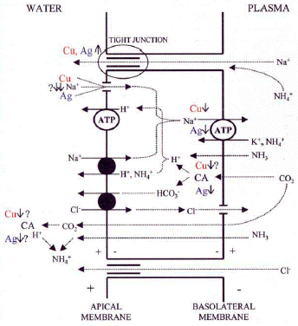
Figure 3-1 Schematic representation of a general model of acid-base, sodium, chloride and ammonia transport across the gill epithelium of freshwater organisms and the transport channels involved (after Grosell et al., 2002a)

Figure 3-1 summarises the current understanding of sodium transport across the freshwater gill epithelium (Grosell et al., 2002).
Chronic toxicity to fish and invertebrates
It is still unclear how ionoregulatory disturbance affects organisms in long-term exposures. Paquin et al. (2002b) indicate that in chronic exposures, one should also take into account that organisms may exhibit acclimation effects. To our knowledge, no studies have been performed investigating the possible effect of ionoregulatory malfunctioning on reproductive success. It has been suggested that a decrease of whole body Na⁺ concentrations in D. magna chronically exposed to silver may have been responsible for the observed decreased reproduction (Bianchini and Wood, 2002). Although high sodium losses may indeed result in an overall decreased fitness of the organism and in an enhanced energy requirement for maintenance purposes, there is no evidence that this is the only mechanism causing reduced reproductive success in chronic exposures.
De Schamphelaere and Janssen (2003) demonstrated the influence of water characteristics on chronic toxicity of D. magna and showed that for D. magna, waterborne copper and not dietary copper uptake is responsible for copper toxicity (De Schamphelaere and Janssen, 2004). For fish, Kamunde et al. (2001 & 2005) demonstrated that at normal copper exposure levels, dietary copper plays an important role in total copper uptake and turnover rates in rainbow trout, O. mykiss. High dietary copper exposure further increased clearance from the gut, increased excretion through the bile and decreased uptake through the gills. In spite of the observed induction in copper regulation mechanisms, dietary copper exposure had no effect on growth, condition factor, or food consumption efficiency. Waterborne Cu exposure induced marked decrease in the uptake rates from waterborne exposure but not from dietary exposure because waterborne exposure modified gill but not gut uptake mechanisms (Kamunde et al, 2005). Allinson et al. (2002) further demonstrated the absence of bioaccumulation or bioconcentration of copper from the diet for the freshwater crayfish, Cherax destructor. The authors further showed that the crayfish did not appear to be sensitive to copper through dietary exposure.
For copper therefore these studies thus demonstrate the gills and gill-like surfaces seem to be the key target organs for acute as well as chronic copper toxicities in fish and invertebrates whereby the influence of water characteristics on copper toxicity plays a key role. The close link between acute and chronic toxicities is furthermore evidenced from the correlation between acute and chronic toxicity data in a variety of natural surface waters and the observed low acute to chronic ratios (De Schamphelaere et al (2002) and Figure 3-2). These studies further indicate the great importance of copper homeostatic regulation mechanisms and the homeostatic interaction between uptake routes.
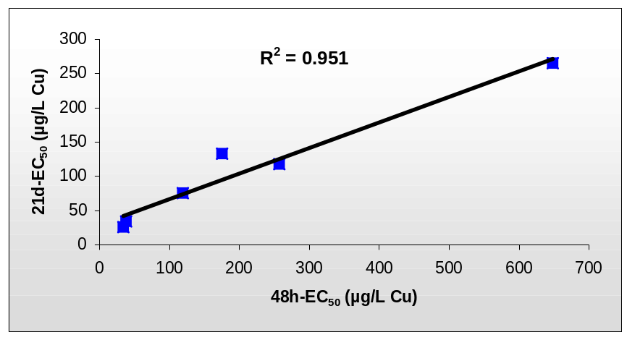
Figure 3-2: Correlation between the observed acute and chronic Cu-toxicity to D. magna in six EU surface waters.

Handy (2003) evaluated chronic sub-lethal copper toxicity in fish and observed that target tissues are broadly the same as acute exposures. In chronic exposure fish have more time to down-regulate Cu across the gills and re-distribute newly acquired copper to the liver for excretion, to minimise toxic effects. The data suggest a well regulated physiological process in fish. Indeed, the authors explain the mentioned physiological changes, observed at high copper doses, as being related to a neuro-endocrine control system whereby cellular and physiological changes are not a random cascade of events but a temporally ordered and synvhronised series of events in different body systems that integrate to enhance the survival of animals. The initial effects, observed after dietary exposure were altered gill morphology and NA +K+ ATPase activities and are thus consistent with the waterborne driven ecotoxicity profile. It must further be noted that the doses used are relatively high and indirect effects from waterborne exposure can not be excluded.
Clearwater et al (2002), reviewed the literature on copper toxicity after dietary copper exposures. Unfortunately not one study has been able to unambiguously demonstrate toxic effects on endpoints which are typically considered relevant for risk assessment (survival, growth, reproduction) when using ecologically relevant diets, i.e. diets in which copper had been biologically incorporated. Only two such studies were cited in the review that have used naturally contaminated food, while all other studies cited by Clearwater et al. (2002) used artificial diets. Bryan and Gibbs (1983) found no effects on growth of Gurnard (Trigla lucerna) when fed polychaete worms contaminated with Cu up to 2000 mg Cu ∙ kg⁻¹ dry wt, which corresponded to a weight-specific Cu ingestion rate (IR_{Cu}) of the Gurnard of 20 to 40 mg Cu ∙ kg⁻¹ wet wt ∙ day⁻¹. Mount et al. (1994) found no effects on survival and growth of rainbow trout fry (Oncorhynchus mykiss ) fed live Artemia with a body burden of 352 mg Cu ∙ kg⁻¹ dry wt, corresponding to IR_{Cu} of the rainbow trout of 21 mg Cu ∙ kg⁻¹ wet wt ∙ day⁻¹. At higher dietary Cu doses effects on survival were noted, but this could not be attributed unambiguously to dietary Cu, because up to 40 µg Cu/L leached from the food into the test solution. More details on the review of the Clearwater paper can be seen from Appendix env T.

Hansen et al (2004), performed a metal exposure study on growth performance in rainbow trout fed a live diet pre-exposed to metal contaminated sediments. This study, involving mixture exposures, did NOT indicate a copper related effect of diet-borne exposure in rainbow trout (i.e. effects were related to arseen) the study included results on copper accumulation in food showing a range from 22.9 µg/g to 731 µg/g dry weight. The study therefore indicates the absence of copper toxicity at high dietary copper levels.

Copper toxicity to unicellular algae
It is commonly accepted that mechanisms of metal toxicity in algae are very different from those observed in fish and invertebrates. This seems logical, as the border between the intra- and extra-cellular environment in algae is not a gill but is generally composed of a polymeric cell wall and a plasma-membrane. A number of copper toxicity mechanisms to algae have been reviewed by Stauber and Davies (2000). At the cell-membrane, copper may cause changes in membrane potential and permeability or may compete with essential metals for binding and uptake (Sunda and Huntsman, 1983; Cid et al., 1996; Franklin et al., 2001). Interactions between copper and manganese and copper and zinc have been reported (Sunda and Huntsman, 1983; Reuter and Morel, 1981). Following transport into the cytoplasm, copper can inhibit enzymes such as esterase and B-galactosidase (Peterson and Stauber, 1996; Franklin et al., 2001) and cause changes in intracellular pH (Cid et al., 1996). Copper is also reported to affect organelles such as chloroplasts and mitochondria. Wong et al. (1994) reported structural alterations to thylakoid membranes of Chlorella species and inhibition of photosynthesis. Cid et al. (1995) reported a disrupted mitochondrial electron transport upon copper exposure. Finally, copper inhibits algal growth due to the disruption of the glutathione metabolism: Cu-related oxidation of oxidize thiol groups on enzymes or free thiols such as glutathione, results in a decrease of the reduced/oxidized glutathione ratio and subsequent inhibition of cell division (Stauber and Florence, 1987).
        - Biotic-ligand model (BLM)
Description of the model
From the latter chapters it seems that specific water quality parameters (DOC, hardness, pH) ameliorate the acute and chronic toxicity of copper to aquatic biota. However, a more intensive program of acute/chronic toxicity testing was needed to test this hypothesis and to quantify the magnitude of the influence of these parameters. The understanding of the mechanisms involved in copper toxicity resulted in the development of a mechanistically based model that is able to describe copper bioavailability and toxicity to aquatic biota.
Indeed it is recognised that metal species that form in aquatic solutions are hydrophilic and their uptake largely depends on the presence of specific transport systems that provide biological gateways for the metal to cross the membrane. Exceptions are organo-metallic species that are lipophilic, behave like non-polar organics and are taken up across the membrane by passive diffusion (Campbell, 1995).
The uptake of copper is mainly through active transport systems and is largely restricted to specialised organs (biotic ligands) such as the gills. The biotic ligand modelling (BLM) approach was developed to incorporate aqueous speciation reactions and competition of cations for binding to biotic receptors. This BLM is based on a conceptual model similar to the gill site interaction model (GSIM) originally proposed by Pagenkopf (1983) and the free ion activity model (FIAM) as described by Campbell (1995). The model is based on the hypothesis that toxicity is not simply related to total or dissolved copper concentration but that metal complexation and interaction at the site of action need to be considered. Copper toxicity is simulated as the accumulation of the metal at the biologically sensitive receptor, the ‘biotic ligand’, which represent the site of action of metal toxicity. It is therefore assumed to occur as the result of the free metal ion reacting with the physiologically active binding sites at the site of action. This is represented as the formation of a metal-biotic ligand complex. For fish the biotic ligand appears to be sites on the surface membrane of the gill. The principal feature that distinguishes the biotic ligand from considering only the free metal ion as the toxic species is that the free metal ion competes with other cations, e.g. Ca²⁺, H⁺, for binding at the biotic ligand. As a result, the presence of these cations in solution can mitigate toxicity, with the degree of mitigation depending on their concentrations and the strength of their binding to the biotic ligand.
Biotic ligand models have been developed for the different trophic levels (algae, daphnids, fish) using the different methodologies proposed by Di Toro et al. (2001) and De Schamphelaere and Janssen (2002).
Di Toro et al. (2001) used conditional stability constants for competing cations (e.g. H⁺, Ca²⁺, Na⁺) and the metal (e.g. Cu²⁺) that were derived by Playle et al. (1993) in gill-binding experiments, for fitting BLMs to existing literature (acute) toxicity data for daphnids and fish. De Schamphelaere and Janssen (2002) refined the original invertebrate/fish acute Cu-BLM model (Di Toro et al., 2001) using toxicity data with D.magna.
De Schamphelaere and Janssen, 2002, 2004, De Schamphelaere et al., 2002 and De Schamphelaere et al., 2003) further developed a chronic Cu-BLM for the invertebrate D. magna and for the green alga Pseudokirchneriella subcapitata. Existing fish toxicity studies (Erickson, 1996 and Waiwood and Beamish, 1978), performed under chronic copper exposure regimes with varying water chemistry were used by De Schamphelaere and Janssen (2004) for the development of the chronic Cu-BLM for fish (details see Appendix env U). A All models were developed from the observed linear relationships between the observed toxicity effect concentration of the metal and the individual competing cation concentration (both expressed as free ion activity).
The stability constants for the 48 hour acute D. magna Cu-BLM (De Schamphelaere and Janssen (2002) are similar to the ones derived by Di Toro et al (2001), but De Schamphelaere and Janssen (2002) and De Schamphelaere et al. (2002) refined the initial model by adding a stability constant for magnesium and incorporated the contribution of CuCO₃ and Cu(OH)⁺ towards toxicity into the model.
In analogy with the methodology used for the development of the acute D. magna Cu-BLM, De Schamphelaere et al, 2004 developed a chronic D. magna model from the observed linear relationships between the observed 21 reproductive NOECs of copper for D. magna and the individual competing cation concentration (both expressed as free ion activity). Comparison between the measured NOEC values and NOEC values predicted by the model is shown in Figure 3-3. From Figure 3-3 it is therefore concluded that the D. magna Cu-BLM can adequately predict the NOEC values of copper within a factor of 2.

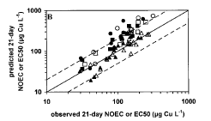
Figure 3-3: Predictive capacity of the chronic Daphnia magna biotic ligand model as shown by observed versus predicted 21-d no-observed-effect concentrations (NOECs) and 21-d 50% effective concentrations (EC50s). (De Schamphelaere and Janssen, 2004). DOC from three different surface waters was added to the artificial test media (circles : Behain, squaures: Ossekolk, triangles : Ankeveen; closed sympbols : NOECs; open symbols : EC50 values.

For the development of the chronic fish BLM for Cu, the predictive capacity of parameter sets of existing BLMs at varying water chemistry was investigated based on literature data (De Schamphelaere and Janssen, 2004 (for more details, see appendix U). The existing BLMs that were considered are the initial acute BLM (developed originally from fish ecotoxicty data, Santore et al., 2001), the refined acute BLM (developed using D. magna toxicity data, De Schamphelaere et al., 2002) and the chronic (reproduction) D. magna Cu-BLM (De Schamphelaere and Janssen, 2004). In addition, potential refinements for one or more parameter constants were investigated based on existing literature data. The literature survey on the effects of water chemistry on chronic copper toxicity to fish species revealed two adequate studies in which sub-lethal effects of copper to fish are reported for test waters with different ionic composition, i.e. the 7 days larvae growth test with P. promelas of Erickson et al. (1996) and the 10/30 days juvenile growth test with O. mykiss of Waiwood and Beamish (1978).
Erickson et al. (1996) reported 7d-growth data for larval fathead minnows in a number of test media (Lake Superior water) in which Ca, Mg, Na, pH, alkalinity and dissolved organic carbon (DOC, added as Aldrich humic acid) were modified (n=22). Data on the chemical composition of all test media was reported in Erickson et al. (1987). Free copper ion concentrations were measured with the Ion Selective Electrode. The reported range of pH, Ca, Mg and Na are respectively, 6.63-8.65, 13.6-93.8 mg/L, 2.9-51.5 mg/L and 1.6-47.6 0-5 mg Humic acid DOC /L was added to lake Superior water, characterized by 1 mg DOC/L. Waiwood and Beamish (1978) report growth data of 5-6 gram juvenile rainbow trout (O. mykiss) upon flow-through copper exposure at varying conditions of pH and hardness. A hard well water (hardness = 360 mg CaCO₃/L, alkalinity = 220 mg CaC0₃/L, pH = 8) was used as test water. To adjust hardness the well water was diluted with deionized water. Hardness ranged from 30 to 360 mg/L CaCO₃ (Ca concentration varied between 12-144 mg/L). pH was subsequently adjusted to the desired level using H₂SO₄ (pH varied between 6.0 and 8.0). Growth was monitored in three 10-day intervals during 30 days. 10-day growth results are used for the chronic Cu-BLM development as rainbow trout growth was most sensitive to copper during the first 10 days of exposure. The 10 days Cu BLM could nevertheless also adequately predict the toxicity observed at respectively 20 and 30 days.
The toxicity data illustrates that both the dissolved and the free cupric ion Cu²⁺-activity are not able to explain the variation in ECx values. This illustrates that both the dissolved/Cu²⁺ are not good predictors of chronic toxicity (in this case growth effects).The BLM equations were used to attempt to explain the variability of the toxicity data.
From the evaluation, it is concluded that the acute fish and invertebrate Cu-BLM parameters were better predictors than the chronic D. magna Cu-BLM parameters (De Schamphelaere et al., 2004). The refined acute D. magna Cu BLM (De Schamphelaere et al., 2002) was able to predict all toxicity data within a factor of 2. When no data of pH > 7.5 were considered, the fish (Di Toro et.al, 2001) and Daphnia model parameters (De Schamphelaere et al., 2002) perform equally well. For pH > 7.5, the old fish BLM underpredicted toxicity and, as observed in the refined acute D.magna model, the inclusion of u CuOH⁺ and CuCO₃ toxicity in the BLM is needed. Since effect concentrations were on average predicted by an error of less than factor 2, the stability constants derived for the acute Daphnia BLM constants (De Schamphelaere et al., 2002) are used for predicting the effects of bioavailability on chronic copper toxicity to fish species.

Figure 3-4 and Figure 3-5 illustrate the predictive ability of the developed chronic fish BLM and demonsrate that the chronic fish Cu-BLM can adequately predict the NOEC values of copper observed for fish larvae and juvenile growth within a factor of 2.

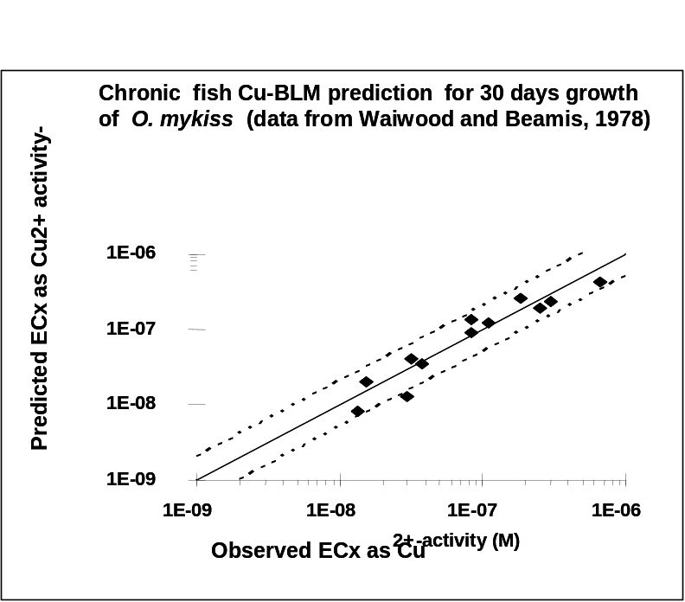

Figure 3-4 :Observed vs. predicted EC₆₀,Cu2+ for 30 days juvenile growth of O. mykis, using the developed chronic fish BLM parameters. Full line indicates perfect predictions. Dashed lines indicate a factor of 2 prediction.

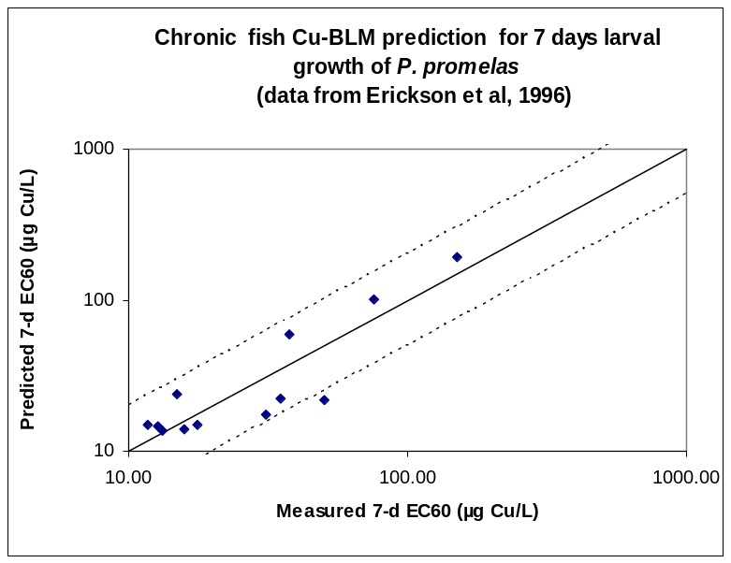
Figure 3-5:Observed vs. predicted EC₆₀,Cu2+ for 7 days larval growth of P.promelas, using the developed chronic fish BLM parameters. Full line indicates perfect predictions. Dashed lines indicate a factor of 2 prediction.
The final model parameters retained for the prediction of acute and chronic effects of copper to aquatic invertebrate and fish are listed in Table 3-3
Table 3-3 : Summary of BLM constants of different Cu-BLMs
 | Acute fish BLM  Di Toro et al., 2001 | Acute D. magna BLM  De Schamphelaere et al, 2002 | Chronic fish BLM  De Schamphelaere et al., 2005 | Chronic D. magna BLM  De Schamphelaere et al., 2004
Relative toxicity of Cu-complexes
R_{CuOH} = K_{CuOHBL}/ K_{CuBL} | 0.063 | 0.20 | 0.20 | 1.00
R_{CuCO3} = K_{CuCO3BL} / K_{CuBL} | - | 0.10 | 0.10 | 0.26
Copper constants
log K_{CuBL} | 7.4 | 8.02 | 8.02 | 8.02
log K_{CuOHBL} | 6.2 | 7.32 | 7.32 | 8.02
log K_{CUCO3BL} | - | 7.01 | 7.01 | 7.44
Competition constants
log K_{HBL} | 5.4 | 5.40 | 5.40 | 6.67
log K_{CaBL} | 3.6 | 3.47 | 3.47 | -
log K_{MgBL} |  | 3.58 | 3.58 | -
log K_{NaBL} | 3.0 | 3.19 | 3.19 | 2.91

The BLM data (Table 3-3) clearly show that fish/invertebrate acute and chronic BLM parameters are very similar, thus confirming a basic common mechanism of action for gill breathers. Indeed, when considering copper speciation and comparing the BLM parametric values for respecively acute and chronic models for fish and invertebrates. The data across all models show that DOC and pH are the 2 dominant bioavailability factors.
Detailed comparison of the chronic fish and invertebarte Cu-BLMs, further point towards the similarities but also indicate differences between the two BLMs. The observed competition stability constants for H (log K-H) to the fish and invertebrate biotic ligands are respectively 5.4 and 6.7. For fish as well as invertebrates relatively small and similar competition stability constants were observed for Na, with log K-Na values ranging between 2.9 and 3.2. Small stability constants (and thus relative small influence of these parameters) are also observed for Ca and Mg (Log K values between 3.5 and 3.6) in the chronic fish BLM. For the chronic invertebrate studies, the influence of Ca/Mg was non-significant and thus no Ca/Mg stability constants were derived.

For the green alga Pseudokirchneriella subcapitata (De Schamphelaere et al., 2003), performed a range of chronic (72 hours) alga growth inhibition tests and derived the chronic algae BLM. The algae BLM only considers binding of Cu to the biotic ligand (i.e., no competition with other cations). The value of the Cu- stability constant (Log K_{CuBL}), however,
is pH-dependent and increases with increasing pH. The algal model was formulated as: Log (E_{b}C10_{Cu2+}) (nM) = -1.14 pH – 0.812 (R² = 0.91) (De Schamphelaere et al., 2003), and the log K equals -((-1.14 pH)-0.812). A slope of -1.43 was derived if EC50 values were used. This algal model has been further validated using different species like C. reinhardtii and C. vulgaris and it has been demonstrated that although single species derived slopes slightly differed among species, a unified slope of - 1.354 was applicable to the ECx of all three algal species and strains (Figure 3-6) (De Schamphelaere and Janssen, 2006). Based on the E_{b}C10_{Cu2+} and unified slope, a species/strain specific intercept can be determined and, subsequently, the value of the pH-dependent log K_{CuBL}. With this information it is possible to normalise algal toxicity to various environmental conditions. The above-discussed results clearly indicate that the key feature of Cu toxicity models for green microalgae is the linear relation between ECxpCu and pH. Although the slopes of these relations may slightly differ between species, endpoints, and effect levels, they are similar enough so that predictive capacity is not substantially affected when a “universal” slope is used. The fact that one such universal slope has been demonstrated applicable to different species, endpoints, effect levels, water types suggests the possibility of universal mechanisms of Cu bioavailability in green microalgae. Mechanistically, this universality may stem from a similarity across species of the Cu²⁺/H⁺ binding characteristics of different cell surface ligands involved in Cu uptake and/or toxicity.

Figure 3-6 : Predictive capacity as shown by observed vs. predicted effect levels (ECx, as dissolved Cu) of the species and endpoint specific models (A and B) and of the unified models (C and D) for P. subcapitata (A,C) and C. vulgaris (B,D) growth rate inhibition, and of the unified models for P. subcapitata biomass inhibition (in natural waters), and for C. reihardtii growth rate inhibition (E).
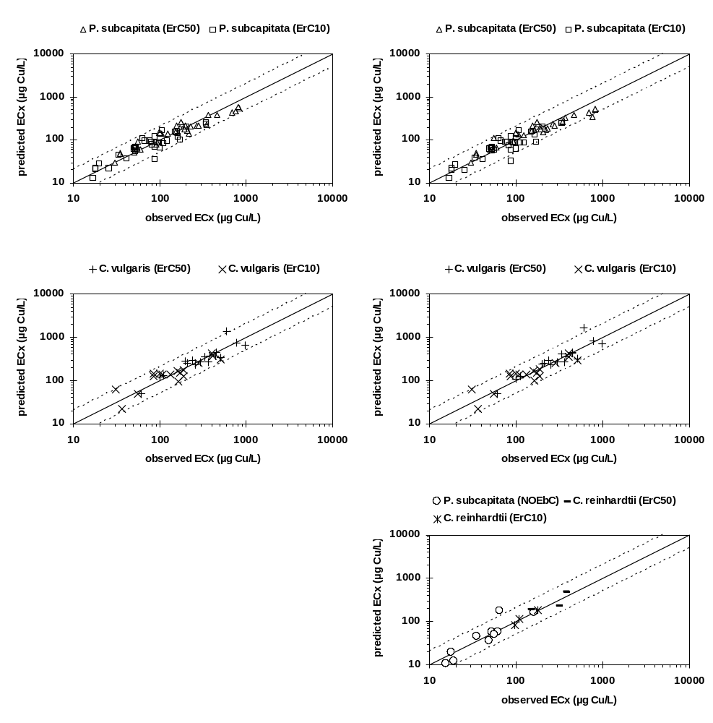

An important difference between the chronic fish/invertebrate and algae BLM is related to the differences in sensitivity with changing pHs (Figure 3-7). Indeed, an increase of pH for algae results in an increase in toxicity while for invertebrates/fish a decrease in toxicity is observed. These findings on algae seem to be contradictory with earlier observations that metal toxicity is reduced at increased pHs because of the reduction of the free metal ion fraction which is considered to be the most bioavailable (and toxic) metal species (Morel, 1983; Morel and Hering, 1993). The results indicate that for algae, Cu become less toxic at lower pH. There is growing evidence that competition between hydrogen ions and the free metal ions for binding at the cell surface ligands could be responsible for reduced metal uptake (and toxicity) at lower pH-levels (Peterson et al., 1984; Campbell and Stokes, 1985; Parent and Campbell, 1994). However, whereas biotic ligand models for fish and invertebrates typically consider only one type of site, with one characteristic pKa value for proton binding, this may not necessarily be valid for algae. These differences in pH sensitivity for different DOC percentiles in EU surface waters is clearly shown by De Schamphelaere et al. (2002).

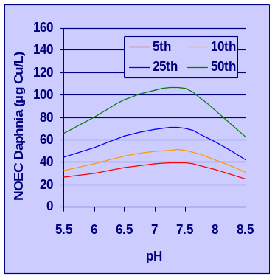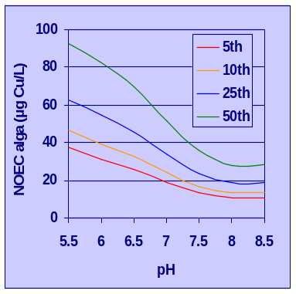
Figure 3-7 : Differences in pH sensitivity between algae and invertebrates for different DOC percentiles in EU surface waters.

Conclusion : From the above discussion, it is therefore concluded that the chronic Cu-BLMs, developed for invertebrates (D. magna), fish (O. Mykis and P. Promelas) and algae (R. Subcapitata, C. vulgaris and C. reihardtii) can adequately predict the Cu-NOEC values for these species within a factor of 2.
The further application and validation of the models for fish, invertebrates and algae is outlined below.
Application & validation of the speciation models in natural waters

The basic models developed for fish, invertebrates and algae are based on Cu²⁺ measurements, using Ion Selective Electrodes. The predictions of Cu²⁺ concentrations have been based on Whindemeyer Humic Acid Model version V (WHAM V). The predicted Cu²⁺ measurements validated the predicted Cu²⁺ concentrations (eg De Schamphelaere et al, 2003) and the comparison of the observed versus predicted toxicity values (Figure 3-3, Figure 3-4, Figure 3-5, Figure 3-6) all include these WHAM V speciation model predictions and are therefore a validation of the abiotic speciation as well as the biological part of the BLMs .

In view of defining the copper binding capacity of natural organic matter, some definitions are useful. Natural Organic Matter is defined as NOM. The dissolved portion of the NOM is called Dissolved Organic Matter (DOM). The DOM is usually measured as Dissolved Organic Carbon (DOC). Only a fraction of the DOC is actively binding to copper.

For the extrapolating the copper binding capacity of humic and fulvic acid (used for the WHAM V model calibrations) towards copper binding capacity of natural organic matter (NOM) occurring in natural surface waters, Tipping et al, (1991) compared observed and predicted Cu²⁺ concentrations in a wide range of natural surface waters and concluded that, only between 40% and 80% of the dissolved organic carbon (DOC) are active copper binding fulvic acids, the rest of the DOC being inert with respect to ion binding. Dwane and Tipping, 1998 further evaluated natural samples and suggested, in absence of knowledge on the active binding fraction of the NOM to assume that 50% of the DOC consists of fulvic acids. Bryan et.al., 2002 compared ion selective electrode measured Cu²⁺ levels with the WHAM V predicted Cu²⁺ level for 15 natural samples (DOC ranging between 4.4 and 26.7 mg DOC/L) and concluded that 65% of the total DOC, is to be considered as active fulvic acid DOC. The , illustrates the predictive power of the WHAM 5 model for the measured Cu²⁺ concentrations across these 15 natural UK surface water samples (lakes, ponds, streams and rivers with wide range of physico-chemistry : DOC between 4.6 to 27 mg C/L, pH between 4 and 8.1) and therefore demonstrates adequate extrapolation of laboratory waters to natural surface waters.

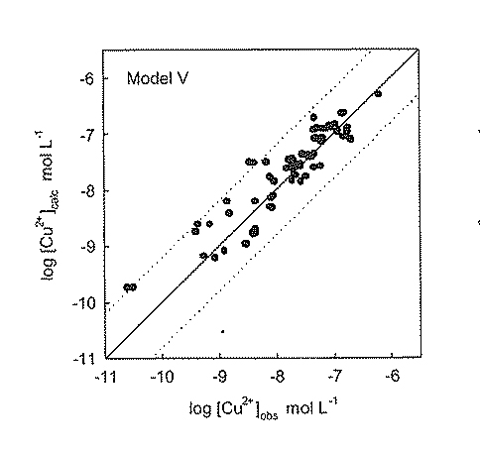
Figure 3-8 : Comparison of observed and predicted Cu²⁺ concentrations in 15 natural UK surface water samples covering lakes, ponds, streams and rivers with varying physico-chemistry. The study considers that 65% of the DOC has copper bonding capacity (from Bryan et al., 2002)

For the copper RAR, if no information is available on the humic acid or the active fulvic acid fraction, the following default DOC assumptions (consistent with Dwane and Tipping, 1998) are therefore made : for BLM applications in natural waters, 50 % of the total DOC is considered as inert to copper binding and the remaining 50% of the total DOC is considered as active fulvic acids. For BLM calculations, the humic acid fraction is therefore set to a minimum value (0.01%).

Application & validation of the acute BLMmodels in natural surface waters

The ability of the acute fish Cu-BLM (Di Toro et al., 2001) to reproduce the effect of variations in water chemistry on copper toxicity to fish was investigated extensively in the framework of the copper Water Quality Criteria set by the US EPA whereby the derivation of effect concentration for the metal to be investigated in the site specific water is compare to the effect concentration in a standard laboratory water, i.e. the water effect ratio (WER) approach. Several data sets were used for WER studies using fathead minnows in order to determine site specific water quality criteria for copper in effluent impacted streams (Diamond et al., 1997; Dunbar, 1996). In addition, the data set from Erickson et al. (1987), designed to test the effect of specific water quality adjustments on copper toxicity, was included in the comparison. Good agreement between the observed and BLM-predicted results from the WER analysis was noticed. Predicted values correlate well with measured values and nearly all results are within a factor of 2 of measured values (Figure 3-9).
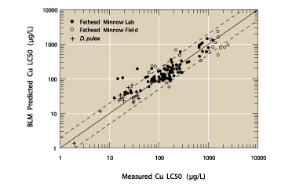
Figure 3-9 : Measured versus predicted LC50 values for P.promelas early life stage mortality LC50s tested in laboratory waters and field surface waters (from Di Toro et al., 2001).

- The acute D. magna model as developed by De Schamphelaere et al. (2002), was validated with the acute Cu-toxicity data generated in 19 copper-spiked natural waters that are representative for the observed variation in water characteristics in European surface waters (pH : 5.5 to 8.5; Hardness: 10 to 500 mg CaCO₃/l, DOC: 1.6 to 23 mg/l). Observed 48h-EC₅₀ ranged between 35.2 and 792 µg Cu/l (factor of 22). With the acute Cu-BLM, however, all 48h-EC₅₀s observed were accurately predicted within a factor of two for all surface water tested, i.e. when the physicochemistry of the surface waters is taken into account (pH, cation composition, DOM-concentrations), the EC₅₀-variability is reduced with more than a factor of 10.
- Recently, Kramer et al. (2004) performed acute D. magna ecotoxicity tests by spiking copper to six Dutch surface waters, collected at four different periods (DOC between 0.1 and 22 mg/l) and demonstrated that natural organic matter decreases bioavailability, uptake and acute ecotoxicity for D. magna and derived a linear relation between DOC and D. magna EC₅₀ values. The acute Cu-toxicity (48hr-EC₅₀) to D. magna in these surface waters could be predicted within a factor of two from the acute BLM model, calibrated to the D.magna data-set (Figure 3-10).
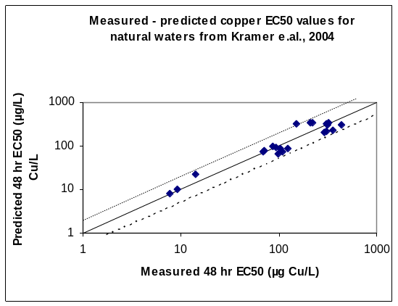
Figure 3-10 : Predicted versus measured copper acute LC₅₀ values D;magna tested in 6 Dutch natural surface waters (From Kramer et al., 2004.

.- Additional comparison and validations of the acute BLMs, developed in the US and Europe, using Chilean surface waters were performed for D. magna, D. pulex and D. obtusa (Rodriguez et al., 2004). The work of Rodriguez at al, 2004 showed that the acute Biotic Ligand Model for copper, in any of the versions used (with somewhat different BLM parameters as discussed above) was a robust tool of metal toxicity prediction in a broad variety of natural waters of Chile. The difference in predictive power between the acute models was smaller than the variability between LC50 measurements from different laboratories. Moreover the differences between the models were mainly observed in synthetic waters. These data thus showed that the acute BLM is sound enough to tolerate some changes in the parameter values without affecting its overall predictive capacity
Application & validation of the chronic Cu-BLM model in a range of surface waters

- The ability of the developed algal model to predict 72-hour EbC₅₀s and NOE_{b}Cs of copper to P. subcapitata in natural waters was investigated by De Schamphelaere et al. (2003). For the validation, also the default DOC assumption was applied : the DOC consists of 50% active fulvic acid. These authors evaluated the toxicity of thirteen Cu-spiked European surface waters to this algal species. Eighty-one% of the predictions of 72-hour EbC_{10,dissolved} and 72-hour EbC_{50,dissolved}, differed less than a factor of two with the observed 72-hour NOE_{b}C_{dissolved} and 72-hour EbC_{50,dissolved} values (Figure 3-11). For one surface water both predicted EbC_{10,dissolved} and EbC_{50,dissolved} were more than a factor of 2 (up to factor 4) higher than the observed NOEC_{dissolved} and EbC_{50,dissolved}. The relative weaker performance of the model in this case was probably a combination of low pH values (<5.5) and relatively high Fe and Al concentrations in these specific waters. This may results in a strong competition with copper for binding sites on the DOM, thus making copper more bioavailable than predicted. Indeed, because of their higher valence, Fe(III) and Al(III) ions are known to form very strong complexes with organic matter (Gamble and Schnitzer, 1973; Tipping, 1994). On the other hand, the control reproduction in this water was the lowest of all tested natural waters. The low pH, low hardness, high Fe and/or Al concentration and/or other local factors therefore may have influenced the results for that specific water. The boundaries for the use of the applicability of the BLM can hence be defined as : pH : 5.5 to 8.7, hardness: 10 -500 mg CaCO3/L, Fe : 307 mg /L and Al: 332 mg/L.
- De Schamphelaere et al., 2004 performed BLM validations for the chronic D. magna BLM whereby 21 days chronic NOEC values obtained in 10 copper-spiked European natural surface waters are compared to BLM predicted 21d-NOEC and 21d-EC₅₀ values. The chronic Daphnia copper-BLM parameters were applied to the water-specific physico-chemical characteristics to predict the 21d-NOEC and 21d-EC₅₀ values in these waters. For this Cu-BLM validation exercise, the default DOC assumption (the DOC consists of 50% active fulvic acid) was applied. The chronic Cu-toxicity (21d-NOEC and 21d-EC₅₀) to D. magna in these ten different surface waters could, in most cases, be predicted within a factor of two of the observed effect concentrations whereas the difference between lowest and highest effect concentration was about a factor of 20 (Figure 3-11). The boundaries for the use of the applicability of the BLM are defined as : pH : 5.5 to 8.5, hardness: 10 -500 mg CaCO3/L, Fe : 307 mg /L and Al: 332 mg/L.
With these validation studies the potential use of Biotic Ligand Models for predicting chronic Cu-toxicity to algae and daphnids in natural surface waters has clearly been demonstrated (;after De Schamphelaere, 2003).

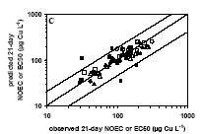
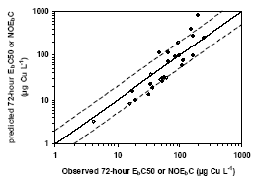
Figure 3-11 : Relationship between observed and predicted chronic EbC₅₀ dissolved (closed symbols) and NOECdissolved (open symbols) of copper for Daphnia magna (figure left) and Pseudokircherniella subcapitata (figure right) in natural waters (De Schamphelaere, 2003)

The BLM development/validation of fathead minnow is provided in Figure 3-5. The DOC source used in this data-set was humic acids. Ryan et.al (2004) evaluated the influence of natural organic matter (NOM) quantity (2 to 18 mg DOC/L) and NOM quality (NOM from 9 different Norwegian surface waters, extracted through reverse osmosis) on the early life stage toxicity of copper to fathead minnows and observed a relationship between the DOC concentrations and the toxicity (96 hr LC50 values) in these NOM amended test waters (). The EC50 values observed in the DOC amenned waters (Ryan et al, 2004) were used to validate the chronic fish Cu-BLM for natural surface waters. The toxicity data were used to calibrate the chronic Cu- BLM and default DOC assumptions (50% active DOC and 0.01% active HA) were used. Considering the copper amended waters, Figure 3-13 shows that with the exception of one outlier, the chronic Cu-BLM can usually predict the observed early life stage toxicity within a factor of 2. Useful to note that, for the outlier, the measured/predicted toxicity values from the same DOC sources tested at 10 mg DOC/L (instead of 2 mg/l), did demonstrate that the BLM could adequately predict the ecotoxicity within a factor of 2.

- Hollis et al., 1997 and 1996, further demonstrated from copper accumulation and toxicity experiments with Oncorhynchus mykiss that DOC (5 mg DOC/L) from a commercial source and from a natural surface water protected small rainbow trout from copper toxicity during respectively 9 and 15 days exposure because copper was kept from binding to gills during this 9 days exposure experiment. These data as well as the original data for Erickson et al., 1996 used to develop the chronic fish Cu-BLM can therefore confirm that the protective effect of natural organic matter are also valid for long term chronic exposures. These data can therefore validate the chronic fish Cu-BLM model for fish species.

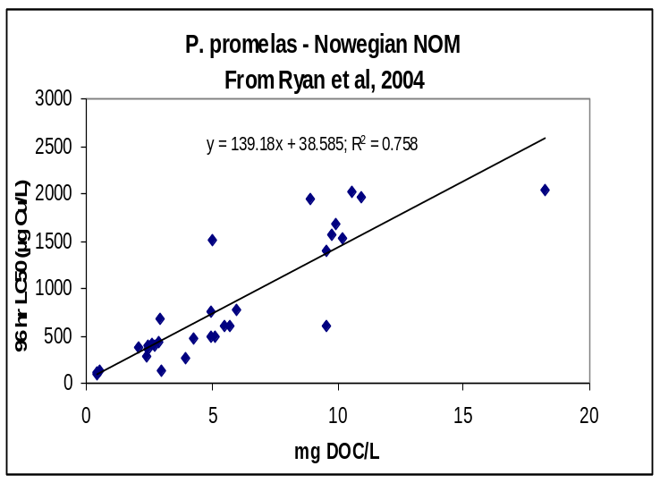

Figure 3-12 : Relation between early life stage LC50 values for P; promelas and DOC levels (Data from Ryan et al, 2004). DOC was collectes form 9 different Norwegian surface waters and added to a US EPA articial medium at three concentrations (0, 2, 5 and 10 mg DOC./L)
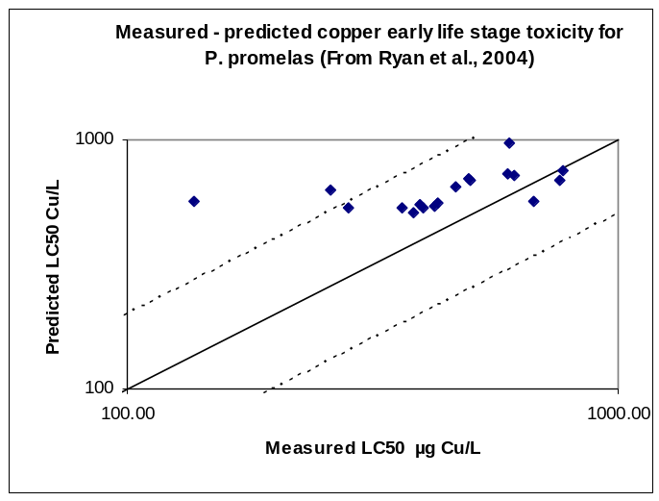
Figure 3-13: Predicted versus observed LC50 values for P. promelas for test waters with added Natural Organic Matter. The test media consists of a US EPA articial medium, amended with DOC form 9 different Norwegian surface wates at 2, 5 and 10 mg DOC./L ((Data from Ryan et 2004). The chronic fish BLM parameters, average test water chemistry and default DOC assumptions (50% active DOC and 0.01% active HA) were used for the model predictions.

In summary, chronic copper BLMs were developed/valided for algae, invertebrates and chronic Cu-BLMs are provided in Table 3-4.

Table 3-4 : Summary of the physico-chemical characteristics of the waters used for the development and validations of the chronic algae, invertebrates and fish models.

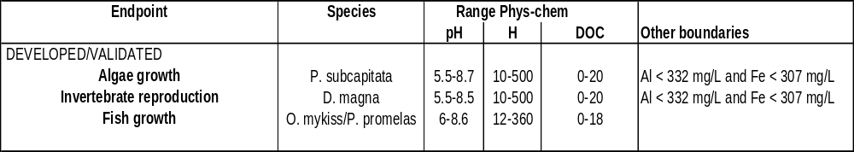

Nature of organic matter
The origin and nature of DOC in natural surface waters may be highly variable. Questions have been raised if the variability in DOC quality may have significant implications for the accuracy and predictability of the BLM. To evaluate the importance of the origin and nature of DOC, a detailed investigation of the literature was carried out (details in Appendix env ZA), considering chemical and physical properties of natural organic matter (NOM) as well as the relation between these properties and the BLM predictions.

Variation in the chemical and physical properties of NOM is clearly evident when comparing the characteristics of samples from different sources. Variation can also be seen in the apparent metal binding capacity of different NOM samples. However, some of the reported variation in observed metal binding can be attributed to confounding factors such as variation in pH, or the presence of variable amounts of other ions and metals known to affect NOM chemistry. When these confounding effects are controlled, either experimentally or by application of comprehensive modelling analyses, the NOM from different sources have very similar behaviour with respect to metal binding properties. These major effects are already well described by predictive models such as WHAM and NICA-Donnan, and these model formulations can therefore be used to predict NOM effects in the BLM. At most, the remaining differences that have been observed in chemical speciation measurements can be corrected by the use of a simple scaling parameter. Organic matter derived from WWTP effluent does appear to be chemically distinct from other NOM especially with respect to the presence of very strong metal binding substances consistent with the presence of reduced forms of sulfur. Ignoring these additional binding sites results in a simpler model that is cheaper and easier to implement, and introduces a bias that makes the model tend to over-predict toxic effects (and hence, will tend to derive slightly lower and slightly more protective regulatory limits).

When NOM is introduced to exposures of metal toxicity to aquatic organisms, there is a reduction in observed toxicity. Although some variability in this effect has been observed in numerous studies, nearly all of the observed response can be explained by consideration of the amount of NOM, and factors that affect NOM speciation such as pH, and the presence of ions and other metals. Although some additional explanatory power may be attributable to variation in NOM quality, the effect overall is small especially relative to the primary effects of NOM quantity and NOM chemistry. Observed variation in replicate toxicity measurements suggests that toxicity measurements are inherently noisy, and variation within a factor of 2 of a median response is typical of the unexplained variability associated with these measurements. The additional benefit, if any, in explaining effects on toxicity that are attributable to NOM quality appears to be approximately comparable in magnitude to this “noise” and this may explain the lack of consistent results in attempts to quantify the effects of quality from different NOM sources. This last observation is especially relevant as it relates to the BLM, because the introduction of additional factors in the model must ultimately be based on whether it improves the ability of the model to explain observed toxicity data consistently across diverse geographic areas. An extensive review on the variability in NOM quality in surface waters and implications on trace metal speciation and bioavailability modelling is provided by Santore et al. (2006) and can be found in Appendix ZA.

In addition, Cleven (2002) investigated the functionality of organic matter in four river systems in Spain, Sweden, Finland and The Netherlands, in relation to its ability to complex copper. Within each of the four river systems, consistent geochemical regional patterns exist, in which the physico-chemical characteristics investigated (pH, DOC, …) did not differ significantly, whereas between the basins these characteristics differed markedly. The DOC content in the samples was the highest in the Finnish (about 8 mg/l) and the lowest in the Spanish rivers (about 2 mg/l). The higher values of DOC were correlated to the lower pH values of the water. Binding constants for the association of copper were within a narrow range (log K = 8.3 ± 0.2) for all the systems studied.

From the above information, it can indeed be concluded that the BLM model adequately predicts the natural binding between Cu- and natural DOC constituents and that the Cu-DOC binding characteristics are rather constant across Europe.
Therefore, in this risk assessment, consistent with the recommendations, resulting from copper speciation studies, by Tipping et al., 1991, Dwane and Tipping, 1998 and Bryan et al., 2002 (details see above sections on applications of the speciation and BLM models in natural waters), if no information on the active fulvic acid fraction was available, the following default assumptions is made: 50 % of the DOC is considered as active fulvic acids (no binding to humic acids was considered necessary), the remainder of the DOC is considered as inert. The use of 50% active fulvic acid was finally validated from ecotoxicity test, performed in European natural waters. The acute and chronic algae, daphnia and fish BLMs validation exercises using natural surface waters or natural NOM from EU surface waters confirmed that the use of 50 % of the DOC as active fulvic acids (no binding to humic acids is included) can be used as a valid default assumption as it allows for an adequate prediction of the observed ecotoxicity within a factor of 2. Such validations include (details see above):
- predicted chronic toxicity for P. subcapitata in 13 copper spiked surface waters, collected across Europe (De Schamphelaere et al., 2003)
- predicted the chronic toxicity for D. magna in 10 copper spiked surface waters, collected across Europe (De Schamphelaere et al., 2003)
- predicted the chronic toxicity for P. promelas in water with DOC collected from 9 Norwegian surface waters (Ryan et .al., 2004)
- The BLM predictions of the HC5 for three high quality mesocosm studies (discussed below)

From these observations, it is clear that the BLM , using 50 % active fulvic acids, consistently allows for a predictive capacity within a factor of 2 across European surface waters. Changing the %AFA would seriously decrease the predictive power of the BLM model for natural surface waters.

To further study the importance of NOM variability, De Schamphelaere et al., 2004b evaluated the use of UV absorption measurements for estimating the copper complexation capacity (expressed as % optimal active fulvic acids (AFA)). The water-specific optimal % AFA determined from UV adsorption and toxicity tests also found an average of 57% AFA. The comparison of the BLM predictive power for predicting acute Daphnia magna toxicity, using respectively 50 % AFA and the optimal %AFA, showed that, although the %AFA varied (17-108%), that the optimal AFA only slightly reduced the Cu-BLM predictive power: from a factor of 2 down to a factor of 1.3. It is important to realize that the factor of two is already similar to the variability that is typically observed when an ecotoxicity tests is repeated twice. So the BLMs (without accounting for difference in DOM binding properties) perform equally well in estimating the toxicity in a given water as performing an ecotoxicity test in this water would do.
Bossuyt et .al, 2004 provided, as mentioned above, evidence on the applicability of the acute D.magna model across field collected cladoceran species from ecotoxicity tests carried out with 43 cladoceran species (4 families, 11 genera) sampled at two occasions from 6 different sites. The data showed that the acute D.magna BLM (with 50%AFA), used within the boundaries of its applicability, could predict the community sensitivity. The authors additionally measured UV absorption in 3 surface waters and, using the linear relation (UV-AFA) from De Schamphelaere et al., 2004b, the optimal AFA fractions for these 3 waters was estimated as ranging between 16 to 27%. Although, these optimal AFA fractions are relatively low, the comparison the BLM, using the standard 50% AFA allowed to predict the mean site sensitivity to copper within a factor of 2 (Figure 3-14). The use of the optimal AFA allowed to predict the site sensitivity to copper within a factor of 1.2. These data therefore again show the robustness of the 50% AFA assumption and do as such not contradict the RAR. Interestingly, the figure also shows that BLM predictions at the lower pH and hardness sites (pH >5.5; hardness <10 mg CaCO₃/l) were over-protective, likely due to acclimation of the organisms to low pH conditions.

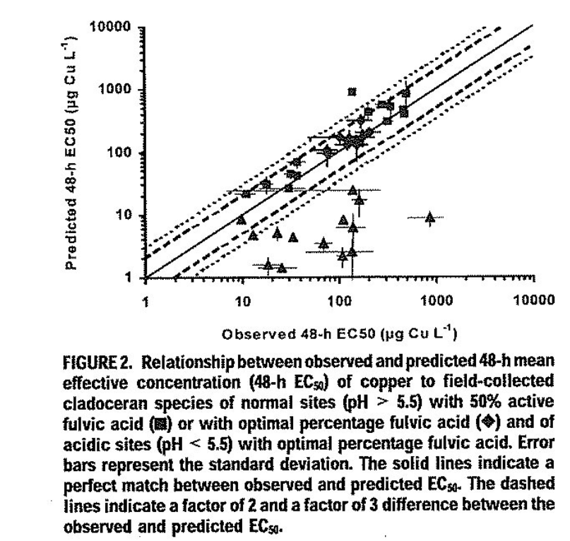
Figure 3-14 : relationship between observed and predicted 48-h mean effective concentration of copper to field collected cladoceran species (from Bossuyt et al., 2004).
Other research groups also evaluated the possibility to refine the predictions of results from ecotoxicity data with information from DOC quality:
- Kramer et al., 2004, observed a linear relationship between DOC and acute D. magna toxicity, for 6 Dutch surface waters irrespective of the source of natural water.
- Ryan et al, 2005 also concluded from Norwegian NOM characterisation versus fish toxicity that no additional variability could be explained from NOM quality
Conclusion : When considering the intra-laboratory variability in ecotoxicity (easily a factor of 2), it is therefore concluded that the BLMs (using 50%AFA, without accounting for any differences in DOM binding properties) perform equally well in estimating the toxicity in a given water as performing an ecotoxicity test in this water would do. Changing the %AFA (to eg a lower value) would seriously decrease the predictive power of the BLM model for natural surface waters. This conclusion does not invalidate that there may be exceptional cases with evidence of a different DOM source that may merit further investigations.

Applicability of the BLMs across species
The BLMs developed as described above will account for both the interactions of a metal ion with the media, which should be common to each metal, and the interaction of the available forms of the metal with the organism, which is organism/species specific. It is therefore important to demonstrated that a BLM for one taxonomic group may be applicable to another.

For the purpose of read-across species, the approach below is based on TCNES discussions considering the approach proposed by MERAG and integrating the views of certain Member States, expressing their view at TCNES and in writing.

The general approach for cross-species normalization outlined hereunder has been developed under the MERAG project (see also www.euras.be/merag). In Merag it is proposed to verify read-across of the available bioavailability models (e.g. BLM algae, fish, daphnids) developed and the subsequent PNEC derivation using the scheme as outlined in Figure 3-15.

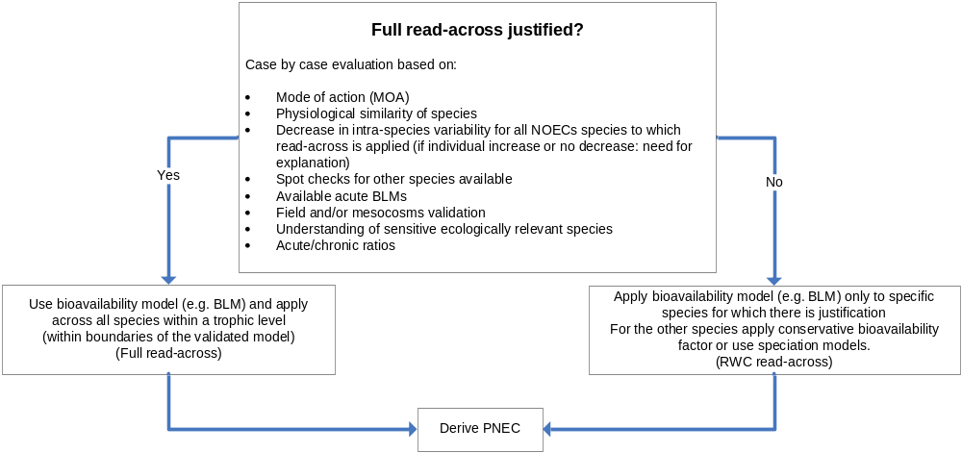

Figure 3-15: MERAG Approach for read-across of bioavailability models.

The MERAG read-across proposal was discussed at and after TCNES - September 06 and resulted in a TCNES discussion paper on normalization of ecotoxicity data for metals and submitted to TCNES for its December 2006 meeting. The TCNES discussion paper includes read-across acceptance criteria, as outlined in Figure 3-16.
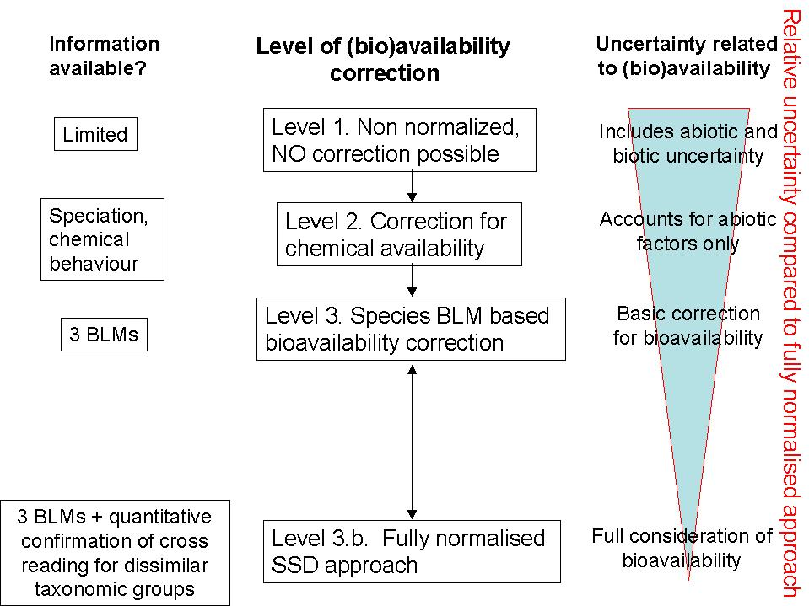

Figure 3-16: TCNES read-across approach and read-across criteria

- The first step consists of the read across approach thus consists in evaluating if full read-across to all species (full read-across) within a trophic level is justified. The application of a bioavailability model across species assumes similar mechanism of actions (e.g. similar stability constants between the cations (Ca, Mg, H) and the biotic ligands, similar site of action) and therefore the applicability across species needs to be investigated. Information on the applicability of the bioavailability model across species can be obtained from information on the mechanism of action (MOA) of the metal under consideration, physiological similarities between the species, observed changes in intra-species variability after application of the bioavailability model across species as outlined in Figure 3-16.

- The TCNES 2006 read across paper (fig 3.10b) provides the following read-across criteria : “In the ideal situation, quantitative evidence is available to confirm the applicability of at least 3 BLMs to at least 3 dissimilar taxonomic groups. In these cases, full BLM normalization of the SSD is justified. Such quantitative information should consist of ‘spot checking’ of the BLMs for species for which no validation had been undertaken. The ‘spot checking’ would amount to confirmation that the BLMs are able to adequately predict the toxicity of metals to dissimilar taxonomic groups, in chronic or acute tests. The level of checking, e.g. testing of additional taxa to confirm applicability of the BLM would be determined on a case by case basis taking into account the level of uncertainty in the extrapolations, and the extent to which it is necessary to reduce uncertainty. The accuracy of such predictions should be within a factor of 5 but could be altered depending the robustness of the endpoint tested. If the above information is not available, other evidence related to read-across of existing BLMs to other species can be used. Each of these bioavailability refinement criteria (eg Simiar mode of actions, similar species, decrease in intra-species variability) bring some inherent uncertainties when used for full BLM normalisation.

The TCNES approach further considers that bioavailability corrections, based on the three BLMs only is considered as the baseline correction. In this approach, if read-across can not be sufficiently demonstrated, the most conservative bioavailability factor (BioF) is subsequently used as decided on a metal by metal basis. This approach is expected to provide the most conservative implementation of bioavailability.
3) If full read-across is justified the next step consists of applying the bioavailability model across species of similar trophic levels (e.g. applying the Daphnia magna BLM for normalization of the toxicity data from other invertebrates like amphipods, insects,…) towards a specific set of geochemical conditions (e.g. a defined eco-region). The bioavailability model normalizes the no-effects threshold concentration of the metal for each species’ endpoint and the model therefore retains the intrinsic metal sensitivities of the different species and endpoints. The species-specific normalized geomean NOEC’s for the most sensitive endpoints are then used to derive the PNEC using the assessment factor approach (AF) (data poor metals) or by constructing an SSD (data rich metals) from which the HC₅, as outlined in the TGD, can be derived.

In case read-across is only justified for some species and not for others (e.g. unsufficient read-across data or unexplained significant increase in variability after normalization or different mode of action) the alternative approaches (reasonable read-across) as developed in the MERAG or the conservative approach (most conservative correction) as developed under the UK/NL approach need to be applied.

To evaluate the applicability of the copper BLMs from one species to the other the following evidence was obtained :
- Mechanism of action of copper uptake and toxicity
As already mentioned, the uptake of copper is mainly through active transport systems and is largely restricted to specialised organs (biotic ligands) at the water/organism interface such as the gills of fish/invertebrates and the cell wall & membranes in algae and higher plants.
The main target of acute as well as chronic metal toxicity in fish and invertebrates appears to be the ion-regulation mechanisms, with the key target the disturbance of the sodium homeostasis and, to a lesser extent, the chloride absorption and nitrogenous waste excretion (Grosell et al., 2002 – Figure 3-1). Copper induced disturbance of sodium balance was first demonstrated in Daphnia magna, (Holm-Jensen, 1948). Later findings of reduced plasma osmolarity, Cl and Na concentrations, in various freshwater fish exposed to copper confirmed that this metal is an osmoregulatory toxicant (McKim et al., 1970; Stagg and Shuttleworth, 1982).
At molecular level, copper appears to inhibit the basolateral Na⁺/K⁺ ATPase (e.g. Laurén and McDonald, 1987), related to increased copper concentration in the gill tissue (Li et al., 1998; De Boeck et al., 2000). Via a complex cascade of events, this eventually leads to cardiovascular collapse resulting in death (Hogstrand and Wood, 1998; Grosell et al., 2002a).
The copper BLM, was developed through detailed fish acute and chronic accumulation and toxicity tests, demonstrating that copper toxicity can be predicted directly from measured copper accumulation levels at the fish gill (Playle at al., 1993 and Hollis, 1997) or from modelled copper accumulations levels at the “biotic ligand” of invertebrates, as calculated form invertebrate toxicity tests (De Schamphelaere and Janssen, 2002).
The biotic ligand model was initially developed for acute toxicity for fish and later extended to cover invertebrate acute toxicity as well as chronic toxicity to invertebrates and fish. The models include the free metal ion, CuCO₃ and CuOH as the toxic copper species as well as competition of the free metal ions with other cations, e.g. Na⁺, H⁺ for binding at the biotic ligand. As a result, the presence of these cations in solution can mitigate toxicity, with the degree of mitigation depending on their concentrations and the strength of their binding to the biotic ligand.
Acute and chronic BLMs were thus developed/validated for 2 species of fish (P. promelas and O. mykiss) and 1 species of invertebrates (D. magna).
The BLM data clearly show that fish/invertebrate acute and chronic BLM parameters are very similar, thus confirming a basic common mechanism of action for gill breathers. Indeed, when considering copper speciation and comparing the BLM parametric values for respecively acute and chronic models for fish and invertebrates (Table 3-3) the data across all models show that DOC and pH are the 2 dominant bioavailability factors.
Detailed comparison of the chronic fish and invertebarte Cu-BLMs, further point towards the similarities but also indicate differences between the two BLMs. The observed competition stability constants for H (log K-H) to the fish and invertebrate biotic ligands are respectively 5.4 and 6.7. For fish as well as invertebrates relatively small and similar competition stability constants were observed for Na, with log K-Na values ranging between 2.9 and 3.2. Small stability constants (and thus relative small influence of these parameters) are also observed for Ca and Mg (Log K values between 3.5 and 3.6) in the chronic fish BLM. For the chronic invertebrate studies, the influence of Ca/Mg was non-significant and thus no Ca/Mg stability constants were derived.

The mechanism of action related to of algae and plant toxicity has been less investigated but toxicity experimentsand subsequent algae BLM developments have clearly demonstrated that copper speciation is of equal importance with a similar protective effect from DOC for all species. The main difference between the chronic fish/invertebrate BLM and the algae BLM is related to the differences in sensitivity with changing pHs (Figure 3-7). Indeed, an increase of pH for algae resulted in an increase in toxicity while for invertebrates/fish a decrease in toxicity is observed.

Considering these similarities and differences among chronic Cu-BLMs, it is therefore important to evaluate the applicability of the models across species. The following principles were applied for the cross-species checkings
- Chronic fish Cu-BLM was developed/valided for two species
- A chronic algae Cu- BLM was initially developed for Pseudokirchneriella subcapitata and validated for Chlamydomonas reinhardtii and Chlorella vulgaris
- The application of the chronic D.magna Cu-BLM for other invertebrates is further evaluated below
- The application of the chronic algae Cu- BLM for higher plants is is further evaluated below

B. Application of the chronic Daphnia magna model to other invertebrates

The copper chronic toxicity database includes the following invertebrate taxa : 1 rotifer species (Brachionus calyciflorus); 4 mollusc species (Juga plicifera, Campeloma decisum; Villosa iris; Dreissenia polymorpha); 3 insect species (Clistoronia magnifica; Chironomus riparius; Paratanytarsus parthenogeneticus), and 5 crustacean species (Ceriodaphnia dubia; Daphnia magna; Daphnia pulex; Hyalella azteca; Gammarus pulex)

BLM read across spot checking was carried out for three additional taxonomic groups : rotifers, molluscs and amphipods

- ROTIFER : The rotifer Brachionus calyciflorus has a short life cycle and several generations are covered in a 48 hrs test. For the chronic D.magna Cu-BLM validation, De Schamphelaere et al. (2006) focussed on the relevant chronic D.magna Cu-BLM parameters (DOC, pH, Na) and thus compared observed and predicted chronic copper NOEC values generated under varied pH (6-7.8), DOC (5-15 mg/L) and Na (37-160 mg/L) concentrations (full chemistry in Table 3-5). The chronic D.magna Cu-BLM does not include a competitive effect of Ca nor Mg and therefore this parameter was not included in the spot check. In order to apply the BLM from D.magna to B. calyciflorus, the pecies-specific NOEC at the biotic ligand (copper concentration the D. magna biotic ligand at which no effects are observed) is to be re-calibrated towards the species-specific NOEC data obtained from the B. calyciflorus ecotoxicity tests. Figure 3-17 clearly shows that the chronic Daphnia magna Cu-BLM, calibrated towards the sensitivity of Brachionus calyciflorus, could explain the observed variability in B. calyciflorus NOEC values (8 to103 µg/l) within a factor of 2 (De Schamphelaere et al. (2002). These data therefore confirm the applicability of the chronic D. magna Cu-BLM towards rotifers.

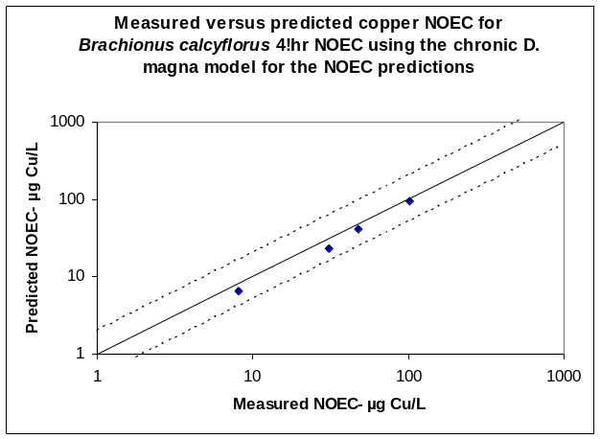

Figure 3-17 : Relation between observed and BLM predicted ecotoxicity of Brachionus calyciflorus. The characteristics of the test media are provided in the text

- BIVALVE : The applicability of the chronic D.magna model to predict the ecotoxicity for bivalves was investigated from 2 studies : the early life stage 96 hours EC50s obtained for Lampilis siliquoidea (Kunz et al.,2006) and the valve movement EC10 values obtained for Hyridella depressa (Markich et al., 2003).

- For the bivalve fatmucket (Lampsilis siliquoidea), Kunz et al (2006), performed 28 96-h copper toxicity tests with newly-transformed fatmucket (Lampsilis siliquoidea) in modified EPAs (2003) standard waters, with varying of Ca (11-86 mg/L), Mg (3-40 mg/L), Na (3-341 mg/L), pH (8-8.7) and DOC (0.5-11 mg/L) (full chemistry in Table 3-5). The observed 96 hour LC50 values ranged from 29 to 400 µg dissolved Cu/L. The chronic D.magna Cu-BLM, was applied on the full dataset by adjusting the species sensitivity. The predicted LC50 values were compared to the observed LC50 values. Figure 3-18 demonstrates that the chronic D. magna Cu-BLM can predict the early life stage copper toxicity for L. siliquoidea within a factor of 2.

The pH of the test media used by Kunz et al, 2006 ranged between 8 and 8.7 and therefore it is important to also check the validity of the copper BLM from tests performed at lower pH ranges as performed by Markich et al., 2003.

- Markich et al. (2003) measured acute (48h) valve movement behaviour of the bivalve Hyridella depressa exposed to a control and several Cu concentrations in 11 different artificial test media with varying pH (6.5 to 7.5) and DOC (0-11 mg/L FA). The observed EC10 values varied between 20 and 792 µg dissolved Cu/L (full chemistry in Table 3-5). The chronic D. magna sensitivity was calibrated to the dataset and the predicted EC10 compared to the measured EC10 values. Figure 3-19 demonstrates the predictive capacity of the chronic D. magna Cu-BLM for the copper effect on Hyridella depressa valve movements : EC10 values can be predicted within a a factor of 2.

These two studies, including sensitive endpoints such as early life stages and valve movements, therefore clearly illustrate that the chronic D. magna Cu-BLM can predict the copper bivalve toxicity. The possible remaining concern, related to the short term duration of these studies, can be released by the data from Wang et al., 2005 (same research group as Kunz et al.,2006).

- Wang et al. (2005) compared the copper sensitivitiy of Lampsilis siliquoidea at different life stages and test durations. The authors compare the newly released juveniles 96hr EC50 copper ecotoxicity with the 28 days chronic NOEC for the species : 96hr EC50 for newly released juveniles of 12-13 µg Cu/L versus 28 days chronic NOEC for the species of 4.4-8.8 µg Cu/L. The ratio between the chronic NOEC and acute early life stage EC50 thus varies between 1.4 and 2.9. This small 96hr EC50/ 28 days NOEC ratio therefore provides further evidence on the applicability of the chronic D. magna model to chronic bivalve ecotoxicity data.

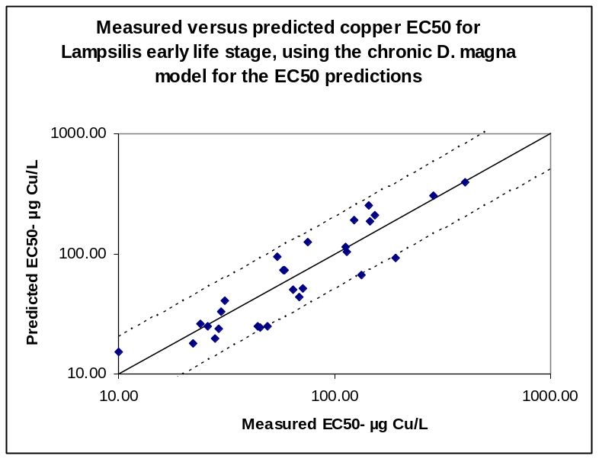

Figure 3-18: Relation between observed and BLM predicted ecotoxicity of Lampsilis siliquoidea (n=28). The characteristics of the test media are provided in the text. Data from Kunz et al (2006).

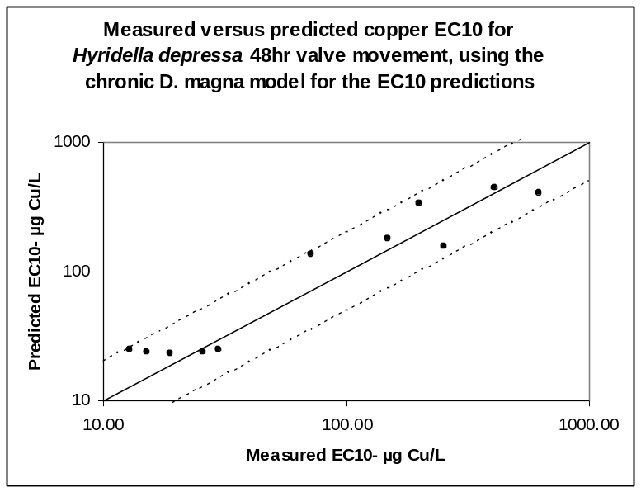

Figure 3-19: Relation between observed and BLM predicted ecotoxicity of Hyridella depressa (n=11). The characteristics of the test media are provided in the text. Data from Markich et al. (2003).

- AMPHIPOD : The applicability of the chronic Cu-BLM developed for the cladocera D. magna to predict the LC50- 7 days for the amphipod Hyalella azteca was evaluated from the data of Borgmann et al., 2005. The study includes 42 ecotoxicity tests, performed in modified artifical media and tap water and includes with wide variations in pH (6.5-8.5) and cation concentrations (Ca : 4-100 mg/L, Mg : 0.6-15 mg/L, and Na :2-125 mg/L) (full chemistry in Table 3-5). The Hyalella azteca study reported average DOC levels of 0.9 mg/L for artificial water and 1.3 mg/L for tapwater. The chronic D.magna Cu-BLM could predict the observed variations in toxicities (27- 106 µg Cu/L) within a factor of 2 with the exception of one outlier (Figure 3-20).

This dataset therefore provides evidence on the applicability of the chronic D.magna BLM model to amphipods chronic toxicity data. Considering that the chronic D.magna Cu-BLM was validated for 2 species of crustacean, it canthus be concluded that the D.magna model is applicable to all crustacean species.

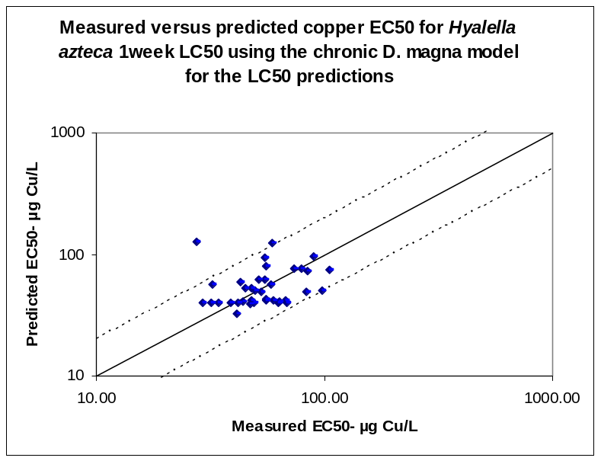

Figure 3-20: Relation between observed and BLM predicted ecotoxicity of Hyalella azteca (n=42). Data from Borgmann et al, 2005. The toxicity data with control mortality >80% were not used (nr of datapoints used= 37).

Evidence on the applicability of the chronic D. magna BLM is thus available for 3 additional taxonomic groups:
- Rotifers (Brachionus calycyflorus)
- Bivalves (Lampilis siliquoidea and Hyridella depressa)
- Amphipods (Hyalella azteca)

Table 3-5 summarizes the physico-chemistry of the read-across test media and demonstrates the validity of the chronic D.magna Cu-BLM for bivalves, amphipods and rotifers over a wide range of water chemistry.

Table 3-5 : Variations in test medium characteristics used for the validation of the chronic D.magna BLM for other invertebrate endpoints
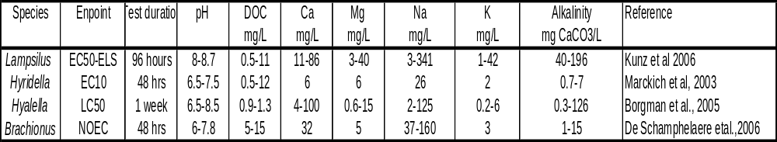

Crtitcally looking at the copper ecotoxicity database (Table 3-8), the only taxonomic group for which no quantitative data are currently available are insects (insect larvae). Read across of the D. magna BLM towards insects is nevertheless most likely and not really critical for the PNEC derivation , considering that

- BLMs were validated for many invertebrate taxonomic groups
- Insect larvae have similar respiratory tissues as other invertebrates,
- insects are not very sensitive to copper. Indeed insects arer not specifically at the lower end of the copper SSD, described in this report. Additional evidence on the lesser sensitivity of insects is noted from
(1)Brix et al. (2005) investigated acute toxicity datasets for different metals, and found that for copper the cladocerans were much more sensitive than other species. Insects were the least sensitive among all taxonomic groups evaluated, as indicated in

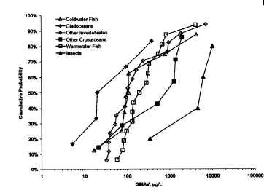

Figure 3-21 : Acute species sensitivity distributions for copper.
→ insects are less sensitive

(2) Winner et al. (1990) performed enclosure experiments to evaluate differences in the seasonal response of planktonic and benthic communities to chronic copper exposure in a small oligotrophic pond. The authors found that the invertebrate benthic community, which was dominated by larval insects (from the orders of Diptera and Ephemeroptera) was less sensitive to Cu than either the phytoplankton or zooplankton community.
→ insects are less sensitive

(3) Hedtke (1984) performed microcosm studies using natural pond sediment to assess structural and functional copper effects. Their 32 weeks exposure experiments showed that the filamentous alga Vaucheria were the most sensitive organism in this experiment, i.e. effects were observed at 9.3 µg Cu/l (8.8 µg Cu/L measured). The microcosm studies further revealed that snails, macroinvertebrates and midge emergence (insect) are less sensitive towards copper, with effects observed at 30 µg Cu/l.
→ insects are less sensitive

(4)Analysis of the macroinvertebrates and nematodes in the sediments of the pond microcosm, revealed an EC10 value of 99 µg Cu/l on the density of chironomids (insects) (Schafers et al., 2001). These insects are therefore less sensitive compared to the observed effects on zooplankton, macrophyte and phytoplankton communities, i.e. the No Observed Ecologically Acceptable Concentration was set at 20 µg Cu/l.
→ insects are less sensitive

(5) Roussel (2005) investigated the effects of copper on emerging insects. The only taxonomic group represented was Diptera, from which the Chironomini and Orthocladiinae were the most important communities. The emergence of Chironomini was depressed in the medium (25 µg/l) and high (75 µg/l) treatment. On the contrary, emergence of Orthocladiinae seems to be favoured in the medium and high treatments during both emergence periods as the number of emerging insects is greater in the treated mesocosms than in the control. The main effects occur in the month of march (with NOEC at 5 µg/l) and therefore the NOEC_{community} was set to be 5 µg/L of dissolved copper for both emergence periods. Although also very variable (depending on the season) similar sensitivity is observed for other invertebrates.
→ insects are equally sensitive

The absence of quantitative BLM read across data for insects does therefore not unvalidate the acceptance of a full SSD normalization for the derivation of the copper HC5.

C. Application of the chronic algae model to other algae and higher plants

The chronic algae bioavailability model was shown to be applicable to:
- Algae (Pseudokircherniella subcapitata, Chlorella vulgaris and Chlamidomonas reinhardtii)
- Higher plants (Hordeum vulgare) (see RAR)
For algae, data from 3 species of algae (R. subcapitata, C. Reinhardti and C. vulgaris) allowed to develop a unified bioavailability model thus demonstrating the applicability of the model across algae.

In view of evaluating the applicability of the algae model to higher plants such as Lemna, evidence on the similarity between the mechanism of action in higher plants and algae is obtained from terrestrial data. Zhao et al (2006) indeed noted from the barley root elongation and tomato growth assays that estimated EC10s & EC50s of free Cu ²⁺ activities correlated closely and negatively with soil pH, consistent with the protective effect of organic carbon and H⁺. Hydroqual (2007) further showed that the empirical regression model for describing copper toxicity to algae as well as the terrestrial BLM developed for Barley root elongations are consistent with the toxic response due to copper exposure seen in barley root growth (higher plant). Since the regression model is based on free copper ion, metal speciation and complexation effects are considered, and since the free ion concentration at the EC50 (or EC10) varies with pH, competitive effects with protons are considered as well. The consistency of the models observed in algae and barley effects data suggests that there is a similarity in the factors that explain bioavailability of copper to these two organisms. This indicates that the algae model can be used to normalise higher plant toxicity. Both the algae model and the terrestrial higher plant BLM could reasonably predict copper EC50 values in soil solutions from a variety of EU soils (Figure 3-22). Considerable scatter remains in the empirical model relative to the terrestrial BLM suggesting that factors other than pH and free copper have additional effects on copper bioavailability. Useful to note that, within the pH range relevant for EU surface waters, the algae Cu-BLM predicts, in some cases lower EC50 values than observed and therefore the use of the algae Cu-BLM is somewhat more conservative than the terrestrial model. It is therefore concluded that the algae model can be used for normalization of the Lemna NOEC values
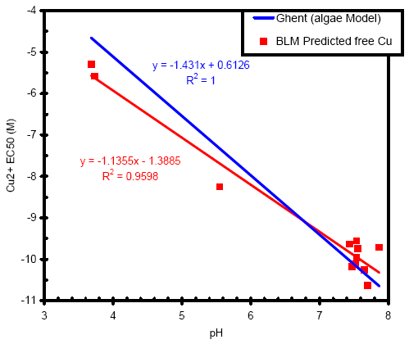
a
b
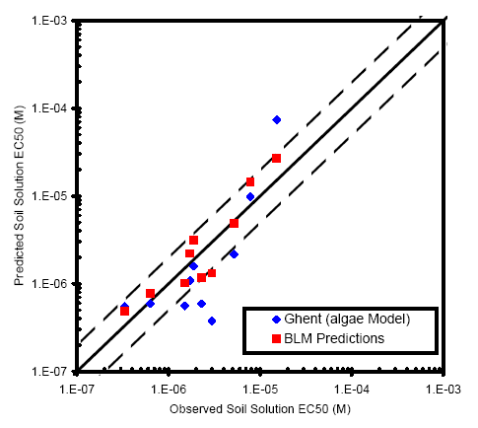
Figure 3-22: Comparison of predicted and measured soil solution EC50s using the empirical algae regression and the terrestrial BLM for the higher plant barley and b) free Cu ion versus pH relationship based on speciation of soil solutions in barley tests, compared with the regression model developed for algae
D. Other BLM validation data
In addition to the chronic Cu-BLM read across data discussed above, several studies have evaluated the applicability of the acute BLMs across species and some key studies are summarized below:

(1) The acute model parameters developed for fathead minnows predicted the measured LC₅₀ values for several invertebrates. Although the model calibration was based on parameters developed for fathead minnows, predicted values (LC₅₀) seemed to correlate well with measured values and nearly all results were within a factor of 2 of measured values (Figure 3-23 ). An overview of the BLM predicted and measured LC₅₀ values for the fish fathead minnow (Pimephales promelas) and several invertebrates (Daphnia magna, Daphnia pulicaria, Daphnia pulex, Ceriodaphnia dubia and Hyalella azteca) (data from Santore et al, 2002 , obtained from several existing databases
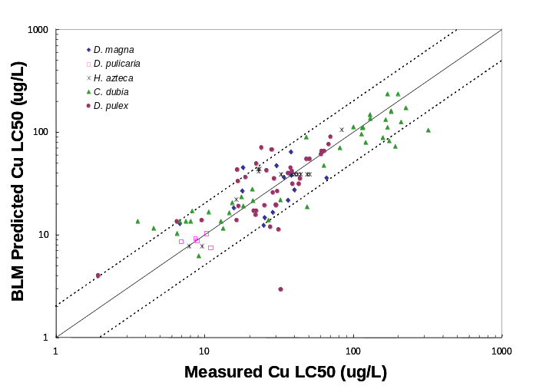

Figure 3-23: Predicted versus measured copper acute LC₅₀ values for fish and invertebrates (from Santore et al., 2002)
(2) Evidence on the applicability of the acute D.magna model across field collected cladoceran species was obtained from ecotoxicity tests carried out with 43 cladoceran species (4 families, 11 genera) sampled at two occasions from 6 different sites whereby the acute D.magna BLM, used within the boundaries of its applicability, could predict the community sensitivity within a factor of 2.3 for 4 sites. For the two acidic waters, falling outide the BLM boundaries, the data showed that the model predictions were too conservative. (Bossuyt et al, 2004).

(3) Additional comparison and validations of the acute Cu-BLMs, developed in the US and Europe, using Chilean surface waters were performed for D. magna, D. pulex and D. obtusa (Rodriguez et al., 2004). The acute Cu-BLM models could predict the observed toxicity within a factor of 2.

(4) For the marine environment, BLM model development has been performed with copper toxicity data (48 h EC₅₀ values) for the mussel Mytilus edulis. The acute BLM for the mussel has been tested and validated with waters from different locations around the USA (i.e. north of the Dumbarton Bridge in San Francisco Bay; Puget Sound, Pacific Ocean; Galveston Bay, Gulf of Mexico; and Narragansett Bay, Atlantic Ocean) - Arnold et al. (2005). The authors has shown that DOC was the key driving factor mitigating the toxicity of copper for the mussel M. edulis. The study further indicated that the (marine) model is capable of predicting the observed toxicity.

To summarize, chronic Cu-BLMs were developed for 3 taxonomic groups (4 species) and the key elements responding to the read across criteria identified in the UL/NL normalization paper are :
- The similarity of the chronic Cu-BLM parameters across fish species (Oncorhynchus and Pimephales).
- Spot checkings, demonstrating the read across of the chronic D. magna Cu-BLM parameters towards three other taxonomic groups : amphipods, rotifers and molluscs.
- The demonstration that the chronic algae Cu-model, developed for Pseudokirchernella is also valid for two other algae taxonomic groups (Chlorella and Chlamydomonas).
- The demonstration of the comparability between the chronic algae Cu model and the terrestrial plant models and thus the applicability of the algae model to predict effects in higher plants ( eg Barley root elongation).
- Additional laboratory and field validations of the acute copper BLMs for a wide range of cladocerans and hyalella
- The mechanistic understanding of the copper toxixity

Considering the MERAG approach and UK/Nl normalization discussion paper, a full BLM read across for copper is thus proposed. The analysis of uncertainty related to limited read across versus full read across is further analysed below.

E. Uncertainty analysis related to limited versus full BLM read across.

- Considering that the chronic algae Cu BLM was developed/ validated/spot-checked for all algae species represented in the copper database as well as for higher plants, this model can be used for normalization of algae and higher plant NOEC data used for the derivation of BLM normalized HC5-50 values.

- As already mentioned an important difference between the chronic algae and chronic fish/invertebrate is related to the differences in sensitivity with changing pHs (Figure 3-7). Indeed, an increase of pH for algae resulted in an increase in toxicity while for invertebrates/fish a decrease in toxicity is observed. The application of the invertebrates model to algae and vise versa will therefore not allow for an adequate prediction of the toxicity and will thus largely increase the uncertainty in the predicted HC5-50 value.

- For the same reason, the application of the algae model to fish and invertebrate NOECs is scientically not justified due to the inverse pH relationships described above.

- With regards to the chronic fish data, the chronic Cu-BLM was developed/validated for two species of fish and therefore this model can be used for normalization of the fish NOEC data used for the derivation of BLM normalized HC5-50 values.

- The report from De schamphelare (2004) further demonstrated that the chronic daphnia Cu-BLM was not able to predict the chronic fish toxicity values observed for P; promelas (Erickson, 1996 and O. mykiss (Waiwood and Beamish, 1978 ) and therefore the use of the chronic D.magna model to predict the toxicity to fish is not appropriate and will increase the uncertainty related to the HC5-50 value .

- With regards to the chronic cladoceran species, the chronic Cu-BLM was developed/validated for this taxonomic group and therefore this model can be used for normalization of the cladoceran NOEC data, used for the derivation of BLM normalized HC5-50 values. The use of the chronic fish Cu-BLM to predict the toxicity to cladocerans will increase the uncertainty related to the HC5-50 value.

- The applicability of the chronic D.magna Cu- BLM was further cross-checked for rotifers, molluscs and amphipod crustacea. compare the predicted versus observed toxicity plots for rotifers and amphipods when using respectively the chronic D. magna Cu-BLM and the chronic fish Cu-BLM. The demonstrate the increased uncertainty when using the chronic fish Cu-BLM compared to the chronic D. magna Cu-BLM. An underprediction of toxicity is observed for the tests carried out in high pH waters and an overprediction of toxicity is observed for the tests carried out in low pH waters. For invertebrates, only the chronic D. magna Cu-BLM is therefore justified for normalization of NOEC values used for the derivation of BLM normalized HC5-50 values.

- It is recognized that some remaining uncertainties exist in the extrapolation of a chronic BLM towards other phylogenetically different species such as insects. Therefore, a sensitivity analysis was performed and HC₅ values for the different eco-regions were derived using the following approaches:

- *) the full read across normalisation where:
- for algae and higher plants, the Pseudokirchneriella subcapitata/Chlamydomonas reinhardtii/Chlorella vulgaris unified BLM was used;
- for invertebrates, the Daphnia magna BLMs were used;
- for fish, the Oncorhynchus mykiss/Pimephales promelas BLM were used.

**) read across + lowest bioavailability correction for all insect species:
the full normalization approach as described in 1) was used (for crustaceans, bivalves and rotifers there is sufficient evidence that the chronic D. magna BLM can be applied; for the other fishes there is sufficient evidence that the chronic O. mykiss/P. promelas BLM can be applied ), but for the insects the lowest bioavailability correction (most conservative value) derived from the ‘animal’ BLMs (i.e. D. magna and O. mykiss/P. promelas) was used.

The results (Table 3-6) show that in all investigated cases (i.e. scenario Lake Monate, River Rhine and acid lake, River Rhine, River Otter and River Teme) the HC5 values are similar between the two scenario’s , and this sensitivity analysis therefore further validates the full BLM read across towards all species in the copper database.

***) For transparency, a scenario using the lowest bioavailability correction was also applied : the original BLMs were only applied to those species species for which they were developed/validated i.e. the algae P. subcapitata/Chlamydomonas reinhardtii/Chlorella vulgaris, the invertebrates D. magna/B. calyciflorus and the fish, the Oncorhynchus mykiss/Pimephales promelas. However, the lowest bioavailability correction (most conservative value) derived from the ‘animal’ BLMs was used to the other non-BLM inverterates/fish. In this scenario, a lower HC5-50 value is observed for the low pH acid lake scenario, consistent with the difference in H+ constant between the invertebrates and the fish BLMs as illustrated in Figure 3-24. Based on the existing knowledge of the applicability of existing developed/validated BLM towards other organisms, it is clear that this scenario is not applicable.

Therefore, from the considered scenarios in this sensitivity analysis, only approach 1) and 2) should be realistically considered.

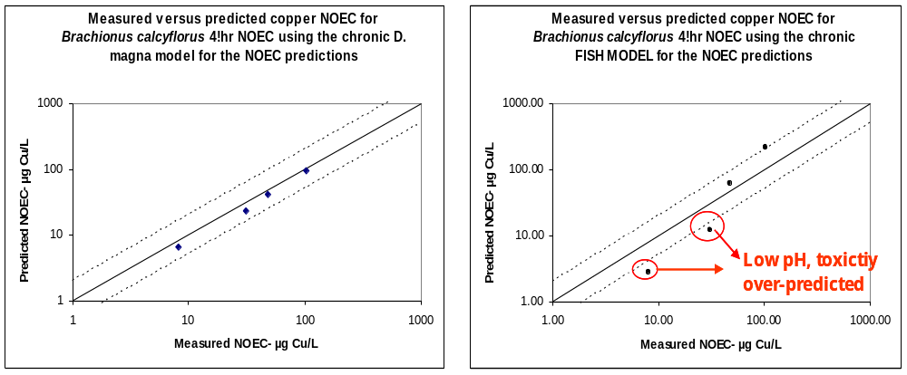

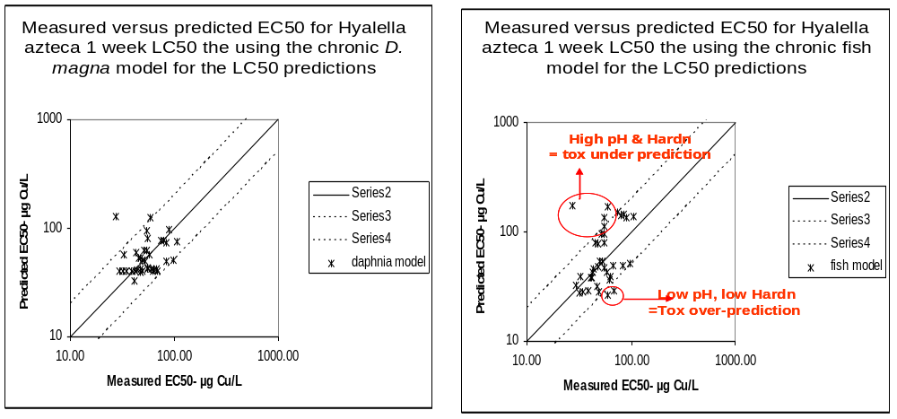

Figure 3-24 : Comparison of the uncertainty of the predictive capacity of the chronic D. magna Cu-BLM versus the chronic fish Cu-BLM for predicting toxicity of the invertebrates Brachonus and Hyalella.
Table 3-6: Normalised HC₅ values in µg/L (derived from log-normal SSD) for all selected eco-regions based on full cross species normalisation and most conservative bioavailability model (see above for the different approaches).
Eco-region scenario | Full read across normalisation | Read across + lowest bioavailability correction for insect species | BLM species + lowest bioavailability correction for all other species
Lake Monate (Italy) | 10.8 | 10.8 | 9.8
River Rhine (The Netherlands) | 8.3 | 8.3 | 7.3
Ditch (The Netherlands) | 27.7 | 27.7 | 24.8
Acid lake (Sweden) | 11.3 | 10.9 | 5.6
River Teme (United Kingdom) | 22.3 | 22.3 | 19.2
River Ebro (Spain) | 10.8 | 10.8 | 9.8
River Otter (United Kingdom) | 7.9 | 7.9 | 7.1

Conclusion : from the above analysis it is scientifically justified to normalize all algae and higher plant NOECs with the chronic algae Cu-BLM, to normalize all fish NOECs with the chronic fish Cu-BLM and to normalize all invertebrates with the chronic D.magna Cu-BLM.
The uncertainty analysis further demonstrated that the use of limited read across will increase the uncertainty of the derived HC5-50 value and this scenario was therefore not retained for further analysis.

        - Chronic toxicity to freshwater organisms
Data on chronic toxicity tests resulting in NOEC values for freshwater algae, invertebrates and fish are summarised here below and in Appendix Env L.
Based on reliability or relevance criteria defined in 2.1.1 a number of studies listed in Appendix Env L-1 are considered not useful for PNEC derivation. These data are rejected (Q3 data), while some could be used as supportive evidence (Q2 data). For the rejected/supportive studies, all listed in the tables in Appendix L, the reason(s) for not using the study are described. A total of 139 individual chronic toxicity data and 27 geometric means per species chronic toxicity entries with the highest quality could be extracted from the scientific literature and databases. It appears that 36.7% of all gathered chronic toxicity data were derived from toxicity tests performed with freshwater fish, 38.8% with invertebrates and 24.5% with algae/higher plants.
Below, somewhat more detailed data are given on the selected NOEC values for freshwater algae, invertebrates and fish (Appendix Env L 1, Table 3-7, Table 3-8 and Table 3-9). Individual NOEC values seemed to range between 2.2 and 510 µg Cu/l for the total risk approach, see Table 3-7, Table 3-8 and Table 3-9. Consistent with OECD guidelines, the average of the copper exposure concentrations and the characteristics of the test media (pH,, DOC, major ions) as measured at the start and end of the test period or media renewal period were used for the assessment. For the algae, consistent with international agreements, the endpoint growth rate was used instead of the endpoint biomass. Background concentrations in the culture media and DOC concentrations, if not reported, were estimated based on available literature data – more details below.
Table 3-7: Overview of the NOEC values and physico-chemical parameters for freshwater algae/higher plants. Selected high quality Q1 NOEC values are underlined selected for the effects assessment and bioavailability normalisation. Legend see table Table 3-9
Organism | Age/size of organisms | Test substance (& purity) | Exposure time | Endpoint | NOEC  (µg/l) | Dose-response | Testtype | Cb (µg Cu/l) | Physico-chemical  conditions | Medium | Reference
Chlamydomonas reinhardtii | Inoculum: 1,000 c/ml | CuSO₄ (reagent grade) | 10 d | growth | 22 | / | FT | 0.5* | T: 24°C; pH: 6.6; H: 25 mg/l CaCO3; DOC: 0.5 mg/l ⁽¹⁾ | Reconstituted | Schäfer et al., 1994 (1)
Chlamydomonas reinhardtii | Inoculum: 10,000 c/ml | CuSO₄ (reagent grade) | 3 d | growth | 178 | yes | S | 0.5* | T: 20°C; pH: 6.02; H: 23 mg/l CaCO3; DOC: 9.84 mg/l | Reconstituted | De Schamphelaere et al., 2006 (2)
Chlamydomonas reinhardtii | Inoculum: 10,000 c/ml | CuSO₄ (reagent grade) | 3 d | growth | 108 | yes | S | 0.5* | T: 20°C; pH: 7.03; H: 23 mg/l CaCO3; DOC: 9.84 mg/l | Reconstituted | De Schamphelaere et al., 2006 (2)
Chlamydomonas reinhardtii | Inoculum: 10,000 c/ml | CuSO₄ (reagent grade) | 3 d | growth | 96 | yes | S | 0.5* | T: 20°C; pH: 8.11; H: 23 mg/l CaCO3; DOC: 9.84 mg/l | Reconstituted | De Schamphelaere et al., 2006 (2)
Chlorella vulgaris | Inoculum: 10,000 c/ml | CuSO₄ (reagent grade) | 3 d | growth | 108.3 | yes | S | 0.5* | T: 20°C; pH: 6.03; H: 97 mg/l CaCO3; DOC: 5.17 mg/l | Reconstituted | De Schamphelaere et al., 2006 (2)
Chlorella vulgaris | Inoculum: 10,000 c/ml | CuSO₄ (reagent grade) | 3 d | growth | 407.4 | yes | S | 0.5* | T: 20°C; pH: 6.04; H: 99 mg/l CaCO3; DOC: 15.5 mg/l | Reconstituted | De Schamphelaere et al., 2006 (2)
Chlorella vulgaris | Inoculum: 10,000 c/ml | CuSO₄ (reagent grade) | 3 d | growth | 55.6 | yes | S | 0.5* | T: 20°C; pH: 7.92; H: 388 mg/l CaCO3; DOC: 5.0 mg/l | Reconstituted | De Schamphelaere et al., 2006 (2)
Chlorella vulgaris | Inoculum: 10,000 c/ml | CuSO₄ (reagent grade) | 3 d | growth | 36.4 | yes | S | 0.5* | T: 20°C; pH: 7.04; H: 242 mg/l CaCO3; DOC: 1.5 mg/l | Reconstituted | De Schamphelaere et al., 2006 (2)
Chlorella vulgaris | Inoculum: 10,000 c/ml | CuSO₄ (reagent grade) | 3 d | growth | 172.9 | yes | S | 0.5* | T: 20°C; pH: 7.97; H: 389 mg/l CaCO3; DOC: 15.8 mg/l | Reconstituted | De Schamphelaere et al., 2006 (2)
Chlorella vulgaris | Inoculum: 10,000 c/ml | CuSO₄ (reagent grade) | 3 d | growth | 98.9 | yes | S | 0.5* | T: 20°C; pH: 7.03; H: 244 mg/l CaCO3; DOC: 10.8 mg/l | Reconstituted | De Schamphelaere et al., 2006 (2)
Chlorella vulgaris | Inoculum: 10,000 c/ml | CuSO₄ (reagent grade) | 3 d | growth | 85.4 | yes | S | 0.5* | T: 20°C; pH: 7.01; H: 486 mg/l CaCO3; DOC: 10.0 mg/l | Reconstituted | De Schamphelaere et al., 2006 (2)
Chlorella vulgaris | Inoculum: 10,000 c/ml | CuSO₄ (reagent grade) | 3 d | growth | 161.9 | yes | S | 0.5* | T: 20°C; pH: 8.75; H: 243 mg/l CaCO3; DOC: 9.9 mg/l | Reconstituted | De Schamphelaere et al., 2006 (2)
Chlorella vulgaris | Inoculum: 10,000 c/ml | CuSO₄ (reagent grade) | 3 d | growth | 282.9 | yes | S | 0.5* | T: 20°C; pH: 7.05; H: 244 mg/l CaCO3; DOC: 19.10 mg/l | Reconstituted | De Schamphelaere et al., 2006 (2)
Chlorella vulgaris | Inoculum: 10,000 c/ml | CuSO₄ (reagent grade) | 3 d | growth | 187.8 | yes | S | 0.5* | T: 20°C; pH: 6.01; H: 389 mg/l CaCO3; DOC: 5.0 mg/l | Reconstituted | De Schamphelaere et al., 2006 (2)
Chlorella vulgaris | Inoculum: 10,000 c/ml | CuSO₄ (reagent grade) | 3 d | growth | 510.2 | yes | S | 0.5* | T: 20°C; pH: 6.05; H: 390 mg/l CaCO3; DOC: 15.2 mg/l | Reconstituted | De Schamphelaere et al., 2006 (2)
Chlorella vulgaris | Inoculum: 10,000 c/ml | CuSO₄ (reagent grade) | 3 d | growth | 31.0 | yes | S | 0.5* | T: 20°C; pH: 7.88; H: 98 mg/l CaCO3; DOC: 5.3 mg/l | Reconstituted | De Schamphelaere et al., 2006 (2)
Chlorella vulgaris | Inoculum: 10,000 c/ml | CuSO₄ (reagent grade) | 3 d | growth | 188.0 | yes | S | 0.5* | T: 20°C; pH: 7.88; H: 99 mg/l CaCO3; DOC: 15.7 mg/l | Reconstituted | De Schamphelaere et al., 2006 (2)
Chlorella vulgaris | Inoculum: 10,000 c/ml | CuSO₄ (reagent grade) | 3 d | growth | 404.1 | yes | S | 0.5* | T: 20°C; pH: 5.5; H: 244 mg/l CaCO3; DOC: 10.3 mg/l | Reconstituted | De Schamphelaere et al., 2006 (2)
Chlorella vulgaris | Inoculum: 10,000 c/ml | CuSO₄ (reagent grade) | 3 d | growth | 158.7 | yes | S | 0.5* | T: 20°C; pH: 7.07; H: 25 mg/l CaCO3; DOC: 10.3 mg/l | Reconstituted | De Schamphelaere et al., 2006 (2)
Chlorella vulgaris | Inoculum: 10,000 c/ml | CuSO₄ (reagent grade) | 3 d | growth | 83.9 | yes | S | 0.5* | T: 20°C; pH: 7.03; H: 244 mg/l CaCO3; DOC: 10.8 mg/l | Reconstituted | De Schamphelaere et al., 2006 (2)
Chlorella vulgaris | Inoculum: 10,000 c/ml | CuSO₄ (reagent grade) | 3 d | growth | 132.3 | yes | S | 0.5* | T: 20°C; pH: 7.04; H: 246 mg/l CaCO3; DOC: 10.2 mg/l | Reconstituted | De Schamphelaere et al., 2006 (2)
Pseudokirchneriella subcapitata | Inoculum: 10,000 c/ml | CuSO₄ (reagent grade) | 3 d | growth | 52.9 | yes | S | 0.5* | T: 20°C; pH: 6.74; H: 10.0 mg/l CaCO3; DOC: 2.72 mg/l | Lake | Heijerick et al., 2002 (3)
Pseudokirchneriella subcapitata | Inoculum: 10,000 c/ml | CuSO₄ (reagent grade) | 3 d | growth | 61.8 | yes | S | 0.5* | T: 20°C; pH: 7.0; H: 12.4 mg/l CaCO3; DOC: 2.34 mg/l | Lake | Heijerick et al., 2002 (3)
Pseudokirchneriella subcapitata | Inoculum: 10,000 c/ml | CuSO₄ (reagent grade) | 3 d | growth | 94.7 | yes | S | 0.5* | T: 20°C; pH: 6.14; H: 7.9 mg/l CaCO3; DOC: 12 mg/l | Lake | Heijerick et al., 2002 (3)
Pseudokirchneriella subcapitata | Inoculum: 10,000 c/ml | CuSO₄ (reagent grade) | 3 d | growth | 17.9 | yes | S | 0.5* | T 20°C; pH: 7.66; H: 48.7 mg/l CaCO3; DOC: 2.52 mg/l | Lake | Heijerick et al., 2002 (3)
Pseudokirchneriella subcapitata | Inoculum: 10,000 c/ml | CuSO₄ (reagent grade) | 3 d | growth | 49 | yes | S | 0.5* | T: 20°C; pH: 8.0; H: 220 mg/l CaCO3; DOC: 6.42 mg/l | Lake | Heijerick et al., 2002 (3)
Pseudokirchneriella subcapitata | Inoculum: 10,000 c/ml | CuSO₄ (reagent grade) | 3 d | growth | 35.4 | yes | S | 0.5* | T: 20°C; pH: 7.84; H: 238 mg/l CaCO3; DOC: 8.24 mg/l | Lake | Heijerick et al., 2002 (3)
Pseudokirchneriella subcapitata | Inoculum: 10,000 c/ml | CuSO₄ (reagent grade) | 3 d | growth | 23.1 | yes | S | 0.5* | T: 20°C; pH: 7.93; H: 191 mg/l CaCO3; DOC: 1.99 mg/l | River | Heijerick et al., 2002 (3)
Pseudokirchneriella subcapitata | Inoculum: 10,000 c/ml | CuSO₄ (reagent grade) | 3 d | growth | 19.3 | yes | S | 0.5* | T: 20°C; pH: 7.93; H: 191 mg/l CaCO3; DOC: 1.99 mg/l | River | Heijerick et al., 2002 (3)
Pseudokirchneriella subcapitata | Inoculum: 10,000 c/ml | CuSO₄ (reagent grade) | 3 d | growth | 56.4 | yes | S | 0.5* | T: 20°C; pH: 7.69; H: 132 mg/l CaCO3; DOC: 6.13 mg/l | River | Heijerick et al., 2002 (3)
Pseudokirchneriella subcapitata | Inoculum: 10,000 c/ml | CuSO₄ (reagent grade) | 3 d | growth | 164 | yes | S | 0.5* | T: 20°C; pH: 7.84; H: 166 mg/l CaCO3; DOC: 17.8 mg/l | Lake | Heijerick et al., 2002 (3)
Pseudokirchneriella subcapitata | Inoculum: 10,000 c/ml | CuSO₄ (reagent grade) | 3 d | growth | 65.5 | yes | S | 0.5* | T: 20°C; pH: 7.35; H: 134 mg/l CaCO3; DOC: 20.4 mg/l | Lake | Heijerick et al., 2002 (3)
Pseudokirchneriella subcapitata | Inoculum: 10,000 c/ml | CuSO₄ (reagent grade) | 3 d | growth | 15.7 | yes | S | 0.5* | T: 20°C; pH: 8.16; H: 169 mg/l CaCO3; DOC: 1.7 mg/l | Lake | Heijerick et al., 2002 (3)
Lemna minor | Double fronded colonies | CuSO₄ (analytical grade) | 7 d | growth | 30 | / | S | 0.5* | T: 25°C; pH: 6.5; H : 26.8 mg/l CaCO3; DOC: 0.5 mg/l ⁽¹⁾ | artificial | Teisseire et al., 1998 (4)

- Schäfer et al., 1994
Comments:
- Background Cu concentrations in control water (artificial water) are not reported,
- Mean alkalinity and hardness of culture media (OECD medium) for S. subspicatus is 1.22 10⁻⁴ M/l CaCl₂, 6.1 10⁻⁵ M/l MgSO₄, 5.9 10⁻⁵ M/l MgCl₂ (total hardness of 25 mg/l CaCO₃); pH 8,
- Mean alkalinity and hardness of culture media (SAG medium) for C. reinhardtii (static test) is 18 mg/l CaCl₂, 29.5 mg/l MgSO₄, (total hardness of 25 mg/l CaCO₃); pH 8,
- Mean hardness of culture media for C. reinhardtii (flow through test) is 18 mg/l CaCl₂ 29.5 mg/l MgSO₄ (total hardness of 25 mg/l CaCO₃); pH is 6.2,
- DOC concentration was estimated as 0.5 mg/l for reconstituted waters,
- Statistics are reported,
- Cu concentrations tested are not reported,
- Dose responses are not reported,
- Reported NOEC data for C. reinhardtii are 5 (static), 22 (flow-through) µg/l Cu (growth - biomass) and 636 µg/l Cu (photosynthesis).
- Reported NOEC data for S. subspicatus are 56 (static) µg/l (growth) and 41 µg/l Cu (photosynthesis)
- Only the data from the flow-through experiment were retained. The rejected data : nominal concentrations reported in static exposure system.

- De Schamphelaere et al.,2006
Comments:
- All tests were performed according to the OECD guidelines (N°201 for Chlorella vulgaris and Chlamydomonas),
- Background Cu concentrations in control water (reconstituted) are not reported,
- Mean hardness of testmedia was 23 mg/l CaCO₃ for the test with Chlamydomonas reinhardtii and varied between 25 and 486 mg/l CaCO₃ for Chlorella vulgaris,
- Reported pH value varied between 6.0 and 8.0 for the Chlamydomonas reinhardtii tests and between 5.5 and 8.75 for the Chlorella vulgaris tests,
- DOC reported between 1.5 and 19.1 mg/l,
- Statistics are reported,
- Dose response curve are reported,
- Cu concentration tested (5 concentrations and 1 control),
- Reliable NOEC (3 days of exposure) values for Chlamydomonas reinhardtii are (endpoint growth - biomass): 178, 108, 96 µg/l Cu,
- Reliable NOEC (3 days of exposure) values for C. vulgaris are (endpoint growth) 108.3, 407.4, 55.6, 36.4, 172.9, 98.9, 85.4, 161.9, 282.9, 187.8, 510.2, 31, 188, 404.1, 158.7, 83.9 and 132.3 µg/l Cu.

- Heijerick et al., 2002
Comments:
- All tests were performed according to the OECD guidelines (N°201 for Pseudokirchneriella subcapitata),
- Background Cu concentrations in control water (reconstituted) are not reported,
- Mean hardness of testmedia varied between 7.9 and 238 mg/l CaCO₃ for the algae tests,
- Natural DOC extracted from rivers and lakes (between 1.99 and 20.4 mg/l),
- Reported pH value varied between 6.14 and 8.16 for the algae tests,
- Statistics are reported,
- Dose response curve are reported,
- Cu concentration tested (5 concentrations and 1 control),
- Reliable NOEC (3 days of exposure) values for P. subcapitata are (endpoint growth - biomass): 52.9, 61.8, 94.7, 17.9, 49, 35.4, 23.1, 19.3, 56.4, 164, 65.5 and 15.7 µg/l Cu.

- Teisseire et al., 1998
Comments:
- Background Cu concentrations in control water (artificial growth medium) are not reported,
- Mean hardness of testmedia is 26.8 mg/l CaCO₃,
- DOC concentration was assumed to be 0.5 mg/l,
- Reported pH value is 6.5,
- Statistics are reported,
- Dose response curve are reported,
- Cu concentration tested (5 concentrations and 1 control),
- Reliable NOEC (7 days of exposure) value for Lemna minor is (endpoint growth): 30 µg/l Cu.

Table 3-8 Overview of the NOEC values and physico-chemical parameters for freshwater invertebrates. Selected NOEC high quality Q1 values are underlined selected for the effects assessment and bioavailability normalisation. Legend see table Table 3-9
Organism | Age/size of organisms | Test substance (& purity) | Exposure time | Endpoint | NOEC  (µg/l) | Dose-response | Testtype | Cb (µg Cu/l) | Physico-chemical  conditions | Medium | Reference
Ceriodaphnia dubia | neonates (< 24 h) | CuSO₄ (reagent grade) | 7 d | reproduction | 10 | / | R | 0.5* | T: 23°C; pH: 7.6; H: 85 mg/l CaCO3; DOC: 0.5 mg/l ⁽¹⁾ | Reconstitued | Cerda & Olive, 1993 (5)
Ceriodaphnia dubia | neonates (< 24 h) | CuSO₄ (reagent grade) | 7 d | mortality | 20 | / | R | 0.5* | T: 23°C; pH: 7.6; H: 85 mg/l CaCO3; DOC: 0.5 mg/l ⁽¹⁾ | Reconstitued | Cerda & Olive, 1993 (5)
Ceriodaphnia dubia | neonates (< 24 h) | Not reported (AA standard) | 7 d | reproduction | 10 | yes | S | 1.5* | T: 25°C; pH: 9.0; H: 98 mg/l CaCO3; DOC: 2.9 mg/l ⁽²⁾ | River (New River) | Belanger & Cherry, 1990 (6)
Ceriodaphnia dubia | neonates (< 24 h) | Not reported (AA standard) | 7 d | reproduction | 20 | yes | S | 1.5* | T: 25°C; pH: 8.0; H: 114 mg/l CaCO3; DOC: 2 mg/l ⁽³⁾ | River (Amy Bayou) | Belanger & Cherry, 1990 (6)
Ceriodaphnia dubia | neonates (< 24 h) | Not reported (AA standard) | 7 d | reproduction | 20 | yes | S | 1.5* | T: 25°C; pH: 9.0; H: 114 mg/l CaCO3; DOC: 2 mg/l ⁽³⁾ | River (Amy Bayou) | Belanger & Cherry, 1990 (6)
Ceriodaphnia dubia | neonates (< 24 h) | Not reported (AA standard) | 7 d | reproduction | 20 | yes | S | 1.5* | T: 25°C; pH: 6.0; H: 182 mg/l CaCO3; DOC: 3 mg/l ⁽⁴⁾ | River (Clinch River) | Belanger & Cherry, 1990 (6)
Ceriodaphnia dubia | neonates (< 8 h) | Not reported (not reported) | 7 d | mortality | 19 | / | S | / | T: 25°C; pH: 7.0; H: 22 mg/l CaCO3; DOC: 2 mg/l ⁽³⁾ | River | Jop et al., 1995 (7)
Ceriodaphnia dubia | neonates (< 8 h) | Not reported (not reported) | 7 d | mortality | 4 | / | S | / | T: 25°C; pH: 6.95; H: 20 mg/l CaCO3; DOC: 0.5 mg/l ⁽¹⁾ | Reconstituted | Jop et al., 1995 (7)
Ceriodaphnia dubia | neonates (< 24 h) | Cu(NO₃)₂ (reagent grade) | 7 d | mortality | 122 | yes | R | 3.4 | T: 25°C; pH: 8.25; H: 100 mg/l CaCO3; DOC: 5.7 mg/l ⁽⁵⁾ | River (Lester River) | Spehar & Fiandt, 1985 (8)
Ceriodaphnia dubia | neonates (2-8 h) | Not reported (AA standard) | 7 d | reproduction | 6.3 | yes | S | 1.5 | T: 25°C; pH: 8.15; H: 94 mg/l CaCO3; DOC: 2.9 mg/l ⁽²⁾ | River (New River) | Belanger et al., 1989 (9)
Ceriodaphnia dubia | neonates (2-8 h) | Not reported (AA standard) | 7 d | reproduction | 24.1 | yes | S | 4.7 | T: 25°C; pH: 8.31; H: 179 mg/l CaCO3; DOC: 3 mg/l ⁽⁴⁾ | River (Clinch River) | Belanger et al., 1989 (9)
Ceriodaphnia dubia | neonates (< 8 h) | Not reported (not reported) | 7 d | reproduction | 4 | / | S | / | T: 25°C; pH: 6.3-7.6; H: 20 mg/l CaCO3; DOC: 0.5 mg/l ⁽¹⁾ | Reconstituted | Jop et al., 1995 (7)
Ceriodaphnia dubia | neonates (< 8 h) | Not reported (not reported) | 7 d | reproduction | 10 | / | S | / | T: 25°C; pH: 6.6-7.4; H: 22 mg/l CaCO3; DOC: 2 mg/l ⁽³⁾ | River | Jop et al., 1995 (7)
Ceriodaphnia dubia | neonates (< 24 h) | Cu(NO₃)₂ (reagent grade) | 7 d | reproduction | 31.6 | yes | S | 3.4 | T: 25°C; pH: 8.25; H: 100 mg/l CaCO3; DOC: 5.7 mg/l ⁽⁵⁾ | River (Lester River) | Spehar & Fiandt, 1985 (8)
Daphnia magna | neonates | CuCl₂ (purity >99%) | 21 d | growth | 12.6 | yes | R | 2.6 | T: 20°C; pH: 8.1; H: 225 mg/l CaCO3; DOC: 2 mg/l ⁽³⁾ | Lake (Lake Ijssel) | Van Leeuwen et al., 1988 (10)
Daphnia magna | neonates | CuCl₂ (purity >99%) | 21 d | mortality | 36.8 | yes | R | 2.6 | T: 20°C; pH: 8.1; H: 225 mg/l CaCO3; DOC: 2 mg/l ⁽³⁾ | Lake (Lake Ijssel) | Van Leeuwen et al., 1988 (10)
Daphnia magna | neonates | CuCl₂ (purity >99%) | 21 d | population growth | 36.8 | / | FT | 2.6 | T: 20°C; pH: 8.1; H: 225 mg/l CaCO3; DOC: 2 mg/l ⁽³⁾ | Lake (Lake Ijssel) | Van Leeuwen et al., 1988 (10)
Daphnia magna | neonates | CuSO₄ (reagent grade) | 21 d | reproduction | 28 | yes | R | 0.5* | T: 20°C; pH: 6.31; H: 10 mg/l CaCO3; DOC: 2.72 mg/l | Lake | Heijerick et al., 2002 (11)
Daphnia magna | neonates | CuSO₄ (reagent grade) | 21 d | reproduction | 21.5 | yes | R | 0.5* | T: 20°C; pH: 6.1; H: 12.4 mg/l CaCO3; DOC: 2.34 mg/l | Lake | Heijerick et al., 2002 (11)
Daphnia magna | neonates | CuSO₄ (reagent grade) | 21 d | reproduction | 71.4 | yes | R | 0.5* | T: 20°C; pH: 8.3; H: 238 mg/l CaCO3; DOC: 8.24 mg/l | Lake | Heijerick et al., 2002 (11)
Daphnia magna | neonates | CuSO₄ (reagent grade) | 21 d | reproduction | 68.8 | yes | R | 0.5* | T: 20°C; pH: 8.06; H: 191 mg/l CaCO3; DOC: 1.99 mg/l | River | Heijerick et al., 2002 (11)
Daphnia magna | neonates | CuSO₄ (reagent grade) | 21 d | reproduction | 106 | yes | R | 0.5* | T: 20°C; pH: 7.55; H: 132 mg/l CaCO3; DOC: 6.13 mg/l | River | Heijerick et al., 2002 (11)
Daphnia magna | neonates | CuSO₄ (reagent grade) | 21 d | reproduction | 181 | yes | R | 0.5* | T: 20°C; pH: 7.5; H: 134 mg/l CaCO3; DOC: 20.4 mg/l | Lake | Heijerick et al., 2002 (11)
Daphnia pulex | neonates (< 24 h) | CuSO₄ (reagent grade) | 42 d | mortality | 4 | yes | R | 0.5* | T: 20°C; pH: 8.6; H: 57.5 mg/l CaCO3; DOC: 0.1 mg/l ⁽⁶⁾ | Deionized reconstituted | Winner, 1985 (12)
Daphnia pulex | neonates (< 24 h) | CuSO₄ (reagent grade) | 42 d | mortality | 20 | yes | R | 0.5* | T: 20°C; pH: 8.5; H: 57.5 mg/l CaCO3; DOC: 0.475 mg/l ⁽⁶⁾ | Deionized reconstituted + DOC | Winner, 1985 (12)
Daphnia pulex | neonates (< 24 h) | CuSO₄ (reagent grade) | 42 d | mortality | 30 | yes | R | 0.5* | T: 20°C; pH: 8.7; H: 57.5 mg/l CaCO3; DOC: 0.85 mg/l ⁽⁶⁾ | Deionized reconstituted + DOC | Winner, 1985 (12)
Daphnia pulex | neonates (< 24 h) | CuSO₄ (reagent grade) | 42 d | mortality | 5 | yes | R | 0.5* | T: 20°C; pH: 8.7; H:115 mg/l CaCO3; DOC: 0.1 mg/l ⁽⁶⁾ | Deionized reconstituted | Winner, 1985 (12)
Daphnia pulex | neonates (< 24 h) | CuSO₄ (reagent grade) | 42 d | mortality | 20 | yes | R | 0.5* | T: 20°C; pH: 8.55; H: 115 mg/l CaCO3; DOC: 0.475 mg/l ⁽⁶⁾ | Deionized reconstituted + DOC | Winner, 1985 (12)
Daphnia pulex | neonates (< 24 h) | CuSO₄ (reagent grade) | 42 d | mortality | 40 | yes | R | 0.5* | T: 20°C; pH: 8.55; H:115 mg/l CaCO3; DOC: 0.85 mg/l ⁽⁶⁾ | Deionized reconstituted + DOC | Winner, 1985 (12)
Daphnia pulex | neonates (< 24 h) | CuSO₄ (reagent grade) | 42 d | mortality | 10 | yes | R | 0.5* | T: 20°C; pH: 8.55; H: 230 mg/l CaCO3; DOC: 0.175 mg/l ⁽⁶⁾ | Deionized reconstituted + DOC | Winner, 1985 (12)
Daphnia pulex | neonates (< 24 h) | CuSO₄ (reagent grade) | 42 d | mortality | 15 | yes | R | 0.5* | T: 20°C; pH: 8.6; H: 230 mg/l CaCO3; DOC: 0.475 mg/l ⁽⁶⁾ | Deionized reconstituted + DOC | Winner, 1985 (12)
Daphnia pulex | neonates (< 24 h) | CuSO₄ (reagent grade) | 42 d | mortality | 20 | yes | R | 0.5* | T: 20°C; pH: 8.6; H: 230 mg/l CaCO3; DOC: 0.85 mg/l ⁽⁶⁾ | Deionized reconstituted + DOC | Winner, 1985 (12)
Brachionus calyciflorus | neonates (< 2 h) | CuSO₄ (reagent grade) | 2 d | reproduction | 8.2 | yes | S | 0.3 | T: 25°C; pH: 6.0; H: 100 mg/l CaCO3; DOC: 4.9 mg/l | Reconstituted | De Schamphelaere et al., 2006 (13)
Brachionus calyciflorus | neonates (< 2 h) | CuSO₄ (reagent grade) | 2 d | reproduction | 31.2 | yes | S | 0.3 | T: 25°C; pH: 6.0; H: 100 mg/l CaCO3; DOC: 14.5 mg/l | Reconstituted | De Schamphelaere et al., 2006 (13)
Brachionus calyciflorus | neonates (< 2 h) | CuSO₄ (reagent grade) | 2 d | reproduction | 47.8 | yes | S | 0.3 | T: 25°C; pH: 7.8; H: 100 mg/l CaCO3; DOC: 4.84 mg/l | Reconstituted | De Schamphelaere et al., 2006 (13)
Brachionus calyciflorus | neonates (< 2 h) | CuSO₄ (reagent grade) | 2 d | reproduction | 103 | yes | S | 0.3 | T: 25°C; pH: 7.8; H: 100 mg/l CaCO3; DOC: 14.7 mg/l | Reconstituted | De Schamphelaere et al., 2006 (13)
Gammarus pulex | mixed sizes (1.5-14 mm) | CuSO₄ (not reported) | 100 d | population response | 11 | yes | FT | 2.6 | T: 11°C; pH: 8.0; H: 103 mg/l CaCO3; DOC: 1 mg/l ⁽⁷⁾ | Tap | Maund et al., 1992 (14)
Hyalella azteca | 2 - 3 weeks old | CuSO₄ (not reported) | 10 d | mortality | 50 | yes | S | / | T: 20°C; pH: 7.65; H: 36 mg/l CaCO3; DOC: 1 mg/l ⁽⁸⁾ | Spring | Deaver & Rodgers, 1996 (15)
Hyalella azteca | 2 - 3 weeks old | CuSO₄ (not reported) | 10 d | mortality | 50 | yes | S | / | T: 20°C; pH: 7.8; H: 50 mg/l CaCO3; DOC: 1 mg/l ⁽⁸⁾ | Spring | Deaver & Rodgers, 1996 (15)
Hyalella azteca | 2 - 3 weeks old | CuSO₄ (not reported) | 10 d | mortality | 82 | yes | S | / | T: 20°C; pH: 8.05; H: 64 mg/l CaCO3; DOC: 1 mg/l ⁽⁸⁾ | Spring | Deaver & Rodgers, 1996 (15)
Hyalella azteca | 2 - 3 weeks old | CuSO₄ (not reported) | 10 d | mortality | 82 | yes | S | / | T: 20°C; pH: 7.5; H: 22 mg/l CaCO3; DOC: 1 mg/L ⁽⁸⁾ | Spring | Deaver & Rodgers, 1996 (15)
Hyalella azteca | 2 - 3 weeks old | CuSO₄ (not reported) | 10 d | mortality | 30 | yes | S | / | T: 20°C; pH: 6.95; H: <10 mg/l CaCO3; DOC: 1 mg/l ⁽⁸⁾ | Spring | Deaver & Rodgers, 1996 (15)
Hyalella azteca | <7 days old | Not reported (not reported) | 35 d | mortality | 32 | yes | R | 3.0 | T: 22°C; pH: 7.6; H: 128 mg/l CaCO3; DOC: 1 mg/l ⁽⁷⁾ | Tap | Othman & Pascoe, 2002 (16)
Chironomus riparius | eggs (< 12 h) | CuSO₄ (not reported) | 10 d | growth | 16.9 | yes | R | 0.5* | T: 20°C; pH: 6.8; H: 151 mg/l CaCO3; DOC: 0.5 mg/l ⁽¹⁾ | Reconstituted | Taylor et al., 1991 (17)
Clistoronia magnifica | larvae 1st generation | CuCl₂ (reagent grade) | 240 d | Life cycle | 8.3 | yes | FT | / | T: 15°C; pH: 7.3; H: 26 mg/l CaCO3; DOC: 1.3 mg/l ⁽⁹⁾ | Well | Nebeker et al., 1984 (18)
Clistoronia magnifica | larvae- 2nd generation | CuCl₂ (reagent grade) | 240 d | Life cycle | 13 | yes | FT | / | T: 15°C; pH: 7.3; H: 26 mg/l CaCO3; DOC: 1.3 mg/l ⁽⁹⁾ | Well | Nebeker et al., 1984 (18)
Paratanytarsus parthenogeneticus | larvae (7 days old) | CuSO₄ (not reported) | 16 d | growth | 40 | yes | / | 0.5* | T: 23°C; pH: 6.9; H: 25 mg/l CaCO3; DOC: 0.5 mg/l ⁽¹⁾ | Reconstituted | Hatakeyama & Yasuno, 1981 (19)
Paratanytarsus parthenogeneticus | larvae (7 days old) | CuSO₄ (not reported) | 16 d | reproduction | 40 | yes | / | 0.5* | T: 23°C; pH: 6.9; H: 25 mg/l CaCO3; DOC: 0.5 mg/l ⁽¹⁾ | Reconstituted | Hatakeyama & Yasuno, 1981 (19)
Dreissenia polymorpha | 18-22 mm | CuCl₂ (not reported) | 63-77 d | Filtration rate | 13 | / | S | 3.0 | T: 15°C; pH: 7.9; H: 150 mg/l CaCO3; DOC: <7.34 mg/l ⁽¹⁰⁾ | Lake (Lake Markermeer) | Kraak et al., 1994  (20)
Dreissenia polymorpha | 18-22 mm | CuSO₄ (not reported) | 27 d | Filtration rate | 21 | yes | R | / | T: 13.4°C; pH: 7.8; H: 296 mg/l CaCO3; DOC: 1.0 mg/l ⁽⁷⁾ | Tap | Mersch et al., 1993 (21)
Villosa iris | glochidia | CuSO₄ (not reported) | 30 d | mortality | 19.1 | yes | FT | 3.2 | T: 20.8°C; pH: 8.4; H: 152 mg/l CaCO3; DOC: 3.0 mg/l ⁽⁴⁾ | River (Clinch River) | Jacobson et al., 1997 (22)
Campeloma decisum | 11 to 27 mm snail | CuSO₄ (ACS grade) | 42 d | mortality | 8 | yes | FT | 1.9 | T: 15°C; pH: 8.15; H: 44.9 mg/l CaCO3; DOC: 1 mg/l ⁽⁷⁾ | Tap | Arthur & Leonard, 1970 (23)
Campeloma decisum | 11 to 27 mm snail | CuSO₄ (ACS grade) | 42 d | mortality | 8 | yes | FT | 1.9 | T: 15°C; pH: 8.15; H: 44.9 mg/l CaCO3; DOC: 1 mg/l ⁽⁷⁾ | Tap | Arthur & Leonard, 1970 (23)
Juga plicifera | mature | CuCl₂ (reagent grade) | 30 d | mortality | 6 | / | FT | 0.5* | T: 15°C; pH: 7.1; H: 21mg/l CaCO3; DOC: 1.3 mg/l ⁽⁹⁾ | Well | Nebeker et al., 1986 (24)

- Cerda & Olive, 1993
Comments:
- Background Cu concentration in control water (reconstituted water) was not reported,
- Mean hardness of testmedia is 85 mg/l, mean alkalinity of testmedia is 62 mg/l and mean reported pH value is 7.6,
- DOC concentration was estimated from the values reported Santore et al. (2002), i.e. 0.5 mg/l for reconstituted waters,
- Statistics are reported,
- 11 Cu concentration tested, between 5 and 100 µg/l Cu,
- No dose response curve was given,
- Effects of 4 different diets was tested: 1. Selenastrum, 2. Chlamydomonas, 3. YCTF+Selenastrum and 4. YCTF. Only the diet YCTF+Selenastrum fulfilled in 100% of the cases the validity criteria of >80% survival and 15 young/female.
- Reliable NOEC data for C. dubia is 20 µg/l (survival) and 10 µg/l (reproduction)

- Belanger and Cherry, 1990
Comments:
- Background Cu concentrations in control water are reported (< 3 µg/l Cu),
- Information concerning the culture water (i.e. New river and Clinch river),
- Origin of the fish: US EPA Duluth laboratory stock,
- Mean alkalinity and hardness of New River is 74.2 and 97.6 mg/l CaCO_{3,}
- Mean alkalinity and hardness of Clinch River is 144.3 and 182.0 mg/l CaCO_{3,}
- Mean alkalinity and hardness of Amy Bayou is 121.9 and 113.6 mg/l CaCO_{3,}
- Reported pH value is 8.12, 8.29 and 8.27 for New river, Clinch river and Amy Bayou,
- DOC concentration of 3.0 mg/l was estimated from the reported TOC concentration in the Clinch and New River water (i.e. respectively 3.7/3.65 mg/l; source: USGS database), and from Santore et al. (2002) for the Amy Bayou River with unknown DOC concentration (i.e. 2.0 mg/l),
- Statistics are reported,
- 2 Cu concentration tested (10- 40 µg/l Cu) and 1 control,
- Dose response curve is reported,
- Reliable NOEC value for C. dubia on reproduction is 10 (New river at pH 9), 20 and 20 (Amy Bayou at pH 8 and 9) and 20 (Clinch river at pH 6) µg/l Cu.

- Jop et al., 1995
Comments:
- Background Cu concentrations in control waters are reported: 8.4 µg/l (river water) & < 1 µg/l (reconstitued water),
- Mean hardness of testmedia is 20 mg/l (reconstituted water) and between 16 and 28 mg/l (river water) CaCO_{3,}
- Mean alkalinity of testmedia is 19 mg/l (reconstituted water) and 13 mg/l (river water) CaCO_{3,}
- Mean reported pH value is 7.0 for both dilution waters,
- DOC concentration was estimated from the values reported Santore et al. (2002), i.e. 2.0 mg/l for natural river waters and 0.5 mg/l for reconstituted waters,
- Statistics are reported,
- 4 Cu concentration tested, 1- 64 µg/l Cu for Ceriodaphnia dubia,
- No dose response was given,
- Reliable reported NOEC data for C. dubia is 4 µg/l (Cu survival and reproduction in reconstituted water), 19 µg/l Cu (survival in river water) and 10 µg/l Cu (reproduction in river water),

- Spehar and Fiandt, 1985 (EPA document)
Comments:
- Background Cu concentrations in control waters are reported, 3.4 µg/l for the Lester water with C. dubia,
- All the organisms were cultured in their respective water before they were tested,
- Reported hardness and alkalinity of Lester water, 100 and 97 mg/l CaCO₃ respectively,
- Reported pH of Lester water is 8.0-8.5,
- DOC concentration of 5.7 mg/l was estimated from the reported TOC concentration in the Lester water (i.e. 7.1 mg/l),
- Concentration series (6 concentrations between 9.9 and 237 µg/l Cu for C. dubia) and dose-response curve are reported,
- Dose response curve for reproduction and mortality for C. dubia are reported,
- Control mortality for C. dubia is 10%,
- Statistics are reported,
- Reliable NOEC values for C. dubia are 122 (mortality) and 31.6 (reproduction) µg/l Cu,

- Belanger et al., 1989
Comments:
- Background Cu concentrations in control water are reported, 1.5-3.9 µg/l Cu for New River water/ Clinch river water (2.9-6.3 µg/l Cu),
- River water was filtred over 11 µm,
- Culture water is the New River/ Clinch river water,
- Reported hardness and alkalinity of New River are 94 and 69.6 mg/l CaCO₃ respectively,
- Reported hardness and alkalinity of Clinch River are 179 and 140 mg/l CaCO₃ respectively,
- Reported for New River and Clinch River pH is 8.15 and 8.31 respectively,
- DOC concentration of respectively 3.0/2.9 mg/l was estimated from the reported TOC concentration in the Clinch and New River water (i.e. 3.7/3.65 mg/l; source: USGS database),
- Cu concentrations reported in the food (algae : between 35.7 and 73.2 µg/g dw),
- Concentration series are reported (6 concentrations between 6.3 and 33.8 µg/l Cu ; 2 concentrations 10.5 and 21.9 µg/l Cu) for New River,
- Concentration series are reported (6 concentrations between 19.3 and 122.5 µg/l Cu ; 2 concentrations 24.1 and 52.3 µg/l Cu) for Clinch River,
- Statistics are reported,
- No control mortality,
- Dose-response curve is reported; reliable NOEC value for C. dubia (reproduction) for Clinch river experiments is 24.1 µg/l Cu,
- Dose-response curve is reported; reliable NOEC value C. dubia (reproduction) value for New river experiments is 6.3 µg/l Cu.

- Van Leeuwen et al., 1988
Comments:
- Background Cu concentrations in control water (filtred Lake Ijssel water) are reported (2.6 µg/l Cu)
- Nominal concentration never deviated more than 10% from nominal concentration,
- Mean alkalinity of testmedia is not reported,
- Hardness of testmedia is 225 mg/l CaCO_{3,}
- Reported pH is 8.1,
- DOC concentration was estimated from the values reported Santore et al. (2002), i.e. 2.0 mg/l for natural lake waters,
- Statistics are reported,
- Dose reponse curve for mortality/ growth is clear,
- No dose response curve for rate of increase,
- Mortalities in control is 4%,
- 5 Cu concentraton (110-3.9 µg/l Cu),
- NOEC calculation for D. magna on rate of increase not possible because in 110 µg/l Cu concentration all organisms died !,
- Reliable NOEC values for D. magna should therefore be 36.8 (mortality), 36.8 (population growth) and 12.6 µg/l Cu (growth).

- Heijerick et al., 2002
Comments:
- All tests were performed according to the OECD guidelines (N°202 for Daphnia magna),
- Background Cu concentrations in control water (reconstituted) are not reported,
- Mean hardness of testmedia varied between 7.9 and 238 mg/l CaCO₃ for daphnid tests,
- Natural DOC extracted from rivers and lakes (between 1.99 and 20.4 mg/l),
- Reported pH value varied between 6.14 and 8.3 for the daphnid tests,
- Statistics are reported,
- Dose response curve are reported,
- Cu concentration tested (5 concentrations and 1 control),
- Reliable NOEC (21 days of exposure) values for Daphnia magna are (endpoint reproduction): 28, 21.5, 71.4, 68.8, 106, 181 µg/l Cu.

- Winner, 1985
Comments:
- Background Cu concentrations in control water (ultrapure reconsituted water from distilled, carbon filtred, deionised water) are not reported,
- Testwater contains organics at concentrations which are below detection limit,
- Measured concentrations never deviate more than 10% from the nominal values,
- DOC added as Aldrich humic acids at 0.15, 0.75 and 1.5 mg/l to ultrapure water containing 0.1 mg/l DOC (according to Santore et al., 2002) resulting in final estimated DOC concentrations of 0.1 (no DOC addition), 0.18, 0.48 and 0.85 mg/l,
- Mean reported hardness and alkalinity of testmedia are 58-115-230 and 115 mg/l CaCO₃,
- Reported pH ranges from 8.4 to 8.7,
- Cu concentration series are reported (concentration series vary between treatments ; minimum 3 Cu concentrations tested and 1 control),
- Dose-response curve mortality is reported,
- Control survival between 80 and 100%,
- Renewal of test water every 2 to 3 days,
- Statistics are reported,
- The following reliable NOEC values for D. pulex on survival are derived :
  - soft water : 4, 20 and 30 µg/l,
  - medium hard water : 5, 20 and 40 µg/l,
  - hard water : 10, 15 and 20 µg/l.

- De Schamphelaere et al., 2006
Comments:
- Background Cu concentrations (reconstituted water with added natural DOC from the Ankeveensche Plassen) in control water is 0.3 µg/l,
- Tests were performed in static systems,
- Reported hardness of testmedia is 100 mg/l CaCO₃,
- Tests were performed at pH values of 6 and 7.8; and at DOC concentrations of 5 and 15 mg/l,
- Individual Cu concentration series are reported (5 test concentrations between 7.5 and 270.2 µg/l depending on the experiment),
- Exposure time: different neonates (<2 h) were exposed for 48 h (= full life cycle) at 25°C,
- Dose-response curve is reported,
- Intrinsic rates of increase is reported as endpoint,
- Copper concentrations were determined using a flame-AAS or a graphite furnace AAS,
- Statistics are reported,
- Reliable NOEC values for the rotifer B. calyciflorus are 8.2, 31.2, 47.8 and 103 µg Cu/l depending on the pH and DOC of the test media.

- Maund et al., 1992
Comments:
- Background Cu concentrations in control water (dechlorinated tapwater that passed through a copper selective chelating resin) are reported: 2.6 µg/l,
- Measured and nominal concentration never deviated more than 10%,
- Origin organisms: river Ely in South Wales,
- Mean hardness of testmedia is 103 mg/l CaCO_{3,}
- Mean reported pH value is 7.9,
- DOC concentration was estimated from the values reported Santore et al. (2002), i.e. 1.0 mg/l for tap waters,
- Statistics are reported,
- 4 Cu concentration tested (11.0-23.1 µg/l Cu),
- Dose response was observed,
- Reliable NOEC data for Gammarus pulex (mean population density) is 11.0 µg/l Cu.

- Deaver and Rodgers, 1996
Comments:
- Control water: UMBFS spring water,
- Mean copper recovery was 91.8%,
- Background Cu concentrations in control water are not reported,
- 6 Cu concentrations tested: only shown in graph,
- Mean alkalinity and hardness of testmedia are reported 10-63 and 10-64 mg/l CaCO_{3,}
- pH value reported ranges from 6.9 to 8.0,
- DOC concentration was estimated from the values reported Santore et al. (2002), i.e. 1.0 mg/l for spring waters,
- Statistics reported,
- Dose reponse curve for mortality are reported,
- Control mortality are < 10%,
- Reliable NOEC values for H. azteca are 30, 50, 50, 82 and 82 (mortality) µg/l Cu.

- Othman and Pascoe, 2002
Comments:
- Background Cu concentrations (dechlorinated tapwater) in control water is 3.0 µg/l,
- Tests were performed in static renewal systems,
- Reported hardness of testmedia is 128 mg/l CaCO₃,
- Tests were performed at a pH value of 7.6,
- Individual Cu concentration series are reported (4 test concentrations between 13.0 and 212.5 µg/l; 3 replicates),
- DOC concentration was estimated as 1.0 mg/l for tapwaters (Santore et al., 2002),
- Equilibration time of 72 h,
- Exposure time: different neonates (<7 days old) were exposed for 35 days at 22°C,
- Dose-response curve is reported,
- Mortality is reported as endpoint,
- Copper concentrations were determined using a ICP MS,
- Statistics are reported (Anova and Tukey-Kramer comparison),
- Reliable NOEC values for the rotifer H. azetca is 32 µg Cu/l.

- Taylor et al., 1991
Comments:
- Background Cu concentrations in the reconstitued control waters are not reported,
- Culture water & organisms: no information,
- Mean hardness of testmedia is 151 mg/l,
- Mean reported pH value is 7.0,
- DOC concentration was estimated as 0.5 mg/l for reconstituted waters
- Statistics are reported,
- 5 Cu concentration tested, 8.8-50 µg/l Cu,
- Dose response was found,
- Reliable NOEC data for Chironomus riparius is 16.9 µg/l (growth).

- Nebeker et al., 1984
Comments:
- Background Cu concentrations in control water/ culture water (Western Fish Toxicology Station in Oregon) are not reported,
- Well water is used as test water,
- Reported hardness and alkalinity of testmedia are 26 and 26 mg/l CaCO₃ respectively,
- Reported pH values is varying between 7.2 and 7.4,
- DOC concentration was estimated from the values reported Santore et al. (2002), i.e. 1.3 mg/l for well waters,
- Cu concentration series are reported (10 concentrations between 4.2 and 98 µg/l Cu),
- A clear dose-response curve is reported,
- Control mortality is 20%,
- Statistics are reported,
- Reliable NOEC values for C. magnifica are 8.3 and 13 (life cycle) µg/l Cu.

- Hatakeyama and Yasuno, 1981
Comments:
- Control water: reconstituted artificial soft water; salts were added in distilled water,
- Background Cu concentrations in control water are not reported,
- 9 Cu concentrations tested (2560-10 µg/l Cu),
- No information concerning the culture water ?
- Mean alkalinity is not reported and hardness of testmedia is 25 mg/l CaCO_{3,}
- Reported pH is 6.9,
- DOC concentration for reconstituted waters was estimated as i.e. 0.5 mg/l,
- Statistics are used but methodology is not reported,
- Endpoint of tests is wing length of emerged adults,
- Dose reponse curve for P. parthenogeneticus (reproduction/ growth - wing length) is not clear ; Reliable NOEC value at 40 (growth) and 40 µg/l Cu (reproduction), if statistics are properly applied.

- Kraak et al., 1994
Comments:
- Background Cu concentrations (Lake Markermeer in The Netherlands) in control water is 2.0 µg/l,
- Tests were performed in static renewal systems,
- Reported hardness of testmedia is 150 mg/l CaCO₃,
- Tests were performed at a pH value of 7.9,
- DOC level of Markermeer (origin of the test water) was used as a basis for the DOC estimation; the Markermeer water was however filtered extensively over a sand bed to reduce the TOC (pers. communication) and the resulting DOC value is therefore < 7.3 mg/L.
- Individual Cu concentration series are reported (8 test concentrations; 2 replicates),
- Exposure time: 1.6 to 2.0 cm mussels were exposed for 2 days at 15°C,
- Clear dose-response curve is reported,
- Filtration rate is reported as endpoint,
- Copper concentrations were determined using AAS,
- Statistics are reported (Anova and Scheffe’s comparison),
- Reliable NOEC values for the mussel Dreissenia polymorpha is 13 µg Cu/l.

- Mersch et al., 1994
Comments:
- Background Cu concentrations (tapwater) in control water is 4.5 µg/l,
- Tests were performed in flow through systems,
- Reported hardness of testmedia is 296 mg/l CaCO₃,
- Tests were performed at a pH value of 7.8,
- DOC concentration was estimated as 1.0 mg/l for tapwaters (Santore et al., 2002),
- Individual Cu concentration series are reported (3 test concentrations),
- Exposure time: 18 to 22 mm mussels were exposed for 27 days at 14°C,
- Clear dose-response curve is reported,
- Filtration rate is reported as endpoint,
- Copper concentrations were determined using AAS,
- Statistics are reported (Paired Student t-test)),
- Reliable NOEC values for the mussel Dreissenia polymorpha is 21 µg Cu/l.

- Jacobson et al., 1997
Comments:
- Background Cu concentrations in control water (Clinch river water) are reported (3.2 µg/l Cu),
- Mean alkalinity and hardness of testmedia is 132 and 152 mg/l CaCO_{3,}
- Reported pH value is 8.39,
- DOC concentration of respectively 3.0 mg/l was estimated from the reported TOC concentration in the Clinch River water (i.e. 3.7 mg/l; source: USGS database),
- Statistics are reported,
- Control survival is 97%,
- 2 Cu concentration tested (10.6 and 19.1 µg/l Cu),
- No dose response was observed,
- Reliable NOEC for survival for Villosa iris was 19.1µg/l Cu.

- Arthur and Leonard, 1970
Comments:
- Background Cu concentrations in control water (= tapwater originated from Lake Superior) are reported 1.9-2 µg/l,
- Acclimation time to the testwater between 10 days and 5 weeks,
- Origin of the organisms: St Croix and eau Claire rivers in the vicinity of Gordon,
- Reported hardness and alkalinity of testmedia are 35-55 and 42.7 mg/l CaCO₃ respectively,
- Reported pH value ranges between 7.1 and 8.15,
- DOC concentration was estimated from the values reported Santore et al. (2002), i.e. 1.0 mg/l for tapwaters,
- Cu concentration series are reported (5 concentrations between 28 and 2.9 µg/l Cu and 1 control of 1.9-2 µg/l Cu),
- Dose-response curve for mortality for both species is reported, but no statistics are reported (no significance testing). By own statistical analysis (p<0.05) the following NOEC data could be calculated: NOEC for G. pseudolimnaeus (mortality): 6.2, 8 and 8 µg/l; NOEC for P. integra (mortality): 8 and 14.8 µg/l; NOEC for C. decisum (mortality): 8 and 8 µg/l,
- Control mortality for G. pseudolimnaeus between 30 and 45%,
- Control mortality for C. decisum between 5 and 15%,
- Control mortality for P. integra between 40 and 55%.
- Rjected mortality data for G. pseudolimnaeus and P. integra: high control mortalities (>20%), i.e. between 30 and 75%.

- Nebeker et al., 1986
Comments:
- Background Cu concentrations in control water/ culture water (origin: coastal stream Oregon) are not reported,
- Well water is used as test water,
- Reported hardness and alkalinity of testmedia are 21 and 28 mg/l CaCO₃ respectively,
- Reported pH values is 7.1,
- DOC concentration was estimated from the values reported Santore et al. (2002), i.e. 1.3 mg/l for well waters,
- Individual Cu concentration series are not reported (between 5 and 10; dilution rate of 0.7),
- Dose-response curve is not reported,
- Control mortality is not reported,
- Statistics are reported,
- Reliable NOEC values for Juga plicifera is 6 (mortality) µg/l Cu.

Table 3-9 Summary of the NOEC values and physico-chemical parameters for freshwater fish. Selected high quality Q1 NOEC values are underlined selected for the effects assessment and bioavailability normalisation

Organism | Age/size of organisms | Test substance (& purity) | Exposure time | Endpoint | NOEC  (µg/l) | Dose-response | Testtype | Cb (µg Cu/l) | Physico-chemical  conditions | Medium | Reference
Ictalurus punctatus | fry | CuSO₄ (analytical grade) | 60 d | growth | 13 | yes | FT | 3 | T: 22°C; pH: 7.65; H: 186.3 mg/l CaCO3; DOC: 1.3 mg/l ⁽⁹⁾ | Well | Sauter et al., 1976 (25)
Ictalurus punctatus | fry | CuSO₄ (analytical grade) | 60 d | mortality | 13 | yes | FT | 3 | T: 22°C; pH: 7.65; H: 186.3 mg/l CaCO3; DOC: 1.3 mg/l ⁽⁹⁾ | Well | Sauter et al., 1976 (25)
Noemacheilus barbatulus | adult (8.7 - 12.1 cm) | CuSO₄ (not reported) | 64 d | mortality | 120 | yes | FT | 2 | T 11.9°C; pH: 8.26; H: 249 mg/l CaCO3; DOC: 1.3 mg/l ⁽⁹⁾ | Well | Solbe & Cooper, 1976 (26)
Oncorhynchus kisutch | parr | Not reported (not reported) | 61 d | growth | 22 | / | FT | / | T: 9.5 °C; pH: 7.15; H: 24.4 mg/l CaCO3; DOC: 2.9 mg/l ⁽¹¹⁾ | River (Chehalis River) | Mudge et al., 1993 (27)
Oncorhynchus kisutch | fry | Not reported (not reported) | 60 d | growth | 21 | / | FT | / | T: 16.7 °C; pH: 7.4; H: 31.8 mg/l CaCO3; DOC: 2.9 mg/l ⁽¹¹⁾ | River (Chehalis River) | Mudge et al., 1993 (27)
Oncorhynchus kisutch | parr | Not reported (not reported) | 61 d | growth | 28 | / | FT | / | T: 8.7 °C; pH: 7.0; H: 28.7 mg/l CaCO3; DOC: 2.9 mg/l ⁽¹¹⁾ | River (Chehalis River) | Mudge et al., 1993 (27)
Oncorhynchus kisutch | parr | Not reported (not reported) | 61 d | mortality | 24 | / | FT | / | T: 9.5 °C; pH: 7.15; H: 24.4 mg/l CaCO3; DOC: 2.9 mg/l ⁽¹¹⁾ | River (Chehalis River) | Mudge et al., 1993 (27)
Oncorhynchus kisutch | fry | Not reported (not reported) | 60 d | mortality | 18 | / | FT | / | T: 16.7 °C; pH: 7.4; H: 31.8 mg/l CaCO3; DOC: 2.9 mg/l ⁽¹¹⁾ | River (Chehalis River) | Mudge et al., 1993 (27)
Oncorhynchus mykiss | fry (0.12 g; 2.6 cm) | CuCl₂ (reagent grade) | 60 d | growth | 2.2 | yes | FT | 0.45* | T: 9.8 °C; pH: 7.5; H: 24.6 mg/l CaCO3; DOC: 0.2 mg/l ⁽¹²⁾ | Well + deionised water | Marr et al., 1996 (28)
Oncorhynchus mykiss | parr | Not reported (not reported) | 61 d | growth | 45 | yes | FT | / | T: 9.5 °C; pH: 7.2; H: 24.4 mg/l CaCO3; DOC: 2.9 mg/l ⁽¹¹⁾ | River (Chehalis River) | Mudge et al., 1993 (27)
Oncorhynchus mykiss | eggs | CuCl₂ (not reported) | 63 d | growth | 16 | yes | FT | 3 | T: 12 °C; pH: 7.65; H: 120 mg/l CaCO3; DOC: 1.3 mg/l ⁽⁹⁾ | Well | Seim et al., 1984 (29)
Oncorhynchus mykiss | parr | Not reported (not reported) | 61 d | mortality | 24 | / | FT | / | T: 9.5 °C; pH: 7.15; H: 24.4 mg/l CaCO3; DOC: 2.9 mg/l ⁽¹¹⁾ | River (Chehalis River) | Mudge et al., 1993 (27)
Oncorhynchus mykiss | parr | Not reported (not reported) | 61 d | mortality | 28 | / | FT | / | T: 8.7 °C; pH: 7.0; H: 28.7 mg/l CaCO3; DOC: 2.9 mg/l ⁽¹¹⁾ | River (Chehalis River) | Mudge et al., 1993 (27)
Oncorhynchus mykiss | embryo | CuSO₄ (reagent grade) | 45 d | Growth | 11.4 | yes | FT | 3 | T: 10.8 °C; pH: 7.6; H: 45 mg/l CaCO3; DOC: 1.0 mg/l ⁽¹³⁾ | Lake (Lake Superior) | McKim et al., 1978 (30)
Oncorhynchus mykiss | embryo | CuSO₄ (reagent grade) | 45 d | mortality | 11.4 | yes | FT | 3 | T: 10.8 °C; pH: 7.6; H: 45 mg/l CaCO3; DOC: 1.0 mg/l ⁽¹³⁾ | Lake (Lake Superior) | McKim et al., 1978 (30)
Catostomus commersoni | embryo | CuSO₄ (reagent grade) | 40 d | Growth | 12.9 | yes | FT | 3 | T: 14.9 °C; pH: 7.6; H: 45 mg/l CaCO3; DOC: 1.0 mg/l ⁽¹³⁾ | Lake (Lake Superior) | McKim et al., 1978 (30)
Catostomus commersoni | embryo | CuSO₄ (reagent grade) | 40 d | mortality | 12.9 | yes | FT | 3 | T: 14.9 °C; pH: 7.6; H: 45 mg/l CaCO3; DOC: 1.0 mg/l ⁽¹³⁾ | Lake (Lake Superior) | McKim et al., 1978 (30)
Esox lucius | embryo | CuSO₄ (reagent grade) | 35 d | Growth | 34.9 | yes | FT | 3 | T: 15.6 °C; pH: 7.6; H: 45 mg/l CaCO3; DOC: 1.0 mg/l ⁽¹³⁾ | Lake (Lake Superior) | McKim et al., 1978 (30)
Esox lucius | embryo | CuSO₄ (reagent grade) | 35 d | mortality | 34.9 | yes | FT | 3 | T: 15.6 °C; pH: 7.6; H: 45 mg/l CaCO3; DOC: 1.0 mg/l ⁽¹³⁾ | Lake (Lake Superior) | McKim et al., 1978 (30)
Perca fluviatilis | juvenile (3.8 - 4.3 g) | CuSO₄ (pro analysis) | 30 d | growth | 39 | yes | FT | 1 | T: 17.5 °C; pH: 7.8; H: 194 mg/l CaCO3; DOC: 1 mg/l ⁽⁷⁾ | Tap | Collvin, 1985 (31)
Perca fluviatilis | juvenile (3.8 g) | CuSO₄ (pro analysis) | 30 d | mortality | 188 | yes | FT | 3 | T: 15.1 °C; pH: 7.8; H: 178 mg/l CaCO3; DOC: 1mg/l ⁽⁷⁾ | Tap | Collvin, 1984 (32)
Pimephales notatus | fry (15 - 16 mm) -second generation | CuSO₄ (reagent grade) | 30 d | growth | 44 | yes | FT | 4.3 | T: 25 °C; pH: 8.1; H: 201 mg/l CaCO3; DOC: 0.55 mg/l ⁽¹⁴⁾ | Spring + demineralised tap | Horning & Neiheisel, 1979 (33)
Pimephales notatus | fry (15 - 16 mm) | CuSO₄ (reagent grade) | 60 d | growth | 71.8 | yes | FT | 4.3 | T: 25 °C; pH: 8.1; H: 201 mg/l CaCO3; DOC: 0.55 mg/l ⁽¹⁴⁾ | Spring + demineralised tap | Horning & Neiheisel, 1979 (33)
Pimephales notatus | fry (15 - 16 mm) | CuSO₄ (reagent grade) | 60 d | mortality | 71.8 | yes | FT | 4.3 | T: 25 °C; pH: 8.1; H: 201 mg/l CaCO3; DOC: 0.55 mg/l ⁽¹⁴⁾ | Spring + demineralised tap | Horning & Neiheisel, 1979 (33)
Pimephales promelas | fry (10 - 15 mm) | CuSO₄ (reagent grade) | 330 d | growth | 33 | yes | FT | 3.5 | T: 21°C; pH: 8.0; H: 198 mg/l CaCO3; DOC: 0.55 mg/l ⁽¹⁴⁾ | Spring+ deionised tap | Mount, 1968 (34)
Pimephales promelas | fry (10 - 20 mm) | CuSO₄ (reagent grade) | 327 d | growth | 10.6 | yes | FT | 4.4 | T: 22°C; pH: 6.9; H: 31.4 mg/l CaCO3; DOC: 0.55 mg/l ⁽¹⁴⁾ | Spring+ deionised tap | Mount & Stephan, 1969 (35)
Pimephales promelas | larvae (4 weeks old) | CuSO₄ (reagent grade) | 187 d | growth | 59.5 | yes | FT | 4.2 | T: 23°C; pH: 7.85; H: 202 mg/l CaCO3; DOC: 0.55 mg/l ⁽¹⁴⁾ | Spring+ demineralised tap | Pickering et al., 1977 (36)
Pimephales promelas | embryo-larval | CuSO₄ (reagent grade) | 32 d | growth | 4.8 | yes | FT | 1.25* | T: 25°C; pH: 7.05; H: 44 mg/l CaCO3; DOC: 1 mg/l ⁽¹³⁾ | Lake (Lake Superior) | Spehar & Fiandt, 1985 (37)
Pimephales promelas | fry (10 - 15 mm) | CuSO₄ (reagent grade) | 330 d | mortality | 33 | yes | FT | 3.5 | T: 21°C; pH: 8.0; H: 198 mg/l CaCO3; DOC: 0.55 mg/l ⁽¹⁴⁾ | Spring+ deionised tap | Mount, 1968 (34)
Pimephales promelas | fry (10 - 20 mm) | CuSO₄ (reagent grade) | 327 d | mortality | 10.6 | yes | FT | 4.4 | T: 22°C; pH: 6.9; H: 31.4 mg/l CaCO3; DOC: 0.55 mg/l ⁽¹⁴⁾ | Spring+ deionised tap | Mount & Stephan, 1969 (35)
Pimephales promelas | larvae | CuSO₄ (not reported) | 28 d | mortality | 61 | yes | FT | 0.6 | T: 21°C; pH: 8.17; H: 202 mg/l CaCO3; DOC: 1.3 mg/l ⁽⁹⁾ | Ground water | Scudder et al., 1988 (38)
Pimephales promelas | embryo-larval | Cu(NO₃)₂ (reagent grade) | 32 d | mortality | 4.8 | yes | FT | 1.25* | T: 25°C; pH: 7.05; H: 44 mg/l CaCO3; DOC: 1 mg/l ⁽¹³⁾ | Lake (Lake Superior) | Spehar & Fiandt, 1985 (37)
Pimephales promelas | juvenile (32 - 38 mm; 5 months old) | CuSO₄ (reagent grade) | 270 d | reproduction | 66 | yes | FT | 7 | T: 23°C; pH: 8.1; H: 274 mg/l CaCO3; DOC: 2 mg/l ⁽³⁾ | River | Brungs et al., 1976 (39)
Pimephales promelas | fry (10 - 15 mm) | CuSO₄ (reagent grade) | 330 d | reproduction | 14.5 | yes | FT | 3.5 | T: 21°C; pH: 8.0; H: 198 mg/l CaCO3; DOC: 0.55 mg/l ⁽¹⁴⁾ | Spring+ deionised tap | Mount, 1968 (34)
Pimephales promelas | fry (10 - 20 mm) | CuSO₄ (reagent grade) | 327 d | reproduction | 10.6 | yes | FT | 4.4 | T: 22°C; pH: 6.9; H: 31.4 mg/l CaCO3; DOC: 0.55 mg/l ⁽¹⁴⁾ | Spring+ deionised tap | Mount & Stephan, 1969 (35)
Pimephales promelas | larvae (4 weeks old) | CuSO₄ (reagent grade) | 187 d | reproduction | 25.5 | yes | FT | 4.2 | T: 23°C; pH: 7.9; H: 202 mg/l CaCO3; DOC: 0.55 mg/l ⁽¹⁴⁾ | Spring+ deionised tap | Pickering et al., 1977 (36)
Pimephales promelas | larvae (4 weeks old) | CuSO₄ (reagent grade) | 97 d | reproduction | 23 | yes | FT | 4.2 | T: 23°C; pH: 7.9; H: 202 mg/l CaCO3; DOC: 0.55 mg/l ⁽¹⁴⁾ | Spring+ deionised tap | Pickering et al., 1977 (36)
Pimephales promelas | larvae (4 weeks old) | CuSO₄ (reagent grade) | 7 d | reproduction | 22.5 | yes | FT | 4.2 | T: 23°C; pH: 7.9; H: 202 mg/l CaCO3; DOC: 0.55 mg/l ⁽¹⁴⁾ | Spring+ deionised tap | Pickering et al., 1977 (36)
Salvelinus fontinalis | embryo | CuSO₄ (reagent grade) | 60 d | Growth | 22.3 | yes | FT | / | T: 5.6 °C; pH: 7.6; H: 45 mg/l CaCO3; DOC: 1.0 mg/l ⁽¹³⁾ | Lake (Lake Superior) | McKim et al., 1978 (30)
Salvelinus fontinalis | embryo | CuSO₄ (reagent grade) | 60 d | mortality | 22.3 | yes | FT | / | T: 5.6 °C; pH: 7.6; H: 45 mg/l CaCO3; DOC: 1.0 mg/l ⁽¹³⁾ | Lake (Lake Superior) | McKim et al., 1978 (30)
Salvelinus fontinalis | Alevins/juveniles | CuSO₄ (reagent grade) | 189 d | Growth | 9.5 | yes | FT | / | T: 10.6 °C; pH: 7.5; H: 45 mg/l CaCO3; DOC: 1 mg/l ⁽⁷⁾ | Tap | McKim & Benoit, 1971 (40)
Salvelinus fontinalis | Alevins/juveniles | CuSO₄ (reagent grade) | 189 d | mortality | 9.5 | yes | FT | / | T: 10.6 °C; pH: 7.5; H: 45 mg/l CaCO3; DOC: 1 mg/l ⁽⁷⁾ | Tap | McKim & Benoit, 1971 (40)
Salvelinus fontinalis | yearling | CuSO₄ (reagent grade) | 244 d | growth | 17.4 | yes | FT | / | T: 10.6 °C; pH: 7.5; H: 45 mg/l CaCO3; DOC: 1 mg/l ⁽⁷⁾ | Tap | McKim & Benoit, 1971 (40)
Salvelinus fontinalis | fry | CuSO₄ (analytical grade) | 30 d | Growth | 7 | yes | FT | 3 | T: 10 °C; pH: 6.85; H: 37.5 mg/l CaCO3; DOC: 1.3 mg/l ⁽⁹⁾ | Well | Sauter et al., 1976 (25)
Salvelinus fontinalis | fry | CuSO₄ (analytical grade) | 30 d | growth | 21 | yes | FT | 3 | T: 10 °C; pH:6.9; H: 187 mg/l CaCO3; DOC: 1.3 mg/l ⁽⁹⁾ | Well | Sauter et al., 1976 (25)
Salvelinus fontinalis | yearling | CuSO₄ (reagent grade) | 244 d | mortality | 17.4 | yes | S | 1.9 | T: 10.6 °C; pH: 7.45; H: 45 mg/l CaCO3; DOC: 1 mg/l ⁽⁷⁾ | Tap | McKim & Benoit, 1971 (40)
Salvelinus fontinalis | fry | CuSO₄ (analytical grade) | 60 d | mortality | 13 | yes | FT | 3 | T: 10 °C; pH: 6.85; H: 37.5 mg/l CaCO3; DOC: 1.3 mg/l ⁽⁹⁾ | Well | Sauter et al., 1976 (25)
Salvelinus fontinalis | fry | CuSO₄ (analytical grade) | 30 d | mortality | 21 | yes | FT | 3 | T: 10 °C; pH:6.9; H: 187 mg/l CaCO3; DOC: 1.3 mg/l ⁽⁹⁾ | Well | Sauter et al., 1976 (25)
Salvelinus fontinalis | yearling | CuSO₄ (reagent grade) | 244 d | reproduction | 17.4 | yes | FT | 1.9 | T: 10.6 °C; pH: 7.45; H: 45 mg/l CaCO3; DOC: 1 mg/l ⁽⁷⁾ | Tap | McKim & Benoit, 1971 (40)
Salvelinus fontinalis | fry | CuSO₄ (analytical grade) | 60 d | reproduction | 7 | yes | FT | 3 | T: 10 °C; pH: 6.85; H: 37.5 mg/l CaCO3; DOC: 1.3 mg/l ⁽⁹⁾ | Well | Sauter et al., 1976 (25)
Salvelinus fontinalis | fry | CuSO₄ (analytical grade) | 30 d | reproduction | 49 | yes | FT | 3 | T: 10 °C; pH:6.9; H: 187 mg/l CaCO3; DOC: 1.3 mg/l ⁽⁹⁾ | Well | Sauter et al., 1976 (25)
- DOC concentrations:
(1): DOC estimation of reconstituted water is 0.5 mg/l (De Schamphelaere and Janssen, 2002 (0.3 mg DOC/L); Ryan eta al., 2004 (0.4-0.5 mg DOC/L); Karman et al., 2004 (<0.1 mg DOC/L); Hollis et al, 1997 (0.4-0.6 mg DOC/L).
(2): DOC estimation for New River (USA) water extracted from the United States Geological Survey records (USGS). The USGS database reports TOC concentration of 3.65 mg/l, and assuming a DOC/TOC ratio of 0.8.
(3): DOC estimation for unknown river/lake water or for which no reliable DOC concentration could be estimated is 2.0 mg/l (Santore et al., 2002)
(4): DOC estimation for Clinch River (USA) water extracted from the United States Geological Survey records (USGS). The USGS database reports TOC concentration of 3.7 mg/l, and assuming a DOC/TOC ratio of 0.8.
(5): DOC estimation for Lester River (USA) water extracted from the United States Geological Survey records (USGS). The USGS database reports TOC concentration of 7.1 mg/l, and assuming a DOC/TOC ratio of 0.8.
(6): DOC estimation for deionized water (= 0.1 mg/l according to Santore et al., 2002) with addition of artificial humic acids (no addition; 0.15 mg/l; 0.75 mg/l; 1.5 mg/l). Conversion from humic acid content to organic carbon content was performed after using a factor of 2.
(7): DOC estimation for tap water is 1.0 mg/l (Santore et al., 2002)
(8): DOC estimation for spring water is 1.0 mg/l (Santore et al., 2002)
(9): DOC estimation for well water is 1.3 mg/l (Santore et al., 2002)
(10): DOC level of Markermeer (origin of the test water) was used as a basis for the DOC estimation; the Markermeer water was however filtered extensively over a sand bed to reduce the TOC (pers. communication)) and the resulting DOC value is therefore < 7.3 mg/L.
(11): DOC estimation for Chehalis River (USA) water extracted from the United States Geological Survey records (USGS). The USGS database reports TOC concentration of 3.6 mg/l, and assuming a DOC/TOC ratio of 0.8.
(12): DOC estimation for ultrapure deionized water (0.1 mg/l Santore et al., 2002) and well water (1.3 mg/l according to Santore et al., 2002) in a ratio of 90%/10% is 0.45 mg/l.
(13): DOC estimation for Lake Superior water is 1.0 mg/l (Santore et al., 2002)
(14): DOC estimation for demineralised/deionized water (0.1 mg/l Santore et al., 2002) and spring water (1.0 mg/l according to Santore et al., 2002) in a ratio of 50%/50% is 0.55 mg/l.
- test type
S: static; R: renewal; FT: flow through
- Sauter et al., 1976 (EPA document)
Comments:
- Background Cu concentrations in control water (Bedrock well) is 3 µg/l Cu,
- No information was provided on acclimation conditions/background concentrations,
- Mean alkalinity and hardness of testmedia is 27.8-177.6 and 35-170 mg/l CaCO_{3,}
- pH value 6.6 to 7.8,
- DOC concentration was estimated from the values reported Santore et al. (2002), i.e. 1.3 mg/l for well waters,
- Statistics are reported,
- Dose reponse curve for mortality/ growth is clear,
- Mortalities in control for Salvelinus fontinalis is 2-4% (soft water) and 0-42% (hard water) after 60 days of exposure (test not acceptable),
- Incubation time for Salvelinus fontinalis is 35 days,
- Reliable NOEC for Salvelinus fontinalis should be 13 (survival) for 60 days of exposure and 7 µg/l Cu (growth) for 30 days of exposure in soft water; 21 (survival) and 21 µg/l Cu (growth) after 30 days of exposure in hard waters,
- Other reliable NOEC for Salvelinus fontinalis are 7 µg/l Cu (reproduction) and 49 µg/l Cu (reproduction) in soft water and hard waters respectively,
- 5 Cu concentrations (95-5 µg/l Cu) for Salvelinus fontinalis,
- Mortalities in control for Ictalurus punctatus is 24-34% (soft water ; test not acceptable) and 0% (hard water) after 60 days of exposure,
- Incubation time for Ictalurus punctatus is 6-8 days,
- NOEC for Ictalurus punctatus for soft water testing could be calculated for 30/60 days of exposure, i.e. 12 and 12 µg/l but high control mortalities; NOEC of 13 (survival) and 13 µg/l Cu (growth) after 60 days of exposure in hard waters
- 5 Cu concentrations (3-66 µg/l Cu) for Ictalurus punctatus,
- Mortalities in control for Stizostedion vitreum is 82% (test not acceptable) and 46-39% (test not acceptable) after 30 days of exposure,
- NOEC for Stizostedion vitreum for soft and hard water testing could not be calculated for 30 days of exposure but high control mortalities,
- 5 Cu concentrations for Stizostedion vitreum (3-92 µg/l).
- Rejected data for S vitreum: high control mortality, i.e. > 39%,
- Rejected data for I. punctatus in soft water: high control mortality, i.e. > 24%.

- Solbe and Cooper, 1976
Comments:
- Background Cu concentrations in control water are reported (2 µg/l Cu),
- Culture water ? (origin Staffordshire stream; 15 months of acclimation),
- Mean hardness of testmedia is 249 mg/l CaCO_{3,}
- Reported pH value is 8.26,
- DOC concentration was estimated from the values reported Santore et al. (2002), i.e. 1.3 mg/l for well waters waters,
- Statistics for NOEC calculation are reported,
- Dose response curve not reported,
- No control mortality,
- 6 Cu concentrations (120-760 µg/l Cu) and 1 control,
- Reliable NOEC data for N. barbalutus (survival) is 120 µg/l Cu.

- Mudge et al., 1993
Comments:
- Background Cu concentrations in control/ culture water (organisms from hatchery followed by 2 weeks of acclimation in Chehalis river water, Washington) are not reported,
- Mean reported hardness and alkalinity of testmedia are 24-32 and 14.8-32.4 mg/l CaCO₃,
- Reported pH ranges from 6.6 to 7.9,
- DOC concentration of 2.9 mg/l was estimated from the reported TOC concentration in the Chehalis River water (i.e. 3.6 mg/l; source: USGS database),
- Cu concentration series are not reported (5 concentrations and 1 control of ? µg/l Cu),
- Dose-response curve mortality/growth is not reported (only NOEC values),
- Statistics are used,
- No control mortalities reported,
- Reliable NOEC values for O. mykiss are : (1) for mortality 24 and 28 µg/l Cu ; (2) for growth 45 and >51 µg/l Cu,
- Reliable NOEC values for O. kisuth are : (1) for mortality 18, 24 and >51µg/l Cu ; (2) for growth 21, 22 and 28 µg/l Cu.

- Marr et al., 1996
Comments:
- Background Cu concentrations in control water (well water treated with filtration, reverse osmosis and deionization mixed with well water in a ratio of 90%/10%) are reported (<0.9 µg/l Cu),
- 14 days of acclimation in control water,
- flow-through system with 36 volumes renewal per day,
- Mean alkalinity and hardness of testmedia is 25 and 28 mg/l CaCO_{3,}
- Reported pH value is 7.47,
- DOC concentration of 0.2 mg/l was estimated from the values reported Santore et al. (2002), i.e. 1.3 mg/l for well waters and 0.1 mg/l for deionised waters (taking a 90% deionised water and 10% well into account),
- Statistics are reported,
- 4 Cu concentration tested (1.1 – 9 µg/l Cu),
- Dose response curve for growth is reported,
- Cu concentration in feeding 8.7 mg/kg,
- Reliable NOEC data for O. mykiss (growth) is 2.2 µg/l Cu.

- Seim et al., 1984
Comments:
- Control water (well water),
- Background Cu concentrations in control water are reported (3 µg/l),
- 6 Cu concentrations (121-6 µg/l Cu),
- Origin fish: Alsea Fish hatchery, Oregon; acclimation 6 days), ,
- Mean hardness and alkalinity is reported, 120 and 126 mg/l CaCO_{3,}
- pH value ranges between 7.4 and 7.9,
- DOC concentration was estimated from the values reported Santore et al. (2002), i.e. 1.3 mg/l for well waters,
- Statistics are reported,
- Control survival is >90%,
- Dose reponse curve for growth is clear,
- Reliable NOEC value for O. mykiss is 16 (growth) µg/l Cu.

- McKim et al., 1978
Comments:
- Background Cu concentrations (Lake Superior) in control water is 3.0 µg/l,
- Tests were performed in flow-through systems,
- Reported hardness and alkalinity of testmedia is respectively 45.4 mg/l and 42.4 mg/l CaCO₃,
- Reported pH values is 7.6,
- DOC concentration was estimated as 1.0 mg/l for Lake Superior watyer (Santore et al., 2002),
- Individual Cu concentration series are reported (6 test concentrations between 4 and 1000 µg/l),
- Exposure time: different embryo stages and 30-60 days after hatching,
- Dose-response curve is reported,
- High control mortality was reported for 2 species i.e. Corogenus artedi and Micropterus sp.,
- Statistics are reported,
- Reliable NOEC values for O. mykiss is 11.4 (survival, growth) µg/l Cu; S. fontanilis 22.3 (survival, growth) µg/l Cu; Catostomus commersoni 12.9 µg/l Cu and Esox lucius 34.9 µg/l Cu.
- Rejected data: NOEC values for the fish species Corogonus and Micropterus could not be used because of the high control mortality.

- Collvin, 1985
Comments:
- Background Cu concentrations in control water (tapwater) are reported (1 µg/l Cu),
- Fish were caught from lake Sovdeborgssjon in Sweden; 4 weeks of acclimation in control water,
- Mean alkalinity and hardness of testmedia is 129 and 194 mg/l CaCO_{3,}
- Reported pH value is 7.8,
- DOC concentration was estimated from the values reported Santore et al. (2002), i.e. 1.0 mg/l for tapwaters,
- Statistics are reported,
- 4 Cu concentration tested (13-81 µg/l Cu) and 1 control,
- Dose response curve is reported,
- Reliable NOEC value for P. fluviatilis on growth is 22 µg/l Cu for 18 days and 39 µg/l Cu for 30 days.

- Collvin, 1984
Comments:
- Background Cu concentrations in control water (tap water) are reported 3 µg/l,
- Acclimation of the organisms in tapwater,
- Origin of the organisms: caught in south swedish lake and kept in tap water with background concentration of 3 µg/l,
- Mean reported hardness and alkalinity of testmedia are 178 and 131 mg/l CaCO₃
- Reported pH is 7.8,
- DOC concentration was estimated from the values reported Santore et al. (2002), i.e. 1.0 mg/l for tapwaters
- Cu concentration series are reported (5 concentrations between 700 and 87 µg/l and 1 control of 3 µg/l Cu),
- Dose-response curve mortality is reported, but the statistical treatment is not reported (‘all fish died at 492 and 700 µg/l Cu, while all fish exposed to 3, 87, 145 and 188 µg/l Cu survived’),
- No mortalities in control,
- Reliable NOEC value (30 days of exposure) for P. fluviatilis is 188 (mortality) µg/l Cu.

- Horning and Neiheisel, 1979
Comments:
- Background Cu concentrations in control water (spring water from Newton Fish Farm and demineralised tapwater from Cincinnatti) are reported ( 4.3 µg/l),
- Origin fish: Shayler Run Creek, Ohio, 7 weeks of acclimation in control water,
- Mean reported hardness and alkalinity of testmedia are 172-230 and 150-186 mg/l CaCO_{3,}
- pH ranges between 7.9 and 8.3,
- DOC concentration of 0.55 mg/l was estimated from the values reported Santore et al. (2002), i.e. 1.0 mg/l for spring waters and 0.1 mg/l for deionised waters,
- Cu concentration series are reported (5 concentrations between 18-120 µg/l and 1 control of 4.3 µg/l Cu),
- Dose-response curve mortality/ growth is not reported,
- Dose-response curve reproduction is reported,
- NOEC value for reproduction is <18 µg/l Cu,
- Reliable NOEC values for P. promelas on mortality is: 71.8 µg/l Cu,
- Reliable NOEC value for P. promelas on growth is: 71.8 µg/l Cu,
- Reliable NOEC for growth after 30 days of exposure is 44.1 µg/l, after 60 days of exposure 71.8 µg/l Cu ??,
- Control survival (93-100%),
- Statistics are reported.

- Mount, 1968
Comments:
- Background Cu concentrations in control water (mixture of springwater used in the Newtown Fish hatchery + demineralised Cincinnati tapwater) are reported 3.5 µg/l Cu,
- Origin of the organisms: Newtown Fish Farm,
- 6 weeks of acclimation to the testwater,
- Mean reported hardness and alkalinity of testmedia are 198 and 161 mg/l CaCO₃,
- Reported pH ranges from 7.5 to 8.5,
- DOC concentration of 0.55 mg/l was estimated from the values reported Santore et al. (2002), i.e. 1.0 mg/l for spring waters and 0.1 mg/l for deionised waters,
- Cu concentration series are reported (4 concentrations between 95 and 5.8 µg/l Cu and 1 control of 4.4 µg/l Cu),
- Dose-response curve for reproduction/growth is reported, but very high variability between replicates,
- 80% survival in control,
- Reliable NOEC (330 days of exposure) for P. promelas on mortality, growth and reproduction could be calculated by using own statistical analysis (p<0.05), ie 33, 33 and 14.5 µg/l Cu respectively.

- Mount and Stephan, 1969
Comments:
- Background Cu concentrations in control water (mixture of springwater used in the Newtown Fish hatchery + demineralised Cincinnati tapwater) are reported 4.4 µg/l Cu,
- Origin of the organisms: Newtown Fish Farm,
- 80% survival in control,
- Mean reported hardness and alkalinity of testmedia are 31 and 30 mg/l CaCO₃,
- Reported pH ranges from 6.9 to 7.2,
- DOC concentration of 0.55 mg/l was estimated from the values reported Santore et al. (2002), i.e. 1.0 mg/l for spring waters and 0.1 mg/l for deionised waters,
- Cu concentration series are reported (4 concentrations between 18.4 and 5 µg/l Cu and 1 control of 4.4 µg/l Cu),
- Dose-response curve for reproduction/growth/mortality is reported, but no statistics were applied,
- Reliable NOEC for P. promelas on mortality, growth and reproduction could be calculated by using own statistical analysis at p<0.05, ie 10.6, 10.6 and 10.6 µg/l Cu respectively.

- Pickering et al., 1977
Comments:
- Background Cu concentrations in control water (mixture of springwater used in the Newtown Fish hatchery + demineralised Cincinnati tapwater) are reported (4.2 µg/l),
- All fish were reared from eggs spawned in the laboratory pondwater; larvae were reared for about 4 weeks before they were introduced into the exposure chambers,
- Mean reported hardness and acidity of testmedia are 202 and 8 mg/l CaCO_{3,}
- Reported pH ranges from 7.5 to 8.2,
- DOC concentration of 0.55 mg/l was estimated from the values reported Santore et al. (2002), i.e. 1.0 mg/l for spring waters and 0.1 mg/l for deionised waters,
- Cu concentration series are reported (6 concentrations between 98 and 11 µg/l and 1 control of 4.2 µg/l Cu),
- Dose-response curve mortality is not reported,
- No control mortality,
- Significance testing is used,
- NOEC value for mortality should be >99, >96, >99.5 µg/l Cu,
- Dose response curve for growth/ reproduction is reported,
- Reliable NOEC data for P. promelas on reproduction are 22.5, 23 and 25.5 µg/l Cu,
- Reliable NOEC for P. promelas on growth could be calculated by using own statistical analysis at p<0.05, ie >99.5, >96 and 59.5 µg/l Cu.
- Rejected data for survival: unbounded NOEC.

- Spehar and Fiandt, 1985 (EPA document)
Comments:
- Background Cu concentrations in control waters are reported, 3.4 µg/l for the Lester water with C. dubia and < 2 µg/l for the Lake Superior with P. promelas. A background Cu concentration of 1.25 µg/l was retained for Lake Superior according to Poldoski and Glass (1978),
- All the organisms were cultured in their respective water before they were tested,
- Reported hardness and alkalinity of Lester water, 100 and 97 mg/l CaCO₃ respectively,
- Reported pH of Lester and Lake Superior water are 8.0-8.5 and 6.0-8.1 respectively,
- Reported hardness and alkalinity of Lake Superior water, 44 and 42 mg/l CaCO₃ respectively,
- DOC concentration of 5.7 mg/l was estimated from the reported TOC concentration in the Lester water (i.e. 7.1 mg/l). DOC concentration in Lake Superior water was estimated from Santore et al. (2002), i.e. 1.0 mg/l,
- Concentration series (6 concentrations between 9.9 and 237 µg/l Cu for C. dubia and 5 concentrations between 4.8 and 65 µg/l Cu for P. promelas) and dose-response curve are reported,
- Dose response curve for growth and mortality for P. promelas are reported,
- Control mortality for P. promelas is 10%,
- Dose response curve for reproduction and mortality for C. dubia are reported,
- Control mortality for C. dubia is 10%,
- Statistics are reported,
- Reliable NOEC values for C. dubia are 122 (mortality) and 31.6 (reproduction) µg/l Cu,
- Reliable NOEC values for P. promelas are 4.8 (mortality) and 4.8 (growth) µg/l Cu,

- Scudder et al., 1988
Comments:
- Background Cu concentrations in control water (filtred groundwater on Survey property, California) are reported 0.6 µg/l
- A breeding population was established from stocks obtained from the EPA laboratory from Newtown, Ohio,
- Mean reported hardness and alkalinity of testmedia are 202 and 212 mg/l CaCO₃,
- Reported pH is 8.17,
- DOC concentration was estimated from the values reported Santore et al. (2002), i.e. 1.3 mg/l for wellwaters,
- Cu concentration series are reported (5 concentrations between 621 and 61 µg/l and 1 control of 0.6 µg/l Cu),
- Dose-response curve mortality/growth is reported,
- Statistics are reported,
- Mortality in control < 20%,
- Reported NOEC values for P. promelas on survival are 61 and 338 µg/l Cu, for growth <61 µg/l. NOEC value of 61 µg/l is the only reliable NOEC value.
- Rejected data for growth: unbounded NOEC; and rejected NOEC of 338 µg/l for survival because of both the short term exposure duration (8 days) and the less sensitive life stage (i.e. embryo).

- Brungs et al., 1976
Comments:
- Background Cu concentrations in control water are reported 7 µg/l Cu,
- 2 weeks of acclimation to the testwater,
- Origin of the organisms: Newton Fish Farm in Ohio,
- Mean reported hardness and alkalinity of testmedia are 274 and 183 mg/l CaCO_{3,}
- Reported pH ranges between 8.0 and 8.3,
- TOC concentration was reported to be 5.9 mg/l,
- Water characteristics vary markedly within the 9 month period: hardness (148-340), alkalinity (76-244), temperature (0-30°C),
- Cu concentration series are reported (6 concentrations between 565 and 33 µg/l Cu and 1 control of 7 µg/l Cu),
- Dose-response curve for mortality is not reported,
- Dose response curve for reproduction (spawning) is reported, but very high variability between replicates and no statistics reported,
- Control mortality is not reported,
- No statistics are used (NOEC for reproduction could be calculated by using own statistical analysis at p<0.05),
- Reliable NOEC value for P. promelas is 66 (reproduction) µg/l Cu
- Rejected data for mortality : no significance testing used.

- McKim and Benoit, 1971
Comments:
- Control water (dechlorinated tapwater (Duluth city) taken from Lake Superior),
- Background Cu concentrations in control water are reported (1.9 µg/l),
- Cu concentrations (32.5-3.4 µg/l Cu),
- Origin fish: Grand Lakes Minessota; 3 months of acclimation,
- Mean hardness and alkalinity is reported, 45 and 42 mg/l CaCO_{3,}
- pH value ranges between 6.9 and 8.0,
- DOC concentration was estimated from the values reported Santore et al. (2002), i.e. 1.0 mg/l for tapwaters,
- Statistics are reported,
- Dose reponse curve for mortality/ growth/ reproduction of yearlings is reported,
- Control survival of yearlings is 93%,
- Reliable NOEC for S. fontanilis on the considered endpoints should be 17.4, 17.4 and 17.4 µg/l Cu (mortality/ growth/ reproduction) for yearlings and 9.5, 9.5 µg/l (mortality/ growth) for alevins.
The “species mean” NOEC values as reported in the literature for freshwater invertebrates range from 6.0 µg/l Cu for the snail Juga plicifera (endpoint mortality; 1 test value) to 50.3 µg/l Cu amphipod Hyalella azteca (endpoint mortality; geometric mean value of 6 test results). Most data on freshwater invertebrates are available for the water flea species Daphnia magna, Daphnia pulex and Ceriodaphnia dubia (crustaceans).
The “species mean” NOEC values for freshwater algae range from 43 µg/l Cu for Pseudokircherniella subcapitata (endpoint growth; geometric mean of 12 test values) to 138 µg/l Cu for Chlorella vulgaris (endpoint growth; geometric mean of 17 test values).
The “species mean” NOEC values for freshwater fish range from 11.6 µg/l Cu for rainbow trout Oncorhynchus mykiss (endpoint growth; geometric mean of 4 test values) to 120 µg/l Cu for the loach Noemacheilus barbatulus (endpoint mortality; one test result). Almost all data on freshwater fish are available from tests performed with salmonids and minnows.
In addition to the Q1 data, some Q2 toxicity data (nominal data) for 3 different species were identified and were subjected to a sensitivity analysis. Comparison of sensitivity with similar species was performed and the potential impact on incorporating these Q2 datapoints on the HC5 was investigated in the chapter on sensitivity analysis in 3.2.2.2.8.

Interspecies sensitivity
Based on the individual NOEC values for freshwater organisms from the different tests it was possible to draw some preliminary conclusions on (possible) differences in sensitivity amongst the different taxonomic groups studied. From the sensitivity distribution of the aquatic organisms belonging to different trophic levels (plotted with the individual chronic NOEC values) it seems that the algae/plants were less sensitive towards copper compared to the other trophic levels (Figure 3-25)
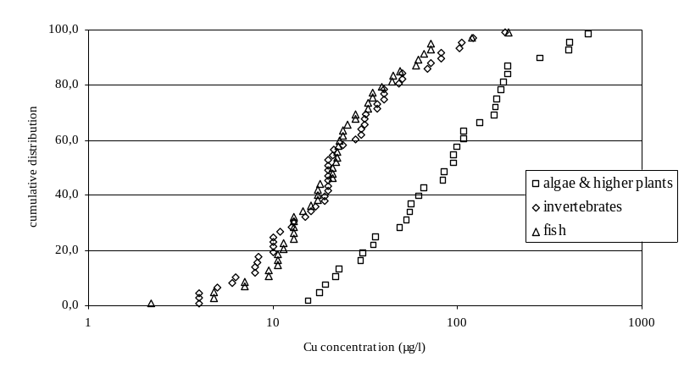

Figure 3-25: Sensitivity of aquatic organisms towards Cu
The high quality chronic toxicity data for the invertebrates vary between 4 and 181 µg/l Cu. The lowest NOEC value was obtained for the waterflea Daphnia pulex (endpoint mortality) and Ceriodaphnia dubia (endpoint mortality and reproduction), the highest for the waterflea Daphnia magna (endpoint reproduction).
The individual high quality NOEC values for fish vary from 2.2 µg/l Cu for the rainbow trout Oncorhynchus mykiss (endpoint growth) to 188 µg/l Cu for the perch Perca fluviatilis (endpoint mortality).
The lowest sensitivity was observed for the other trophic level of concern, i.e. algae/higher plants (primary producers). The NOEC values for freshwater algae range from 15.7 µg/l Cu for Pseudokircherniella subcapitata to 510.2 µg/l Cu for Chlorella vulgaris.
Intraspecies sensitivity
For the same species and endpoint a fairly wide range of NOEC values can be found. For example, the growth tests performed on the micro-algae Chlamydomonas reinhardtii indicated NOEC values ranging between 22 and 178 µg/l Cu resulting in a species mean value of 79.8 µg/l Cu. Such difference in intraspecies sensitivity seemed to be explained by differences in pH and DOC concentrations (hardness was almost constant between 23 and 25 mg/l CaCO₃). The highest NOEC value was obtained in a test performed at a low pH value (i.e. 6.02) and high DOC concentration (i.e. 9.84 mg/l DOC), while the lowest NOEC value was found in a test media with a very low DOC, i.e. 0.5 mg/l.
Similar observations could be formulated from the chronic toxicity test results obtained with the alga Chlorella vulgaris (De Schamphelaere et al., 2006). The observed differences in NOEC values for growth ranged from 31 to 510 µg/l Cu resulting in a “species mean” NOEC of 138 µg/l Cu based on this endpoint. Indeed, the protective effect of DOC is clearly noticed from experiments performed at similar pH’s and hardness. A chronic NOEC value of 108.3 µg/l Cu was estimated from the chronic algae test performed in reconstituted test media with a DOC concentration of 5.17 mg/l DOC, hardness of 97 mg/l CaCO₃ and pH of 6.03. Increasing the DOC concentration to 15.49 mg/l DOC at similar pH and hardness decreased the chronic toxicity towards C. vulgaris reaching a NOEC value of 407.4 µg/l Cu. Similar observations could be noticed from the chronic testing of Cu performed at a similar pH of 8.0 and hardness of 390 mg/l CaCO₃. Increasing the DOC concentrations from 5.04 to 15.82 mg/l DOC decreased toxicity by a factor of 3, i.e. the NOEC value increased from 55.6 to 172.9 µg/l Cu.
The effect of pH on the chronic toxicity of Cu towards C. vulgaris seemed also obvious from the database. Performing the chronic toxicity tests at a constant DOC concentration of 10.2 mg/l and hardness of 245 mg/l CaCO₃ but at a different pH value resulted in significant differences in NOEC values, i.e. 404.1 µg/l Cu at pH 5.5 and 132.3 µg/l Cu at pH 7.04. Therefore, these data indicate that higher toxicity towards the freshwater algae is observed at higher pH values.
Clear indications of the mitigating effect of specific water characteristics on the chronic toxicity of copper was also observed for invertebrates. An example is found in the tests with the water flea Daphnia magna investigating the effect of chronic exposure of Cu on reproduction. A range of NOEC values between 21.5 and 181 µg Cu/l were found resulting in a “species mean” NOEC of 50.4 µg/l based on this endpoint. These differences again seemed to be explained by the differences in the water chemistry parameters DOC and pH. Increasing the DOC concentration from 6.13 to 20.4 mg/l (at similar pH and hardness values) decreased the chronic toxicity by a factor of 1.8, i.e. a NOEC value of 106 and 181.1 µg/l Cu respectively. The pH effect on the chronic toxicity of copper towards the waterflea seemed also to be illustrated by the gathered NOEC values from the Heijerick et al. study (2001). Indeed the lowest NOEC values (highest toxicity) for reproduction, ranging between 20 and 28 µg/l Cu, seemed to be generated at the lowest pHs, i.e. between 6.1 and 7.0. The highest NOEC values, between 68.8 and 181 µg/l Cu, were all estimated at pH values between 7.4 and 7.9. The data suggested therefore that higher toxicity is observed at lower pH values.
Similar results were observed from the Winner database (1985) with the daphnid Daphnia pulex. This database revealed that the 42 days chronic toxicity test results varied between 4 and 40 µg/l Cu for the endpoint mortality. Increasing the DOC concentration (added as Aldrich humic acids at concentrations of 0.15, 0.75 and 1.5 mg/l DOC) in the reconstituted media decreased the toxicity up to a factor 8. Again, it seems that DOC has a protective effect on the chronic toxicity of copper towards the water flea. As for the algae, hardness seemed to have a negligible protective effect on copper toxicity towards invertebrates. Winner (1985) estimated similar effects on the mortality of D. pulex tested at different hardness but similar pH values and DOC concentrations. Similar NOEC values ranging between 15 and 20 µg/l Cu were observed for experiments performed at varying hardness, between 58 and 230 mg/l CaCO₃, but constant pH of 8.6 and added DOC concentration of 0.75 mg/l. This absence of protective effect of hardness is confirmed in testing performed with other DOC concentrations.
The tests performed with the fathead minnow Pimephales promelas investigating the effect of chronic exposure to Cu on the survival resulted in NOEC values ranging from 4.8 to 61 µg/l and in a “species mean” NOEC of 17.8 µg/l based on this endpoint. These differences seemed to be explained by the differences in physico-chemistry. Considering toxicity test results with similar DOC concentrations, lower NOEC values were obtained from testing copper in media with a low pH and hardness. Indeed, a chronic NOEC value for survival of 4.8 µg/l Cu was observed at pH 7/hardness of 44 mg/l CaCO₃ while a higher NOEC value of 61 µg/l Cu was found at pH 8.17/hardness of 202 mg/l CaCO₃ (appr. 30 days of exposure). Similar results were observed from Mount (1968) and Mount & Stephan (1969). Exposing fathead minnow in well water (mixed with deionised water) during appr. 330 days to copper resulted in NOEC values of (1) 10.6 µg/l Cu at pH 6.9 and hardness of 31 mg/l CaCO₃ and (2) 33 µg/l Cu at pH 8.0 and hardness of 198 mg/l CaCO₃. From these results it was not possible to distinguish the protective effect between pH and hardness.
Exposure time
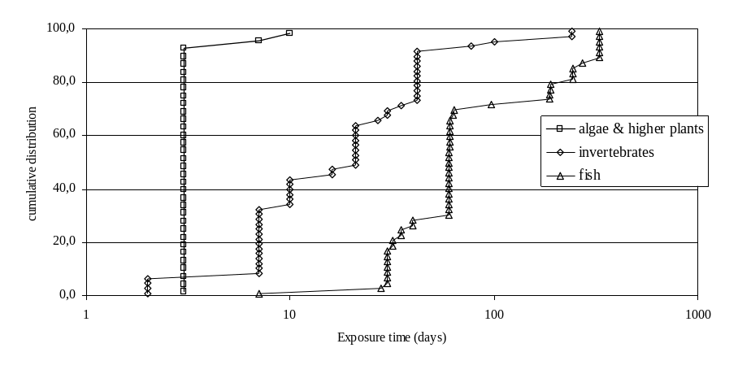
Besides physico-chemistry, exposure time also can influence the sensitivity of the organisms towards copper. An overview of the total exposure time (days) observed in the Cu database for the different trophic levels (algae and plants, invertebrates, fish ) is provided in Figure 3-26
Figure 3-26 : Exposure time (days) observed in the toxicity tests from the copper database
In general it seems that exposure time increases with trophic level. Indeed, the median exposure duration for the algae/plant test is 3 days (range between 3 and 10 days), 21 days (range between 2 and 240 days) for the invertebrates and 60 days (range between 7 and 330 days) for the fish.
Assessment of the influence of exposure time on the NOEC values is provided for different fish species by Mudge et al. (1993) and Seim et al. (1984). Both experiments were performed with the salmonids O. mykiss and O. kisutch in a flow through exposure system. The time course for the response of the organisms to copper exposure is provided in Figure 3-27 and Figure 3-28. Mudge et al. (1993) reported the highest dissolved copper concentrations with no observed effects as indicated by either growth or mortality at 10, 30 and 60 days of exposure. The incipient or asymptotic NOEC for both species tested seemed to be reached after 30 days of exposure (Figure 3-27 and Figure 3-28).

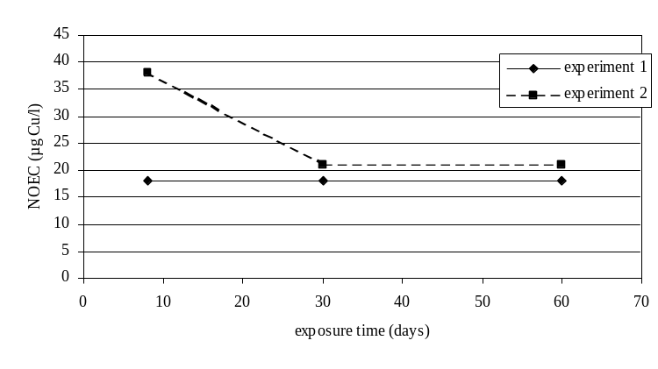

Figure 3-27 Time course for the response of O. kisutch to copper exposure (Mudge et al., 1993)

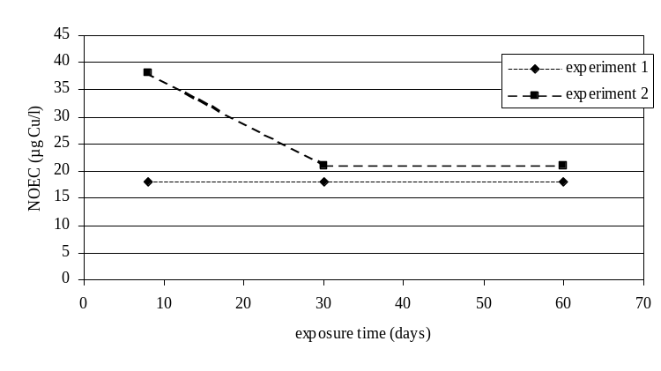
Details on the time courses for responses on growth of the rainbow trout is reported by Seim et al. (1984). The incipient NOEC value for growth of alevins continuously exposed to copper was reached after 60 days of exposure Figure 3-28).
Figure 3-28 Time course for the response of O. mykiss to copper exposure (Seim et al., 1984)

Assessment of the influence of exposure time on the NOEC values for invertebrates is provided from the reproduction data generated with D. magna by Heijerick et al. (2001). The time course for the response of the organisms to copper exposure in natural water (i.e. Ankeveen in the Netherlands) is provided in Figure 3-29.
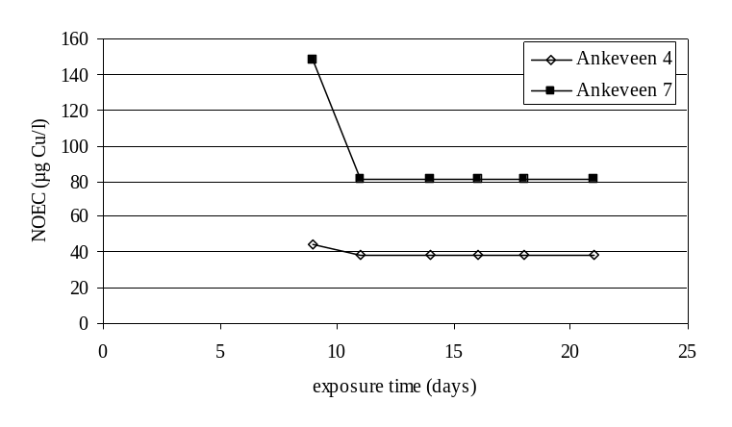
Figure 3-29 Time course for the response of D. magna to copper exposure ( data from Heijerick et al., 2001)
From these experiments it seems that the incipient or asymptotic NOEC for D. magna is reached after 11 days of exposure to copper.
Comparison of these values with the median exposure time for invertebrates and fish from the ecotoxicity database revealed that the latter values (21 days for the invertebrates and 60 days for the fish) equals or exceeds the incipient NOEC for the invertebrates (11 days) and fish (between 30 and 60 days).
Comparison of the exposure times from the toxicity database with those recommended by standard guideline revealed that typically a 3 days exposure is used for performing chronic algae tests while the exposure time in the Cu database ranged between 3 and 10 days. The 3 days algal experiments were all performed under static conditions, while the 10 days experiment from Schäfer et al. (1994) was conducted under flow-through conditions. According to the authors, both test set-ups guaranteed that the algae were maintained in an exponential growth phase during the exposure period. Typical ‘standard’ chronic exposure duration for invertebrates seemed to vary between 7 days (cfr. reproduction toxicity test with Ceriodaphnia dubia; ASTM, 2003) and 21 days (cfr. reproduction toxicity test with Daphnia magna). The Cu database revealed that the exposure time for all invertebrates ranged between 7 and 240 days. Long term toxicity tests with standard fish (e.g. salmon, trout, fathead minnow,…) are typically ≥ 14 days (OECD, 1983)/ ≥ 30 days (ASTM, 2003). The Cu toxicity database revealed that 6 from the 46 high quality NOEC data are generated at exposure times <14 days, i.e. between 7 and 10 days. In general these toxicity tests generated relatively high NOEC values, i.e. 338 µg/l for P. promelas – endpoint mortality (Scudder et al., 1988); 75 and 312 µg/l for S. fontinalis – endpoint mortality (Jop et al., 1995); 75 and 79 µg/l for S. fontinalis – endpoint growth (Jop et al., 1995). However, in case of these rather short exposure times it was decided to retain the toxicity data only in case the fish represent a sensitive life stage, i.e. larvae or juveniles. The 7 days tests reported by Scudder et al. (1988) performed with embryos, i.e. a less sensitive life stage, were therefore not retained as true chronic tests or most sensitive endpoint. In addition, the fish tests performed by Jop et al. (1995) could not be retained as true chronic tests as they were performed with a less sensitive life stage, i.e. 8 months old fishes. The 7 days test with 4 weeks old larvae with P. promelas (Pickering et al., 1977) resulted in a NOEC value of 22.5 µg/l (reproduction) and were retained in the chronic toxicity database. As a summary, the exposure for retained fish data therefore range between 30 and 330 days. In addition, a 7 days P. Promelas larvae test was retained as a sensitive life stage.

Chemical analysis
- Metal fraction
In general it is assumed that almost all copper is present in the dissolved fraction in the toxicity tests. Although this statement generally holds for tests performed in artificial waters, potential discrepancies between total and dissolved copper concentrations might occur in tests performed with natural waters which could contain considerable concentrations of suspended solids, e.g. river or lake water. For the algae (R. subcapitata) and daphnid (D. magna) tests performed with natural lake or river water (Heijerick et al., 2001) all test media were filtered (0.45 µm) prior to testing and the Cu concentrations were subsequently measured. The reported Cu concentrations could therefore be regarded as dissolved concentrations. Similar indications were provided for the tests performed with C. dubia (Belanger et al., 1989; Belanger & Cherry, 1990): all water samples were filtered through a 11 µm filter and Cu concentrations were determined by filtering the samples through a 0.45 µm filter. Spehar & Fiandt (1985) reported toxicity data for the same species as total (acid exchangeable) Cu concentrations. However, samples were periodically filtered through a 0.45 µm filter to measure the portion of dissolved metal, and for copper it seems that 92% (+/- 6%) of the total copper is present as dissolved copper. Deaver & Rodgers (1996) performed toxicity tests with the amphipod H. azteca and reported that dissolved (0.45 µm) was measured in the toxicity test. All toxicity tests performed with G. pulex (Maund et al., 1992) were reported as dissolved (0.45 µm) copper concentrations. Indications on the copper fraction in chronic fish tests were provided by Mudge et al. (1993). All tests were performed with raw water with a reported low solid concentration. Metal fraction (dissolved versus total) was checked after 60 days of exposure for the experiments with both O. mykiss and O. kisutch. Reported total Cu concentrations (at the NOEC level) for the tests with O. mykiss were 24 and 29 µg/l, as dissolved Cu concentrations respectively 18 and 21 µg/l. Similar differences were observed for the long term tests with O. kisutch: total Cu concentrations of 22, 18 and 33 µg/l compared to respectively 17, 14 and 24 µg/l dissolved Cu concentrations. Brungs et al. (1976) performed chronic toxicity tests with the fathead minnow and reported that the mean dissolved Cu concentration was 87% of the total measured copper concentration in the test medium (i.e. river water). Seim et al. (1984) reported that the Cu concentration in the test media (toxicity tests with the rainbow trout) was measured weekly and filtered (0.45 µm) before measurement. Therefore the reported Cu concentrations could be considered as dissolved. Marr et al. (1996) also reported toxicity results with the rainbow trout and indicated clearly that the well water was treated before testing with sediment filtration, reverse osmosis and deionization, suggesting therefore that almost all Cu is present as dissolved fraction. Collvin (1984; 1985) reported that 15% of the total amount of copper in the test water is present as particulate copper. However, some authors do not report any information on the copper fraction in the toxicity tests (e.g. Van Leeuwen et al., 1988; Nebeker et al., 1984; Horning & Neiheisel, 1979). On the other hand, there is also no indication in these publications that there might be a large difference between the dissolved and total copper fraction in the toxicity tests. Based on the aforementioned analysis it is assumed that almost all copper is present in the dissolved form in the toxicity tests.
- Maintenance of exposure concentration
Exposure of organisms to a particular test concentration suggests that the exposure concentration in the test media is maintained during testing. Indications of maintenance of copper concentrations in the test media is provided by several authors. Indeed, Van Leeuwen et al. (1988) performed chronic toxicity tests with the daphnids D. magna in a semistatic exposure system. During the evaluation period of the reliability of the test system, the mean coefficient of variation (representing analytical and dilution errors) of copper was 11%. Maund et al. (1992) reported results from 100 days experiments performed with G. pulex in a flow through exposure system. Dissolved copper concentrations were measured weekly and only small variations were measured through the test duration, i.e. a mean Cu concentration of 11.2 µg/l (with 95% confidence limits of 9.1 – 13.3 µg/l) and 10.8 µg/l (with 95% confidence limits of 8.8 – 12.7 µg/l) were observed at the NOEC level. Deaver & Rodgers (1996) measured copper concentrations on days 0 and 10 of 3 samples for each concentration used in the static tests with H. azteca. No statistical differences were noticed between measured concentrations of total dissolved in each of the tests waters. De Schamphelaere et al. (2006) reported that the dissolved copper concentration after the 48 h toxicity tests were in all cases within 30% of the concentrations before the test. Taylor et al. (1991) reported the 95% confidence interval of the measured copper concentrations during the 10 days testing (in a static renewal exposure system) with C. riparius, i.e. between 16.4 and 17.4 µg/l at the NOEC level. Chronic experiments with the snail C. decisum performed (Arthur & Leonard, 1970) in a flow through system for 42 days revealed a mean copper concentration (at the NOEC level) of 8.0 +/- 2.7 µg/l. Chemical survey through the test duration was performed from daily (5 days a week) copper analysis from 1 duplicate tank for each concentration. Measurement of the weekly total copper concentrations was performed in combined samples. Sauter et al. (1976) reported several chronic values for different fish species using flow through exposure systems. The results of the copper analysis of the water samples taken periodically during continuous exposure to copper indicated that measured concentrations closely approximated nominal concentrations and were relatively constant throughout the 30 to 60 days exposure. Other indications of maintenance of copper concentrations throughout testing is provided by Marr et al. (1996). Water samples were collected from the test media every 3 to 6 days (flow through exposure system) and copper concentrations were measured. The mean (with standard deviation) reported copper concentration, at the NOEC level, was 2.2 +/- 0.37 µg/l (analysis from 25 water samples). The 30 days flow through experiments performed with P. fluviatilis revealed that the mean copper concentration (at the NOEC level) analysed from daily samples was 188 +/- 10.9 µg/l. Horning & Neiheisel (1979) reported mean (with standard deviation) copper concentrations in the test media throughout the test duration with fathead minnow. Such concentrations (from daily samples and composited for 7 days), at the NOEC level, were 71.2 +/- 7.6 µg/l, 72.6 +/- 5.3 µg/l, 43.8 +/- 5.9 µg/l. Pickering et al. (1977) also performed chronic tests with fathead minnow. During copper dosing in the flow through system, water samples for copper analysis were removed daily and composited for 7 days. The mean (and standard deviation) copper concentrations, at the NOEC level, were 25 +/ 2.3 µg/l, 26 +/- 3.1 µg/l, 22 +/- 1.6 µg/l, 24 +/- 3.3 µg/l, 22 +/- 2.6 µg/l and 23 +/- 2.3 µg/l. McKim & Benoit (1971) performed 244 days tests with S. fontanilis in a flow through system. Daily water samples from each tank were composited over a 5 days period for the analysis of copper. The range of copper (mean and standard deviation), at the NOEC level, was 17.4 +/- 1.8 µg/l. The copper analysis (from water samples taken daily) throughout the experiment with P. promelas in a flow through exposure system (Scudder et al., 1988) for 8 to 28 days revealed the following variation at the NOEC level: 61 +/- 8 µg/l and 338 +/- 38 µg/l. Brungs et al. (1976) also reported variation in copper concentrations in the test media throughout testing. The variation of the measured copper concentrations from daily samples and composited for 7 days were 64 +/- 6 µg/l and 67 +/- 7 µg/l. However, some authors do not report any information on the maintenance of copper through the toxicity tests (e.g. Spehar & Fiandt, 1985; Belanger et al., 1989; Belanger & Cherry, 1990; Mudge et al., 1983; Seim et al., 1984). On the other hand, there is also no indications in these publications that there might be a large difference in exposure concentrations through the test duration. Based on the aforementioned analysis it is assumed that the copper level is maintained through the duration of the toxicity tests.
Water chemistry of the test media
In order to better (1) understand the observed differences in intraspecies sensitivity for copper and (2) investigate the quality of the database (i.e. range of freshwater characteristics covered), the physico-chemical characteristics encountered in the toxicity tests were investigated thoroughly as follows:
- Background copper concentration in culture medium
In order to calculate the added NOEC for the aquatic compartment, the background concentrations from the reported culture media to which organisms are adapted/acclimatized to has to be taken into account. Often reconstituted media with unknown background concentrations are used for culturing/acclimatizing invertebrates and fish. For these media a low background concentration of 0.5 µg/l Cu was suggested because such medium is prepared by adding reagent grade salts in ultrapure water produced by distillation/demineralisation/deionisation (e.g. Hatakeyama & Yasuno, 1981; Winner, 1985). A similar low background concentration of 0.5 µg/l Cu was suggested for algal medium. The composition of the most common algal test media used in toxicity testing (e.g. ISO, OECD medium) suggest a negligible addition of appr. 10 ng/l Cu in the test medium. Because such algae tests are also conducted using ultrapure water (e.g. De Schamphelaere et al., 2006) a similar background Cu concentration of 0.5 µg/l was suggested. In case the reported background concentration was below detection limit (DL), a value of DL/2 was used. If the background concentrations in the natural waters were not reported or could not be estimated, the toxicity data were removed from the database for the PNEC_{add} calculation. The reported and estimated background Cu concentrations varied between 0.45 to 7.0 µg/l Cu. About 60% of the background concentration in the test media are estimated below 1 µg/l Cu. The distribution of the observed background Cu concentration to which the freshwater organisms are estimated to be acclimized/adapted to is given in Figure 3-30. These reported background concentrations are similar to those found in European surface waters (range between 0.8 and 5.3 µg/l Cu; Zuurdeeg et al., 1992).

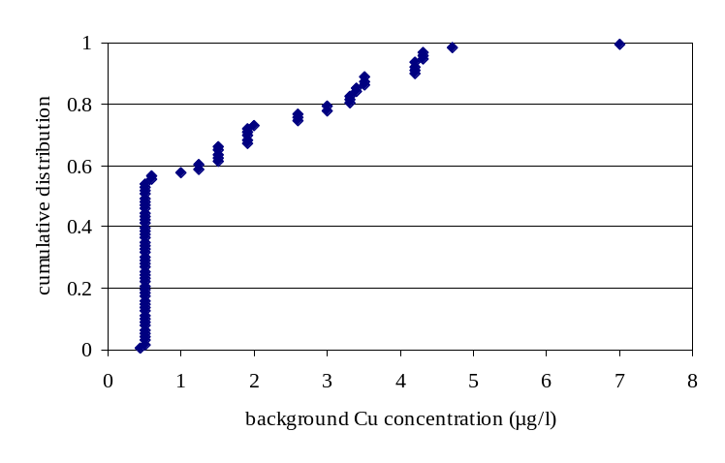
Figure 3-30 Distribution of the observed background Cu concentrations in the ecotoxicity tests
- pH
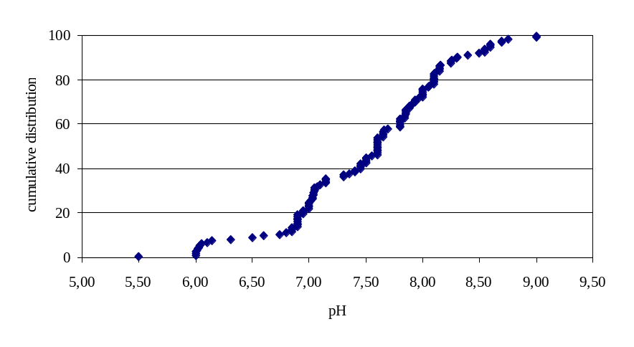
The pH values extracted from the literature database varied between 5.5 and 9.0 and seemed representative for those encountered in European surface waters. The distribution of the observed pH values used in the ecotoxicological tests is given in Figure 3-31.
Figure 3-31 Distribution of the observed pHs in the ecotoxicity tests
- DOC
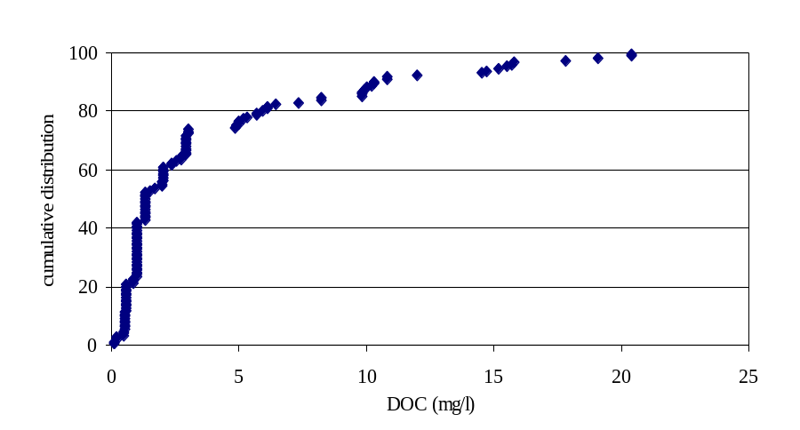
Often the DOC concentrations used in the toxicity tests are not reported. Because of the strong mitigating effect of DOC on Cu toxicity, it was necessary to assume values that were consistent with the water sources used in this report. In general, very low organic carbon concentrations were assumed for studies that used purified water sources. Whenever possible, assumed DOC concentrations were estimated based on reported measurements from literature or existing environmental databases for the same water source. Mean DOC concentrations for the following rivers could be extracted from the USGS (US Geological Survey) database: 3.7 mg/l TOC for the Clinch river (test medium used in Belanger et al., 1989 and Belanger & Cherry, 1990), 3.7 mg/l TOC for the New river (test medium used in Belanger et al., 1989 and Belanger & Cherry, 1990) and 3.6 mg/l TOC for the Chehalis river (test medium used in Mudge et al., 1993). As particulate organic carbon might be present in the surface waters, only a fraction of the TOC will be present as DOC. An estimate of 0.8 * TOC was used based on both DOC/ TOC measurements reported from German surface waters (235 datapoints from river Elbe, 1996). In the absence of any other information default concentrations were assumed based on the estimates suggested by Santore et al. (2002): 0.1 mg/l DOC for deionised water; 1 mg/l DOC for tapwater, spring water and Lake Superior water; 1.3 mg/l DOC for well water. For natural waters (e.g. samples from rivers or lakes) Santore et al. (2002) assumed a DOC concentration ranging between 1 and 3 mg/l DOC. In this study, we used a mean concentration of 2 mg/l DOC if no further information was given on the natural sample used in the toxicity tests. For reconstituted water a default DOC concentration of 0.5 mg/l was assumed from De Schamphelaere and Janssen, 2002 (0.3 mg DOC/L); Ryan eta al., 2004 (0.4-0.5 mg DOC/L); Karman et al., 2004 (<0.1 mg DOC/L); Hollis et al, 1997 (0.4-0.6 mg DOC/L). Based on these assumptions, DOC values extracted/estimated from the literature database varied between 0.1 and 20.4 mg/l DOC and seemed therefore representative for those encountered in European surface waters. According to De Schamphelaere & Janssen (2004) it must be assumed that 50% of the natural organic matter are active fulvic acids. Therefore for computational purposes, all organic matter content in the test media should be divided by a factor of 2. However, in case artificial humic acids are used in testing (i.e. study of Winner, 1985), 100% activity should be assumed. The distribution of the observed DOC values used in the ecotoxicological tests is given in Figure 3-32
Figure 3-32 Distribution of the observed DOC values in the ecotoxicity tests.

- Hardness
The pH values extracted from the literature database varied between 7.9 and 486 mg/l CaCO₃ and seemed therefore for those encountered in European surface waters. The distribution of the observed hardness values used in the ecotoxicological tests is given in Figure 3-33.
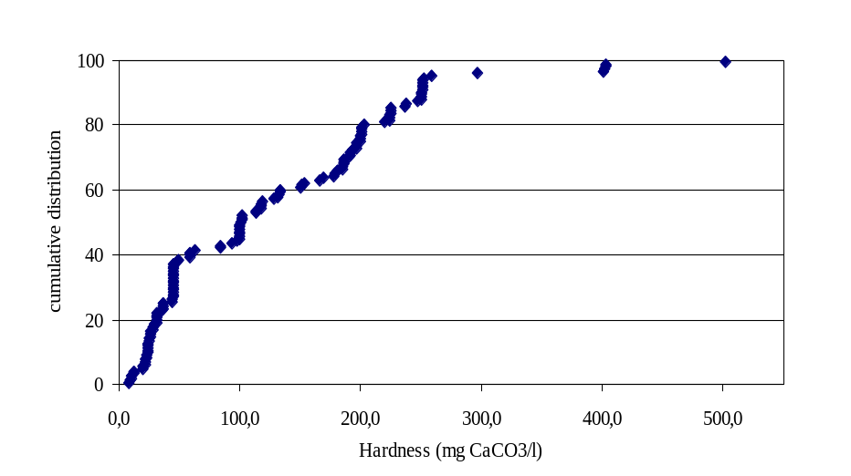
Figure 3-33 Distribution of the observed hardness values in the toxicity tests

An overview of the maps representing the range of physico-chemistry encountered in the EU surface waters according to the Foregs database can be found at : http://www.gsf.fi/publ/foregsatlas/index.php. Comparison between the freshwater properties used in the accepted ecotoxictiy tests and those encountered in EU freshwaters (according to the Swad & Foregs database) revealed similar but somewhat narrower range in pH/DOC from the data collected in the Swad database compared to the FOREGS database (Table 3-10 and ). The visual representation of the ranges of hardness, DOC, and pH shows that the minimum and maximum values from the toxicity database are broader than the 10th – 90th percentiles of the distribution of these parameters that were derived from the EU monitoring programs. Also, the boundaries of the BLMs (narrowest and broadest) for hardness, DOC and pH cover the 10th – 90th percentiles of the distribution of these parameters.

Table 3-10: Physico-chemical parameters of the selected toxicity studies (min-max values) and European freshwaters (reported as 10th , 50th and 90th %).
Parameter |  | Range Range (min-max /(10th% -50th % - 90th %)
pH | Toxicity studies | 5.0- 9.0
 | European freshwaters (Swad) | 6.6 -7.5 - 8.1
 | European freshwaters (Foregs) | 6.4* -7.7 - 8.3
DOC (mg/l) | Toxicity studies | 0.1-20.4
 | European freshwaters (Swad) | 2.6 – 6.4 - 12.4
 | European freshwaters (Foregs) | 0.9*- 5.0 - 17.0
Hardness (mg/l CaCO₃) | Toxicity studies | 7.9-486
 | European freshwaters (Swad) | 37 - 99 - 323
Ca (mg/l) | Toxicity studies | 2.2-160.4
 | European freshwaters (Foregs) | 3.0* – 40 - 119
Mg (mg/l) | Toxicity studies | 0.5-24.5
 | European freshwaters (Foregs) | 0.8* – 6.0 – 27.3
*: estimated value from graphical interpolation

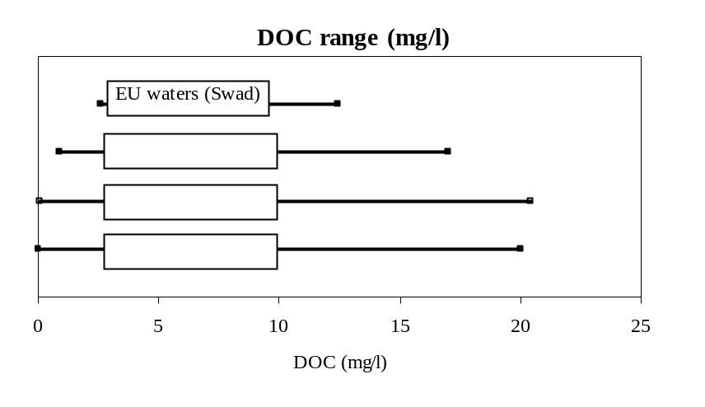

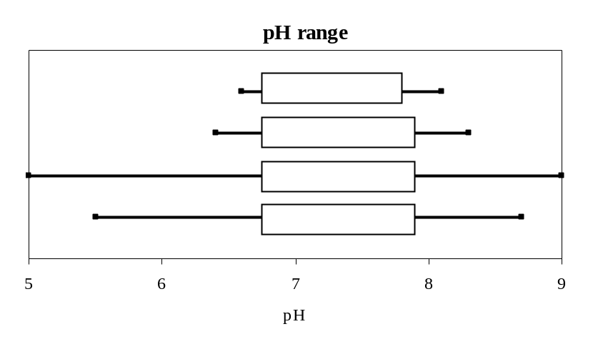

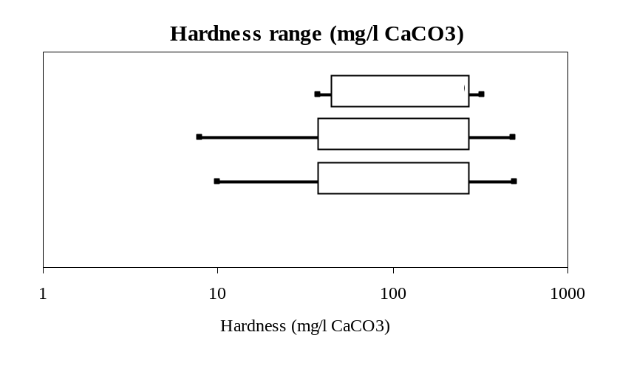
Figure 3-34: Water parameters of the selected toxicity studies (min-max values), hardness, DOC and pH boundaries of the BLMs (min-max values for the broadest and narrowest BLMs), and European freshwaters (reported as 10th and 90th %). Ranges of the narrowest BLMs are shown by the vertical arrows.
        - Derivation of HC5-50 values for surface waters
- Non-normalised HC5-50 for surface waters
The Table 3-11 presents the non-normalised species mean NOEC values for the most sensitive endpoint used for HC5-50 derivation in surface waters. It must be stressed that this approach shows high intraspecies variability for some species and is therefore less ecologically relevant for PNEC derivation compared to the use of BLM-normalised dissolved toxicity data.
Table 3-11 :Summary of the “species mean” NOECs (total risk approach) in µg Cu/l (with most sensitive endpoint and number of datapoints)
Taxonomic group | Non- Normalised “species mean” NOEC values (µg Cu/l)
Algae | 43.1 (Pseudokirchneriella subcapitata, n=12; growth); 138.0 (Chlorella vulgaris, n=17; growth); 79.8 (Chlamydomonas reinhardtii, n=4; growth)
Higher plants | 30.0 (Lemna minor, n=1; growth)
Rotifer | 33.5 (Brachionus calyciflorus; n=4; intrinsic rate of growth)
Molluscs | 8.0 (Campeloma decisum, n=2; mortality); 6.0 (Juga plicifera, n=1; mortality); 19.1 (Villosa iris, n=1; mortality); 18.3 (Dreissenia polymorpha, n=2; filtration rate)
Cladocerans | 13.1 (Ceriodaphnia dubia, n=10; reproduction); 12.6 (Daphnia magna, n=1; growth ); 14.5 (Daphnia pulex, n=9; mortality)
Insects | 10.4 (Clistoronia magnifica, n=2; reproduction/mortality); 16.9 (Chironomus riparius, n=1; growth); 40.0 (Paratanytarsus parthenogeneticus, n=2; growth/reproduction)
Amphipods | 11.0 (Gammarus pulex, n=1; reproduction); 50.3 (Hyalella azteca, n=6; mortality)
Fish | 13.0 (Ictalurus punctatus, n=2; growth/mortality); 20.8 (Oncorhynchus kisutch, n=2; mortality); 11.6 (Oncorhynchus mykiss, n=4; growth); 14.0 (Salvelinus fontinalis, n=5; growth); 17.8 (Pimephales promelas, n=4; growth); 56.2 (Pimephales notatus, n=2; growth); 39.0 (Perca fluviatilis, n=1; growth); 120.0 (Noemacheilus barbatulus, n=1; mortality); 12.9 (Catostomus commersoni; n=1; growth/mortality); 34.9 (Esox lucius; n=1; growth/mortality);

The cumulative frequency distribution (SSD) of the non-normalised species mean NOEC values towards Cu is presented in

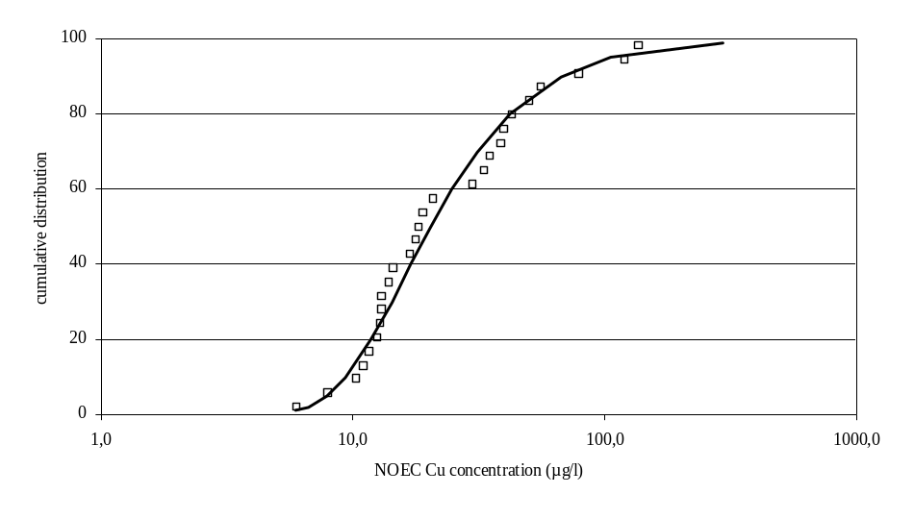

Figure 3-35: The cumulative frequency distributions of the non-normalised species mean NOEC values from the Cu toxicity tests in the dataset of freshwater organisms. Observed data and Pearson V distribution curve (best fitting curve) for the dataset fitted on the data

Using statistical extrapolation results in a HC₅-50 (HC₅ at 50th % confidence value) of 7.3 µg/l (6.1-7.9 µg/l) based on the non-normalised NOEC data with the best fitting approach. Using log normal curve fitting on the non-normalised NOEC data, results in a HC₅-50 (HC₅ at 50th % confidence value) of 6.1 µg/l (3.7-8.6 µg/l).
Table 3-12: Non-normalised “species mean” NOECs (total risk approach) that are used as input values for deriving the HC₅ values as a basis for the freshwater. Median 5th percentile values with 90% confidence bound (HC5-50 with 5% and 95% CI) for freshwater ecosystem in case of statistical extrapolation and using the assessment factor approach. All values in µg/l.
 | Non-normalised scenario
 | Interval of “species mean” NOEC values | HC5-50 with 5% and 95% CI using the “best fit” | HC5-50 with 5% and 95% CI using the “log normal curve fitting” | AF = 10
Total risk approach  (n =27) | 6.0-120.0 | 7.3 (6.1-7.9)  Pearson V | 6.1 (3.7-8.6)  log-normal | 0.6

The approach for HC5/PNEC derivation using dissolved (not normalized) toxicity data shows a very high intra-species variability in NOEC for some species. The derived species –mean values and HC5 are therefore subjected to a relative high level of uncertainty
- BLM-normalised HC5-50 for surface waters
Introduction
Considering the large variation in the abiotic factors, influencing the toxicity of copper in aquatic systems (section 2.5.3), as presented in chapter 2.5.2.3, different typical HC5 values value have been derived after normalisation of all individual NOEC values towards typical conditions for pH, hardness and DOC occurring in representative EU surface waters. Subsequently, the HC5 values for the different surface water (freshwater) were derived from the normalised geometric “species mean” NOEC values, using the two different extrapolation methods, i.e. the use of an assessment factor and statistical extrapolation, with several calculations for the latter methods, using different frequency distribution functions. The use of statistical extrapolation is preferred for PNEC derivation rather than the use of an assessment factor on the lowest NOEC. Based on uncertainty considerations the London workshop recommended to apply an additional assessment factor on the 50% confidence value of the 5th percentile value (thus PNEC = 5th percentile value/AF), with an AF between 1 and 5, to be judged on a case by case basis.
As stated in section 2.5.1 the freshwater and saltwater data are not combined to derive the PNEC_{freshwater} but this value will be derived from the freshwater data only.

Scenario development
The toxicity data are as mentioned above further normalized towards typical physico-chemical conditions occurring in typical region specific EU surface waters. In order to achieve this, abiotic factors mitigating chronic Cu toxicity from both lakes and rivers were collected from different regions in the EU (i.e. Sweden, Italy, The Netherlands United Kingdom and Spain). The different scenarios were selected to provide examples of typical conditions covering a wide range of physico-chemical conditions (pH between 6.67 and 8.21; hardness between 27.8 and 260 mg/l CaCO₃, DOC between 2.5 and 27.5 mg/l) occurring in EU surface waters. The different considered scenarios are summarized in Table 3-13 and Table 3-14. In this exercise small (± 1,000 m³/d), medium sized (± 200,000 m³/d) and large (± 1,000,000 m³/d) alluvial (eutrophic) rivers were considered. In addition, an example of a typical Mediterranean river was also included in this report.

For the lakes, the focus was on the gathering of physico.-chemical. data for sensitive systems, i.e. oligotrophic and acidic lakes. Freshwater scenarios were selected on their ecological relevance, and cover water types with ranges of nutrient status (both oligo- and eutrophic), flow regimes (both lentic and lotic), and geography (Italy, the Netherlands, Sweden, and the United Kingdom).

The different freshwater scenarios were selected to provide typical examples of ecological and abiotic conditions occurring in EU surface waters, covering a reasonably wide range of physico-chemical conditions :
- pH between 6.7 and 8.1;
- hardness between 27.8 and 350.1 mg/l CaCO₃,
- DOC between 2.5 and 12.0 mg/l.
Table 3-13: Summary of the phys.-chem. characteristics of the different selected scenarios.
 | Type |  | Name | Country | pH | H (mg/l CaCO₃) | DOC (mg/l) | Na (mg/l) | Alkalinity (mg/l CaCO₃) | Reference
Rivers | Small (ditches with flow rate of ± 1,000 m³/d) |  | / | The Netherlands | 6.9 | 350.1 (Ca: 88.2; Mg: 31.6 mg/l) | 12.0 | 59.8 | 265 | Van Tilborg, 2002
Rivers | Medium (rivers with flow rate of ± 200,000 m³/d) |  | River Otter  River Teme | United Kingdom | 8.1  7.6 | 165 (Ca: 46.9; Mg: 11.6 mg/l)  159 (Ca: 49.9; Mg: 8.4 mg/l) | 3.2  8.0 | 14.2  12.9 | 116  118 | HMS database
Rivers | Large (rivers with flow rate of ± 1,000,000 m³/d) |  | River Rhine | The Netherlands | 7.8 | 217 (Ca: 68.9; Mg: 10.9 mg/l) | 2.8 | 36.8 | 119 | Van Tilborg, 2002
Rivers | Mediterranean river |  | River Ebro | Spain | 8.2 | 273 (Ca: 72.9; Mg: 22.1 mg/l) | 3.7 | 5.3 | 35.8 | Heijerick, 2006
Lakes | Oligotrophic systems |  | Lake Monate | Italy | 7.7 | 48.3 (Ca: 13.6; Mg: 3.5 mg/l) | 2.5 | 2.3 | 50.6 | Euro-Ecole, 2002
Lakes | Acidic system |  | / | Sweden | 6.7 | 27.8 (Ca: 8.7; Mg: 1.5 mg/l) | 3.8 | 7.7 | 13.6 | Riksinventering lakes database
Boundaries |  | Foregs database |  |  | 6.4-8.3 | / | 0.9-17.0
 |  | Swad database |  |  | 6.6-8.1 | 16.4-253 | 2.6-12.4

The physico.-chemical. conditions of the different scenarios considered were further compared with the phys.-chem. conditions occurring in EU surface waters (see Table 3-14, according to the SWAD database). Based on this comparison it seems that the Swedish acid lake has a low pH, hardness and DOC concentration. The oligotrophic lakes are typically characaterised by a medium pH, a low hardness and a low to very low DOC concentration. The ditches are typically characterised by a high hardness and a high DOC (very close to the 90th % of the DOC concentration in EU surface waters, while the lowland rivers typically have medium to low DOC levels and a medium to high pH/hardness.

Table 3-14 : Comparison of the phys.-chem. conditions of the different scenarios versus EU surface waters (Swad database).
 | Type | Scenario
 |  | pH | H (mg/l CaCO₃) | DOC (mg/l C)
Rivers | Small (ditch) | Low | High | Very hHigh
Rivers | Medium | Medium-high | Medium | Medium-low
Rivers | Large | Medium | High | Low
 | Mediterranean | High | High | Low
Lakes | Oligotrophic systems | Medium | Low | Low
Lakes | Acidic system | Low | Low | Low

The BLMs developed for chronic fish (P.promelas and O. mykiss), invertebrates (D.magna) and algae (R. subcapitata) were used for normalising chronic NOEC values of respectively fish, invertebrates and algae species. Normalisation of the higher plant L. minor was performed using the algal BLM. For the normalization, the DOC type is unknown and therefore, as recommended by Dwane and Tipping (1998) (cfr chronic effects section), 50% of the DOC is considerd as active fulvic acids. Therefore for computational purposes, all DOC concentration have been divided by a factor of 2 and the humic acid fraction has been set at 0.01%.
HC₅-50 for eco-regions
An overview of the species sensitivity distributions (best fitting and log-normal SSD) and the median HC₅-50 values for the different considered scenarios is presented hereunder. To avoid ‘overfitting’ it was recommended that the selected SSD functions should not be too complex (2-3 paremeters functions are preferred over multi-parameters functions). Indeed, a perfect fit can always be obtained by using for example a high degree polynomial distribution. Fitting of the normalised chronic Cu toxicity data is assessed towards the classical log normal distribution function or by selecting the fitting function giveing the best goodness of curve fit in individual cases by selecting among 10 different frequency distributions which could be described by 2 parameters,( i.e. Erlang, Gamma, Normal, Beta, Logistic, Inverse Gaussian, Extreme Value, Weibull, Pearson V, Pareto), and to 2 distributions which could be described using 3 parameters ( i.e. Triangular and Pearson VI). The 5th , 50th and 95% confidence limits of the log-normal distribution were calculated using the ETX-2000 program from RIVM which is based on the approach as described by Aldenberg & Jaworska (2000). The @Risk software was used for the estmation of the confidence limits of all other distributions.
River systems

- Small river (ditch in The Netherlands)
The species sensitivity distribution and the calculated median HC₅-50 based on the best fitting and conventional log-normal approaches for the ‘ditch’ scenario are presented in Figure 3-36 and Figure 3-37 .

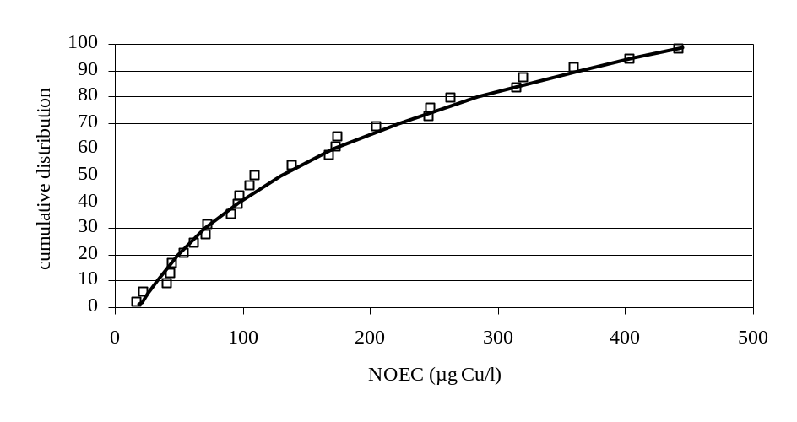
HC₅-50 = 22.1 µg/l

Figure 3-36 : The cumulative frequency distributions of the normalised species mean NOEC or EC₁₀ values from the Cu toxicity tests in the dataset of freshwater organisms (scenario ditches in The Netherlands). Geochemical parameters for this scenario were: pH = 6.9, hardness = 350.1 mg/L CaCO₃, DOC = 12.0 mg/L. Observed data and Beta distribution curve (best fitting curve) for the dataset fitted on the data.
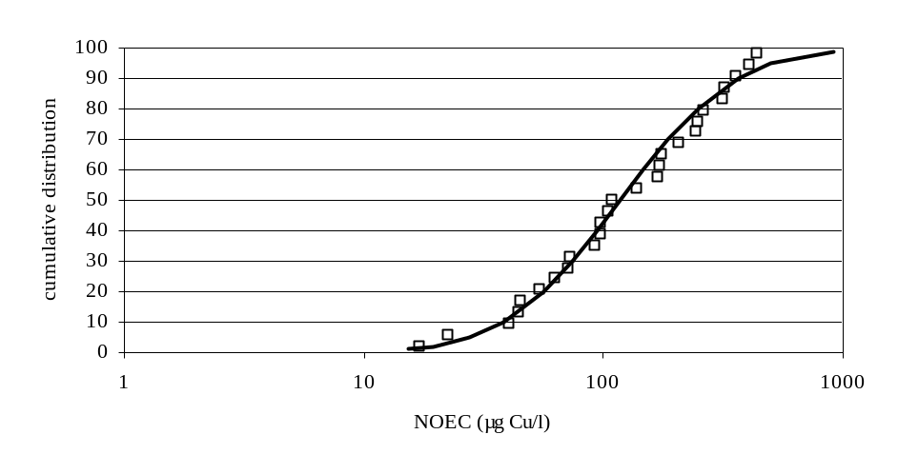
HC₅-50 = 27.2 µg/l

Figure 3-37 : The cumulative frequency distributions of the normalised species mean NOEC or EC₁₀ values from the Cu toxicity tests in the dataset of freshwater organisms (scenario ditches in The Netherlands). Geochemical parameters for this scenario were: pH = 6.9, hardness = 350.1 mg/L CaCO₃, DOC = 12.0 mg/L. Observed data and log-normal distribution curve for the dataset fitted on the data.

- Medium sized river with low DOC (River Otter in the United Kingdom)

The species sensitivity distribution and the calculated median HC₅-50 based on the conventional log-normal (best fitting approach) for the ‘medium sized river with low DOC’ scenario is presented in Figure 3-38

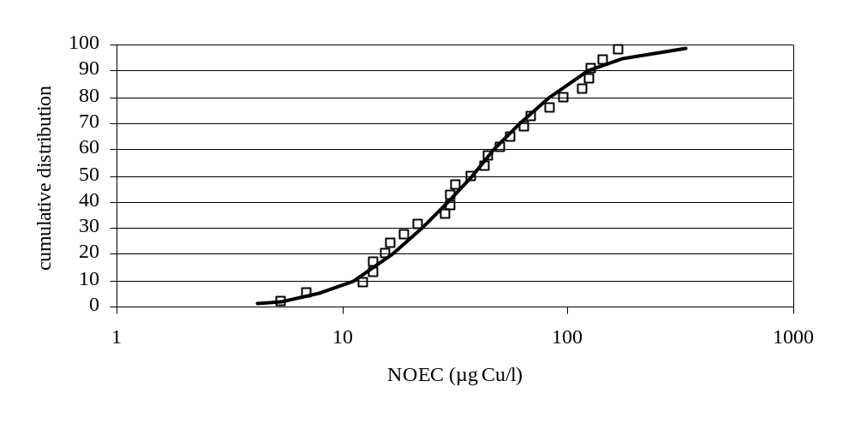
HC₅-50 = 7.8 µg/l

Figure 3-38 : The cumulative frequency distributions of the normalised species mean NOEC or EC₁₀ values from the Cu toxicity tests in the dataset of freshwater organisms (scenario River Otter in the United Kingdom). Geochemical parameters for this scenario were: pH = 8.1, hardness = 165 mg/L CaCO₃, DOC = 3.2 mg/L. Observed data and log-normal distribution distribution curve (best fitting curve) for the dataset fitted on the data.

- Medium sized river with medium DOC (River Teme in the United Kingdom)

The species sensitivity distribution and the calculated median HC₅-50 based on the best fitting and conventional log-normal approaches for the ‘medium sized river with medium DOC’ scenario are presented in Figure 3-39 and Figure 3-40

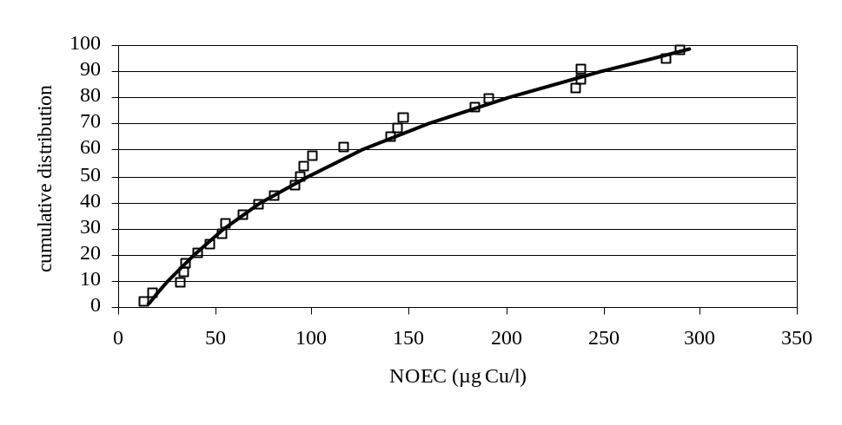
HC₅-50 = 17.6 µg/l

Figure 3-39 : The cumulative frequency distributions of the normalised species mean NOEC or EC10 values from the Cui toxicity tests in the dataset of freshwater organisms (scenario River Teme in the United Kingdom). Geochemical parameters for this scenario were: pH = 7.6, hardness = 159 mg/L CaCO3, DOC = 8.0 mg/L. Observed data and Beta distribution curve (best fitting curve) for the dataset fitted on the data.

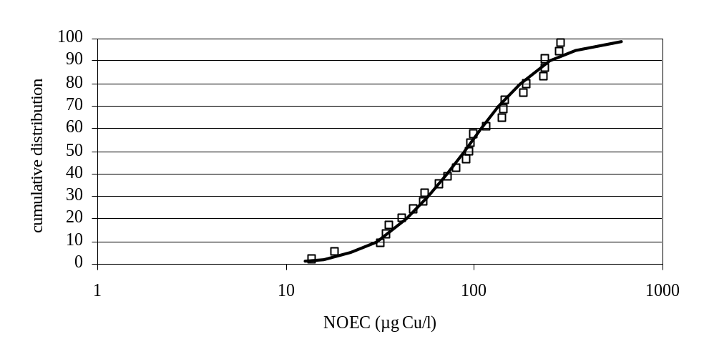
HC₅-50 = 21.9 µg/l

Figure 3-40 : The cumulative frequency distributions of the normalised species mean NOEC or EC₁₀ values from the Cu toxicity tests in the dataset of freshwater organisms (scenario River Teme in the United Kingdom). Geochemical parameters for this scenario were: pH = 7.6, hardness = 159 mg/L CaCO₃, DOC = 8.0 mg/L. Observed data and log-normal distribution curve for the dataset fitted on the data.

- Large river (River Rhine in The Netherlands)

The species sensitivity distribution and the calculated median HC₅-50 based on the conventional log-normal approach (best fitting approach) for the ‘large sized river with low DOC’ scenario is presented in Figure 3-41.
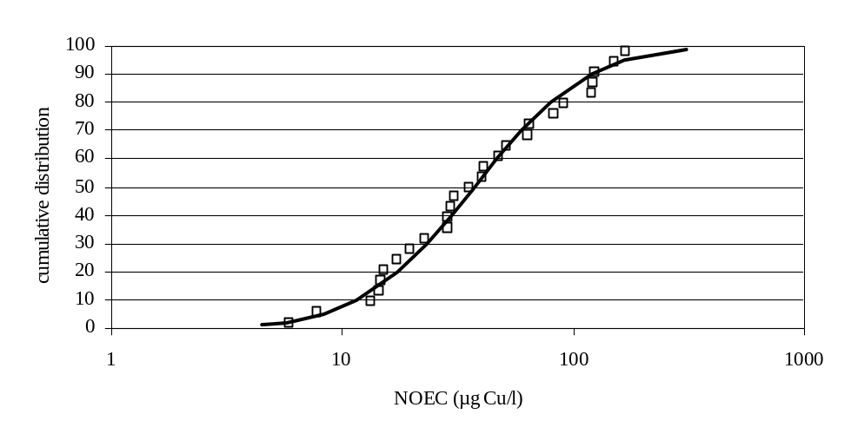
HC₅-50 = 8.2 µg/l

Figure 3-41: The cumulative frequency distributions of the normalised species mean NOEC or EC₁₀ values from the Cu toxicity tests in the dataset of freshwater organisms (scenario River Rhine in The Netherlands). Geochemical parameters for this scenario were: pH = 7.8, hardness = 217 mg/L CaCO₃, DOC = 2.8 mg/L. Observed data and log-normal distribution curve (best fitting curve) for the dataset fitted on the data.

- Mediterranean river

The species sensitivity distribution and the calculated median HC₅-50 based on the conventional log-normal and best fitting approach for the ‘Meditteranean river’ scenario is presented in Figure 3-42 and Figure 3-43.

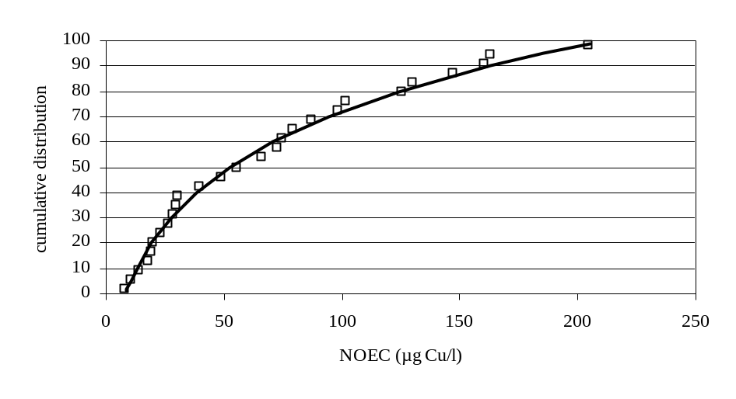
HC₅-50 = 9.3 µg/l

Figure 3-42: The cumulative frequency distributions of the normalised species mean NOEC or EC₁₀ values from the Cu toxicity tests in the dataset of freshwater organisms (scenario River Ebro in Spain). Geochemical parameters for this scenario were: pH = 8.2, hardness = 273 mg/L CaCO₃, DOC = 3.7 mg/L. Observed data and Beta distribution curve (best fitting curve) for the dataset fitted on the data.

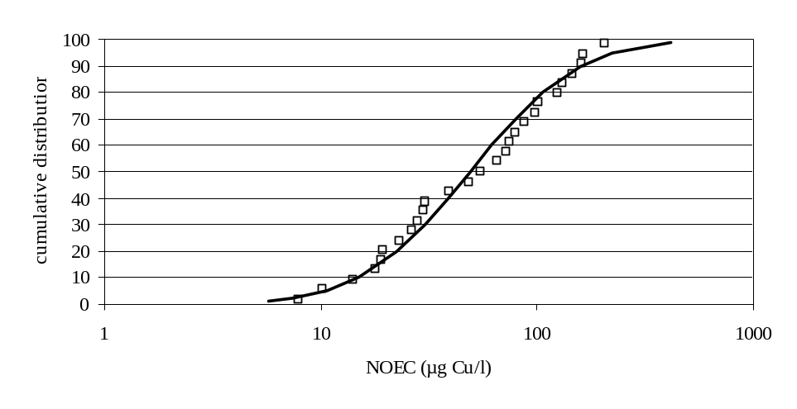
HC₅-50 = 10.6 µg/l

Figure 3-43 : The cumulative frequency distributions of the normalised species mean NOEC or EC₁₀ values from the Cu toxicity tests in the dataset of freshwater organisms (scenario River Ebro in Spain). Geochemical parameters for this scenario were: pH = 8.2, hardness = 273 mg/L CaCO₃, DOC = 3.7 mg/L. Observed data and log-normal distribution curve for the dataset fitted on the data.

Lake systems

- Oligotrophic systems (Lake Monate in Italy)
The species sensitivity distribution and the calculated median HC₅-50 based on the conventional log-normal approach (best fitting approach) for the ‘oligotrophic scenario’ is presented in Figure 3-44.
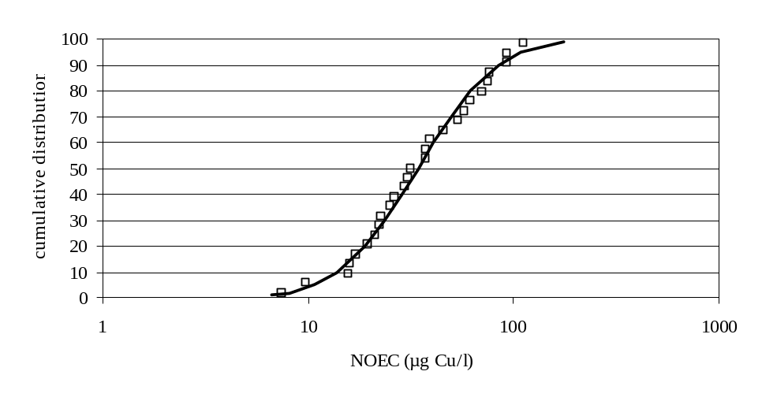
HC₅-50 = 10.6 µg/l

Figure 3-44 : The cumulative frequency distributions of the normalised species mean NOEC or EC₁₀ values from the Cu toxicity tests in the dataset of freshwater organisms (scenario Lake Monate in Italy). Geochemical parameters for this scenario were: pH = 7.87; hardness = 48.3 mg/L CaCO₃, DOC = 2.5 mg/L. Observed data and log-normal distribution curve (best fitting curve) for the dataset fitted on the data.

- Acidic system in Sweden

The species sensitivity distribution and the calculated median HC₅-50 based on the conventional log-normal and best fitting approaches for the ‘Swedish acidic lake’ is presented in Figure 3-45 and Figure 3-46.

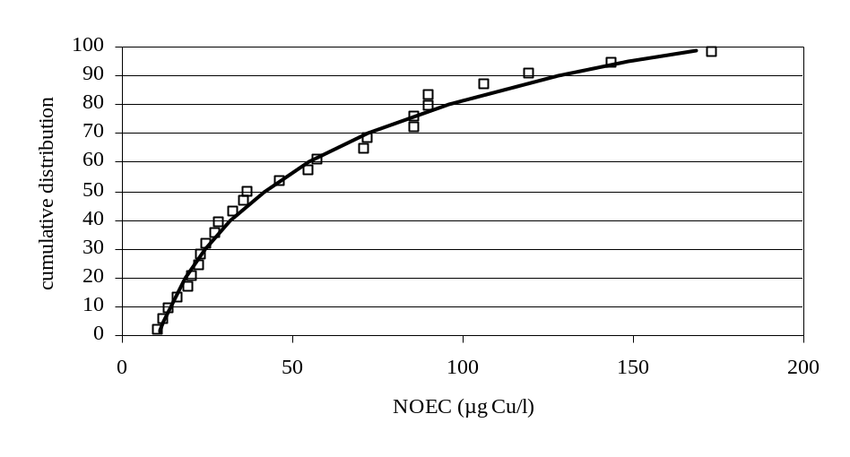
HC₅-50 = 11.5 µg/l

Figure 3-45 : The cumulative frequency distributions of the normalised species mean NOEC or EC₁₀ values from the Cu toxicity tests in the dataset of freshwater organisms (scenario Swedish acidic lake). Geochemical parameters for this scenario were: pH = 6.7; hardness = 27.8 mg/L CaCO₃, DOC = 3.8 mg/L. Observed data and Beta distribution curve for the dataset fitted on the data.

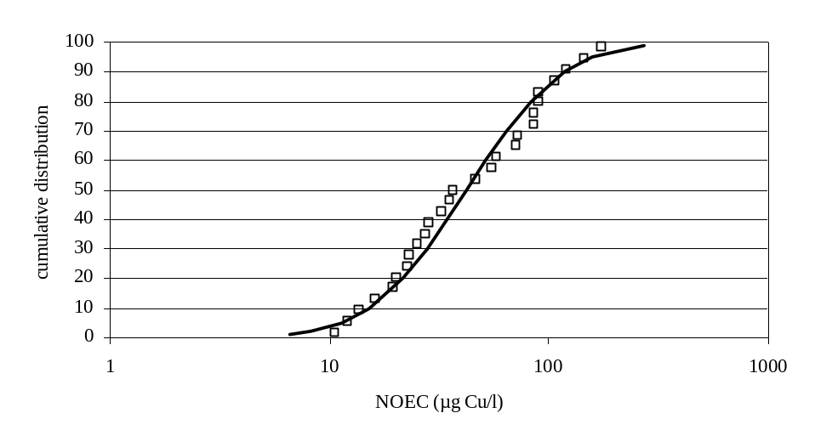
HC₅-50 = 11.1 µg/l
Figure 3-46 : The cumulative frequency distributions of the normalised species mean NOEC or EC₁₀ values from the Cu toxicity tests in the dataset of freshwater organisms (scenario Swedish acidic lake). Geochemical parameters for this scenario were: pH = 6.7; hardness = 27.8 mg/L CaCO₃, DOC = 3.8 mg/L. Observed data and log-normal distribution curve for the dataset fitted on the data.

Summary
The main physico-chemical variable mitigating chronic Cu toxicity in surface waters, i.e. DOC, Hardness and pH, varied between, respectively, 2.5-12 mg/l, 27.8-350 mg/l CaCO₃ and 6.7-8.2 for the different selected typical eco-regions. This results in median HC₅-50 values from log-normals SSDs for the different eco-regions varying between 7.8 and 27.2 µg/l depending on the DOC/Hardness/pH of the surface waters (Figure 3-47). A summary of the most sensitive endpoints per species obtained after normalisation with the BLM is given in Table 3-15.

Table 3-15 : Summary of the most sensitive endpoint and number of datapoints after normalisation using the BLM’s
Taxonomic group | Most sensitive endpoint per species
Algae | Pseudokirchneriella subcapitata, n=12, growth; Chlorella vulgaris, n=17, growth; Chlamydomonas reinhardtii, n=4; growth
Higher plants | Lemna minor, n=1, growth)
Rotifer | Brachionus calyciflorus, n=4, intrinsic rate of growth
Molluscs | Campeloma decisum, n=2, mortality; Juga plicifera, n=1, mortality; Villosa iris, n=1, mortality; Dreissenia polymorpha, n=2, filtration rate
Cladocerans | Ceriodaphnia dubia, n=10, reproduction; Daphnia magna, n=1, growth; Daphnia pulex, n=9, mortality
Insects | Clistoronia magnifica, n=2, reproduction/mortality; Chironomus riparius, n=1, growth; Paratanytarsus parthenogeneticus, n=2, growth/reproduction
Amphipods | Gammarus pulex, n=1, reproduction; Hyalella azteca, n=6, mortality
Fish | Ictalurus punctatus, n=2, growth/mortality; Oncorhynchus kisutch, n=2, mortality; Oncorhynchus mykiss, n=3, mortality; Salvelinus fontinalis, n=5; growth; Pimephales promelas, n=6, reproduction; Pimephales notatus, n=2, growth; Perca fluviatilis, n=1; growth; Noemacheilus barbatulus, n=1, mortality; Catostomus commersoni; n=1; growth/mortality; Esox lucius; n=1, growth/mortality

An overview of all individual normalised toxicity data for the different species for all selected scenarios is provided in Table 3-16 .

Table 3-16: Overview of the individual BLM-normalised NOEC values for the different eco-regions
Species sensitivity | Normalised NOEC (µg/l) | Species sensitivity | Normalised NOEC (µg/l) | Species sensitivity | Normalised NOEC (µg/l) | Species sensitivity | Normalised NOEC (µg/l)
Acidic lake (Sweden) |  | River Ebro |  | River Teme (UK) |  | River Otter (UK)
Brachionus calyciflorus | 10,6 | Brachionus calyciflorus | 7,9 | Brachionus calyciflorus | 13,9 | Brachionus calyciflorus | 5,3
Oncorhynchus kisutch | 12,1 | Juga plicifera | 10,3 | Juga plicifera | 18,2 | Juga plicifera | 7,0
Juga plicifera | 13,7 | Pseudokirchneriella subcapitat | 14,0 | Clistoronia magnifica | 32,1 | Clistoronia magnifica | 12,4
Ictalurus punctatus | 16,2 | Clistoronia magnifica | 17,8 | Dreissenia polymorpha | 34,0 | Campeloma decisum | 13,7
Oncorhynchus mykiss | 19,4 | Dreissenia polymorpha | 19,0 | Campeloma decisum | 35,2 | Dreissenia polymorpha | 13,8
Catostomus commersoni | 20,3 | Campeloma decisum | 19,5 | Ceriodaphnia dubia | 41,6 | Pseudokirchneriella subcapitata | 15,6
Clistoronia magnifica | 22,9 | Ceriodaphnia dubia | 23,0 | Daphnia magna | 47,9 | Ceriodaphnia dubia | 16,4
Dreissenia polymorpha | 23,0 | Daphnia magna | 26,4 | Pseudokirchneriella subcapitata | 53,9 | Daphnia magna | 18,8
Campeloma decisum | 24,9 | Chlamydomonas reinhardtii | 28,3 | Villosa iris | 55,3 | Villosa iris | 21,8
Salvelinus fontinalis | 27,3 | Chlorella vulgaris | 30,0 | Oncorhynchus kisutch | 65,0 | Gammarus pulex | 29,0
Ceriodaphnia dubia | 28,4 | Villosa iris | 30,3 | Gammarus pulex | 72,5 | Oncorhynchus kisutch | 30,3
Daphnia magna | 32,6 | Gammarus pulex | 39,5 | Ictalurus punctatus | 80,9 | Chlamydomonas reinhardtii | 30,3
Pimephales promelas | 35,5 | Lemna minor L. | 48,7 | Oncorhynchus mykiss | 91,8 | Chlorella vulgaris | 32,1
Villosa iris | 36,8 | Oncorhynchus kisutch | 55,2 | Catostomus commersoni | 94,6 | Ictalurus punctatus | 37,7
Gammarus pulex | 46,1 | Ictalurus punctatus | 65,6 | Chlamydomonas reinhardtii | 96,2 | Oncorhynchus mykiss | 42,9
Perca fluviatilis | 54,6 | Oncorhynchus mykiss | 72,4 | Chlorella vulgaris | 100,2 | Catostomus commersoni | 44,3
Pseudokirchneriella subcapitata | 57,6 | Catostomus commersoni | 74,2 | Salvelinus fontinalis | 116,5 | Lemna minor L. | 50,3
Esox lucius | 71,0 | Daphnia pulex | 79,2 | Pimephales promelas | 140,8 | Salvelinus fontinalis | 55,6
Pimephales notatus | 71,9 | Salvelinus fontinalis | 87,2 | Lemna minor L. | 144,7 | Daphnia pulex | 63,7
Daphnia pulex | 85,8 | Chironomus riparius | 98,3 | Daphnia pulex | 146,9 | Pimephales promelas | 69,1
Chlamydomonas reinhardtii | 85,9 | Pimephales promelas | 101,8 | Chironomus riparius | 183,9 | Chironomus riparius | 82,8
Noemacheilus barbatulus | 89,8 | Hyalella azteca | 125,3 | Perca fluviatilis | 191,5 | Perca fluviatilis | 96,0
Chlorella vulgaris | 90,2 | Perca fluviatilis | 129,9 | Esox lucius | 236,1 | Hyalella azteca | 115,4
Chironomus riparius | 106,5 | Paratanytarsus parthenogenetic | 146,9 | Hyalella azteca | 238,7 | Esox lucius | 124,9
Lemna minor L. | 119,3 | Esox lucius | 160,0 | Pimephales notatus | 239,1 | Pimephales notatus | 127,6
Hyalella azteca | 143,5 | Pimephales notatus | 163,0 | Paratanytarsus parthenogenetica | 282,5 | Paratanytarsus parthenogenetica | 142,3
Paratanytarsus parthenogenetica | 173,3 | Noemacheilus barbatulus | 204,8 | Noemacheilus barbatulus | 290,3 | Noemacheilus barbatulus | 167,0

Table 3-16 (continued): Overview of the individual BLM-normalised NOEC values for the different eco-regions.
Species sensitivity | Normalised NOEC (µg/l) | Species sensitivity | Normalised NOEC (µg/l) |  | Species sensitivity | Normalised NOEC (µg/l)
Ditch (Netherlands) |  | River Rhine (Netherlands) |  |  | Lake Monate (Italy)
Brachionus calyciflorus | 17,1 | Brachionus calyciflorus |  | 5,9 | Brachionus calyciflorus |  | 7,5
Juga plicifera | 22,6 | Juga plicifera |  | 7,7 | Juga plicifera |  | 9,7
Clistoronia magnifica | 40,8 | Clistoronia magnifica |  | 13,4 | Clistoronia magnifica |  | 15,9
Dreissenia polymorpha | 44,2 | Dreissenia polymorpha |  | 14,5 | Dreissenia polymorpha |  | 16,0
Campeloma decisum | 45,0 | Campeloma decisum |  | 14,7 | Campeloma decisum |  | 17,2
Ceriodaphnia dubia | 53,9 | Pseudokirchneriella subcapitata |  | 15,2 | Ceriodaphnia dubia |  | 19,6
Daphnia magna | 62,3 | Ceriodaphnia dubia |  | 17,3 | Oncorhynchus kisutch |  | 21,4
Oncorhynchus kisutch | 71,3 | Daphnia magna |  | 19,9 | Daphnia magna |  | 22,4
Villosa iris | 72,5 | Villosa iris |  | 22,8 | Pseudokirchneriella subcapitata |  | 22,5
Ictalurus punctatus | 91,6 | Oncorhynchus kisutch |  | 28,6 | Villosa iris |  | 25,2
Gammarus pulex | 96,8 | Chlamydomonas reinhardtii |  | 28,9 | Ictalurus punctatus |  | 26,4
Pseudokirchneriella subcapitata | 97,5 | Gammarus pulex |  | 29,9 | Oncorhynchus mykiss |  | 29,8
Oncorhynchus mykiss | 106,0 | Chlorella vulgaris |  | 30,5 | Catostomus commersoni |  | 30,7
Catostomus commersoni | 109,8 | Ictalurus punctatus |  | 35,4 | Gammarus pulex |  | 31,5
Salvelinus fontinalis | 139,1 | Oncorhynchus mykiss |  | 40,2 | Chlamydomonas reinhardtii |  | 37,5
Chlamydomonas reinhardtii | 167,7 | Catostomus commersoni |  | 41,4 | Salvelinus fontinalis |  | 37,6
Pimephales promelas | 172,8 | Lemna minor L. |  | 47,2 | Chlorella vulgaris |  | 39,0
Chlorella vulgaris | 175,1 | Salvelinus fontinalis |  | 51,9 | Pimephales promelas |  | 45,3
Daphnia pulex | 205,4 | Daphnia pulex |  | 63,5 | Lemna minor L. |  | 53,7
Perca fluviatilis | 245,9 | Pimephales promelas |  | 65,2 | Daphnia pulex |  | 57,6
Lemna minor L. | 246,8 | Chironomus riparius |  | 82,3 | Perca fluviatilis |  | 61,1
Chironomus riparius | 262,6 | Perca fluviatilis |  | 90,6 | Chironomus riparius |  | 70,4
Esox lucius | 315,3 | Hyalella azteca |  | 120,3 | Esox lucius |  | 75,5
Pimephales notatus | 320,2 | Esox lucius |  | 121,5 | Pimephales notatus |  | 76,5
Hyalella azteca | 359,5 | Pimephales notatus |  | 124,5 | Noemacheilus barbatulus |  | 93,3
Noemacheilus barbatulus | 403,9 | Paratanytarsus parthenogenetica |  | 152,0 | Hyalella azteca |  | 93,6
Paratanytarsus parthenogenetica | 442,0 | Noemacheilus barbatulus |  | 168,6 | Paratanytarsus parthenogenetica |  | 111,2

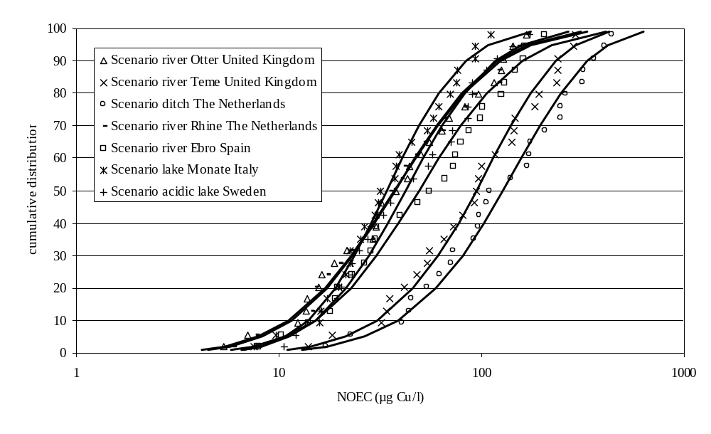
Figure 3-47 : Overview of the SSD for the different freshwater eco-regions as a function of the DOC/pH content.
Influence of frequency distribution on the HC5-50

- HC5-50 for best fitting distributions using A/D versus K/S goodness-of-fit approaches

Goodness-of-fit statistics (Go-F) were used to select the best fitting distribution among all distributions tested. The influence of the choice of the Go-F, i.e. the Anderson-Darling (A/D) versus the Kolmogorov-Smirnov (K/S) approaches, on the selected frequency distribution and estimated HC₅-50 value has been assessed for the different scenarios is summarized in Table 3-17.

Table 3-17: Summary of the HC5-50 for the best fitting distributions using the A/D and the K/S Go-F approaches

Scenario | HC₅-50 (µg/l)
Scenario | A/D | K/S
Ditch in The Netherlands | 22.1  beta | 22.1  beta
River Otter in the United Kingdom | 7.8  log-normal | 7.8  log-normal
River Teme in the United Kingdom | 17.6  beta | 17.6  beta
River Rhine in The Netherlands | 8.2  log-normal | 8.2  log-normal
River Ebro in Spain | 9.3  beta | 9.3  beta
Lake Monate in Italy | 10.6  log-normal | 10.6  log-normal
Acidic lake in Sweden | 11.5  beta | 11.5  beta

Table 3-17 shows that, as expected, the choice of the Go-F, i.e. the Anderson-Darling (A/D) versus the Kolmogorov-Smirnov (K/S) approaches, did not influences the estimated HC₅-50 value. The K/S and A/D values provide information on the goodness of fits.

- HC5 and HC5--50 for best fitting approach (using A/D) versus the conventional log-normal approach

A summary of the HC5 and HC5-50 for the best fitting (using the A/D goodness-of-fit approach) and the ‘conventional’ log-normal distributions derived for the different selected scenarios is provided in Table 3-18 .
Table 3-18: Summary of the HC5 and HC5-50 for the best fitting and log-normal distributions derived for the different selected scenarios
Scenario | HC5 and HC₅-50 (µg/l)
Scenario | Log-normal distribution | Best fitting distribution (A/D based approach)
Ditch in The Netherlands | 27.7 - 27.2  log-normal | 25.1 - 22.1  beta
River Otter in the United Kingdom | 7.9 -7.8  log-normal | 7.9 - 7.8  log-normal
River Teme in the United Kingdom | 22.3 - 21.9  log-normal | 20.0 - 17.6  beta
River Rhine in The Netherlands | 8.3 - 8.2  log-normal | 8.3 - 8.2  log-normal
River Ebro in Spain | 10.8- 10.6  log-normal | 10.4 - 9.3  beta
Lake Monate in Italy | 10.8 - 10.6  log-normal | 10.8 - 10.6  log-normal
Acidic lake in Sweden | 11.3 - 11.1  log-normal | 12.2 - 11.5  beta

Table 3-18 demonstrates that the use of the conventional log-normal frequency distribution is often the best fitting distribution to the toxicity data. In all other cases very similar HC5 and HC5-50 values are observed between the conventional log-normal and the best fitting distribution (maximum factor of difference 1.1).

- Goodness-of-fit statistics (using A/D & K/S) for the best fitting and the log-normal frequency distributions

A summary of the goodness-of-fit statistics (using A/D & K/S) for the best fitting and the log-normal frequency distributions is provided in Table 3-19. These statistics measure how good the distribution fits the data points, i.e. the lower the goodness-of-fit statistic the better the fit.

Table 3-19 : Goodness-of-fit statistics (according to Andersen-Darling (A/D) and Kolmogorov-Smirnov (K/S)) for the best fitting and log-normal frequency distributions.
 | Scenario | Goodness-of-fit statistic (A/D) |  | Goodness-of-fit statistic (K/S)
 |  | Best fitting | Log-normal | Best fitting | Log-normal
Rivers | Small ditches (The Netherlands) | 0.22 | 0.30 | 0.42 | 0.54
Rivers | Medium rivers (United Kingdom)  - River Otter  - River Teme | 0.25  0.25 | 0.25  0.30 | 0.38  0.42 | 0.38  0.47
Rivers | Large rivers (Germany) – River Rhine | 0.25 | 0.25 | 0.46 | 0.46
 | Mediterranean river (Spain) – River Ebro | 0.18 | 0.40 | 0.41 | 0.60
Lakes | Oligotrophic systems (Italy) – Lake Monate | 0.22 | 0.22 | 0.40 | 0.40
Lakes | Acidic system (Sweden) | 0.26 | 0.39 | 0.46 | 0.61

Estimation of the 50th , 5th and 95th % confidence limit on the HC₅.

According to the TGD (2003) the PNEC should be derived from the HC₅ at 50th % conficence limit (µg/l) and considering the application of an additional assessment factor. Table 3-20 provides a summary of the HC5-50 (i.e at 50th % confidence limit together with 5th and 95th confidence limits) derived from the best fitting distribution selected according to the A/D goodness-of-fit statistics.
Table 3-20: HC5-50 (i.e. at 50th % confidence limit together with 5th and 95th confidence limits) derived from the best fitting distribution and log normal distribuiotn.. All values in µg/l..
Scenario | HC5-50 (µg/l) using the best fitting distribution | HC5-50 (µg/l) using the log normal distribution
Ditch in The Netherlands | 22.1 (19.8-24.2)  beta | 27.2 (16.1-39.9)  log-normal
River Otter in the United Kingdom | 7.8 (4.4-11.7)  log-normal | 7.8 (4.4-11.7)  log-normal
River Teme in the United Kingdom | 17.6 (15.9-19.2)  beta | 21.9 (13.4-31.4)  log-normal
River Rhine in The Netherlands | 8.2 (4.7-12.1)  log-normal | 8.2 (4.7-12.1)  log-normal
River Ebro in Spain | 9.3 (8.6-10.0)  beta | 10.6 (6.1-15.8)  log-normal
Lake Monate in Italy | 10.6 (7.0-14.4)  log-normal | 10.6 (7.0-14.4)  log-normal
Acidic lake in Sweden | 11.5 (11.1-12.0)  beta | 11.1 (6.9-15.7)  log-normal

Reduction of intra-species variability
Figure 3-48 and Table 3-21 shows the original (non-normalised) and BLM normalised (to typical conditions) intra-species variability (expressed as the ratio between the highest and lowest NOEC from a specific species, i.e. max/min) thereby demonstrating the reduction in intra-species variability introduced by the BLM. The data from Dreissenia (2 datapoints) were excluded from the analysis due to uncertainty in the DOC level of the testwater.

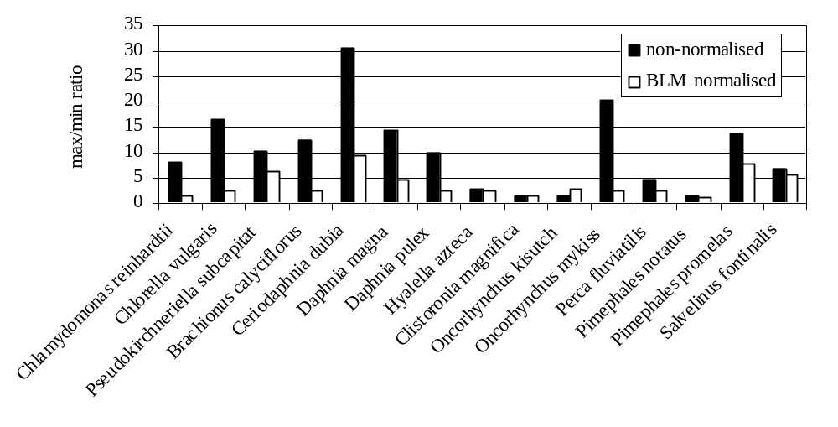

Figure 3-48 : The intra-species variability (expressed as max/min ratios) of the NOECs expressed as dissolved µg Cu/l test medium and BLM-normalised to an EU typical case freshwater environment, using the chronic bioavailability models.
The chronic BLM, developed for D. magna was applied to the other invertebrates through normalising the NOECs, gathered in the copper ecotoxicity database and characterised by varying physico-chemical test conditions, to an EU typical case pH, hardness, DOC. The data show that the chronic copper D. magna BLM drastically reduced the observed intra-species variability for all invertebrate species in the copper effects data base. The max/min ratios for the normalised invertebrate NOEC data show to be all below a factor of 9.4, while originally a considerably higher intra-species variability (up to 31 for C. dubia) was observed for the non-normalised NOEC data. Similar results were obtained with the fish species. Normalisation of the chronic fish data using the developed chronic fish BLM resulted in max/min ratios all below a factor of 8.0 while originally a considerably higher intra-species variability (up to 21 for O. mykiss) was observed for the non-normalised NOEC data. On average, the BLM-normalisation resulted in an average reduction in intra-species variability (expressed as max/min ratios) of 61% for the invertebrates C. dubia, H. azteca, B. calyciflorus, D. magna, D. pulex and 45% for the fish O. mykiss, P. fluviatilis, P. promelas and S. fontanilis, all gill breathers (the data for O. kisutch were not considered here as the intraspecies variability was very low before and after normalisation). In contrast to the gill breathers (i.e. invertebrates/fish), the water/organism inter-phase of algae is the cell wall. The copper toxicity model developed for algae is explained by a (rapid) equilibrium binding of the metal to the cell wall, followed by (slow) transportation of the metal to the plasma-membrane or the cytoplasm, where the toxic effect is elicited (see chapter 2.5.2.3).
Table 3-21 demonstrates that the algae bioavailability model developed for R. subcapitata also allows to understand the variability observed in the ecotoxicity of other algae species such as C. vulgaris and C. reinhardti. On average, the BLM-normalisation resulted in an average reduction in intra-species variability (expressed as max/min ratios) of 69% for the freshwater algae.
It must be emphasized that some toxicity values from the database resulted from tests where a large pH variation was noticed (pH variation > 1 unit). The toxicity database revealed a large pH variation in toxicity data from Jop et al. (1991) on C. dubia (pH between 6.3-7.6), from Spehar & Fiandt (1985) on P. promelas (pH between 6.0-8.1) and from McKim & Benoit (1971) on S. fontanilis. The use of the average pH for BLM calculation could therefore introduce additional uncertainty in the BLM calculation and therefore in the reduction in intra-species variability. The influence of the rejection of such data on the HC₅ derivation is provided in the chapter on sensitivity analysis and the effect on reduction in the Table herebelow. A further increase in intra-species reduction is observed for the toxicity data on the fathead minnow, i.e. from 42% to 56%.
Table 3-21: Comparison of the intra-species variability (expressed as max/min ratios,) before and after BLM normalisation of the NOEC data (n= number of individual datapoints, the variability includes the variability among endpoints)
 | Non-normalised | Normalised | Variability reduction
Invertebrates  Ceriodaphnia dubia (n=14)  Daphnia magna (n=9)  Daphnia pulex (n=9)  Hyalella azteca (n=5)  Brachionus calyciflorus (n=4)  Clistoronia magnifica (n=2) | 30.5  14.4  10.0  2.7  12.6  1.5 | 9.4  4.6  2.4  2.4  2.5  1.6 | +69%  +68%  +76%  +13%  +80%  No reduction
Fish  Oncorhynchus kisutch (n=5)  Oncorhynchus mykiss (n=7)  Perca fluviatilis (n=2)  Pimephales notatus (n=3)  Pimephales promelas (n=14)  Salvelinus fontanilis (n=14) | 1.6  20.5  4.8  1.6  13.8  7.0 | 3.0  2.5  2.4  1.3  8.0 (6.0*)  5.5 | no reduction  +88%  +51%  +22%  +42% (56%*)  +21%
Algae  Chlamydomonas reinhardtii (n=4)  Chlorella vulgaris (n=17)  Pseudokircherniella subcapitata (n=12) | 8.1  16.5  10.4 | 1.4  2.5  6.2 | +82%  +84%  +40%
*: after removal of the Spehar & Fiandt (1985) data for P. promelas where a pH variation of > 1 unit was noticed

Figure 3-49 finally compares the selected high quality copper NOECs, (from Table 3-7, Table 3-8 and Table 3-9), with the NOECs predicted by the BLM at the physico-chemistry of the respective tests. The figure integrates the variability related to physico-chemistry of the test media (normalized by BLM) as well as intra and interlaboratory variability due to differences in test set-up (eg strains, exposure regimes …). The individual NOECs in the database varied with a factor of 232 and can be predicted with the BLM tool with predicted/observed ratios ranging between 0.2 to 3.3. All ratio’s are below the factor 5 set as ctriteria for observed/predicted ratio’s in the TCNES document on read across-species.
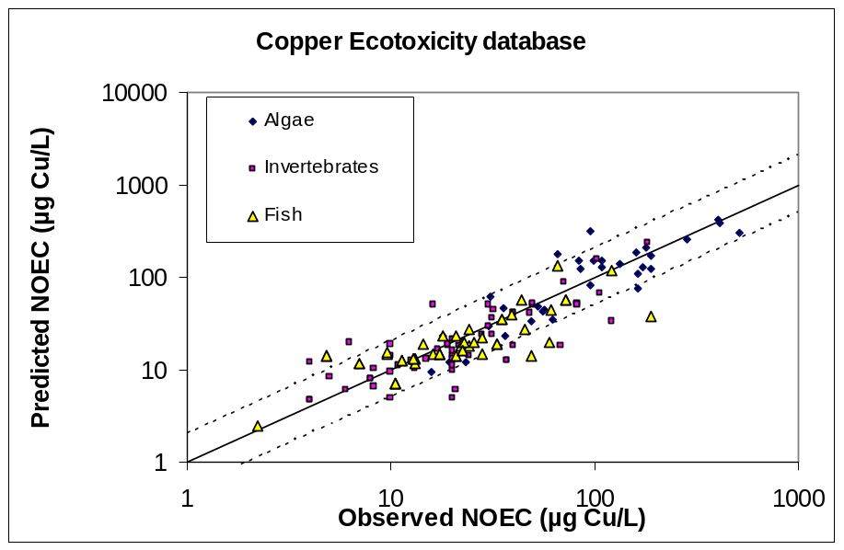
Figure 3-49 : Observed NOECs versus BLM predicted NOECs (by endpoint) at the physico-chemistry of the ecotoxicity tests. This graph includes all NOECs retained in the ecotox database.
The figures therefore demonstrate that the application of the chronic BLMs drastically reduce the uncertainty associated with the effects assessment, further demonstrating its importance for setting an ecologically more relevant PNEC.

Sensitivity analysis
- Impact of the incorporation of the Q2 datapoints on the HC5
Some Q2 ecotoxicty data were identified by the Netherlands and a sensitivity analysis on these data was requested (more details in Appendix ZB). Comparison of sensitivity with similar species was performed and the potential impact on incorporating these Q2 datapoints on the HC₅-50 was investigated (see Appendix env V). The following Q2 nominal chronic toxicity values were assessed:

* Chlorella fusca: a chronic nominal NOEC value of 8.0 µg/l was derived from Wong (1985). The test was performed in Bristol’s medium where the following characteristics were noticed: a pH: 6.8; DOC: 0.5 mg/l; Ca: 9.0 mg/l; Mg: 7.4 mg/l. This medium contains 0.06 mg/l CuSO4.5H2O, resulting in 15 µg Cu/l. The total NOEC value equals therefore 23 µg Cu/l.
* Chlorella pyrenoidesa: a chronic nominal NOEC value of 6.3 µg/l was derived from Stauber & Florence (1989). The test was performed in modified MBL medium where the following characteristics were noticed: a pH: 7.2; DOC: 0.5 mg/l; Ca: 10.0 mg/l; Mg: 6.6 mg/l. This medium contains 2.3 µg Cu/l. The total NOEC value equals therefore 8.6 µg Cu/l.
* Polypedilum nubifer: a chronic nominal NOEC value of 6.7 µg/l was derived from Hatakeyama (1988). The test was performed in underground water where the following characteristics were noticed: a pH: 7.95; DOC: 1.3 mg/l; Ca: 20.4 mg/l; Mg: 4.1 mg/l. No background Cu were reported, therefore a default background of 0.5 µg Cu/l was used in the analysis, resulting therefore in a total NOEC of 7.2 µg Cu/l.

The sensitivity analysis showed that the impact of the incorporation of the Q2 data on the HC₅-50 value was very limited. Indeed, very similar HC₅-50 were noticed for the river Otter eco-region values (7.4 and 7.8 µg/l) and for the river Teme (21.9 and 20.9 µg/l) (Figure 3-50 and Figure 3-51)

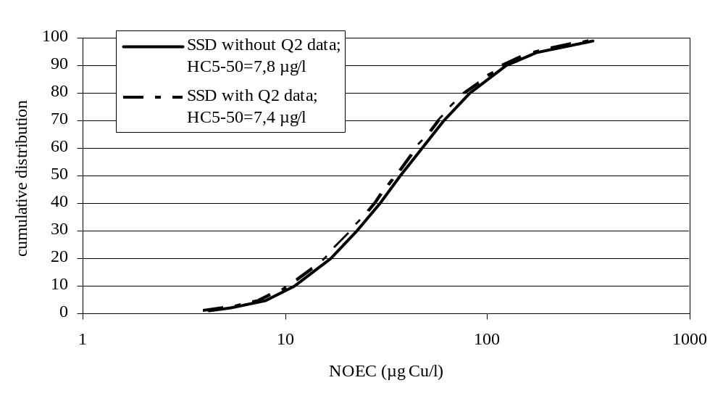

Figure 3-50: Effect of incorporation of Q2 datapoints on the HC₅-50 derivation for the river Otter.

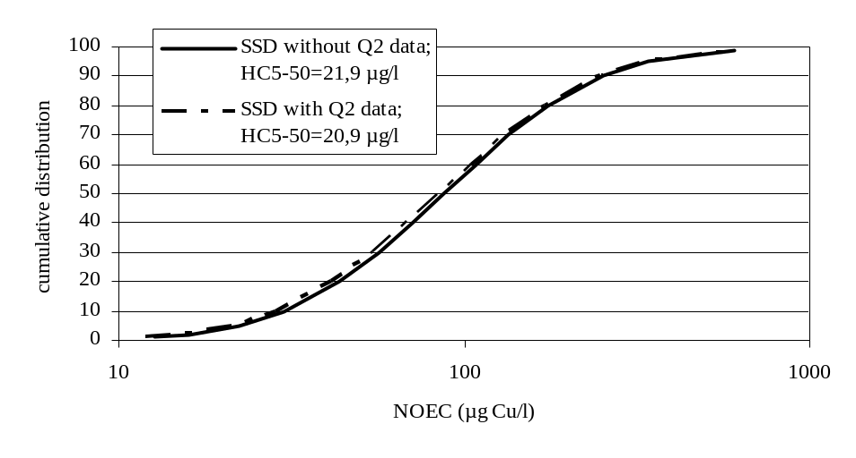

Figure 3-51 : Effect of incorporation of Q2 datapoints on the HC5-50 derivation for the river Teme.

- Impact of the incorporation of the datapoints with large pH variations on the HC5-50

The toxicity database revealed a large pH variation in toxicity data from Jop et al. (1991) on C. dubia (pH between 6.3-7.6), from Spehar & Fiandt (1985) on P. promelas (pH between 6.0-8.1) and from McKim & Benoit (1971) on S. fontanilis. The use of the average pH for BLM calculation could therefore introduce additional uncertainty in the BLM calculation and therefore in the reduction in intra-species variability. The influence of the rejection of such data on the HC5-50 derivation is shown in Figure 3-52 and Figure 3-53. The analysis, performed for the river Teme and Otter eco-regions, clearly showed that removal of the NOEC toxicity data derived from testing with large pH variation did not affect the HC5-50.

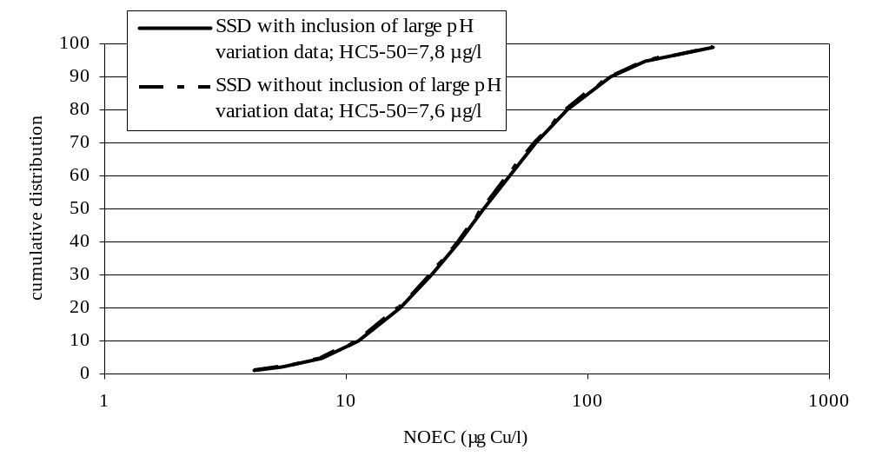

Figure 3-52 :Effect of inclusion of datapoints with high pH variation on the HC₅-50 derivation for the river Otter

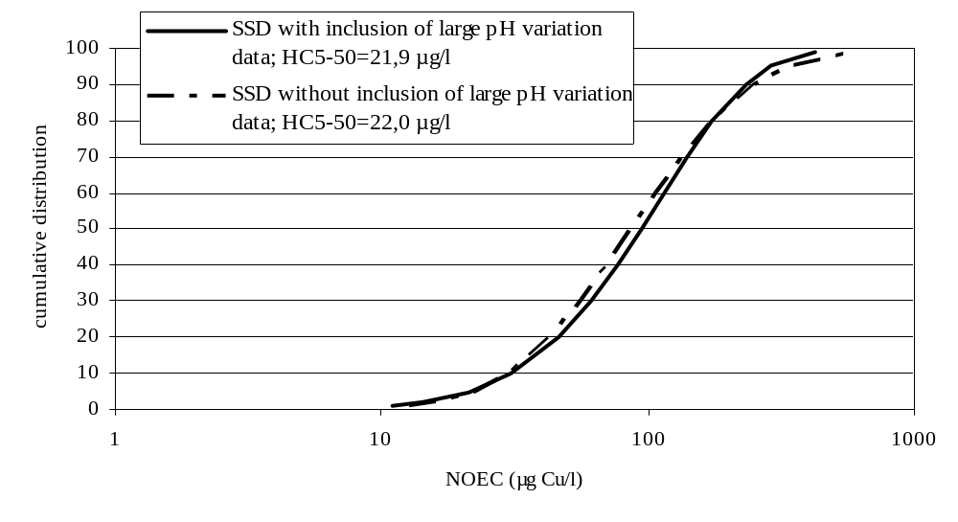
Figure 3-53 :Effect of inclusion of datapoints with high pH variation on the HC5-50 derivation for the river Teme

- Impact of removal of default DOC assumptions on the HC5-50 derivation

Normalisation of the individual NOEC datapoints suggests that reliable assumptions concerning the DOC concentrations are available. For natural waters, the DOC concentrations may however severely fluctuate among rivers or lakes. The following studies were performed in natural waters of unknown origin or in natural waters where reliable DOC estimated could not be made:
  - Jop et al., 1995: river water of unknown origin and unknown DOC concentration,
  - Belanger & Cherry, 1990: Amy Bayou river with unknown DOC concentration,
  - Van Leuwen et al., 1988: Lake Ijssel with unknown DOC concerntration,
  - Deaver & Rodgers, 1996: spring water of unknown origin and unknown DOC concentration,
  - Sauter et al., 1976: well water of unknown origin and unknown DOC concentration,
  - Solbe & Cooper, 1976: well water of unknown origin and unknown DOC concentration,
  - Seim et al., 1984: well water of unknown origin and unknown DOC concentration,
  - Horning & Neiheisel, 1979: spring water of unknown origin and unknown DOC concentration,
  - Mount & Stephan, 1969: spring water of unknown origin and unknown DOC concentration,
  - Mount, 1968: spring water of unknown origin and unknown DOC concentration,
  - Pickering et al., 1977: spring water of unknown origin and unknown DOC concentration,
  - Scudder et al., 1988: groundwater of unknown origin and unknown DOC concentration,

Exclusion of the data from the above mentioned studies resulted in very similar HC₅-50 for the scenario of the river Otter (8.1 µg/l versus 7.8 µg/l) data for the river Teme (22.3 µg/l versus 21.9 µg/l), see Figure 3-54 and Figure 3-55.
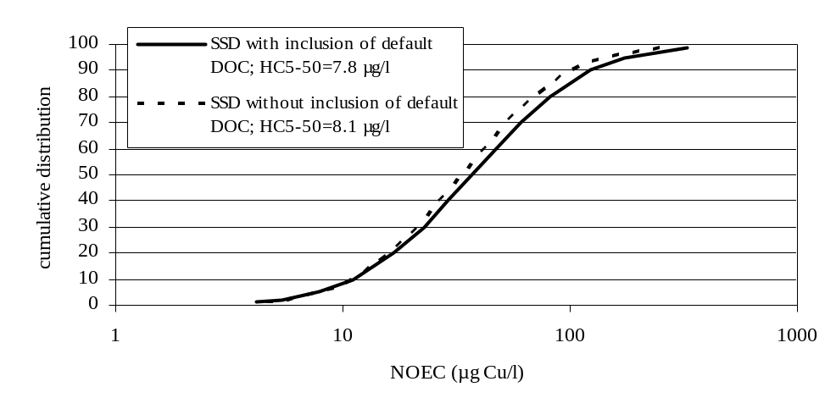
Figure 3-54 :Effect of exclusion of datapoints with default DOC assumptions for natural waters on the HC₅-50 derivation for the river Otter
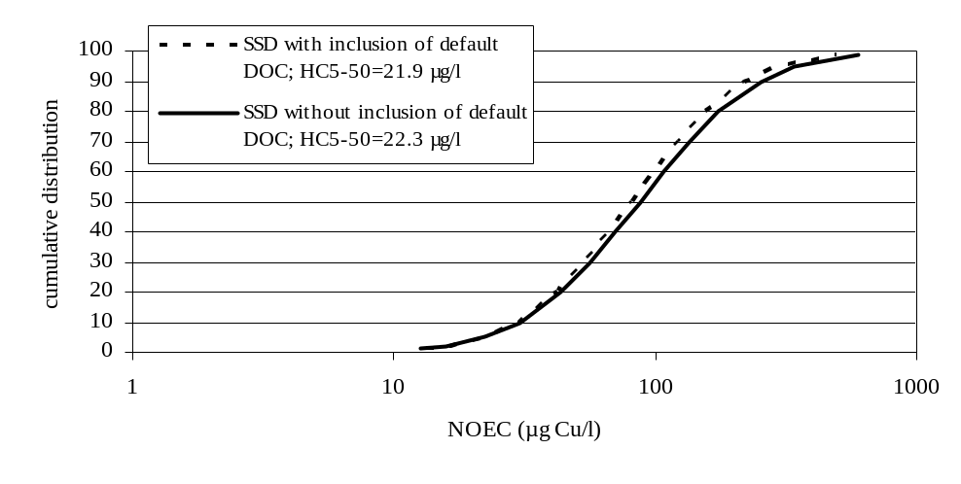
Figure 3-55 :Effect of exclusion of datapoints with default DOC assumptions for natural waters on the HC₅-50 derivation for the river Teme

- Impact of the introduction of more conservative DOC assumptions on the HC5-50 derivation

Normalisation of the toxicity data using the BLM’s suggests that reliable assumptions exists on the DOC content of the test media. In case no reliable DOC assumptions could be made, default values from Santore et al. (2002) were used. For artificial/reconstituted media an assumption of 0.5 mg/l DOC was proposed and for well waters a DOC concentration of 1.3 mg/l DOC. However from the Nickel risk assessment other assumptions, based on measured data, were proposed for reconstituted waters, i.e. 0.3 mg/l DOC, and for the well water from the studies performed by Nebeker et al. (1984), i.e. 1.1 mg/l.

Moreover, for natural waters where the TOC concentrations only were reported, a DOC/TOC ratio of 0.8 was assumed. The impact of assuming a lower and higher DOC/TOC ratio of 0.5 and 1 mg/L on the HC5-50 was also investigated.

Incorporation of such DOC estimates (0.3 mg/l for artificial/reconstituted waters; 1.1 mg/l for well waters from the study of Nebeker et al. (1984); DOC/TOC ratio of 1 for natural waters) resulted in similar to higher HC5-50 for both investigated scenarios: (1) the river Otter (8.8 µg/l and 7.7 µg/l versus 7.8 µg/l) and (2) the river Teme (24.8 µg/l and 21.9 µg Cu/l versus 21.9 µg/l), see Figure 3-56 and Figure 3-57.

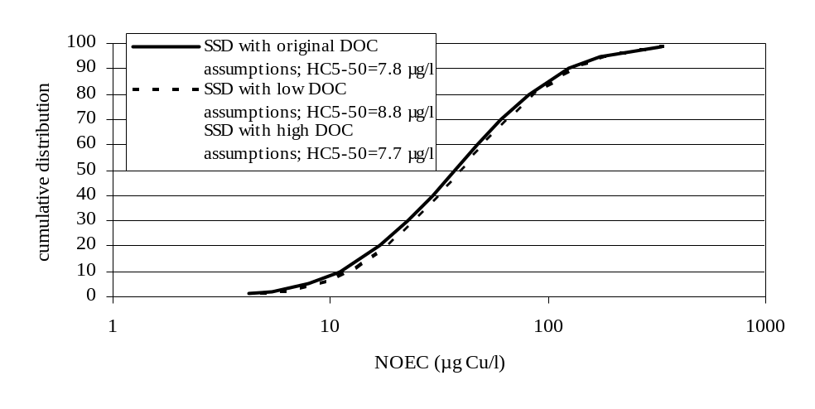

Figure 3-56 : Effect of incorporation of more conservative DOC assumptions on the HC5-50 derivation for the river Otter. Original DOC assumptions: 0.5 mg/l for reconstituted waters; DOC/TOC= 0.8; low DOC assumptions: 0.3 mg/l for reconstituted waters (cfr. University of Ghent) and 1.1 mg/l for well waters from the study of Nebeker et al. (1984); DOC/TOC= 0.5: High DOC assumptions: 1.0 mg/l for reconstituted waters (cfr. Santore et al., 2002); DOC/TOC= 1.0.

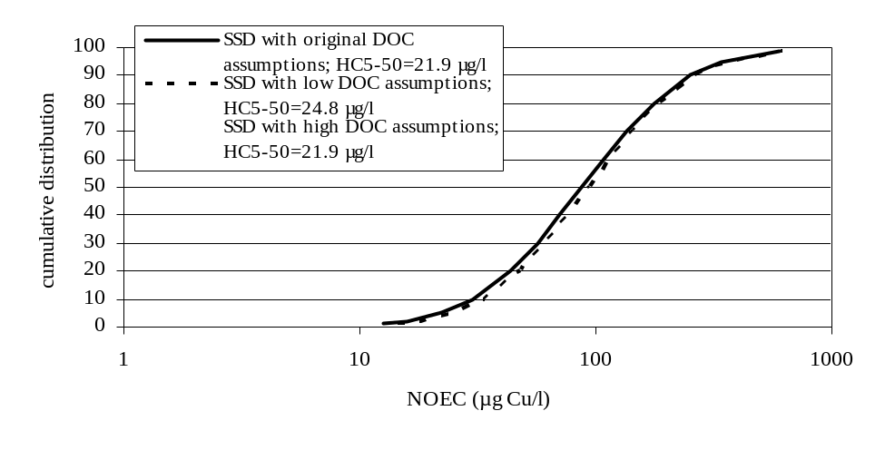
Figure 3-57 :Effect of incorporation of more conservative DOC assumptions on the HC5-50 derivation for the river Teme Original DOC assumptions: 0.5 mg/l for reconstituted waters; DOC/TOC= 0.8; low DOC assumptions: 0.3 mg/l for reconstituted waters (cfr. University of Ghent) and 1.1 mg/l for well waters from the study of Nebeker et al. (1984); DOC/TOC= 0.5: High DOC assumptions: 1.0 mg/l for reconstituted waters (cfr. Santore et al., 2002); DOC/TOC= 1.0.

- Impact of the use of the long-term NOEC for Dreissenia polymorpha (Kraak et al., 1994) on the HC5-50 derivation.

Originally the short term (2 days exposure; endpoint filtration rate) NOEC value of 16 µg/l for the bivalve Dreissenia polymorpha was used in the database. Carefull assessment of all Kraak et al. studies revealed that a long term (9-11 weeks exposure; endpoint filtration rate) NOEC of 13.0 µg/l was available for the same species. Replacement of the short term NOEC by the long term NOEC data from the above mentioned study for the bivalve D. polymorpha resulted in very similar HC₅-50 for the scenario of the river Otter (7.7 µg/l versus 7.8 µg/l) data for the river Teme (21.6 µg/l versus 21.9 µg/l), see Figure 3-58 and Figure 3-59.

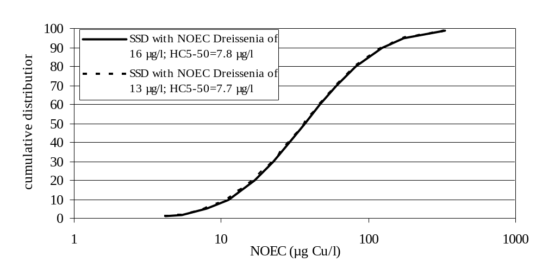

Figure 3-58 :Effect of incorporation of long term NOEC for Dreissenia polymorpha on the HC₅-50 derivation for the river Otter

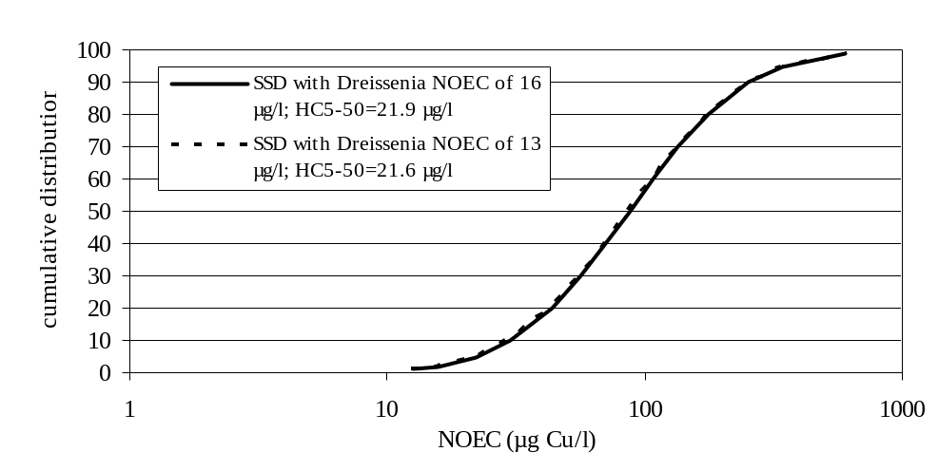
Figure 3-59 :Effect of incorporation of long term NOEC for Dreissenia polymorpha on the HC₅-50 derivation for the river Teme

- Impact of not including amphibians in the database
In view of responding to the TCNES question on the non-inclusion of amphibians, the data from US EPA Ecotox were evaluated (Table 3-22). Almost all tests gathered from literature on the effect of copper towards amphibians were performed on early life stages, in laboratory water (with low DOC concentration), with 4 days exposure times and according to standard guidelines. Most of the studies report however EC50 values and test concentrations were not measured. The results clearly show that amphibians (data were found for Xenopus laevis, Rana pipiens, Rana ridibunda, Rana hexadactyla, Rana Sphenocephala and Rana tigrina) are not sensitive towards copper. Indeed LC50 and NOEC values respectively between 39 and 1,250 µg/l and between 40 and 100,000 µg/l were found.
Table 3-22: EPA Ecotox data on amphibian
Organism | Age/size of organisms | Test substance (& purity) | Exposure time | Endpoint | LC50/NOEC  (µg/l) | Testtype | Physico-chemical  conditions | Medium | Reference
Xenopus laevis | larvae | CuSO4 (ACS grade) | 4 days | development | 100 (EC50) | renewal | 24°C; pH: 7.0-8.0 | Laboratory water | Fort & Stoves, 1996
Xenopus laevis | larvae | CuSO4 (ACS grade) | 4 days | development | 380 (EC50) | renewal | 24°C; pH: 7.0-8.0 | Laboratory water | Fort & Stoves, 1996
Xenopus laevis | larvae | CuSO4 (ACS grade) | 4 days | development | 920 (EC50) | renewal | 24°C; pH: 7.0-8.0 | Laboratory water | Fort & Stoves, 1996
Xenopus laevis | larvae | CuSO4 (ACS grade) | 4 days | development | 950 (EC50) | renewal | 24°C; pH: 7.0-8.0 | Laboratory water | Fort & Stoves, 1996
Xenopus laevis | embryos | CuSO4 (ACS grade) | 4 days | development | 740 (EC50) | renewal | 24°C; pH: 7.0-7.5; H: 102-110 mg/l | Laboratory water | Fort et al., 1996
Xenopus laevis | embryos | CuSO4 (ACS grade) | 4 days | development | 880 (EC50) | renewal | 24°C; pH: 7.0-7.5; H: 102-110 mg/l | Laboratory water | Fort et al., 1996
Xenopus laevis | larvae | CuSO4 (ACS grade) | 4 days | mortality | 1,080 (LC50) | renewal | 24°C; pH: 7.0-8.0 | Laboratory water | Fort & Stoves, 1996
Xenopus laevis | larvae | CuSO4 (ACS grade) | 4 days | mortality | 1,250 (LC50) | renewal | 24°C; pH: 7.0-8.0 | Laboratory water | Fort & Stoves, 1996
Xenopus laevis | larvae | CuSO4 (ACS grade) | 4 days | mortality | 150 (LC50) | renewal | 24°C; pH: 7.0-8.0 | Laboratory water | Fort & Stoves, 1996
Xenopus laevis | larvae | CuSO4 (ACS grade) | 4 days | mortality | 420 (LC50) | renewal | 24°C; pH: 7.0-8.0 | Laboratory water | Fort & Stoves, 1996
Xenopus laevis | embryos | CuSO4 (ACS grade) | 4 days | mortality | 890 (LC50) | renewal | 24°C; pH: 7.0-7.5; H: 102-110 mg/l | Laboratory water | Fort et al., 1996
Xenopus laevis | embryo | CuSO4 (ACS grade) | 66 stages | development | 50 (NOEC) | renewal | 24°C; pH: 7.0-8.0 | Laboratory water | Fort & Stoves, 1996
Xenopus laevis | embryo | CuSO4 (ACS grade) | 4 days | growth | 1,000 (NOEC) | renewal | 24°C; pH: 7.0-8.0 | Laboratory water | Fort & Stoves, 1996
Xenopus laevis | larvae | CuSO4 (ACS grade) | 4 days | growth | 150 (NOEC) | renewal | 24°C; pH: 7.0-8.0 | Laboratory water | Fort & Stoves, 1996
Xenopus laevis | larvae | CuSO4 (ACS grade) | 4 days | growth | 40 (NOEC) | renewal | 24°C; pH: 7.0-8.0 | Laboratory water | Fort & Stoves, 1996
Xenopus laevis | larvae | CuSO4 (ACS grade) | 4 days | mortality | 500 (NOEC) | renewal | 24°C; pH: 7.0-8.0 | Laboratory water | Fort & Stoves, 1996
Rana pipiens | tadpole | Cu (not specified) | 7 days | mortality | 67 (LC50) (0% mortality at 19 µg/l) | static | 20°C | Laboratory water | Redick & La Point, 2004
Rana pipiens | tadpole | Cu (not specified) | 7 days | growth | 71 (NOEC) | static | 20°C | Laboratory water | Redick & La Point, 2004
Rana ridibunda | adults | CuCl2 | 30 days | growth | 100,000 (NOEC) | Not reported | Not reported | Laboratory water | Papadimitriou & Loumbourdis, 2002
Rana hexadactyla | 20 mm | CuSO4 | 4 days | mortality | 39 (LC50) | renewal | 15°C; pH: 6.1; H: 20 mg/l | Laboratory water | Khangarot et al., 1985
Rana pipiens | eggs | CuSO4 | 4 days | mortality | 60 (LC50) | renewal | 22°C; pH: 7.2-7.8; H: 100 mg/l | Laboratory water | Birge & Black, 1979
Rana sphenocephala | tadpole | CuSO4 | 4 days | mortality | 230 (LC50) | static | 22°C; pH: 8.3; H: 171 mg/l | Laboratory water | Bridges et al., 2002
Rana tigrana | larvae | CuSO4 | 4 days | mortality | 389 (LC50) | static | 26.5°C; pH: 7.5; H: 240 mg/l | Laboratory water | Khangarot et al., 1981
- Uncertainty analysis on the normalized HC5-50
In accordance with the Workshop recommendation the 50% confidence level of the 5th percentile value, using the best fitting distribution function would result in a HC5-50 for the freshwater ecosystems varying between 7.8 and 27.2 µg/l.
Based on uncertainty considerations the London workshop recommended to apply an additional assessment factor on the 50% confidence value of the 5th percentile value (thus PNEC = 5th percentile value/AF), with an AF between 1 and 5, to be judged on a case by case basis. Based on the available data, the following points have to be considered when determining the size of the assessment factor:
The overall quality of the database and the end-points covered, e.g., if all the data are generated from “true” chronic studies (e.g., covering all sensitive life stages; real chronic exposure time);
- The Cu-database covered only ecological relevant endpoints. The selected endpoints were all very relevant for potential effects at population level: mortality, growth and reproduction,
- The NOEC data were extracted from tests performed in a variety of natural/artificial freshwaters, covering a considerable part of the wide range of the freshwater characteristics (background concentrations, pH value, DOC and hardness; see Appendix Env L-1) that are normally found in European freshwaters. Ranges of background concentrations, pH, DOC and hardness used in the ecotoxicological tests varied respectively between 0.45-7.0 µg/l Cu, between 5.5-9.0, between 0.1- 20.4 mg/l DOC and hardness between 7.9-486 mg/l CaCO₃. Therefore the Cu-data properly reflect the variability in physico-chemical conditions encountered in European surface waters.
- Covering of sensitive life stages and ‘chronic’ exposure times are also achieved for all trophic levels in the Cu database. For algae, exposure times up to 10 days are found covering therefore different generation times (most exposure times are 3 days). Very sensitive life stages of invertebrates are included in the database: e.g. newly born daphnids (<24 hrs old) exposed for 42 days, insect larvae exposed to Cu for 240 days. For fish very sensitive life stages are also included in the database: e.g. fry of fathead minnow exposed to Cu for 330 days, yearlings from brook trout exposed to Cu for 244 days.
- Comparison of the incipient NOEC values with the median exposure time for invertebrates and fish from the ecotoxicity database (see chapter 2.5.3) revealed that the latter values (21 days for the invertebrates and 60 days for the fish) equals or exceeds the incipient NOEC for the invertebrates (11 days) and fish (between 30 and 60 days). Therefore the compilation of chronic data from organisms exposed for a longer duration to copper would not lead to higher sensitivity of the organisms. The database seems to reflect therefore true chronic exposure.
- Based on the analysis of the maintenance of the copper concentrations during testing of copper to organisms exposed in different systems (static, renewal and flow-through), it could be concluded that the copper level is maintained through the duration of the toxicity tests. Therefore, the selected NOEC values are reliable.
- Although literature data have demonstrated that organisms adapt to copper levels (by e.g. modifying the uptake & elimination rates of copper) whereby decreased copper sensitivity of adapted organisms were observed, these have not been accounted for in the analysis. Therefore the selected NOECs are conservative.
- Through BLM normalisation of the NOEC data towards standard environmental conditions, differences in NOEC values related to differences in physico-chemistry of test media have been accounted for. This allowed the use of all data and resulted in small intra-species variabilities and meaningful species mean values.
- A total risk has been used whereby it is considered that the bioavailability of the added copper is similar to the background copper. This is a conservative approach in comparison to the added risk approach

Conclusion: From the evaluation of the data quality it can be concluded that the Cu-database is of high quality, covers full life stages and has build-in precautionary factors.

The diversity and representativeness of the taxonomic groups covered by the database;
- From the extracted data, it seems that the Cu-database does largely fulfil the requirement of 10-15 different NOEC values. Indeed, 139 individual NOEC values resulting in 27 different species NOEC values (fish, invertebrates and algae) were compiled from the database as presented in Table 3-11. In addition, the taxonomic group requirements are well fulfilled in this database. Species from the 9 different taxonomic groups are found in the Cu-database. Chronic NOEC values are available for 3 unicellular algal species (Pseudokircherniella subcapitata; Chlamydomonas reinhardtii; Chlorella vulgaris), 1 higher plant (Lemna minor), 1 rotifer species (Brachionus calyciflorus); 3 insect species (Clistoronia magnifica; Chironomus riparius; Paratanytarsus parthenogeneticus), 4 mollusc species (Juga plicifera, Campeloma decisum; Villosa iris; Dreissenia polymorpha), 5 crustacean species (Ceriodaphnia dubia; Daphnia magna; Daphnia pulex; Hyalella azteca; Gammarus pulex) and 10 fish species (Pimephales notatus; Pimephales promelas; Oncorhynchus mykiss; Oncorhynchus kisutch; Ictalurus punctatus; Perca fluviatilis; Salvelinus fontanilis; Noemacheilus barbatulus; Catostomus commersoni; Esox lucius). The database includes all the 8 taxonomic groups (families) mentioned in the taxonomic list that has been taken as a starting point (Table 3-23). The US EPA data further showed that the NOECs/EC-50s observed for amphibian (Xenopus laevis, Rana pipiens, Rana ridibunda, Rana hexadactyla, Rana Sphenocephala and Rana tigrina) are relatively high and the inclusion of these organisms will therefore not influence the HC5-50.
Table 3-23 : Minimum taxonomic groups requirements for the extrapolation method
Taxonomic groups |  | Cu-database
1) | Fish (usually tested species like salmons, bluegill, channel catfish, etc.) | OK (e.g. O. mykiss)
2) | A second family in the phylum Chordata (fish, amphibian, etc.) | OK (e.g. N. barbatulus)
3) | A crustacean (e.g. cladoceran, copepod, ostracod, isopod, amphipod, crayfish etc.) | OK (e.g. D. magna)
4) | An insect (e.g. mayfly, dragonfly, damselfly, stonefly, caddisfly, mosquito, midge, etc.) | OK (e.g. C. magnifica)
5) | A family in a phylum other than Arthropoda or Chordata (e.g. Rotifera, Annelida, Mollusca, etc.) | OK (e.g. C. decisum)
6) | A family in any order of insect or any phylum not already represented | OK (e.g. C. riparius)
7) | Algae | OK (e.g. R. subcapitata)
8) | Higher plants | OK (e.g. L. minor)

Information on the mode of action of copper exposure indicated that the key indicator of copper toxicity relates is disturbance of the sodium homeostasis. The key target tissue for copper toxicity is therefore the water/organism interfaces with cellwall and gill-like surfaces acting as target biotic ligands in all species investigated. This can explain the small observed overall inter-species variability (max/min ratio of 23) and small acute to chronic ratios (typical a factor of 1 to 3). Grosell et al (2002a) provided a physiological explanation for the observed inter-species variability in faunal LC50 values. Grosell et al (2002a) observed an inverse relation between Na⁺ influx and body mass and described the relationship by a power function, (the so-call allometric power function, typically used for describing oxygen and energy consumptions of a wide range of organisms as a function of body mass). The authors further related the fish/ invertebrate 96hr LC50 values (two to three orders of magnitude difference) to sodium uptake rates and subsequently to body mass. From this analysis, it was concluded that small fish/invertebrates are expected to have the highest copper sensitivity. The invertebrate/fish NOEC values retained in this copper RAR database are dominated by early life stages (84 %) and juvenile life stages (11%). Therefore, in contradiction to the acute tests, for which body mass and toxicity data differ by two to three orders of magnitude, the retained chronic NOECs values/body masses are much more homogeneous. It is further worthwhile noting that,within metazoan invertebrates, rotifers are recognized as the smallest. Considering that rotifers as well as early life stages of fish/invertebrates are included in the database, it can be concluded that the database does cover sensitive life stages and sensitive taxonomic groups.
Conclusion: Based on the taxonomic groups requirements, the small inter-species variability and the mode of action, it can be concluded that the HC5 derived will be protective for the variety of organisms occurring in natural environments.

Statistical uncertainties around the 5th percentile estimate, e.g., reflected in the goodness-of-fit or the size of confidence interval around the 5th percentile;
- The small statistical uncertainty related to the derivation of species mean value has been drastically reduced by BLM normalisation of the NOEC values.
- The probability distribution of the Cu dataset used for the calculations of the 5th percentile values has been checked with the Anderson-Darling goodness-of-fit test. This goodness-of-fit test highlights differences between the tail of the distribution (lower tail is the region of interest) and the input data. Based on this analysis, a best fit of the data was achieved with the log-normal or beta distribution function depending on the eco-region considered. The HC5-50 values derived from the best fitting distribution and log normal fitting of species-specific geometric mean NOECs are similar. These HC5-50, derived from species mean values are also similar to the HC5-50 values derived from the individual NOECs, thereby further demonstrating the robustness of the derived SSDs and HC5-50 values (Table 3-24).

Table 3-24 Copper HC₅-50 values (i.e. at 50th % confidence limit together with 5th and 95th confidence limits) derived from the best fitting distribution of geometric mean NOECs (n=27), the log normal distribution of geometric mean NOECs (n=27) and the log normal distribution of individual NOEC. All values in µg/l.

Scenario | HC₅-50 (µg/l) using  Geomean NOECS and  Best fitting distribution | HC₅-50 (µg/l) using  Geomean NOECS and  log-normal distribution | HC₅-50 (µg/l) using  all individual NOECS and  log-normal distribution
Ditch in The Netherlands | 22.1 (19.8-24.2)  beta | 27.2 (16.1-39.9)  (n= 27) | 30.7 (25.7-35.8)  (n= 139)
River Otter in the United Kingdom | 7.8 (4.4-11.7)  log-normal | 7.8 (4.4-11.7)  (n= 27) | 12.1 (10-14.1)  (n=139)
River Teme in the United Kingdom | 17.6 (15.9-19.2)  beta | 21.9 (13.4-31.4)  (n= 27) | 23.3 (19.7-27)  (n=139)
River Rhine in The Netherlands | 8.2 (4.7-12.1)  log-normal | 8.2 (4.7-12.1)  (n= 27) | 8.4 (7.0-9.8)  (n=139)
River Ebro in Spain | 9.3 (8.6-10.0)  beta | 10.6 (6.1-15.8)  (n= 27) | 9.4 (7.7-11.2)  (n=139)
Lake Monate in Italy | 10.6 (7.0-14.4)  log-normal | 10.6 (7.0-14.4)  (n= 27) | 10.7 (9.3-12.1)  (n=139)
Acidic lake in Sweden | 11.5 (11.1-12.0)  beta | 11.1 (6.9-15.7)  (n= 27) | 11.6 (9.8-13.4)  (n=139)

The relatively small difference between the HC5, the 50% confidence limit (HC5-50) and the the one-sided 95% left confidence limit (HC5-5), together with the goodness-of-fit statistics reported showed that the statistical uncertainties around the 5th % are minimized.
The difference between the HC5 and its 50 % confidence limit (HC5-50), calculated for the different EU scenarios varies only between a factor of 1.01 and 1.14 (Table 3-25).
As suggested by the TGD, consideration of different levels of confidence, comparing the HC5-50 and the HC5-5, have also been made. These indicate that the factor between the two is 1 to 1.8 for SSDs based on the species specific geomean values. The average ratio was 1.3 for the best fitting distribution and 1.65 for the log normal distribution.
The comparison HC5-50 versus HC5-5 was also performed using the individual NOECs instead of the species mean NOEC values (log-normal distribution). The HC5-50 values are similar to the HC5-50 values derived from species mean NOECS (Table 3-24 and Table 3-26). A constistent HC5-50/HC5-5 ratio of 1.2 is observed across all scenario’s for the log-normal distribution, based on all 139 indicidual NOEC values. The low confidence intervals are related to the high data richness (139 NOECS) and low intra and interspecies variability of the individual NOECs.
Table 3-25: Evaluation of the uncertainty around the HC5 derived for a range of typical EU scenario’s. Comparison between the HC5 and its 50 % confidence limit.
Scenario | Ratio HC5/HC5-50
 | log normal geomean NOECS | best fit  geomean NOECS
Ditch in The Netherlands | 1.02 | 1.14
River Otter in the United Kingdom | 1.01 | 1.01
River Teme in the United Kingdom | 1.02 | 1.14
River Rhine in The Netherlands | 1.01 | 1.01
River Ebro in Spain | 1.02 | 1.12
Lake Monate in Italy | 1.02 | 1.02
Acidic lake in Sweden | 1.02 | 1.06

Table 3-26: Evaluation of the uncertainty around the HC5 derived for a range of typical EU scenario’s. Comparison between the HC5 and 95th left side confidence limit (HC5-5) for the SSD calculated from the best fit of the species geometric mean NOEC values (n=27), the log normal distribution of the species geometric mean NOEC values (n=27) and the log normal distribution using all NOEC values (n=139).
Scenario | Ratio HC5-50/HC5-5
 | log normal geomean NOECS | best fit geomean NOECS | log normal individual NOECS
Ditch in The Netherlands | 1.7 | 1.1 | 1.2
River Otter in the United Kingdom | 1.8 | 1.8 | 1.2
River Teme in the United Kingdom | 1.6 | 1.1 | 1.2
River Rhine in The Netherlands | 1.7 | 1.7 | 1.2
River Ebro in Spain | 1.7 | 1.1 | 1.2
Lake Monate in Italy | 1.5 | 1.5 | 1.2
Acidic lake in Sweden | 1.6 | 1.0 | 1.2

Conclusion: The conventional approach using the log-normal and beta distribution function results in the ’best fitting’ SSD, depending on the eco-region considered. Based on the statistical uncertainty analysis, it can be concluded that the HC5 is a statistical robust determination.

Evaluation of NOEC values below the HC5-50 : The TGD recommends to further evaluate NOEC values below the HC5 and mentions that if such NOEC values are from one trophic level, then this could be an indication of a particulate sensitive group, implying that the underlying assumption for statistical extrapolation method may not be met.

Comparison of normalized HC5-50 values for the different EU scenario’s with the normalized copper NOEC values for these scenario’s, shows that, for all scenario’s, one out of the 27 species-specific NOEC values (Brachionus calyciflorus) falls under the HC5-50 derived from the SSD, derived from species-specific geometric mean values.

For some of the scenario’s, the species mean NOEC for Juga plicifera also falls under the HC5-50. The ratio between the HC5-50 and the Juga plicifera NOEC for these scenario’s is between 1.02 and 1.2, depending on, the fitting and scenario considered. The average ratio HC5-50/J.plicifera NOEC across scenario’s is: 1.07 for the “best fit” and 0.99 for the log-normal distributions. The differences are thus marginal and within the variability of the testing method.

It is important to keep in mind that as the chronic data set increase in size (N) the probability of having a value below the HC5 increases equivalently. Therefore, consideration of NOEC values below the HC₅ should not be considered in the application of an additional assessment factor in isolation without taking the total number of data points into account. Further, it is useful to mention that the difference between the species mean NOEC for Brachionus calyciflorus and the HC5-50 is also very small : the NOEC is on average a factor of 1.3 below the HC5-50 when using the best fitting distribution and a factor of 1.4 below the HC5-50 when using the log normal distribution (Table 3-27).

Table 3-27 : Comparison between the HC5-50 and the lowest NOEC value as observed for Brachionus calyciflorus
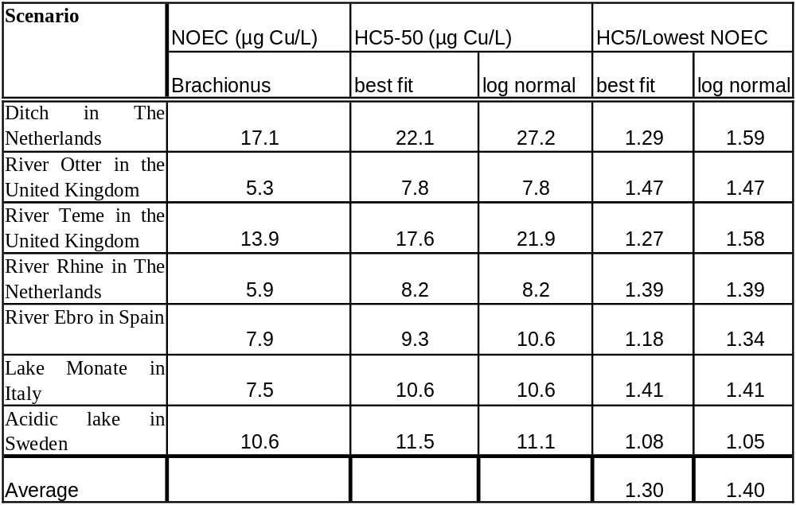

Further comparing the individual Brachionus NOECs with the HC5-50 value (Table 3-28) , shows that actually only 61 % of the Brachionus NOECS are under the HC5-50 with 39 % being above the HC5-50. This information further illustrates that the NOECs under the HC5-50 are within the variability of the testing methods.
Table 3-28: Number of Brachionus NOECs under the HC5-50 (Best fitting)
Scenario | nr of Brachionus datapoints below the best fit HC5-50
Ditch in The Netherlands | 3/4
River Otter in the United Kingdom | 1/4
River Teme in the United Kingdom | 3/4
River Rhine in The Netherlands | 4/4
River Ebro in Spain | 1/4
Lake Monate in Italy | 4/4
Acidic lake in Sweden | 1/4

Additionally, we point out that the BLM, derived for Daphnia magna was validated for Brachionus calyciflorus and bivalves, providing evidence on similar modes of actions.

Conclusions: The observed similarity in mechanism of action among invertebrates, including Brachionus calyciflorus, as well as the large ecotox database and small difference between the NOEC for Brachionus calyciflorus/J.plicifera and the SSD-HC5-50 does demonstrate the applicability of statistical extrapolation to the copper database as well as the robustness of the HC5-50.

Additional evaluations that may help in deciding if additional assessment factors should be applied are provided by the elements of conservatism already build in the effects assessment:
- No Observed Effect Concentration values (NOEC values) are used as input data for the SSD,
- Most sensitive endpoint are used for deriving the geometric species mean,
- The 50th % confidence limit on the 5th percentile of the SSD is used for the PNEC derivation
- Overestimation of toxicity values often occur for tests performed in flow through systems which may lead to an overestimation of the PNEC value. The PNEC is driven by the most sensitive species, i.e. the species with the lowest normalised NOEC values (the fish I. punctatus, O. kisutch and O. mykiss). However, overestimation of the toxicity might have occurred for these species because all tests were performed in flow through systems and an appropriate equilibration time between copper and the test medium might be lacking. This phenomena is illustrated by Erickson et al. (1987). Comparison of BLM predictions to measured LC₅₀ values (for the fathead minnow P. promelas) tested in flow through exposures tend to over-predict LC₅₀ values (). An explanation for this specific discrepant dataset has be given by the kinetics of copper complexation with DOC. In a study by Ma et al. (1999), the authors report measured cupric ion activity after mixing with DOC and found that greater than 24 h was required for equilibration. Toxicity tests performed with the daphnid C. dubia in flow through chambers seemed to be sensitive to the equilibration time of copper and DOC mixtures used in the exposure chambers. Toxicity tests with 1 h hydraulic residence time resulted in lower LC₅₀ determination than tests with longer residence time (Ma et al., 1999).

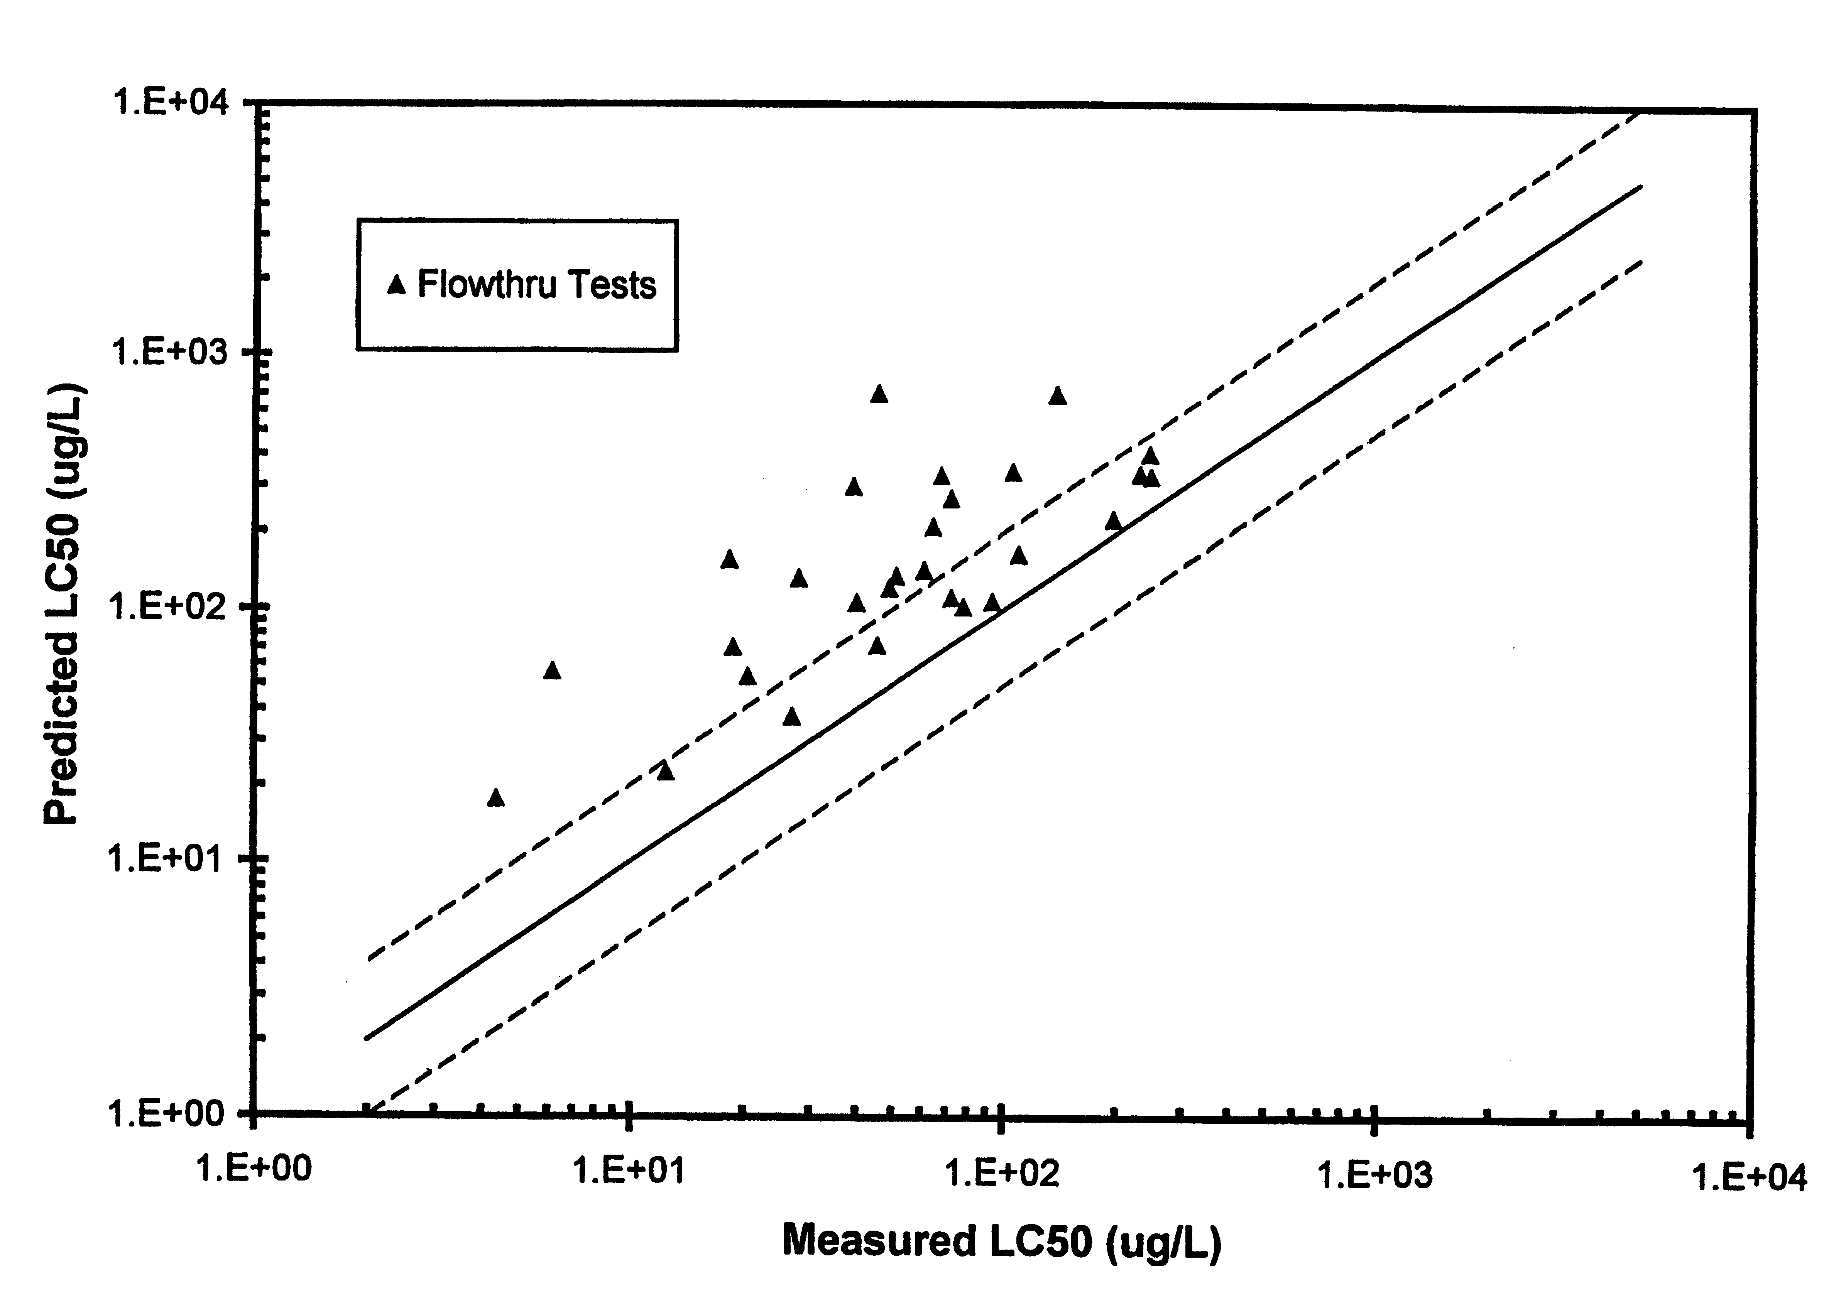

Figure 3-60 : BLM predicted versus measured LC₅₀ values for fathead minnow in flow through toxicity exposures from Erickson et al. (1987)
Conclusion : The uncertainty analysis on the HC5-50 does not suggest that there is a need for an AF on the derived HC5-50 and does indicate built-in conservative elements.
- Comparison of the HC5-50 with background and baseline levels
As recommended by CSTEE, a total risk approach was used in the copper risk assessment. This leads to different HC5-50 values depending on the eco-region considered, varying between 7.8 and 27.2 Cu/l (log normal curve) and is to be compared to copper background levels, the optimal concentration ranges and the essentiality levels.
The total dissolved HC5-50 values are above the average copper background range reported. Indeed country-specific average copper levels range between 0.3 and 2 µg Cu/L (see section 3.1.4.3.3). The ranges of natural backgrounds noted are however much larger: Zuurdeeg et al., 1992 reported dissolved copper background ranges between 0.8 – 5 µg Cu/l and the National Geological survey project FOREGS reported ranges of dissolved copper values in pristine waters between 0.1 and 14 µg Cu/L. The HC5-50 values for the eco-regions situated in the UK (HC5-50 values of 7.8 and 8.3 µg/l) are slightly above the Cu background concentrations reported by FOREGS, i.e. average of 1.4 µg/l and range between 0.2-5.9 µg/l. The HC5-50 values for the eco-regions situated in The Netherlands (i.e. 8.2 and 27.2 µg/l) are around or above the Cu background concentration reported by the FOREGS database of 3.3 µg/l (range between 0.4-14.6 µg/l). In Spain, the average Cu background concentration as reported by FOREGS is 1.0 µg/l (range between 0.1-6.2 µg/l), which is below the HC5-50 value for the selected eco-region in Spain, i.e. HC5-50=9.3 µg/l. For Sweden, a HC5-50 value of 11.5 µg/l was noted, again above the average Cu-background concentration of 0.7 µg/l (range between 0.1-6.1 µg/l). For the selected Italian eco-region, a HC5-50 value of 10.8 µg/l was noted, above the average Cu-background concentration of 1.6 µg/l but below the maximum reported baseline value (range between 0.1-13.4 µg/l). The HC5-50 values are thus above the average but within the range of background levels encounterd in European surface waters
For the pristine waters collected in the FOREGS database, BLM calculations have been carried out for all sites with physico-chemical characteristics within the BLM boundaries (pH 5.5-8.5, Hardness >10 and <500mg CaCO₃/L). For these pristine sites, risk charcterisations were subsequently carried out, using respectively an AF of 1 and an AF of 2 on the BLM derived HC5-50 (Table 3-29). The analysis demonstrates that for the 635 analysed pristine sites, a risk ratio >1 was calculated for 2% of these sites when using an AF 1 and for 9% of the sites when using an AF 2. With an AF 2, large percentage of exceedences are observed in some countries, eg 30% in France and 20% in Italy. The application of an AF 1 reduces such high amounts of country-specific risks at pristine sites down to a maximum of < 11% for all countries with an average of 2%.
Looking at the detailed calculation for all sites for which risks are identified Table 3-30, the data show that the risks identification at the “pristine sites” are related to relative high sensitivities of some of these local pristine waters (low BLM determined HC5-50 values). With a few exceptions, the copper concentrations measured at these “pristine sites” are very low with 10th, 50th and 90th percentiles of respectively 0.6, 1 and 2.5 µg Cu/L. The analysis therefore demonstrated that the application of an AF >1 on BLM calculated HC5-50 values will lead to the inappropriate identification of risks in pristine areas characterised by copper concentrations at background levels.
Table 3-29: Risk calculations on the FOREGS database with the copper BLM. Only sites within the BLM bounderies (pH 5.5-8.5; Hardness 10-500 mg CaCO3/L )are considered
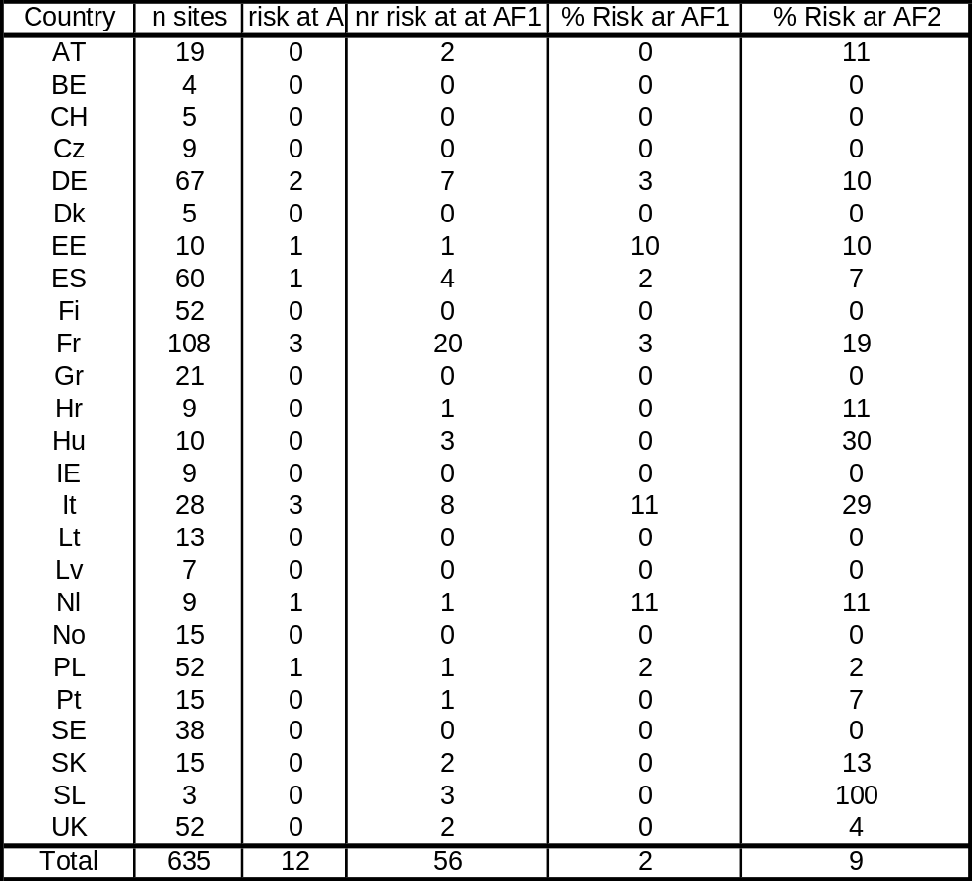

Table 3-30 : Physico-chemistry, BLM calculated HC5-50 and risk characteristaion (using anAF 1 and AF 2) for the individual sites at risk within the Foregs database. Only sites within the BLM bounderies (pH 5.5-8.5; Hardness 10-500 mg CaCO3/L) are considered
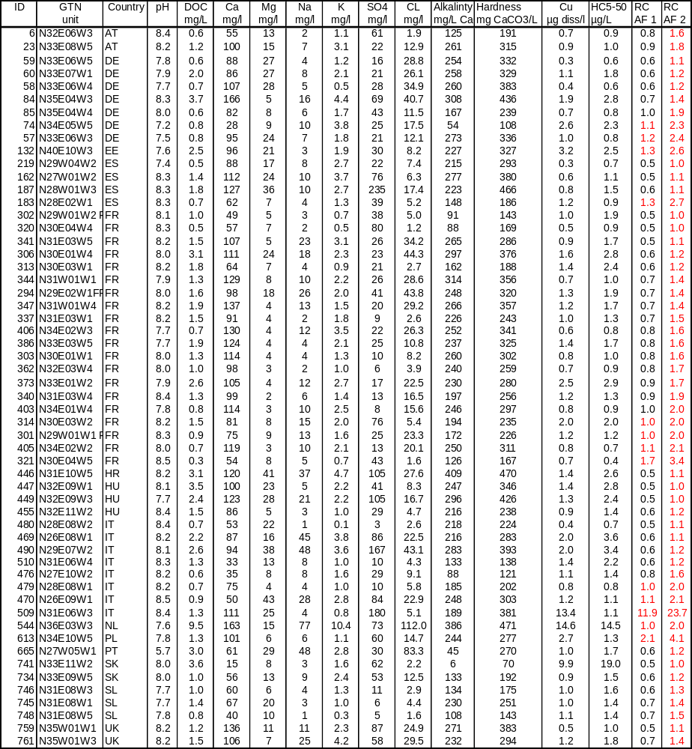
Conclusion : The HC5-50 values are above the average but within the range of background levels encounterd in European surface waters. The site specific application of the BLM at pristine sites demonstrates that the application of an AF >1 may lead to inappropriate risk identifications of pristine areas.
- Comparison between the HC5-50 and essentiality and homeostasis levels
Copper has been proven to be an essential element for many biological processes. Copper is required for the functioning of a variety of enzymes such as superoxide dismutase (a scavenger of toxic oxy-radicals), cytochrome c-oxidase (part of the electron transport system in eukaryotic organisms), several oxidases (e.g. amine oxidase, ascorbate oxidase), mono-oxygenases and di-oxygenases (Cass and Hill, 1980). Copper is also essential for haemocyanin, which is a wide-spread oxygen-carrier in molluscs and arthropods and which is the second most widely distributed pigment in the animal kingdom (Brunori et al., 1979; Cass and Hill, 1980). According to Liebig’s law of the minimum, each species has for each essential element an optimal concentration range in which it can satisfy its metabolic requirements and develop and perform in an optimal way (Hopkin, 1989). Van Assche et al. (1997) termed this range the optimal concentration range of essential elements (OCEE). The OCEE is linked with the natural concentration of the essential element in the species’ natural habitat. It is further determined by the species’ homeostatic capacity that allows it to regulate actively its metabolically required tissue concentrations and maintain optimal levels under varying external concentrations of the essential element. However, when the external concentration of the element becomes too low or too high, homeostatic regulation will not be sufficient and deficiency or toxicity can occur, respectively. Recently, studies have demonstrated the existence of an OCEE for invertebrates and algae for copper (Bossuyt and Janssen, 2003a, 2003b, 2003c). These studies have also indicated that the OCEE may shift to lower or higher concentrations upon acclimation to lower or higher concentrations. However, based on acute and chronic toxicity test data these authors only report a maximum of a factor of two to three decrease in sensitivity of D. magna and P. subcapitata in laboratory acclimation studies with these metals. A similar decrease in sensitivity by a factor of 2 was also demonstrated for O. mykiss, acclimated to increased waterborne copper levels (Taylor et al., 2004). Although the importance of this acclimation still needs to be addressed under field circumstances, acclimation effects only account for sensitivity differences up to factor two to three (within one species), whereas bioavailability has been demonstrated to account for differences well over 2 orders of magnitude within the same species (Erickson et al., 1996; Di Toro et al., 2001).
Within the ecotoxicity data base, a decreased growth of O. mykiss below 7.8 µg Cu/l and above 16 µg Cu/l indicated a copper OCEE range between 8 & 16 µg Cu /l (Seim et al, 1984).
Fort et al.,2000 further demonstrated developmental effects of copper deficiency and toxicity on Xenopus laevis. Three different copper containing diets (copper adequate diet, copper deficient diet and copper supplemented diet) were administered to adult X. laevi for 28 days. Egg production was assessed in the three groups. Larval developments were subsequently evaluated in a 4 days standard test, using varying copper concentrations. Reduced egg production as well as developmental effects were evidenced with the copper deficient diet (). Malformations related to copper deficiency included limb development as well as malformation of the eyes, brain, limbs and heart. Some of the observed copper deficiency symptioms were attributed to decreased lysil oxidase activities (a copper containing enzymze) and the resulting poor cross-linking of collagen fibers. Figure 3-62 compares mortality/malformations effects as a function of copper concentrations and demonstrates the U shaped copper dose-effects relationship. The curve indicates optimal concentrations range for copper between 1 and 10 µg /L. Interestingly, the development of larvae from parents fed copper supplemented diet did not show copper deficiency, indicating that with the copper supplemented diet the eggs had accumulated sufficient copper to sustain development.
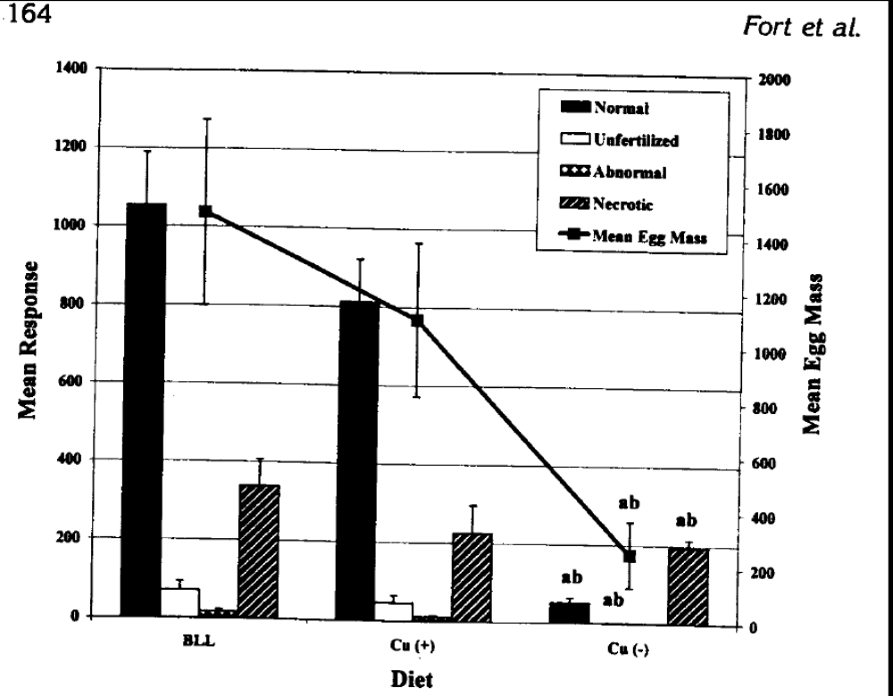

Figure 3-61: Effects of copper diet on egg development and larvae malformations of Xenopus larvae (BBL= normal diet; Cu(+)= copper supplemented diet, Cu(-)=copper defiecinet diet)
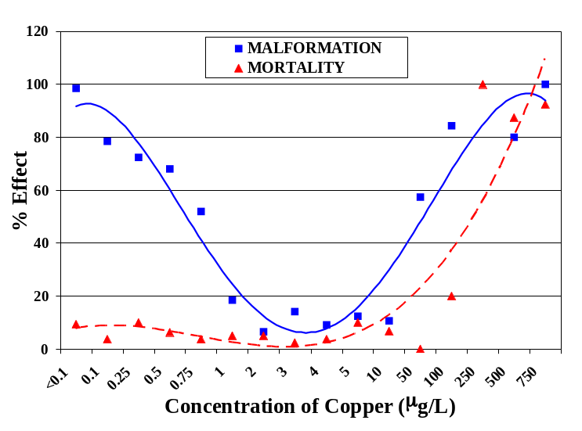

Figure 3-62: Effect of copper concentrations on 4-days development of X. laevis. Adult X. laevis were maintained on beef liver and lung diet for 28days.

Bossuyt et al, 2004 performed acclimation experiments with D. magna and showed that after three generation of acclimation, the optimal concentration ranges (from energy reserves and number of offsprings) remained constant between 1 and 35 µg Cu/L (Figure 3-63). Highest energy reserves were observed around 12 µg Cu/L. Below 1 µg Cu/L (a concentration often used as background copper concentration in the ecotoxicity media), copper defieciency was clearly observed.

Comparison between this homeostatic range with the chronic toxicity (expressed as 21 days EC₅₀ values) of copper for the same species shows a clear overlap between the OCEE and the toxicity thresholds. In other words, chronic toxicity of copper for D. magna is expected to occur within the species’ homeostatic capacity (Figure 3-64).
Such overlap could be explained because both the experiments in the toxicity and homeostatis studies were conducted in different test media, reflecting therefore different levels of bioavailability. Normalisation of both the ecotoxicity data and the homeostatic range to similar conditions (i.e. reasonable worst case EU conditions) using the chronic BLM resulted in a clear differentiation between the optimal copper levels and the toxicity levels for D. magna Figure 3-65. Deficiency and toxicity effects, normalised at the same level of bioavailability, seemed to occur when the external copper concentrations are < 1.1 µg/l and > 23 µg/l respectively.

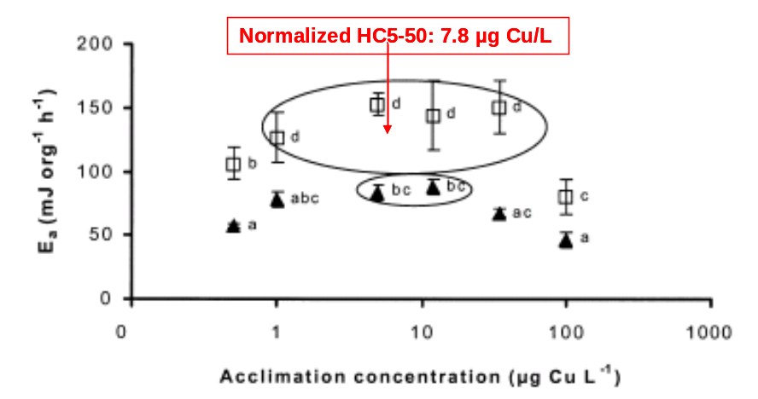

Figure 3-63 Energy reserves (Ea) of first (triangles) and 4th to 15th (squares) generation D. magna acclimated to different copper concentrations (error bars represent standard deviations. Mean levels for same letter are not significantly different at p<0.05). Ovals represent the optimal concentration range.

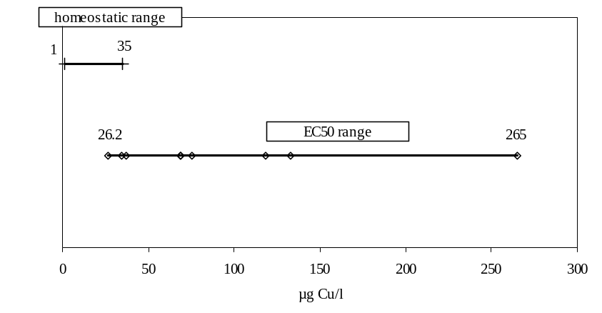
Figure 3-64 : Comparison between the chronic EC₅₀ values and the homeostatic range for D. magna
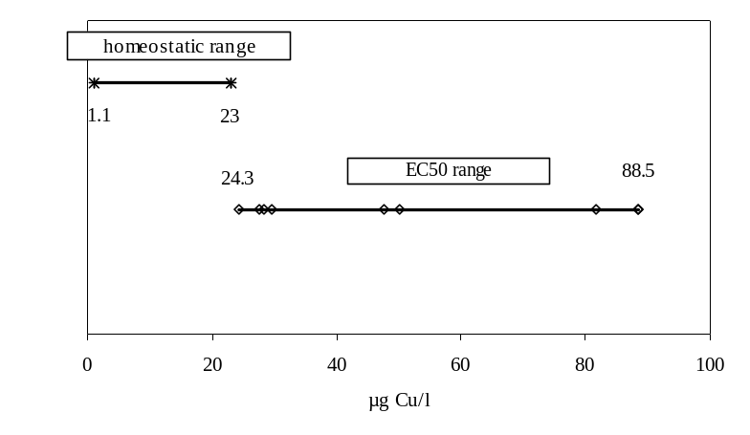
Figure 3-65 :Comparison between the BLM-normalised chronic EC50 values and the homeostatic range for D. magna
BLM normalizations of the whole SSD, towards the water used for the acclimation experiments allows to calculate an HC5-50 of 7.8 µg Cu/L, being right at the centre of optimal concentration range Figure 3-63.

Some studies have evaluated the influence of dietary versus waterborne exposure on copper homeostasis and acclimation processes. Kanmundu et al. (2001 & 2005) demonstrated the importance of dietary uptake under normal copper exposure levels, and the importance of dietary uptake for copper homeostasic regulation of gill, and gut copper uptake as well as biliary excretion. Along the same reasoning, Bossuyt et al. (2004) performed acclimation studies with D. magna and demonstrated that acclimation is more related to the total copper concentration of the culture medium, than to the copper activity. Therefore, it is likely that although copper toxicity is related to bioavailable copper species and thus to water chemistry, higher organisms (fish and invertebrates) acquire the essential copper levels mainly through the diet and as a consequence copper toxicity is driven by bioavailability while copper deficiency and copper homeostasis seems to be driven by dietary and hence total copper levels.
Conclusion : Copper is an essential element and the above analysis confirms that the BLM derived HC5-50 will protect the organisms from copper toxicity as well as copper deficiency.
- Comparison between the HC5-50 with model ecosystem and field studies
Model ecosystem toxicity data
It is important to relate the results from single-species toxicity data from laboratory tests to the results of (model) ecosystem studies and field studies. These studies allow to analyse the effects of copper to freshwater organisms under more realistic exposure conditions. In addition, these experiments allow to study ecologically more relevant endpoints compared to the single species tests because they focus on populations and communities instead of individuals. In total, 21 different papers related with the effect of copper on model ecosystems or in field studies were found in the literature. Summaries of the studies as well as tables of extracted values are given in Appendix Env L-4. As no clear quality criteria are developed for such studies, the present section will describe the available literature on model ecosystems and field studies.
The quality of each individual mesocosm study was checked against the criteria proposed by Van Leeuwen et al, (1994) and in the Draft Guidance Document on Simulated Freshwater Lentic Field Tests (2003).
- A distinct concentration-effect relationship should be obtained (QC 1);
- A reliable MS NOEC should be derived (appropriate statistics & test concentration series) (QC 2);
- Several taxonomic groups, in more or less natural ecosystems, should be exposed to one test concentration for a longer period (duration of the study should be appropriate to the life cycle of the organisms) (QC 3);
- In each experiment several concentrations should be tested, consisting of 1 control and at least 2 test concentrations for NOEC derivation and 3 test concentrations for EC_{x} derivation (QC 4);
- Each test concentration should have at least one replicate (QC 5);
- The concentration of the test compound should be measured analytically several times during the experiment (QC 6);
- Physico-chemical parameters like pH, temperature and hardness should be measured. The DOC level in the mesocosm studies is not used as a criterion for data selection. However, because of its crucial role in the bioavailability of copper, the DOC concentration in the test media should be ecologically relevant (= within the boundaries of the 10th-90th % for the EU and should be estimated in every test media). If not reported, the DOC concentrations were estimated from available water surface databases or from scientific literature. (QC 7);
- Apart from effect parameters like population density and biomass, effect parameters on higher integration levels such as species diversity and species richness should also be measured (QC 8).

An experiment was classified as reliable (Q1) if it was carried out according to all criteria. If one or several criteria were missing the experiment was classified as unreliable (R).
An overview of the quality screening exercise on the mesocosm toxicity data according to the criteria mentioned above is provided in Table 3-32. The multispecies toxicity test results are expressed as total or dissolved Cu concentrations. When available, preference is given on the use of dissolved copper concentrations. However, in case only total concentrations are provided these results can be regarded as being dissolved copper concentrations as shown by the data from Schäfers et al. (1991) – see Table 3-31
Table 3-31 Measured copper concentrations using ICP for total and dissolved copper (Schäfers et al., 2001)
Treatment – nominal concentration | Sample | Total copper (µg/l) | Dissolved copper (µg/l)
Control | 1 | 0.8 | 0.6
 | 2 | 1.8 | 2.0
 | 3 | 3.2 | 2.5
 | 4 | 1.2 | 1.2
5 µg/l | 1 | 7.0 | 5.9
 | 2 | 6.6 | 8.3
10 µg/l | 1 | 9.6 | 9.9
 | 2 | 11.1 | 10.2
20 µg/l | 1 | 21.5 | 19.5
 | 2 | 20.2 | 19.3
40 µg/l | 1 | 33.3 | 27.2
 | 2 | 28.3 | 25.2
80 µg/l | 1 | 50.8 | 37.2
 | 2 | 52.8 | 40.4
160 µg/l | 1 | 108.7 | 84.5
 | 2 | 103.0 | 74.6

Table 3-31 shows that the dissolved copper concentrations in the tests are very close to the total copper concentrations. Indeed very limited discrepancies between total and dissolved copper concentrations are observed at the NOEC (i.e. 20 µg/l) and LOEC (i.e. 40 µg/l) concentrations (mean difference between dissolved and total copper concentrations of 13% with min-max between 0-25%). Based on the aforementioned analysis it is assumed that almost all copper is present in the dissolved form in these multi-species toxicity tests. The reason(s) for accepting or rejecting a specific study is listed in Appendix Env L-5.
Table 3-32 Overview of the high quality mesocosm toxicity data (Q1)
Organism | Test system | Exposure time (d) | pH | DOC  (mg/l) | Hardness  (mg/l CaCO₃) | Endpoint | Lowest bounded NOEC (µg Cu/l) - | LOEC  (µg Cu/l)
 |  |  |  |  |  |  | Non normalised values
Phytoplankton community | Natural pond microcosm | 224 | 8.9* | 1.8 | 184 | Primary production | 3.6 (diss.); 4.0 (total) | 8.8 (diss.)  9.3 (total)
 |  |  |  |  |  | Hedtke, 1984
Benthic macro-invertebrates (oligochaetes, gastropods) | Natural pond microcosm | 224 | 8.9* | 1.8 | 184 | # individuals/ growth | 8.8 (diss.); 9.3 (total) | 25.0 (diss.); 30..0 (total)
 |  |  |  |  |  | Hedtke, 1984
Zooplankton community (crustaceans, copepods) | Natural pond enclosure | 35 | 8.2 | 8.0 in spring;  11.0 in summer | 102 | Population density | 19.7 (total) | 19.7 (total)
 |  |  |  |  |  | Moore & Winner, 1989
Benthic macro-invertebrates (mayflies, chironomids) | Natural pond enclosure | 35 | 8.2 | 8.0 in spring;  11.0 in summer | 102 | Population density | 19.7 (total) | 38.3 (total)
 |  |  |  |  |  | Moore & Winner, 1989
Zooplankton community (copepods) | Natural pond enclosure | 35 | 8.2 | 8.0 in spring;  11.0 in summer | 108 | Population density | 20.0 (total) | 20.0 (total)
 |  |  |  |  |  | Winner et al., 1990
Benthic macro-invertebrates (mayflies) | Natural pond enclosure | 35 | 8.2 | 8.0 in spring;  11.0 in summer | 108 | Population density | 20.0 (total) | 40.0 (total)
 |  |  |  |  |  | Winner et al., 1990
Phytoplankton community | Natural pond enclosure | 35 | 8.2 | 8.0 in spring;  11.0 in summer | 108 | Community richness | 20.0 (total) | 20.0 (total)
 |  |  |  |  |  | Winner & Owen (1991)
Phytoplankton community | Pond microcosm | 110 | 9.0 | 4.4 | 47 | Abundance | 20.0 (diss.) | /
 |  |  |  |  |  | Schäfers et al. (2001)
Zooplankton community | Pond microcosm | 110 | 9.0 | 4.4 | 47 | Abundance | 20.0 (diss.) | /
 |  |  |  |  |  | Schäfers et al. (2001)
Phytoplankton community; zooplankton community | Stream mesocosm using tapwater | 540 | 7.6  + 0.1  (6.5-8.8) | 1.8  + 0.7  (0.6-6.9) | Ca: 119+ 10 mg/l; Mg: 11.6 mg/l + 0.6 | Community structure | 4 (diss.) | 20 (diss.)
 |  |  |  |  |  | Roussel, 2005
*: pH estimated based on the alkalinity (180 mg/l CaCO₃) in open system..
A short description of the retained high quality mesocosm studies (Q1) is provided hereunder.
Schäfers et al.(2001) study
A detailed description of the rejected/accepted high quality mesocosm data is provided hereafter. The most recent high quality study is a microcosm study of the Fraunhofer Institute for Molecular Biology and Applied Ecology (IME, former IUCT, 2001; authors Schäfers et al., 2001). This study is conducted in accordance to an OECD draft guideline (OECD, 1996) and recommendations of the expert workshops HARAP (Campbell et al., 1999) and CLASSIC (Giddings et al., 2002) focussing on higher tier risk assessment studies for pesticides. The study represents a conservative scenario with respect to:
- poor nutrient status (oligotrophic system), low hardness and DOC values resulting in a high proportion of free copper ions compared to meso- and eutrophic ecosystems,
- high exposure and resulting direct effects due to the frequent dosing with copper to maintain constant copper levels in the water body leading to short term exceeding of the complexation capacity,
- missing (re-)colonisation and resulting recovery (microcosm are located in a green house),
- high statistical power due to reduced variability and enhanced comparability between systems,
- covered seasons comprising sensitive stages of different life history traits (r, K).

Due to the high quality of the study and the worst case character with respect to the detection of effects, the IME study was used as the ‘base line’ for the comparison with the other available studies. From the results of the IME study, it was concluded that a total copper concentration in the water of 20 µg/l is unlikely to have unacceptable ecological effects. Thus, in the sense of the European Commission (2002), 20 µg/l were suggested to represent the NOEAEC (No Observed Ecological Adverse Effect Concentration) which is a study specific endpoint while the EAC (Ecological Acceptable Concentration) is a substance specific threshold value.
For understanding the results from mesocosm studies, the bioavailability of copper is important: the main toxic agent is the free Cu²⁺ ion, which is only a fraction of the total copper in the water. Some copper is particulate, while the rest is dissolved. From the dissolved fraction, the amount of free copper depends on the complexation capacity of the water, which is driven by hardness, pH, and especially the amount of DOC. In the oligotrophic IME microcosm the complexation capacity was measured to be around 30 µg/l. This resulted in concentrations of free copper ions between 0.001 to 0.01 µg/l in the cosms treated up to 20 µg/l total copper. Thus, the suggested NOEAEC is driven by the threshold concentration, at which concentrations of free copper started to increase linearly (up to 10 µg/l at a nominal copper concentration of 160 µg/l).
For this IME microcosm, the effects of a permanent copper sulphate (CuSO₄) exposure to a lentic aquatic system were observed for a period of 110 days simulating early summer to autumn in indoor semi-realistic microcosms including phyto- and zooplankton, macrophytes, and benthic invertebrates. Sixty different taxonomic groups were assessed (Table 3-33). Nominal concentrations of 5, 10, 20, 40, 80, and 160 µg total copper/l were maintained by three treatments weekly. The measured concentrations were 9, 14, 19.4, 33, 64, respectively 122 µg/l total copper). Up to nominal/measured concentrations of 20 µg/l, more the 90% of total copper was dissolved. Because the complexation capacity was around 30 µg/l, concentrations of the free Cu²⁺ were very low.
Primary production indicated by oxygen saturation and pH showed slight and temporary effects at concentrations as low as 5 µg/l (measured concentration of 9 µg Cu/L). Considerable and permanent effects started at a nominal concentration of 40 µg/l. The same threshold level (40 µg/l) was observed for significant effects on macrophyte biomass. Phytoplankton in total showed higher densities compared to controls starting at 20 µg/l (19.4 µg Cu/l measured Cu) due to indirect effects, whereas Cryptophyta species and the green algae Ankyra tended to decrease, either due to direct (copper) or indirect effects (out-competed by small green algae).
Daphnia longispina and Phyllopoda in general were identified as the most sensitive zooplankton taxa with a NOEC of 20 µg/l. Copepoda and Rotatoria were not affected or only at the highest treatment level. No effects could be detected for macroinvertebrates (Chironomidae, Tubificidae, snails).
Species-specific geometric mean NOEC values, indicative of no negative effects on the populations (abundance) were quantified for 17 mesocosm species (Table 3-34). In addition to these 17 NOECs, several species-specific NOECs are situated at or above the highest concentration tested (160 µg Cu/L) and several species NOECS are related to increased growth/abundance with increased copper concentrations. The lowest geometric mean NOEC was observed for Rhodomonas minutes (17 µg Cu/L). Based on the 17 most sensitive geometric mean NOEC values for the mesocosm species, a SSD- HC5-50 of 19.6 µg Cu/L was derived from the log-normal distribution (ETX-RIVM tool)
With respect to water qualities and bioavailable exposure comparable to that of the microcosms tested the NOEAEC (No Observed Ecologically Acceptable Concentration) for this study was set to 20 µg/l total respectively dissolved copper. At this concentration some significant effects occurred. However, all these effects were slight and mainly temporary effects without permanent impact on ecosystem quality, neither in structure nor in function (standing crop). It is also consistent with the copper speciation measurement results indicating an increase of inorganic copper (including the biological active species) at concentrations above 20 µg/l and the HC5-50 (19.6 µg Cu/L), calculated from the most sensitive geometric mean NOEC values..
Hereunder, a brief discussion of the main results obtained from other publications in both lentic (i.e. nonflowing or standing body of fresh water such as a lake or pond) and lotic systems (i.e. flowing body of fresh water, such as a river or stream) is given.

Table 3-33: Taxonomic groups evaluated in Schaefers et al, 2001
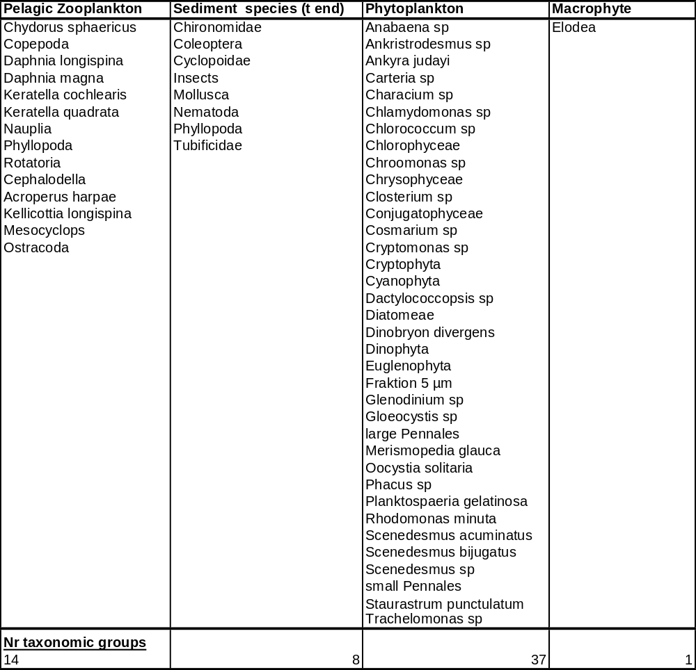
Table 3-34: Geometric mean NOEC values for the most sensitive taxonomic groups, in Schaefers et al, 2001

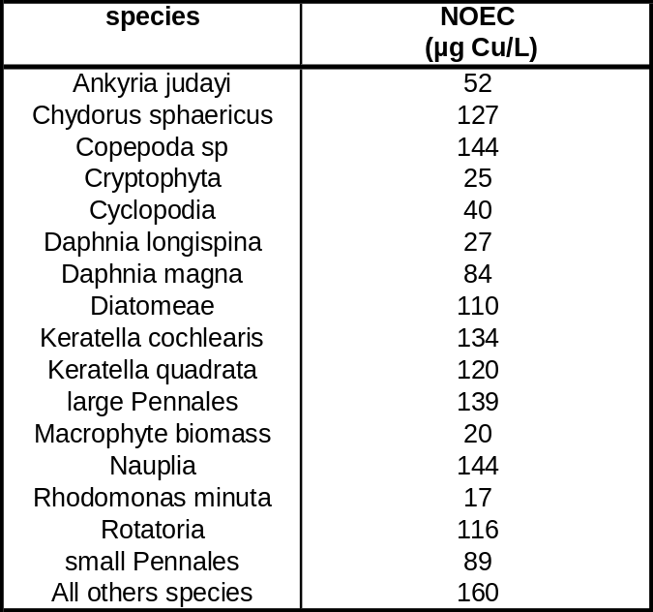
Hedtke (1984) study
The lowest NOEC of 4.0 µg/l (total copper)/ 3.6 µg/l (dissolved copper) is given by Hedke (1984) for primary producers. The lowest NOEC values for benthic macro-invertebrates were respectively 9.3 µg/l (total copper) and 8.8 µg/l (dissolved copper). The study was conducted in laboratory microcosms with a 5 cm layer of natural pond sediment (depth of the water body = 15 cm). The systems were exposed over 32 weeks exposure under flow-through conditions to nominal concentrations of 0, 10, 30, 90, 270 and 810 µg Cu/l (CuSO₄). The corresponding mean concentrations in the water were 1.4 (control), 4.0. 9.3, 30, 90, 420 µg/l total Cu. Concentration of dissolved copper were close to the total concentrations with values of 1.4 (control), 3.6, 8.8, 25, 70, and 360 µg/l Cu respectively. The water was characterised by an alkalinity of 180 mg/l and a hardness of ±200 mg/l, which is 5 to 6 times more than for the water used in the IME study. DOC values of the inflow were in the range of 0.7 to 1.8 mg C/l (average of 1.25 mg DOC/L). From the reported DOC data, and water flow, the added concentration of DOC was calculated. It was found that respectively 1.1, 0.8 and 0.3 mg DOC/l was produced during 32 weeks at 3.6, 8.8 µg and 25 Cu/l. Adding 1.1 mg/l (the DOC level observed at the NOEAC) to the 0.7-1.8 mg/l in inflow water would give a final concentration mean DOC concentration of 2.35 mg/l DOC at the end of the test. The mesocosm is therefore characterised by an average DOC level of 1.8 mg/L.
At the end of the study, 32 weeks after the starting exposition, gross primary production was significantly lower at 9.3 µg/l total Cu, respectively 8.8 µg/l dissolved Cu (reduction around 22 % compared to control, significant according Dunnett’s t-test, α=0.05). The macroalgae Vaucheria showed significantly lower abundances at 8.8 µg dissolved Cu/l after 32 weeks (reduction around 71 % compared to controls). On the first of the two observations, after 16 weeks, no effects were found at 8.8 µg dissolved Cu/l. Based on observed abundances of different taxonomic groups (including cladoceran zooplankton groups), the authors further concluded that macro-invertebrate abundance, microbial population activities and periphyton growth were less sensitive than primary producers or zooplankton species. 25 µg dissolved Cu/l was the lowest concentration for which effects were observed (eg reduced survival of snails Viviparus).
In summary, Hedke (1984) states that substantial structural effects were observed only at 25 µg dissolved Cu/l . Considering all the results, a NOEAEC of 3.6 µg Cu/L can be derived.
The 32 days species-specific geometric mean NOEC values, indicative of no negative effects on the populations (abundance) were quantified for 18 taxonomic groups of the mesocosm study (Table 3-35). These species-specific NOECs were used to construct a SSD and derive a mesocosm HC5-50 of 3.8 µg dissolved Cu/L. The derived SSD-HC5-50 of 3.8 µg Cu/L (ETX RIVM tool) is similar to the derived NOEAEC (3.6 µg Cu/L) for the mesocosm structure and functioning.

Thus, this microcosm seems to be somewhat more sensitve than the IME microcosm. The difference is likely related to the lower DOC concentrations, the flow-through conditions, and the small size of the systems. The resulting bioavailability was therefore likely higher than in regular lentic systems. Application of the quality criteria to this study revealed that the derived NOEAEC and HC5-50 values could be used in the further effects assessment.
Table 3-35: NOEC values for the most sensitive taxonomic groups in Hedtke, 1984
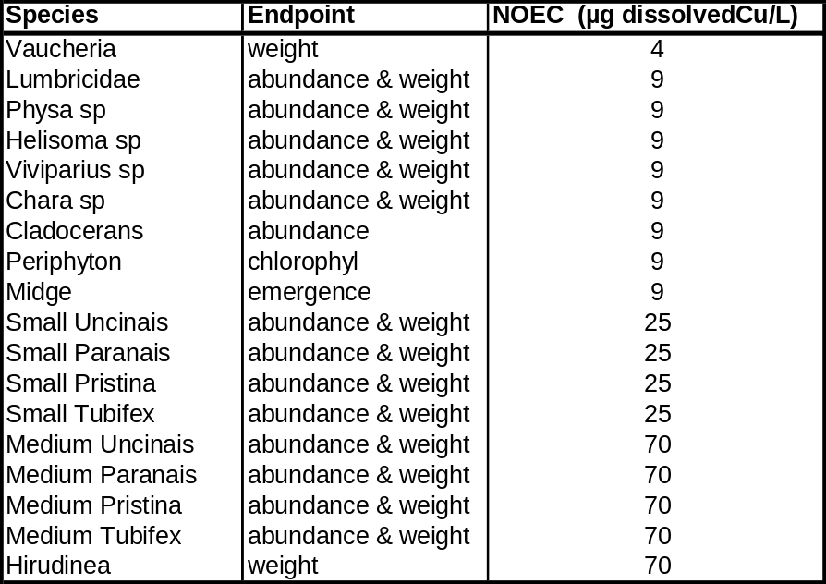

Roussel study (2005)
The PhD thesis prepared by Roussel (2005) aimed to evaluate the effects of copper on the structure and function of freshwater ecosystems. To achieve this goal, the use of experimental streams allowed to realize an ecologically realistic study while controlling many parameters (contaminant exposure, water and sediment quality, antecedent of biotic and abiotic material, etc.). During 18 months, environmentally realistic concentrations of copper (0, 5, 25 and 75 µg/L) were applied on 12 outdoor mesocosms of 20 m long (using tapwater). Each river system distinguished two regions with distinct depth profiles and sediments type. The mesocosm is characterised by large variation in physico-chemical characteristics (eg 0.6 to 6.8 mg DOC/L). Mean measured abiotic factors in the mesocosms were a pH of 7.6, Ca concentration of 119 mg/l and a DOC level of 1.8 mg/l. Community structure of phytoplankton, periphyton, macrophytes, zooplankton, macroinvertebrates, emerging insects, aquatic hyphomycètes and population dynamics of three-spined sticklebacks was monitored. The taxonomic groups assessed, include 39 genus of phytoplankton, 50 genus of periphyton, 13 taxa of macrophytes, 21 zooplankton taxa and 38 taxa of macroinvertebrates (). Copper effects on the ecosystem functioning was studied through (1) the leaf decomposition process and (2) the build up of a food web model followed by qualitative loop analyses. Results showed, in the 75 µg/L treatment, a decreased abundance of macrophytes, zooplankton, macroinvertebrates and an increased abundance of periphyton, emerging insects and fish. Taxa richness was lowered in all communities in the 75 µg/L treatment. The Principal Response Curve analyses, showed that copper at 25 and 75 µg/L altered community structure of all communities. Functioning of the leaf decomposition was altered at 75 µg/L. Aquatic hyphomycetes showed functional redundancy in their ability to degrade leaf litter. Copper direct toxic effects propagated within the trophic levels lead to indirect positive or negative effects. To help disentangling all these effects a food web model based on functional groups was build and qualitatively analyzed with loop analyses. Factors other than trophic interactions probably played an important role in structuring the ecosystem (tolerance, seasonal benefit, habitat availability, external invasion, access to more resources such as light or nutrient etc.). In conclusion, this study highlighted the interest of studying both ecosystem structure and function to identify a range of responses as symptoms of ecosystem dysfunctions. Considering all those results, a NOEAEC ecosystem was set at 5 µg/L (and 4 µg/l as dissolved).

Species-specific geometric mean NOEC values, indicative of no negative effects on the populations (abundance) were quantified for 15 mesocosm species (Table 3-37), having the highest weight in the principle response curves (PRC) developed in the sudy. Results were considered valid if the treatment effects was observed for at least two consecutive sampling dates. Many species-specific NOECs are situated at or above the highest measured concentration tested (57 µg Cu/L) and increased growth/abundance with increased copper concentrations was demonstrated for several species. Based on the 15 most sensitive geometric mean NOEC values, a SSD and HC5-50 was derived. In cases of temporal unbound NOECs, the lowest test concentration divided by either 2 or 3 did not influence the HC5-50 value and the NOEC/3 was used, resulting in a conservative value of 1.3 µg Cu/L. For the most sensitive species (Mytilina), this value was used two times. Useful to note that during the experiment, clear recovery was noted for this species with, NOECs approaching 20 µg Cu/L at the end of the esperiment. The lowest geometric mean NOECs were observed for the two rotifer group Mytilina (4 µg Cu/L) and Trichocera (5 µg Cu/L). The derived SSD-HC5-50 (ETX RIVM tool) of 5.2 µg Cu/L (with 5th and 95th confidence levels of respectively 3.1 and 7.3 µg Cu/L) is similar to the NOEAEC (4 µg Cu/L) derived for the mesocosm structure and functioning, possibly related to the large difference in test concentrations applied in the mesocosm study. The difference becomes much more evident if species mean values instead of geomean values would be taken (SSD HC5-50 around 9 µg Cu/L).

This sensitivity of the microcosm is somewhat higher than the IME microcosm. The difference is likely related to (1) the higher bioavailability of copper in the system (lower DOC concentrations, flow-through conditions), (2) the spatial non-homogeneity of the system and (3) the large ratio between tested concentrations. Application of the quality criteria to this study revealed that the derived NOEAEC and HC5-50 values could be used in the further effects assessment.

Table 3-36: Taxonomic groups evaluated in Roussel, 2002

Functional

Taxa

groups

Phytoplankton

Zygophyceae (Zygnema, Mougeotia, Spirogyra, Cosmarium, Teilingia),

Ulothricophyceae (Ulothrix, Microspora, Oedogonium, Binuclearia),

Euchlorophyceae (Oocystis, Kirchneriella, Crucigenia, Scιnιdesmus,

Ho
rmidiopsis, Dispora, Chlamydomonas), Chrysophyceae (Stephanoporos),

Cryptophyceae (Cryptomonas), Diatomophyceae (Melosira, Cyclotella, Synedra,

Fragilaria, Eunotia, Achnanthes, Cocconeis, Gyrosigma, Navicula, Gomphonema,

Amphora, Epithemia, Cymbel
la, Rhopalodia, Surirella, Nitzschia), Cyanophyceae

(Lyngbya, Oscillatoria, Pseudanabaena, Calothrix, Homeothrix)

Macrophytes

Nasturtium officinale, Callitriche platycarpa, Ranunculus aquatilis, Myriophyllum

verticillatum, Groenlendia densa, Lemna
minor, Gramineae, Berula erecta, Chara

sp., Mentha aquatica, Filamentous macroalgae, Nymphea alba, Iris Pseudacorus

Periphyton

Zygophyceae (Zygnema, Mougeotia, Spirogyra, Cosmarium, Teilingia),

Ulothricophyceae (Ulothrix, Uronema, Microspora, Oed
ogonium, Binuclearia,

Stigeoclonium), Euchlorophyceae (Oocystis, Kirchneriella, Crucigenia,

Scιnιdesmus, Hormidiopsis, Dispora, Chlamydomonas Radiococcacee,

Apatococcus), Rodophyceae (Protoderma, Audouinella, Mischococcus),

Chrysophyceae (Steph
anoporos), Dinophyceae (Gymnnodinium), Cryptophyceae

(Cryptomonas), Euglenophyceae (Euglena, Entosiphon), Diatomophyceae

(Melosira, Cyclotella, Synedra, Fragilaria, Eunotia, Achnanthes, Cocconeis,

Gyrosigma, Navicula, Gomphonema, Amphora, Epithemi
a, Cymbella, Rhopalodia,

Nitzschia), Cyanophyceae (Lyngbya, Oscillatoria, Pseudanabaena, Calothrix,

Homeothrix, Anabaena, Spirocoleus)

Decomposer

Alatospora acuminata, Claviariopsis aquatica, Tetracladium marchalianum,

microoganisms

Tetracladiu
m setigerum, Tricladium angulatum, Undetermined short filiform,

Anguillospora longissima, Articulospora tetracladia, Lemonniera aquatica,

Tripospermum myrti, Undetermined terrestrial filiform, Tricladium
chaetocladium,

Anguilospora furtiva, Tricel
lula botryosa, Tricladium gracile, Undetermined tri
-

radiate

Shredders

Gammaridae, Asellidae, Odontoceridae, Tipulidae, Stratiomydae, Phryganeidae

Grazers

Lymnaeidae, Physidae, Hydrobiidae, Bithyniidae, Ancylidae, Planorbidae,

Limnephilidae, Goe
ridae, Elmidae, Baetidae

Collectors
-

Chironomidae, Oligochaetes, Caenidae

gatherers

Zooplankton

Cyclopoids, Rotifers (Notholca, Trichotria, Trichocerca, Lecane, Lepadella,

Mytilina, Notommatidae, Scaridium, Squatillena, Colurella, Bdelloοdes,

Ascomorpha), Cladoceran (Chydorus sphaericus, Alona quadrangularis, Leydigia

acanthocercoides, Graptoleberis testudinella), Ciliate (Vorticella)

Invertebrate

Planariidae, Dendroncoelidae, Glossiphoniidae, Hirudidae, Piscicolidae,

predators

Erpobd
ellidae, Coenagrionidae, Platycnemididae, Corixidae, Naucoridae,

Notonectidae, Gerridae, Ceratopogonidae, Haliplidae, Dytiscidae

Table 3-37: Geometric mean NOEC values for the most sensitive taxonomic groups in Roussel, 2006

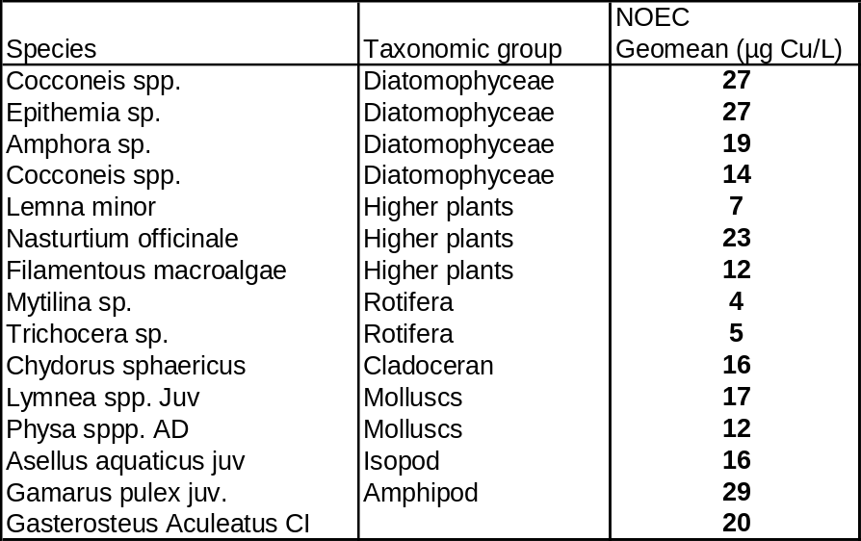

Moore & Winner (1989); Winner et al. (1990); Winner & Owen (1991) studies
Winner et al. (1990), Winner & Owen (1991) and Moore & Winner (1989) conducted two enclosure (i.e. 0.6 m diameter, 1.1 m deep in Brandenburg pond, USA) experiments for a 5 week period. Three replicate enclosures were used for each copper concentration and control, although one control and one 20µg Cu/L enclosure was lost in the 1987 experiment. Reported mean hardness concentrations was 102 mg CaCO₃/l and pH 8.2. The enclosures were dosed with copper (as CuSO₄) to achieve concentrations of 20 and 40 µg/l total copper. Total copper concentrations were monitored at 2 to 3 day intervals using AAS and were close to nominal concentrations. Before copper addition the zooplankton community was very similar among all enclosures.
Winner et al. (1990) reported significant depressing densities of total algal cells in the 20 µg/l enclosures in the spring. No effect of the copper treatment was observed in the summer (and to a less extent in the fall). By the final sampling date in the spring, densities of both calanoid and cyclopoid copepods were significantly reduced in both the 20 and 40 µg/l enclosure. In the summer experiment neither calanoids nor cyclopoids were reduced in the 20 µg/l enclosure but calanoids were reduced in the 40 µg/l enclosure. The invertebrate benthic community was dominated by larval insects and molluscs. In both the spring and summer experiments densities of the mayfly Caenis sp. were significantly reduced in the 40 µg/l enclosures. Therefore, NOEC and LOEC values were observed at similar Cu concentration (i.e. 20 µg/l) depending on the season/community investigated.
Moore & Winner (1989) (discussing the same experiment as reported in Winner et al., 1990) observed significant reductions of cyclopoids copepods (Cyclopoidea) and rotifers at the 20 µg/l treatment (i.e. 19.7 µg/l measured copper) during 5 weeks of exposure, where the maximum abundance of rotifers was reduced by a factor around 4. Crustacean and nauplii copepods densities were significantly reduced only at 40 µg/l. The benthic community was numerically dominated by chironomids and Chaoborus. At the end of the experiment small caenid mayflies and small chironomids were affected by copper. Both of their densities were significantly (p<0.05) lower at the high copper treatment than in the control. Therefore, NOEC and LOEC values were observed at similar Cu concentration (i.e. 19.7 µg/l) depending on the season/community investigated.
Winner & Owen (1991) observed that during the spring experiments that total algal densities were significantly depressed in both 20 and 40 µg/l enclosures from week 2 to 4-5 of the experiment. During the summer experiment, total algal density was never significantly reduced in both enclosures. Over the course of the experiment 82 taxa of planktonic phototrophs were identified. The results of the spring experiments indicate that a chronic exposure to 20 µg/l caused significant changes in phytoplankton community structure. In the summer experiment 3 taxa were affected by copper in both enclosures, while Peridinium was only affected at 40 µg/l. Therefore, NOEC and LOEC values were observed at similar Cu concentration (i.e. 19.7 µg/l) depending on the season/community investigated.
It is worthwhile noting that the Winner group analysed the data using simple statistics (result significantly different from controls at each time/endpoint), without the incorporation of higher level statistics such as diversity/similarity analysis and principle response curve analysis, as performed in the Schaefers and Roussel studies. These higher level statistical tests are key to mesocosm interpretations because of the natural complexity of mesocosms and the usually small statistical power of mesocosms with regards to replica’s and doses used (2 doses in2/3 replica’s in this case). The robustness of the analysis and thus final actual NOEC/LOEC value in the Winner studies is therefore much smaller.

To summarize the Winner studies, 2 studies were carried out and reported in 3 artcles. Clear NOECs (20 µg Cu/L) were derived for the summer period, however in spring only a LOEC could be determined. The authors observed temporal effects for zooplankton and phytoplankton groups in spring (not summer) and thus reported a LOEC of 20 µg Cu/L. At 20 µg Cu/L spring effects were specifically observed for rotifers (Keratella and Polyarta), Cyclopoid and Calanoid copepods. For the algae, only significant spring-‘87 effects for Cryptophyta, were confirmed from the 1989 experimental data. Cryptophyta were less abundant at both treatments in all seasons and is therefore considered as the most sensitive phytoplankton group in this study.

The Winner and co-authors (1990) further concluded that the higher zooplankton sensitivities observed in spring could not be attributed to different life stages nor availability of food and therefore, the authors concluded that the seasonal difference in sensitivity was to be attributed to changes in complexation capacity of the pond water. Information on DOC levels in 1989 showed that the lowest DOC concentration in the pond was measured in the spring season (between 7.2 and 8.7 mg/l).

It further seems worthwhile mentioning that during the Moore and Winner (1989) spring 1987 experiment, the authors observed that the rotifer populations as well as the Daphnia populations were far less abundant in the control exposures compared to the original pond. The data further showed that in the enclosures, the Daphnia densities increased in the 20 µg Cu/L enclosure and surpassed those in the control exposure. The authors explained this as follows: “These unusual results suggest to us that a chemical, deleterious to Daphnia, was present in the water of the control enclosures and that the chemical effect was ameliorated by the addition of copper”. Such conclusion was supported by the results from single species laboratory ecotoxicity tests performed with Ceriodaphnia at 4 exposure concentrations (0, 20, 40 and 60 µg Cu/L), using the control water from the spring enclosure experiment as test medium. The authors observed high mortality rates in the control, 20 and 40 µg Cu/L exposures and stopped the experiment. Repeating the same single species experiment 2 weeks later again showed increased mortality rates and decreased reproduction in the controls and lower test concentrations, compared to the higher test concentrations. Toxicity of exudates from the Uroglena population to daphnids in controls compared to 40 µg Cu/L exposures, was further reported by the authors. This may have confounded the results and therefore adds substantial doubt on the acceptability of this study for use in EU wide RAs.

Considering the “Uroglena toxicity” as confounding factor and the uncertainty in the DOC level, the acceptability of this study for use in EU wide RA is questioned. To ensure that all sensitive groups have been covered in this RAR, the most sensitive taxonomic groups of the Winner study are further addressed below.

Soldo and Behra (2000)
Soldo & Behra 2000 evaluated long term copper exposure on the community structure of periphyton & short term community tolerance to photosynthesis. The communities were exposed to copper concentrations ranging between 3 and 300 µg Cu/L using a flow-through system. The data showed significant shifts in populations with significantly less cyanophycae in the highest exposure group (300 µg Cu/L) The sensitivity of individual species ranges between 6 to 300 µg Cu/L. The data also showed significant increases in tolerance to copper in communities previously exposed to > 6 µg Cu/L. The physico-chemistry of the system was not reported but the authors reported from calculations of free metal ion concentrations that 95% was free Cu²⁺. The test set-up is therefore characterized by high levels of bioavailability, comparable to the systems described in Hedtke (1984) and Roussel (2005) and the reported threshold value (6 µg Cu/L) are comparable with the threshold values observed by Hedtke (1984) and Roussel (2005) (3.6-4 µg Cu/L)

In summary, effects on lentic/lotic mesocosm systems revealed NOEAEC values varying between 3.6 and 20.0 dissolved µg/l. The lowest NOEC value is obtained in a ‘flow through’ pond mesocosm system characterised by a low DOC concentration of 1.8 mg/l while the higher toxicity values were obtained in pond waters with substantially higher DOC levels. Recognising that variations in bioavailability and toxicity may exist across waters with differences in water quality characteristics it is highly recommended to incorporate this concept in the field/mesocosm assessment of copper. In addition, some further evaluation of the apparently most sensitive taxonomic groups of the Winner study is recommended.
Bioavailability correction of mesocosm toxicity data
The different NOEC-values that are currently retrieved in the mesocosm/field studies have been generated in test media with varying physicochemical characteristics known to alter copper bioavailability and toxicity (e.g. pH, hardness, dissolved organic matter). However the currently available BLM as described in 2.5.2.3. were developed for single species and therefore do not account for potential multispecies interactions. Moreover the single species BLMs were developed for considering conventional endpoints such as mortality or reproduction and therefore do not guarantee its use for functional endpoints (e.g. primary production). It was therefore decided to normalise all single species NOEC values towards the average abiotic conditions occurring in the different mesocosms.

Schaefers et al, 2001.
The 139 single species laboratory NOECs were normalized to the physico-chemistry of the mesocosm and a mesocosm-specific single species SSD and HC₅-50 of 9.9 µg Cu/L (with confidence limits between 5.8 – 14.6 µg/l) was calculated from the ETX RIVM tool. Figure 3-66 compares the SSD for the observed mesocosm NOECs (Schaefers, 2001) with the SSD calculated from the single species NOECs, normalized to the physico-chemistry of the Schaefers study, The figure clearly illustrates that the single species SSD is protective for this multi-species system. The predicted single-species HC₅-50 (9.9 µg Cu/L) is a factor 2 lower that the observed mesocosm HC₅-50 (19.6 µg Cu/L with confidence limits between 10.4 – 29.8 µg/l) or NOEAEC observed for the ecosystem structure and function (20 µg Cu/L).

The analysis therefore shows that the single species SSD and BLM predicted HC₅-50 is protective to the mesocosm communities evaluated in Schaefers et al., 2001.

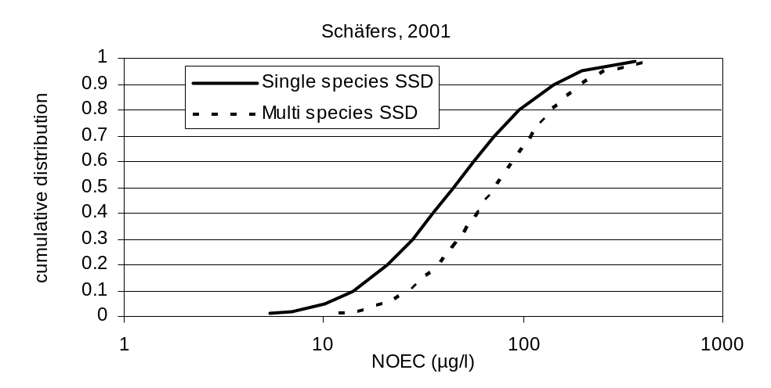

Figure 3-66 : Comparison of the log normal SSD obtained from the mesocosm (Schaefers et al., 2001, Table 3-34 with the SSD of the single species NOEC values, normalized to the average physico-chemistry of the study. The SSD curves allowed to calculate a HC5-50 for the multi-species mesocosm of 19.6 µg Cu/L and a single-species BLM predicted HC5-50 of 9.9 µg Cu/L (see text)

Hedtke, 1984
A BLM normalization of the single-species NOEC values to the average physico-chemistry of the mesocosm allowed to calculate a HC₅-50 of 3.4 µg dissolved Cu/L (with confidence limits between 1.7 – 5.6 µg/l). These calculation show that the HC₅-50 (3.4 µg Cu/L) is protective for the mesocosm functions and structure (NOEAEC of 3.6 µg Cu/L) and mesocosm HC₅-50 (i.e. 3.8 µg Cu/L with confidence limits between 1.8-6.3 µg/l). Figure 3-67 compares the multi-species SSD with the single species SSD, normalized to the physico-chemistry of the Hedtke study at the average physico-chemistry of the experiment and further illustrates that the single species HC5-50 is protective for multi-species systems.
This conclusion is even more pronounced when considering the exposure regime used: no pre-equilibration between copper and the test media in this flow-through system and thus reduced Cu-DOC complexation compared to natural systems

The analysis therefore shows that the single species SSD and HC5-50 is protective to the mesocosm communities evaluated in Hedtke, 1984.

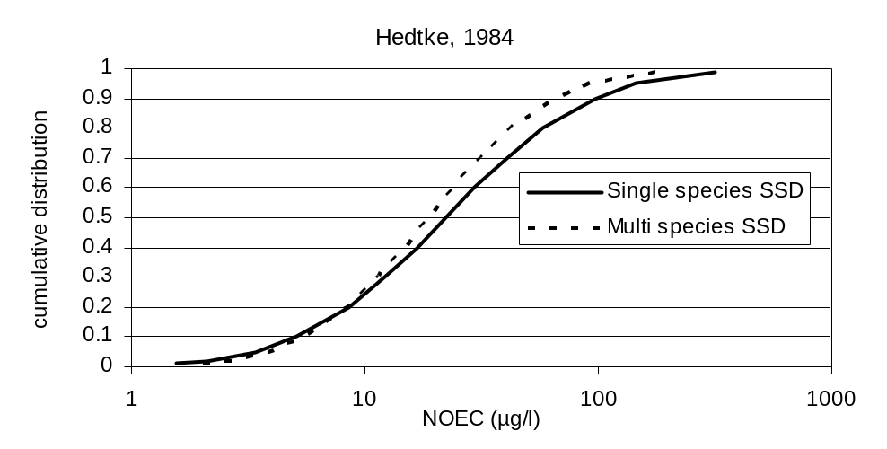

Figure 3-67: Comparison of the SSD obtained from the mesocosm (Hedtke, 1984,Table 3-35) with the SSD of the single species NOEC values, normalized to the average physico-chemistry study. The SSD curves allowed to calculate a HC5-50 for the multi-species mesocosm of 3.8 µg Cu/L and a single-species BLM predicted HC5-50 of 3.4 µg Cu/L (see text)

Roussel, 2006.
In this microcosm system, each river system distinguished two regions with distinct depth profiles and sediments type and the mesocosm is therefore characterised by large variation in physico-chemical characteristics (eg 0.6 to 6.8 mg DOC/L). To compare the mesocosm NOECs and NOAEC with the NOEC values and HC5-50, derived from the single species laboratory tests, consideration needs to be given to the large variations of physico-chemical characteristics in the mesocosm (see above). Such large variation might therefore affect the sensitivity of the system. To characterize the variation in sensitivity of the mesocosm system, a sensitivity analysis was performed using the lowest/average and highest values in abiotic conditions (pH, DOC and alkalinity) occurring during the experiment. BLM normalization of the 139 single-species NOEC values towards the average (min-max) system physico-chemistry resulted in a BLM predicted HC5-50 value of 6.9 (1.2-10.3) µg Cu/L. Figure 3-68 compares the observed multi-species SSD with the predicted single species SSD, normalized to the average physico-chemistry of the study. The predicted single-species HC5-50 (6.9 µg Cu/L) is a factor 1.3 higher than the mesocosm species SSD HC5-50 (5.2 µg Cu/L) and a factor of 1.7 higher than the NOEAEC observed for the ecosystem structure and function (4 µg Cu/L). The latter difference can be explained by the large difference between the test concentrations used (factor 5 difference), the observed variations in physico-chemistry and the non-equilibration conditions used. Indeed, normalization of the single species to the minimum and maximum physico-chemistry reported in Roussel (2006) results in HC5-50 values of respectively 1.2 and 10.1 µg Cu/L.

The figure and HC5-50 therefore illustrate that the single species SSD and HC5-50 is protective for multi-species systems. This conclusion is even more pronounced when considering
- the differences in test concentrations applied : factor 5 between the 2 lowest test concentrations
- the exposure regime used: no pre-equilibration between copper and the test media in this flow-through system and thus reduced Cu-DOC complexation compared to natural systems
- the large variability in physicochemistry within the river system.

The influence of “no pre-equilibration” between copper and the test media in this flow-through system and thus the reduced Cu-DOC complexation in the mesocosm compared to natural systems can be further demonstrated from Ma et al. 1999. Ma et al. (1999), studied the effects of kinetics of complexation by humic acids on copper speciation, measured by a copper ion selective electrode and by Ceriodaphnia dubia ecotoxicity, using a continuous flow-through system. From the speciation measurements, the authors developed a first order rate constants model described as :

Cu ²⁺= 0.576(Cu^{2+t0}).e^{-1.85t} + 0.424 (Cu^{2+t0}).e^{-0.094}
Varying copper concentrations or DOC concentrations had no influence on the model parameters. Considering the hydrodynamic characteristics of the bioassay chambers demonstrated that the copper toxicity was related to the free copper ion concentrations rather than the total dissolved concentrations. The data further showed that the a first order rate constants model could be used to predict the C. dubia ecotoxicity in the flow-through systems.

In the Roussel (2006) study, the hydrodynamics are well described: concentrations of copper (0, 5, 25 and 75 µg/L) were applied during 18 months. The system was 20 m long whereby copper sulphate in tap water was administered at a flow of 800L/hr. Each river system distinguished two regions of 10 m length, with distinct depth profiles (0.3 and 0.7 m depth). The ecological characteristics of the mesocosm were determined from samples collected at every meter along the system and pooling the samples. The knowledge of the hydrodynamics and the model developed by Ma et al, 1999 therefore allows the estimation of free cupric ions and the subsequent overestimation of toxicity due to non-equilibration. Figure 3-69 provides results of these calculations and shows that the fraction bound copper ranges from 0.2 at 1m to 0.9 at 20m from the inlet. This corresponds to an overprediction of toxicity with a factor of 3.3 at 1 m to 1.2 at 20 m for the inlet. These data indicate towards an overprediction of toxicity in this mesocosm of a factor of 1.5 (in the middele of the mesocosm) compared to a pre-equilibrated system. The application of the pre-equilibration factor of 1.2 to 3.3, determined from Ma et al, 1999, to the Roussel mesocosm HC-50 (5.2 µg/L) leads to the derivation of HC5-50 values between 6.2 and 17.2 µg Cu/L, applicable to field surface waters, with a median of 8 µg Cu/L.

The analysis therefore shows that the single species SSD and HC5-50 is protective to the mesocosm communities evaluated in Roussel, 2006.

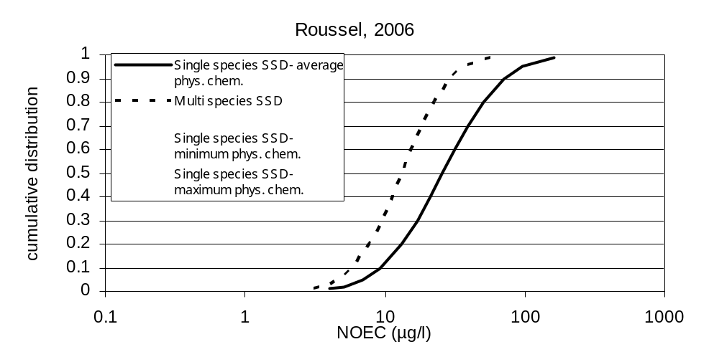
Figure 3-68: Comparison of the SSD obtained from the mesocosm (Roussel, 2006, Table 3-37) with the SSD of the single species NOEC values, normalized to the average physico-chemistry of the study.

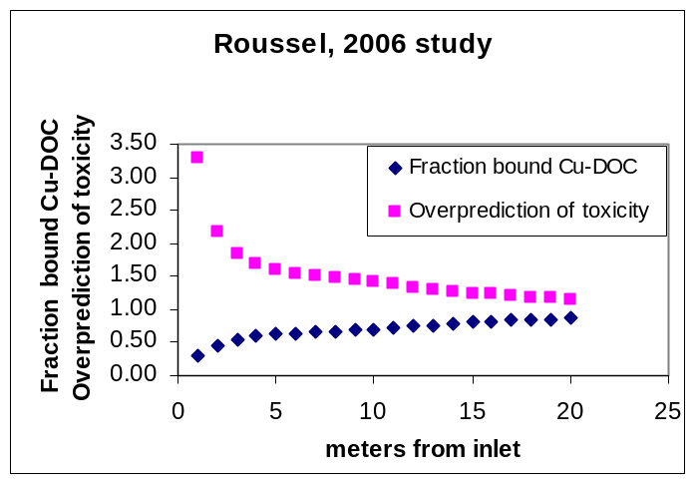
Figure 3-69: Calculated fraction bound copper and estimated overprediction of toxicity in the Roussel 2006 study compared to a fully pre-equilibrated system. The kinetic model described by Ma et al., 1999 (see text) was used for the calculations.

To evaluate the relevance of copper-DOC non-equilibration in EU surface waters, the copper use pattern described in the exposure chapters of this risk assessment must be considered. From chapter 3.1.8.1.3. (env exposure chapter 3 part 2) and chapter 3.1.2.4.2. (env exposure chapter 3 part 1), the impact of the various emission sources on the steady state regional PEC water was estimated as: 19% from natural sources, 51 % from soil run-off, 16 % indirect/direct emissions from air (traffic run-off) and 14 % direct emission to water. Within the direct emissions the identified sources are: waste management, traffic, households and industry.

Considering accumulation for 100 years instead of steady state shows a similar pattern with a somewhat lower contribution from soil run-off. summarizes the information on the relative contribution of the various sources to the regional emissions and confirms that in field situation, the relative contribution of direct emissions of non-equilibrated soluble copper salts, as done in flow-though systems, can be considered as very small. From the regional emission inventory, the emissions that could be considered as non-equilibrated emissions of soluble salts are : emissions from firework, copper drinking water tubes, not connected to sewage treatment plants (the figure actually includes connection to septic tanks), run-off from external buildings directly into surface waters (assumption of 70% directly emitted to surface waters). The relative contribution of these sources to the regional emissions (100 years) are respectively 0.5%, 0.2% (includes an equilibrated portion -septic tanks) and 0.8%. These figures therefore confirm that the relative contribution of non-equilibrated copper emissions is very small.

The inclusion of a non-equilibration factor, is therefore most relevant when translating the NOECs/NOAECs/HC50s from flow-through systems to field situations.

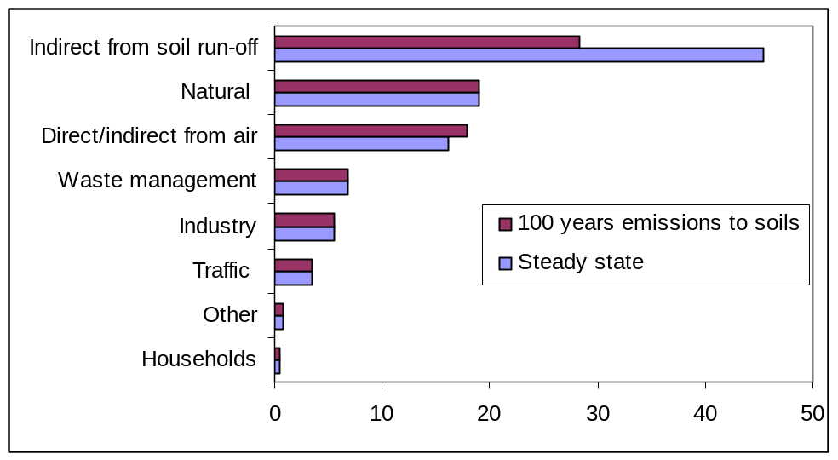

Figure 3-70: Relative contribution of emission sources to the total copper emissions in natural surface waters, considering accumulations to steady steady and up till 100 years.

Further evaluation of the LOECs observed by Winner

As mentioned above, the acceptability of the Winner studies for use in EU wide RA is questioned to to several quality criteria issues (eg. toxicity from Uroglena exudates, uncertainty in the actual DOC values of the mesocosms,no real NOECs,). To ensure that all sensitive groups have been covered in this RAR, the most sensitive taxonomic groups of the Winner study aretherefore further addressed below.

Winner and co-authors (1989-1991) identified relative high sensitivity for Rotifera (Keratella and Polyarta), Copepoda and Cryptophyta. The sensitivity of taxonomically related groups were therefore evaluated from Schaefers’ mesocoms (2001) data. Schaefers’ mesocoms (2001) includes 2 species Keratella (Keratella cochlearis and Keratella quadrata), Copepoda and Cryptophyta and the species mean NOEC of these groups are also provided in Table 3-34. These species are thus protected by the mesocosm NOEAEC as derived by Schaefers (2001). The BLM normalization of the single-species NOEC values to the physico-chemistry of the mesocosm allowed to calculate an HC5-50 of 9.8 µg Cu/L being below theNOEAEC (20µg Cu/L), providing evidence for the protective character of the single species HC5-50 values for under more Keratella cochlearis and Keratella quadrata, Copepoda as well as Cryptophyta .

For the rotifer, Keratella cochlearis, a species-mean NOEC values of 134 µg Cu/L was calculated from Schaefers (2001). For the other rotifer species, Keratella quadrata, a species mean NOEC values of 120 µg Cu/L is observed. For the Rotatoria group, a NOEC of 116 µg Cu/L was calculated. The Schaefers, 2001 study can therefore NOT confirm a general high sensitivity for Keratella nor Rotatoria. Recognising that Winner only observed high sensitivity in spring, further in detail evaluation of the most sensitive among the two (Keratella quadrata) was performed. Figure 3-71 shows that the species has an opportunistic population dynamics (r-strategy) with an abundance being quite variable in time as well as among controls. Especially at the end of the testing period, the Keratella quadrata population has dramatically increased at all tested concentrations, but the increase is highly variable, also among the control ponds. Considering all sampling dates, a species mean NOEC of 120 µg Cu/L was calculated for Keratella quadrata. A high variability may also have occurred in the Winner study but due to the limited number of replica’s/concentration (one control replica and test replica were lost during the experiment) available such natural variability may have been lost. The fact that Winner also saw decreased rotifer population abundance in the control exposures compared to the original pond may be an indication of an adverse effect of the confounding factor (Uroglena toxicity) on the Keratella populations and may thus further explain the difference between the two studies

It must be noted that two species of rotifers, tested in the Roussel (2006) mesocosms, were the two most sensitive taxa of the Roussel study. The test species belong to different groups then the ones studied in Winner and can thus not be directly compared to the rotifer species from the Winner study. The rotifer species, evaluated in Roussel (Mytilina (4 µg Cu/L) and Trichocera (5 µg Cu/L) is in the range of the BLM predicted SSD (single species NOECs normalized to the minimum, average and maximum physico-chemistry of the Roussel mesocosm) with normalized HC5-50 values ranging between 1.2 and 10 µg Cu/L and average HC5-50 of 6.8 µg Cu/L. The average HC5-50 is a factor 1.4 to 1.7 above the lowest NOEC values. In this respect, it is important considering the non-equilibrium situation (flow-through without pre-equilibration) of the Roussel test system.

In order to also address the LOECs observed by Winner on copepods and phytoplankton, populations, the observations for these groups have also been retrieved from the “more reliable” Schaefers 2001 mesocosm study. The species mean NOEC for Copepoda and Cryptophyta are respectively 144 and 24 µg Cu//L. For these two taxonomic groups, the variations in abundance as a function of exposure concentration and time are shown in Figure 3-72 and Figure 3-73. The abundance data and NOECs do not indicate towards a high sensivity of Copepods. Also Cryptophyta are protected by the HC5 derived from the mesocosm SSD (20 µg Cu/L) as well as the HC5, derived from the single species SSD normalized towards this mesocosm chemistry (9.9 µg Cu/L).

The information retrieved therefore allow to conclude that the BLM derived single species SSD and HC5-50 are also protective for the “sensitive taxonomic groups” observed in the Winner study.

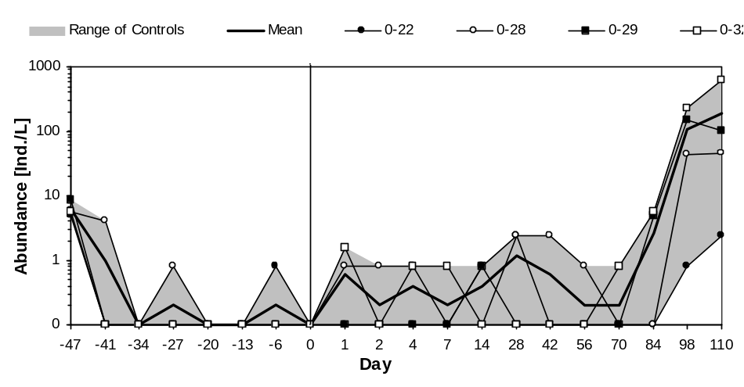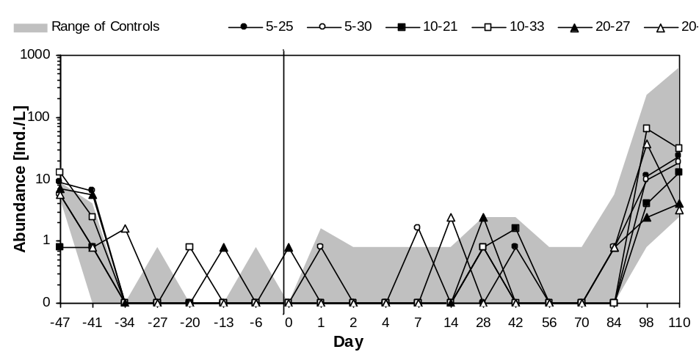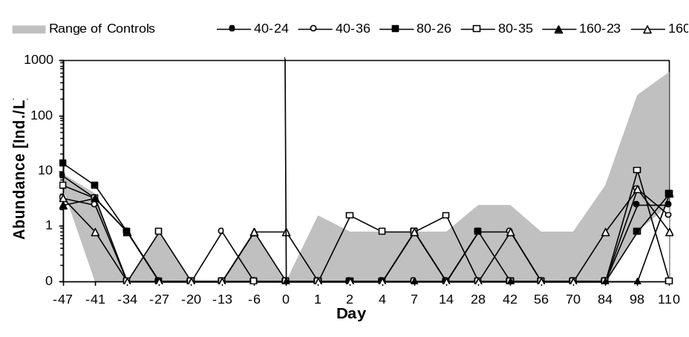
Figure 3-71: Abundance of Keratella quadrata as a function of concentration and time.

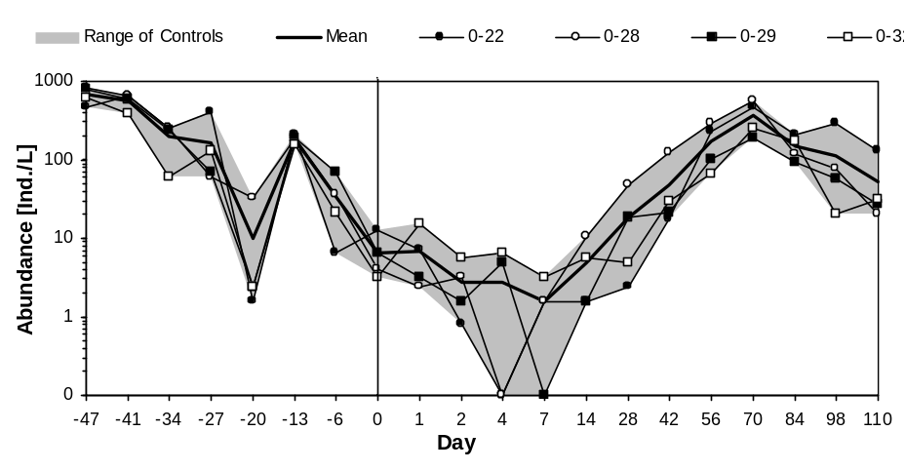
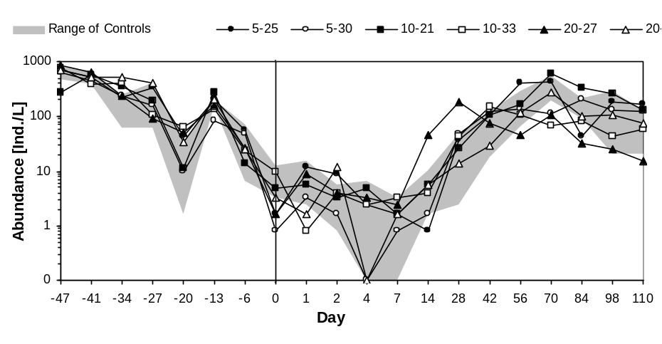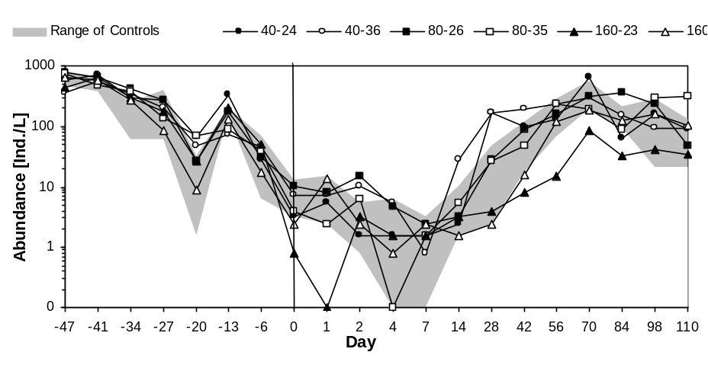
Figure 3-72: Abundance of Copepods as a function of concentration and time.

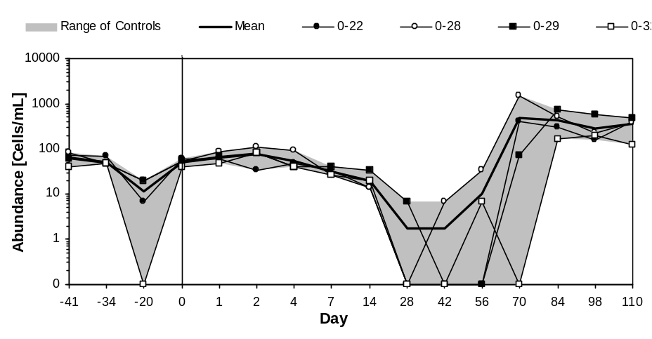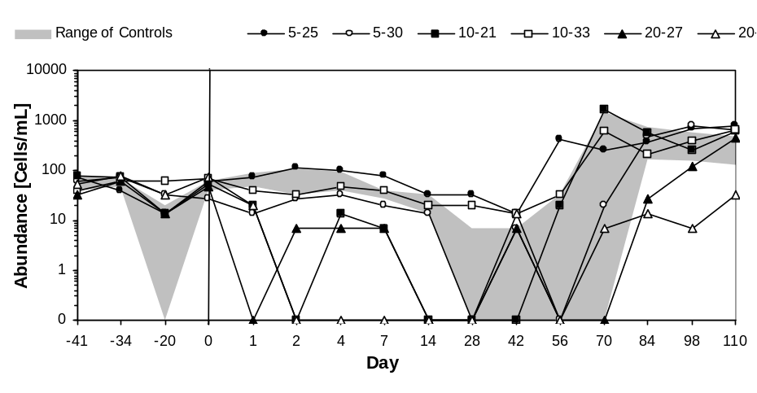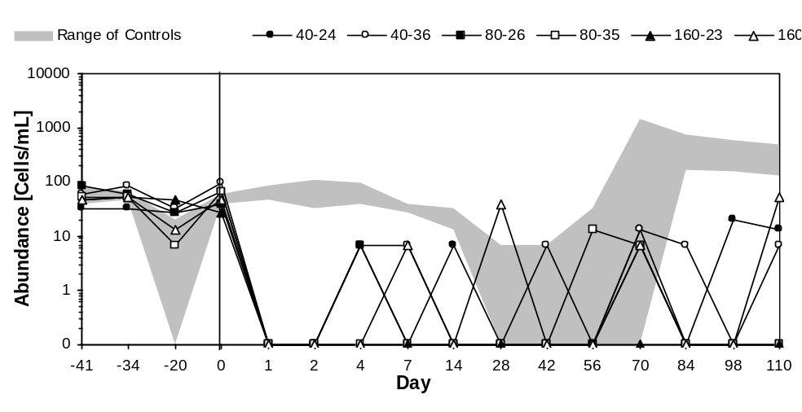
Figure 3-73: Abundance of Cryptophyta as a function of concentration and time.

Conclusion : Five (six if the 2 Winner studies are taken separately) high quality studies (based on pre-set quality criteria) were identified in the RAR. For some taxonomic groups, the mesocosm studies show some conflicting results. Further in detail investigations of the mesocosm studies shows that the Winner study has several quality issues, including confounding toxicity from exudates of Uroglena. These issues and confounding factor put doubt on the acceptability of this study for use in EU wide RAs.

The information retrieved from the Schaefers 2001 study on the taxonomic groups identified as sensitive in Winner allow to conclude that the BLM derived single species SSD and HC5-50 are also protective for the “potential sensitive taxonomic groups” observed in the Winner study. The Winner data will therefore not be used for the final derivation of the PNEC.

Summary and conclusions on the mesososm data
Information from high three quality mesocosm studies, mimicking lotic and lentic systems of different copper sensitivities, demonstrates that the mesocosm communities structure and function are protected by the BLM normalized HC5-50, derived from the single species NOECs. The results from Soldo and Behra (2000) could not be normalized but the information on the reported free cupric ion levels demonstrated the consistency of this study with the other three studies.

Table 3-38 presents an overview of the mesocosm NOEAEC values and HC5-50 values derived from the NOECs for the mesocosms species from the three basic mesocosms as compared to the single species NOEC values (& HC5/PNEC value with 5th and 95confidence limit) normalised towards the average conditions occurring in the respective mesocosms.
The comparison, as mentioned hereabove, is based on BLM normalisation using the average conditions occurring in the test media of the mesocosm studies. To characterize the variation in sensitivity of the mesocosm system, a sensitivity analysis was performed using the lowest/average and highest values in abiotic conditions (pH, DOC and alkalinity) occurring during the experiment. An overview of the different scenarios considered in the sensitivity analysis is provided in Table 3-39. summarizes the detailed comparison between the calculated single species HC5-50 (BLM calculations from the single species SSD, using the minimum, maximum and average physico-chemistry) and the observed mesocosm NOEAEC and LOEAEC(Lowest Observed Adverse Effect Concentration). The average BLM calculated HC5-50 values are close to the observed ecosystem NOEAEC with predicted/observed ratio’s of 0.5 (Schaefers, 2001); 0.9 (Hedtke, 1984) and 1.7 (Roussel, 2006). Considering all three studies, the average predicted/observed ecosystem HC5/NOEAEC is 1. The observed mesocosm LOEAECs are 2 to 5 times higher than the average BLM calculated HC5-50 values with predicted/observed ratio’s of 0.2 (Schaefers, 2001); 0.4 (Hedtke, 1984) and 0.3 (Roussel, 2006). Considering all three studies, the average predicted/observed ecosystem HC5/LOEAEC is 0.3. For Roussel, 2006) a large difference in predicted/observed ecosystem HC5-50/NOAEC versus HC5-50/LOAEC reflects the factor 5 difference in tested concnetrations
Considering the large variations between NOEAECs and LOEAECs, further summarizes the detailed comparison between the calculated single species HC5-50 values (BLM calculations from the single species NOECs, using the average physico-chemistry) with the observed HC5-50 values, calculated from the observed geometric mean NOECs for the mesocosm species. The BLM calculated HC5-50 are always around the observed HC5-50 values derived with predicted/observed ratio’s are respectively: 0.5 (Schaefers, 2001), 0.9 (Hedtke, 1984) and 1.3 (Roussel, 2005) with an average ratio of 0.9. The difference between the Schaefers (2001) and the other two studies can be explained by the fact that no pre-equilibration between the copper dose and the test media was applied in Hedtke (1984) nor Roussel (2006) as well as the large difference in tested concentrations in the Roussel, 2006 study.
This comparison therefore clearly strengthens the conclusion that the BLM can adequately predict the mesocosm sensitivities and thus adequately protect natural ecosystems.

This conclusion is even more pronounced when considering
- the differences in test concentrations used : factor 5 between test concentrations (NOEC : 5 µg Cu/L (4 µg Cu/L measured), LOEC 25 µg Cu/L (20 µg Cu/L measured) in Roussel (2006)
- the exposure regime used: no pre-equilibration between copper and the test media in this flow-through system and thus reduced Cu-DOC complexation compared to natural systems for the Roussel (2006) and the Hedtke (1984) studies. Evidence of the influence of pre-equilibration is obtrained from Ma et al., 1999. The application of the pre-equilibration factor of 1.2 (at the outflow) to 3.3 (at the inflow), determined from Ma et al, 1999, to the Roussel mesocosm HC-50 (5.2 µg/L) leads to the derivation of HC5-50 values between 6.2 (at the outflow) and 17.2 µg Cu/L (at the inflow). The The BLM derived HC5-50 of 6.9 µg Cu/L is therefore protective for the mesocosm system, evaluating pooled samples across the river systems ().
- the large variability on physico-chemistry within the Roussel river system and resulting variations in BLM predicted HC5-50 values.

Table 3-38 : Overview of the individual mesocosm NOEC values and the single species NOEC values and HC5-50 value with 5th and 95th confidence limit) normalised towards the conditions occurring in the respective mesocosms.
Roussel (2005) |  | Hedtke (1984) |  | Schaefers (2001)
NOAEC/LOAEC mesocosm:4.0 -20 µg/l  HC5-50 mesocosm species: 5.2 (3.1-7.3)  µg Cu/L  Normalised single species SSD  HC5-50: 6.9 µg/l (4.3-9.7 µg/l) |  | NOAEC/LOAEC mesocosm:3.6 -8.8µg/l  HC5-50 mesocosms species:3.8 (1.8-5.6) µg Cu/L  Normalised single species SSD  HC5-50: 3.4 µg/l (1.7-5.6 µg/l) |  | NOAEC/LOAEC mesocosm:20-40 µg/l  HC5-50 mesocosm species:19.6 (10.4-29.8) µg/L  Normalised single species SSD  HC5-50: 9.9 µg/l (5.8-14.6 µg/l)
Single species sensitivity | Normalised NOEC (µg/l) | Single species s  ensitivit | Normalised NOEC (µg/l) | Single species  sensitivity | Normalised NOEC (µg/l)
Brachionus calyciflorus | 5.0 | Brachionus calyciflorus | 2.7 | Brachionus calyciflorus | 6.9
Juga plicifera | 6.5 | Juga plicifera | 3.6 | Pseudokirchneriella subcapitat | 21.6
Pseudokirchneriella subcapitata | 9.6 | Pseudokirchneriella subcapitata | 6.0 | Juga plicifera | 9.1
Clistoronia magnifica | 10.8 | Clistoronia magnifica | 6.6 | Clistoronia magnifica | 16.2
Dreissenia polymorpha | 11.0 | Campeloma decisum | 7.0 | Dreissenia polymorpha | 18.2
Campeloma decisum | 11.8 | Dreissenia polymorpha | 7.2 | Campeloma decisum | 17.8
Ceriodaphnia dubia | 13.5 | Ceriodaphnia dubia | 8.9 | Chlamydomonas reinhardtii | 41.9
Daphnia magna | 15.5 | Daphnia magna | 10.3 | Chlorella vulgaris | 44.4
Villosa iris | 17.5 | Villosa iris | 12.1 | Ceriodaphnia dubia | 21.4
Chlamydomonas reinhardtii | 18.1 | Chlamydomonas reinhardtii | 13.0 | Daphnia magna | 24.5
Chlorella vulgaris | 18.9 | Chlorella vulgaris | 14.0 | Villosa iris | 28.5
Gammarus pulex | 22.1 | Gammarus pulex | 16.7 | Oncorhynchus kisutch | 27.0
Oncorhynchus kisutch | 24.3 | Oncorhynchus kisutch | 18.4 | Lemna minor L. | 70.1
Lemna minor L. | 28.5 | Ictalurus punctatus | 23.6 | Gammarus pulex | 38.1
Ictalurus punctatus | 28.8 | Lemna minor L. | 24.6 | Ictalurus punctatus | 34.7
Oncorhynchus mykiss | 31.7 | Oncorhynchus mykiss | 27.5 | Oncorhynchus mykiss | 40.5
Catostomus commersoni | 32.5 | Catostomus commersoni | 28.5 | Catostomus commersoni | 41.9
Salvelinus fontinalis | 38.5 | Salvelinus fontinalis | 37.7 | Salvelinus fontinalis | 54.8
Daphnia pulex | 40.9 | Daphnia pulex | 43.0 | Pimephales promelas | 70.4
Pimephales promelas | 45.3 | Pimephales promelas | 49.8 | Daphnia pulex | 86.3
Chironomus riparius | 49.9 | Chironomus riparius | 59.3 | Chironomus riparius | 113.4
Perca fluviatilis | 58.1 | Perca fluviatilis | 74.8 | Perca fluviatilis | 103.0
Hyalella azteca | 65.0 | Hyalella azteca | 94.3 | Esox lucius | 135.1
Esox lucius | 71.7 | Esox lucius | 108.3 | Pimephales notatus | 137.3
Pimephales notatus | 73.1 | Pimephales notatus | 111.6 | Hyalella azteca | 158.7
Paratanytarsus parthenogenetica | 76.3 | Paratanytarsus parthenogenetica | 126.2 | Paratanytarsus parthenogenetic | 197.2
Noemacheilus barbatulus | 91.5 | Noemacheilus barbatulus | 163.1 | Noemacheilus barbatulus | 175.7

Table 3-39: HC5-50 normalised towards different phys-chem conditions occurring in the mesocosm studies (the other parameters were kept constant cfr -Table 3-32).
Reference of mesocosm | Conditions | pH | DOC (mg/l | Alkalinity (mg/l CaCO3) | Normalised HC5-50 (µg/l)
Roussel (2005) | average | 7.6 | 1.8 | 8.9 | 6.9
Roussel (2005) | Lowest | 6.5 | 0.6 | 0.7 | 1.2
Roussel (2005) | highest | 8.8 | 6.9 | 148.6 | 10.3
Schäfers et al. (2001) | average | 9.0 | 4.4 | 243.2 | 9.9
Schäfers et al. (2001) | Lowest | 8.1 | 3.4 | 28.3 | 17.7
Schäfers et al. (2001) | highest | 9.5 | 5.8 | 911.5 | 9.5
Hedtke (1984) | average | 8.9* | 1.8 | 180* | 3.4
Hedtke (1984) | Lowest | 8.9* | 0.7 | 180* | 1.4
Hedtke (1984) | highest | 8.9* | 2.6 | 180* | 5.1
*: the literature did not allow to characterize the variation of the abiotic factor during the experiment

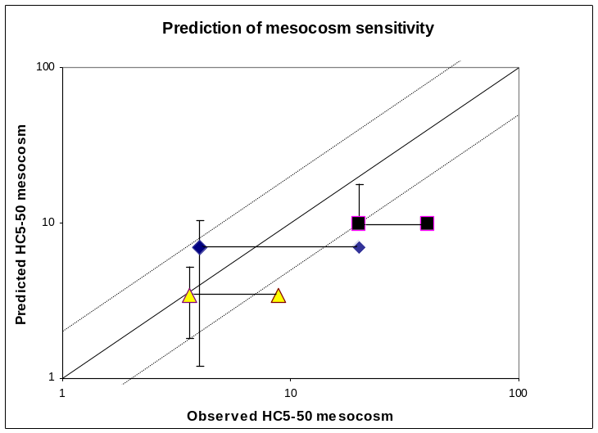

Figure 3-74: Predicted BLM normalised HC5-50 values (mean + standard deviation) versus observed mesocoms No Observed Ecological Adverse Effects ( NOEAEC) and Lowest Observed Ecological Adverse Effects (LOEAEC), connected by a line. Rhomb:Roussel, 2006; Squares:Schaefers, 2001; Trangles:Hedtke, 1984

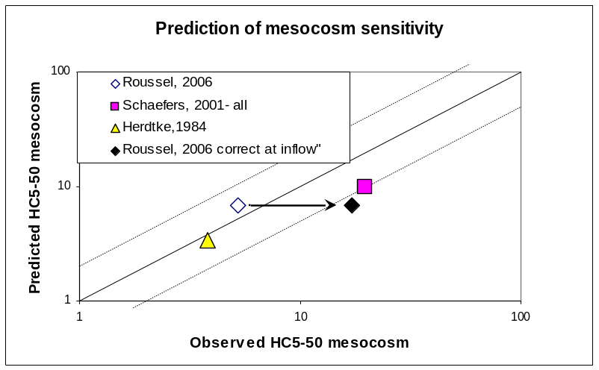

Figure 3-75: BLM predicted HC5-50 value, from single species NOECs versus observed mesocoms HC50 values.
For the Roussel, 2006 study, a range between the original HC5-50 and the HC5-50 corrects for non-equilibration at the inflow is provided.

        - Derivation of the Predicted No Effect Concentration surface waters (PNEC_{freshwater})

i. HC5 derived from statistical extrapolation
From the above summary, it is concluded that the copper aquatic effects database contains a large number of high quality chronic NOEC values (139 chronic NOECs for 27 species). In accordance to the multi-metal discussions and agreements made in the Ni RA, normalized HC5-50 values for copper have been derived for a range of typical EU scenario’s and range between 7.8 to 22.1 Cu/L when using the best fitting distribution and between 7.8 to 27.2 Cu/L when using the log-normal distribution. The statistical analysis of the data demonstrated the robustness of the derived copper HC5 values. TCNES agreed that the HC5-50 value (log-normal distribution) can be used as a conservative basis for the PNEC setting.

ii. PNEC derived from the assessment factor method
A PNEC derived using the assessment factor method would lead to the following considerations:
    - Using an assessment factor of 10 on the lowest species specific chronic NOEC value leads to a PNEC between 0.8 and 2.2 µg Cu/l for respectively the most and least sensitive eco-region. This value is within the range of EU copper background values and below the optimal copper levels as determined for optimal growth & development of D. magna & O. mykiss and therefore not useful for the EU RA.

    - Using an assessment factor of 1 on the mesocosm/ field NOEAEC values allows the derivation of a PNEC value between 3.6 and 20 µg Cu/l. These value falls within the range of optimal concentrations and normal copper background levels in Europe.

iii. Summary and final derivation of the PNEC freshwater
The use of statistical extrapolation, using all NOECs in the ecotoxicity database is preferred for the PNEC derivation rather than the use of the assessment factor method on the lowest NOEC.
The HC5-50 derived from statistical extrapolation is therefore used as a basis for the PNEC derivation. Based on uncertainty considerations the London workshop recommended to apply an additional assessment factor on the 50% confidence value of the 5th percentile value (thus PNEC = 5th percentile value/AF), with an AF between 1 and 5, to be judged on a case by case basis.
The uncertainty analysis, the mesocosms, the information on copper background levels and the information on copper’s essentiality and homeostasis can be used to validate the derived PNEC from the single species studies. Based on the available data discussed in details above, the following summary can be provided :

- Data quality

The overall quality of the database and the end-points covered, e.g., if all the data are generated from “true” chronic studies (e.g., covering all sensitive life stages; real chronic exposure time)

From the evaluation of the NOEC data quality and quantity it can be concluded that the Cu-database is of high quality, covers complete life stages and has built-in factors providing additional degrees of protection. Two important built-in conservative factors are :
- The effects are total effects, not added effects. Copper is homeostatically regulated and acclimation to changes in copper concentrations in the aquatic environment have not been accounted for in this RA.
- Further, it is worthwhile noting that 60% of the laboratory test waters had copper background levels below the range of copper background levels as reported by Zuurdeeg et al. (1992) for European lowlands. This leads to further protection and conservatism as organisms acclimated to low copper levels in culture waters are somewhat more sensitive.
- Overestimation of toxicity values occurs for laboratory tests performed in flow through systems which leads to an overestimation of the NOEC value and ultimately the HC5. Indeed, the kinetics of copper complexation with DOC are not respected in flow-through systems unlike natural ecosystems. Considering the single species tests, 43% of the NOECs were derived from flow through systems. All fish tests were carried out in flow-through systems. For the algae, most tests were carried out in a static test set-up (only 1 test in flow-through). 16% of the invertebrate tests were carried out in flow-through system.

Conclusion : the retained NOEC data are of high quality and includes built-in conservative elements

- The taxonomic groups covered

The TGD recommends to evaluate all information on the mode of action, to include the minimum species requirements specified and to include possible other sensitive taxonomic groups, realizing possible differences in the mode of action.
The TGD further specifies as minimum requirement: 10 (preferably more than 15) NOECs for different species covering 8 taxonomic groups

For copper, 139 individual NOEC values resulting in 27 different species NOEC values (fish, invertebrates and algae) were compiled from the database. NOEC values are available for 3 unicellular algal species (Pseudokircherniella subcapitata; Chlamydomonas reinhardtii; Chlorella vulgaris), 1 higher plant (Lemna minor), 1 rotifer species (Brachionus calyciflorus); 3 insect species (Clistoronia magnifica; Chironomus riparius; Paratanytarsus parthenogeneticus), 4 mollusc species (Juga plicifera, Campeloma decisum; Villosa iris; Dreissenia polymorpha), 5 crustacean species (Ceriodaphnia dubia; Daphnia magna; Daphnia pulex; Hyalella azteca; Gammarus pulex) and 10 fish species (Pimephales notatus; Pimephales promelas; Oncorhynchus mykiss; Oncorhynchus kisutch; Ictalurus punctatus; Perca fluviatilis; Salvelinus fontanilis; Noemacheilus barbatulus; Catostomus commersoni; Esox lucius).

From the extracted effects data, it is thus shown that the Cu-database extensively fulfills the requirement of 10-15 different NOEC values. The database includes all 8 taxonomic groups (families) mentioned in the taxonomic list of the TGD that has been taken as a starting point. The TGD taxonomic group requirements are thus more than fulfilled in this database.

Information on the mode of action of copper exposure indicated that across taxonomic groups of invertebrates and fish, the key indicator of copper toxicity is disturbance of the sodium homeostasis. The key target tissue for copper toxicity is therefore the water/organism interfaces with cell wall and gill-like surfaces acting as target biotic ligands in all species investigated. This can explain the small observed overall inter-species variability (max/min ratio of 23) and small acute to chronic ratios (typical a factor of 1 to 3).

Conclusion: Based on the taxonomic group requirements and the known mode of action, it can be concluded that the copper database complies with all TGD criteria and in fact considerably exceeds them.

C. Treatment of multiple data for one species

The TGD specifies to make a pre-selection of the data in relation to realistic environmental parameters in Europe (hardness, pH, DOC…). Multiple values from the same species should be investigated on a case by case basis, looking for reasons for differences.

Detailed investigation of the ecotox database covers realistic environmental conditions in Europe. The original database showed large variations among multiple values from the same species. A sensitivity analysis was performed to understand the relative importance of bioavailability versus acclimation/adaptation of the organisms to a range of copper concentrations. The results clearly showed that bioavailability was the most important factor explaining the large intra-species variability.

Chronic copper bioavailability models (Biotic Ligand Models) were therefore developed and validated for a 3 taxonomic groups (4 species). In order to respond to the BLM read-across criteria document, proposed by the TCNES, additional information was obtained to evaluate the applicability of the BLMs for other taxonomic groups. Key elements responding to the read across criteria are :
- The similarity of the chronic Cu-BLM parameters across fish species (Oncorhynchus and Pimephales).
- The demonstration that the chronic algae Cu-model, developed for Pseudokirchernella is also valid for two other algae taxonomic groups (Chlorella and Chlamydomonas).
- Spot checkings, demonstrating the read across of the chronic D. magna Cu-BLM parameters towards three other taxonomic groups : amphipods (Hyalella azteca), rotifers (Brachydanio rerio) and molluscs (Hyridella depressa and Lampsilis siliquoidea).
- The demonstration of the comparability between the chronic algae Cu model and the terrestrial plant models and thus the applicability of the algae model to predict effects in higher plants ( eg Barley root elongation).
- Additional laboratory and field validations of the acute copper BLMs for a wide range of cladocerans and Hyalella
- The uncertainty analysis whereby it is demonstrated that full read across, using the chronic BLM parameters developed for each trophic level will reduce the uncertainty in the copper NOEC values usually down to a factor of 2, while limited read-across for copper is will not allow such reduction in uncertainty.
- The mechanistic understanding of the copper toxicity

The research data therefore justify the full BLM read across for copper. The full BLM read across allows to maintain the large database (no need for pre-selection) and to normalize all NOEC values to a series of realistic environmental conditions in Europe (the EU scenario’s). The intra-species variability after normalization was drastically reduced and allowed the derivation of meaningful species–specific geometric mean NOEC values for each endpoint and species. For each species, the lowest endpoint-specific geometric mean value was used as input into the SSD.

Conclusion : the copper RAR complies with the TGD criteria related to multiple species inputs and has provided a scientific robust solution that allows to recognise bioavailability, while maintaining the data-richness.

D. Statistical uncertainties around the 5th percentile estimate

The TGD proposes the use of the 5th percentile as the intermediate value for the derivation of the PNEC. The 50 % confidence interval associated with this concentration should also be derived.

For the copper database, the probability distribution of the Cu dataset used for the calculations of the 5th percentile values has been checked with the Anderson-Darling goodness-of-fit test. This goodness-of-fit test highlights differences between the tail of the distribution (lower tail is the region of interest) and the input data. Based on this analysis, a best fit of the data was achieved with the log-normal or beta distribution function depending on the eco-region considered.

The comparison between the derived 5th percentile and the 50 % confidence interval illustrate the small statistical uncertainty related to the HC5 value determined from the geometric species mean NOEC values. The difference between the HC5 and its lower 50 % confidence limit (HC5-50), calculated for the different EU scenario’s varies only between a factor of 1.01 and 1.14 (average of 1.07) for the best fitting distributions and between 1.01 and 1.02 for the log normal distributions. As suggested by the TGD, consideration of different levels of confidence, comparing the HC5-50 and the HC5-5, have also been made. These indicate that the factor between the two is 1-1.8 with an average of 1.3 for the best fitting distributions and between 1.5 and 1.8 with an average of 1.65 for the log normal distributions.

HC5-50 versus HC5-5 values were also determined from individual NOECs instead of the species mean NOEC values (log-normal distribution). The individual NOEC-HC5-50 values are similar to the HC5-50 values derived from species mean NOECS. A constistent HC5-50/HC5-5 ratio of 1.2 is observed across all scenario’s for the log-normal distribution, based on all 139 indicidual NOEC values.

Conclusion : the statistical analysis demonstrated the robustness of the derived copper HC5-50 values. The HC5-50 value was proposed as a conservative basis for the PNEC setting

- Evaluation of NOEC values below the HC5-50

The TGD recommends to further evaluate NOEC values below the HC5 and mentions that if such NOEC values are from one trophic level, then this could be an indication of a particulate sensitive group, implying that the underlying assumption for statistical extrapolation method may not be met.

Comparison of normalized HC5-50 values for the different EU scenario’s with the normalized copper NOEC values for these scenario’s, shows that only one or two out of the 27 species-specific NOEC values (Brachionus calycifloru and sometimes Juga plicifera) fall under the HC5-50 derived from the SSD. It is important to keep in mind that as the chronic data set increase in size (N) the probability of having a value below the HC5 increases equivalently. Therefore, consideration of NOEC values below the HC₅ should not be considered in the application of an additional assessment factor in isolation without taking the total number of data points into account. Further, it is useful to mention that the difference between the geomean NOECs for Brachionus calyciflorus/Juga plicifera and the HC5-50s are very small. For ther most sensitive species, Brachionus calyciflorus the species geomean NOEC are respectively a factor of 1.3 (best fit SSD) and 1.4 (log normal SSD) below the HC5-50. Further comparing the individual Brachionus NOECs under the HC5-50 values shows that only part of the individual NOECS are under the HC5-50, further illustrating that we are dealing with very small remaining uncertainties, within the variability of the ecotoxicity testing methods.

Additionally, we point out that the BLM, derived for Daphnia magna was validated for other invertbrates, including Brachionus calycifloru and bivalves, providing evidence on similar modes of actions.

Conclusions: The observed similarity in mechanism of action among invertebrates, including Brachionus calyciflorus, as well as the large ecotox database and small difference between the NOEC for Brachionus calyciflorus/J. Plicifera and the SSD-HC5-50 does demonstrate the applicability of statistical extrapolation to the copper database and suggests there is no need for an AF on the derived HC5-50.

- Additional conservative elements related to the HC5-50

From the above summary, it is concluded that the copper aquatic effects database contains a large number of high quality chronic NOEC values (139 chronic NOECs for 27 species). Based on the taxonomic group requirements and the known mode of action, it can be concluded that the copper database complies with all TGD criteria and in fact considerably exceeds them.

The copper RAR further complies with the TGD criteria related to multiple species inputs and has provided a scientific robust solution that allows to recognise bioavailability, while maintaining the data-richness.

In accordance to the multi-metal discussions HC5-50 values for copper have been derived for a range of typical EU scenario’s and range between 7.8 to 22.1 Cu/L when applying the best fitting approach on the species geomean NOEC values, between 7.8 and 27.2 µg Cu/,L when applying the log-normal fitting approach on the species geomean NOEC values. The HC5-50 values derived from the SSD of individual NOEC instead of species-speciifc geometric mean values are also very similar. The statistical analysis of the data therefore demonstrated the robustness of the derived copper HC5-50 values.

Only one or two species out of the 27 species-specific NOECs fall under the HC5-50 value. The observed similarity in mechanism of action among invertebrates/fish, including the most sensitive species Brachionus calyciflorus as well as the large ecotox database and small difference between the NOEC for Brachionus calyciflorus and the SSD-HC5-50 does demonstrate the applicability of statistical extrapolation method to the copper database

Sensitivity analysis performed with regards to the data quality, the DOC assumption and the BLM read across clearly demonstrate the robustness of the derived copper HC5-50 values.

A comparison between the HC5-50 derived for the most sensitive eco-region, the 10th-90th percentile of the bioavailability parameters and non-normalized HC5-50 values further confirm the applicability of EU scenario-derived HC5-50 values for European surface waters. The HC5 calculated from the best fitting distributions for the reasonable worst case (invertebrates/fish), the most sensitive eco-region and the generic scenario are almost identical, i.e. respectively 7.5, 7.9 and 7.9 µg/l (Table 3-40 and Figure 3-76).

Table 3-40 Physico-chemistry of the EU sensitive scenario’s

 | pH | DOC | Ca (mg/l) | Mg (mg/l)
Rwc – algae | 8.1 | 2.6 | 11.4 | 2.0
Rwc – invertebrates/fish | 6.6 | 2.6 | 11.4 | 2.0
Most sensitive eco-region – river Otter | 8.1 | 3.2 | 46.9 | 11.6

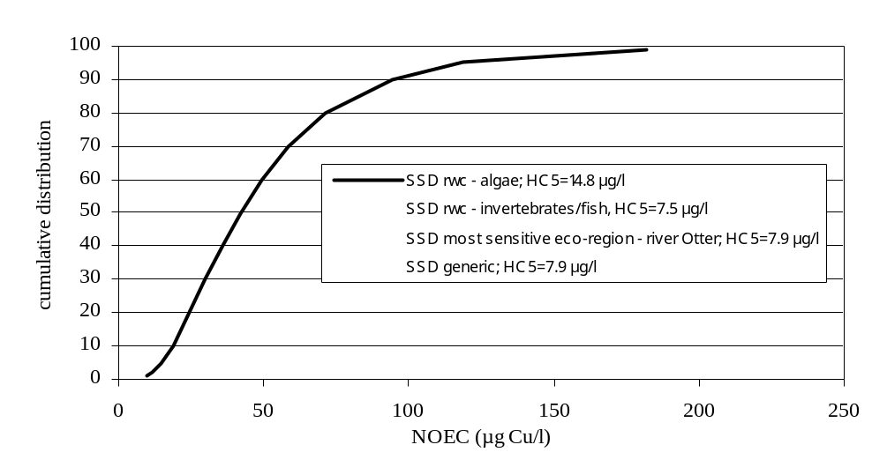

Figure 3-76 : Sensitivity analysis of the HC5 for the most sensitive EU scenario versus the reasonable worst case for algae and invertebrates and the non-normalized data.

It is further worthwhile listing some conservative elements that have been incorporated in the HC5-50 settings proposed in the RAR include :

- The most sensitive endpoint for deriving the geometric species mean has been used
- The 5th percentile of the SSD is used as threshold concentration, using 27 species instead of the needed 10 species
- The 50th % confidence limit is used for the PNEC derivation
- Overestimation of toxicity values often occur for tests performed in flow through systems because the Cu-DOC complexes have not yet been formed in the tests media. BLMs assume equilibration of Cu-DOC and therefore will underestimate the free cupric ion activity in non-equilibrated media. This will lead to lower normalized NOECs and thus lower HC5-50 values.
- No acclimation of the organisms (no limit was set to the copper in the test media). The influence of background values was tested and demonstrated that acclimation may decrease the sensitivity up to a factor of 3.

Conclusion : The evaluation of the single species copper data base therefore suggests there is no need for an AF on the derived HC5-50 values.

G. Validation of the HC5-50 for very sensitive laboratory systems and mesocosms

The protective nature of the BLM can be further evaluated from BLM calculations using the physico-chemistry of a Dutch standard waters. The predicted HC5-50 values for the Dutch standard media scenario’s, results in an HC5-50 of respectively 1 µg Cu/L. This Dutch standard waters scenario is clearly outside the scope of the RA and results in HC5-50 value below the average background levels in Europe but illustrates that the BLM can protect very sensitive waters.

Species-specific NOECs and threshold values, protective of ecosystem structure and functions are obtained form three distinct high quality mesocosm studies, representing lentic and lotic systems and including a large variety of taxonomic groups. Detailed comparison between the BLM predicted NOECs and HC5-50 values and the observed ecosystem NOEAECs and HC5-50 values clearly demonstrate that BLM derived HC5-50 values can adequately predict the mesocosm sensitivity and thus adequately protect natural ecosystems.

Conclusion : The BLM scenario calculations thus further confirm that the derived HC5-50 values are protective to sensitive waters and that there is no need for an AF on the derived HC5-50 values. The HC5-50 values are therefore proposed as PNECs.

- Comparison of the HC5-50 with background levels

Considering that copper is a natural element, essential for all life forms, it is important to compare the proposed PNEC for the EU scenario considered with the copper background levels, the optimal concentration ranges and the essentiality levels.
The total dissolved HC5-50 values, derived for EU typical scenario’s (7.8 to 27.2 Cu/L) are above the average country-specific copper background range reported. (0.3 and 2 µg Cu/L). The HC5-50 values derived for the EU typical scenario’s are however just above the range of natural background levels reported for Europe by Zuurdeeg et al., 1992 (between 0.8 – 5 µg Cu/L) and within the ambient levels reported in pristine areas in Europe by FOREGS (range between 0.1 and 14 µg Cu/L with a 90th Percentile of 3.3 µg Cu/L).

BLM calculations of 635 pristine sites, identified by FOREGS demonstrated that the BLM can also protect very sensitive waters, outside the 10/90th percentile of EU surface waters. The analysis of the FOREGS data further showed that the application of an AF 2 on BLM calculated HC5-50 values lead to the identification of inappropriate risks in 11% of the pristine areas within low background levels (median 1 µg Cu/L).

Conclusion : The proposed PNEC values may thus already be below background levels in some EU waters. This therefore further cautions to the use of an unnecessary AF on the derived HC5-50 values.

H. Comparison of the HC5-50 with levels on essentiality and homeostasis
Different studies have quantified levels of homeostasis in invertebrates, fish and amphibian. Levels below 1 µg Cu/L were leading to copper deficiency.

Bossuyt et al, 2004 performed acclimation experiments with D. magna and showed that after three generation of acclimation, the optimal concentration ranges (from energy reserves and number of offsprings) remained constant between 1 and 35 µg Cu/L. Below 1 µg Cu/L (a concentration often used as background copper concentration in the ecotoxicity media), copper defieciency was clearly observed, the highest energy reserve was observed at 11 µg Cu/L and toxicity was observed above 35 µg Cu/l. BLM calculations carried out in the water used for the acclimation experiments allows to calculate an HC5-50 of 7.8 µg Cu/L, being right at the centre of optimal concentration range.

The total dissolved HC5-50 values of the most sensitive eco-regions are close to the reported deficiency levels reported for fish and invertebrates (< 8 µg Cu/l).
Fort et al., 2000 determined optimal copper concentration ranges for the early life stages of the amphibia X. Laevis : 1 to 10 µg Cu/L

Conclusion : The HC5-50 is protective towards toxicity and essentiality and the information on essentiality and homeostasis cautions to the use of an unnecessary AF on the derived HC5-50 values.

I. Comparison with other RAR

Comparison of the copper database with other databases shows that:

- Single species data richness are far beyond the TGD requirements and equal to or higher than the ones observed in other data rich RARs (Zn, Ni, Cd)
- Small intra-species variability through BLM applications compared to many other RAs
Smaller intra-species variability for copper compared to Zn, Cd, similar intra-species variability for copper compared to Ni )
- Availability of high quality pond and river mesocosms with demonstration that the BLM derived HC5 is protective for multi-species ecosystems
The copper RAR is unique in this aspect.
- Information on copper’s essential functions in all life forms as well as the quantitative information on copper’s homeostatic ranges demonstrated that the HC5-50 needs to be protective towards toxicity and essentiality. This is crucial when using a total risk approach
The copper RAR is unique in this aspect

- An assessment factor of 1 was already used for eg the derivation of a terrestrial PNEC in the zinc and cadmium RA. Basis for AF 1 under the zinc RA- terrestrial compartment - includes:
-small difference between the 50% and the 95% confidence limits found for both the log-normal and log-logistic calculation. In both cases less than a factor of 2.
The difference between the 50% and the 95% confidence limits for the copper aquatic effects (best fot and log –normal distributions) are less than a factor of 2.
-use of the log-logistic and log-normal distribution results in the same median 5th percentile value and this value is close to the results of the best-fit distributions.
Best fit and log normal distribution HC5-50 values are very similar for the copper aquatic effects.
-wide range of exposure times including very short exposure times.
The copper data-sets includes true chronic exposures as well as short term early life stage tests.
-wide range of test media.
The copper toxicity was tested in a wide range of surface waters and all data were BLM normalized, thereby reducing the intra-species sensitivity and thus the relevance of the PNEC.
-range of sensitivities of functions.
The copper toxicity was tested in single species and multi-species systems, considering direct and indirect exposure, organisms growth,, mortality and reproduction, population dynamics, diversities, community structures and function.
-some values below HC5-50.
Only one or two geomean NOECs are somewhat below the HC5-50 (< factor 1.4).
Conclusion : Comparison of the copper database with other databases for which an AF was used further shows that, for copper the AF of 2 is not proportionate to the amount of information that allowed to validate the HC5-50.

J. Final summary and conclusion

Thorough consideration of
- the large amount of high quality single species chronic NOEC values for a wide variety of taxonomic groups
- the knowledge on the mechanism of action of copper
- the robustness of the copper BLM
- the conservative factors build into the NOECs, the BLM and HC5 derivations
- the small statistical uncertainty around the HC5-50
- the validation of the BLM predicted HC5-50 values for mesocosms threshold values, protective to the structure and functioning of the ecosystems and representing lotic and lentic systems of varying sensitivity.
- the EU natural background levels
- the essentiality of copper and the homeostatic capacity of aquatic organisms
- the assessment factors used in other RAs,

it is concluded that all information points towards the robustness and relevance of the BLM derived HC5-50 values and suggests that there is no need for an additional AF on the HC5-50. The effects analysis therefore allows the derivation of an aquatic PNEC equal to the BLM calculated HC5-50 values. The BLM calculated HC5-50 values from the log-normal distribution have been carried forward to the risk characterisation

    - Effects assessment for aquatic micro-organisms in STP
Because substances can have an adverse impact on microbial activity, it is crucial to estimate the risk associated with copper upon micro-organisms in the STP (Sewage Treatment Plants). Ideally, the copper concentration in the aeration tank should be used. However, assuming steady state and complete mixing in all tanks, the effluent concentration approximates the really bioavailable copper concentration in activated sludge (TGD revisions, 2003). For the risk characterisation, the concentration of copper in the effluent will be used and compared with the PNEC (estimated at the same level of bioavailability) for micro-organisms. Data on adverse effects on microbial activity in STP, although limited, are available for copper and thus can be used to derive the PNEC for aquatic micro-organisms. Because not much information is available on the toxicity of Cu towards micro-organisms, less stringent selection criteria were applied to the extracted ecotoxicity data, e.g. both nominal and measured toxicity data were used in the effects assessment.
At present, only a few internationally accepted test systems, such as the OECD N° 209 (inhibition of respiration of activated sludge) and ISO N° 9509 (inhibition of nitrification) exist. Generally, short-term measurements (in terms of hours) are preferred, corresponding with the retention time in the STP. Furthermore, the information available has to be relevant for the endpoint considered, i.e. microbial degradation activity in a STP (e.g. respiration or nitrification inhibition). Testing using a mixed inoculum are considered more relevant than using single-species inoculum. Information reported on individual bacterial populations like Microtox (with Vibrio fisheri as test organism), Pseudomonas putida, Pseudomonas fluorescens and even Escherichia coli are therefore considered as less relevant.
Additionally, the results from biodegradation/removal studies and tests with ciliated protozoa can be evaluated and potentially used for deriving a PNEC_{micro-organisms}. In this case, protozoa have to be regarded as additional species, not as an additional trophic layer (TGD revisions, 2003). Because the function of the protozoa in STP is correlated to their growth, growth inhibition tests (preferably with Tetrahymena) are relevant for the risk assessment. According to the EU Zn risk assessment effect levels based on both actual (measured) and nominal concentrations have been found reliable. For the PNEC derivation, NOEC, L(E)C₁₀ or L(E)C₅₀ values were collected from literature. In that respect L(E)C₁₀ values are considered as equivalent to NOEC.
      - Toxicity data for aquatic micro-organisms (STP)
Data on the toxicity tests performed with aquatic bacteria and protozoa, reported as L(E)C₅₀ and NOEC values, are summarized in Appendix Env L-5. Only studies assessing the effect of copper on ciliated protozoa (preferably T. pyriformis) and respiration/nitrification using bacteria originating from sewage treatment plants were considered in this effects assessment. The following publications were selected for assessing the toxic effects of copper on bacterial populations: Dutka (1983), Waara (1992), Madoni et al. (1999), Milksch & Schürmann (1988), Almanza et al. (1996) and the results from the Cha et al. (2003) research project.
Bacterial populations
Milksch & Schürmann (1988) studied the toxic effect of CuSO₄ on mixed populations of activated sludge by means of reduction in oxygen uptake (i.e. respiration activity). The tests were performed by adding activated sludge (collected from the Gliwice urban STP in Poland) to a series of vessels with added glucose substrate. The test was performed at an average pH of 6.0, and temperature of 17 °C. The respiratory activity was measured and an EC₅₀ value of 7 mg/l copper was estimated.
Almanza et al. (1996) investigated the effect of CuSO₄ on micro-organisms using a fed-batch reactor. A synthetic activated sludge was obtained through the isolation of 6 different colony types from a domestic effluent. Synthetic waste water and different copper concentrations were added to the 3 h test. The EC₅₀ for microbial respiration was estimated to be 6.5 mg copper /l.
The short-term inhibition of respiratory activity of activated sludge using copper sulphate was investigated by Dutka et al. (1983). The tests were performed by adding activated sludge (collected from the Rungsted municipal STP in Denmark) to a series of vessels with synthetic sewage according to OECD and different concentrations of the test material. The concentration of sludge in the test was 1.5 g/l, the pH of test media 7.5. The respiratory activity (i.e. oxygen uptake) was measured after 0.5 and 3 h contact time between the sludge and copper. From that experiment an EC₅₀ value of 17 mg/l copper was estimated.
Nitrate reduction test were reported by Waara (1992) and showed the lowest EC₅₀ for bacteria (i.e. 25 µg/l). In this test, sludge originating from the sewage treatment plant in Uppsala (Sweden) was inoculated in glass tubes containing artificial (supplemented with nitrate and glucose) medium which is used for BOD measurements according to the Swedish standard SS 028143.The aim of this study was to investigate the effects of heavy metals on nitrate reduction in both natural and synthetic waters and was therefore of poor relevance for the protection of degradation and nitrification functions and processes performance and efficiency in STPs. Consequently, the data reported from this study were not used for the derivation of the PNEC_{micro-organisms} .
All experiments in the Madoni et al. (1999) study were performed using micro-organisms living in activated sludge mixed liquor collected from the aeration tank of the waste water treatment plant (for urban and industrial waste treatment) in Roncocesi (Italy). The bacteria (i.e. activated sludge) were inoculated in a completely mixed and aerated tank and respiration (Oxygen Uptake Rate, OUR)/ nitrification (Ammonium Uptake Rate, AUR) activities were measured after 1 and 24 hours of incubation. Therefore the Madoni et al. (1999) study typically investigated the short term effect of exposure (ranging from 1 hr to 24 hr) following the spiking of copper to a batch culture. Nine Cu concentrations and 3 replicates were used in the test design. A first set of experiments with copper (nominal concentrations between 500 µg/l and 20 mg/l; dissolved concentrations between 20 µg/l and 920 µg/l Cu) resulted in an 1h-NOEC value <500 µg/l (endpoint respiration), as nominal copper, or <20 µg/l as dissolved copper while no effects were observed by means of AUR measurements indicating the scarce sensitivity of nitrifying bacteria towards copper (NOEC ≥20 mg/l). In order to test AUR inhibition more accurately, a second experiment was set up (nominal concentrations between 50 mg/l and 100 mg/l Cu; dissolved concentrations between 3.63 and 7.0 mg/l) resulting in an 1h-NOEC value of <50 mg/l nominal Cu or <3.63 mg/l dissolved copper (endpoint nitrification). Because of the more appropriate choice of the Cu-concentration range in the first experiment and of the no effects observed at 20 mg/l, a reliable NOEC value for nitrifying bacteria of 20 mg/l Cu was selected
A similar study aiming to assess the effects of copper on the respiration inhibition of activated sludge was recently performed by Fiebig & Noack (2004). For that purpose non-adapted activated sludge from the municipal sewage treatment plant (mostly municipal sewage) at Sarstedt (Germany) was inoculated at a 4 g/l concentration (dry sludge) for a period of 3 h. The activated sludge was mixed with the test substance and fed with synthetic sewage. All tests were performed according to the OECD guideline 209 in a static test system. The test concentration range used was 58, 100 and 180 mg/l (as CuSO₄.5H₂O). All tests were performed at a temperature between 18 and 22 °C. The authors investigated the effects of copper in the period 1991-2004 and reported 225 individual EC₅₀ values ranging between 16 and 40 mg Cu/l (mean value of 26 mg Cu/l). Proper Probit statistical analysis was used to calculate the EC₅₀ values. All tests were performed according to the national principles of GLP.
Recently, Cha et al. (2003) performed a study to assess the effect of copper on nitrifying and heterotrophic populations in activated sludge. This study was designed to investigate the steady-state effect of copper discharges on the performance of bench-scale nitrifying activated sludge treatment plants. The nitrifying activated sludge used in this study was obtained from the wastewater treatment plant in Kennett Square, PA (USA). Once in the laboratory, the nitrifying activated sludge cultures were established in bench-scale reactors on a continuous feed of primary effluent from Elkton Wastewater Treatment Plant (Elkton, MD) supplemented with the OECD synthetic wastewater at 1:1 ratio. The dissolved oxygen (DO) concentration was maintained at 5 mg/l to prevent the development of low DO filamentous microorganisms. The pH of the aeration basins were maintained to pH 7.5 using pH recorder/controller and base (NaOH) addition. Temperature in the aeration basin was maintained at 25°C by an aquarium heater (equipped with thermostat) immersed in the aeration basin.
The effect of copper was studied, according to the ISO method (ISO 9509), by determination of the changes in the performance of nitrifying and heterotrophic populations following addition of copper to the influent wastewaters and by determining the copper inhibition of nitrification rates and respiration rates as a function of mean cell residence time (MCRT) of the bench-scale systems. For five MCRTs studied, NOEC values for nitrifiers ranged from 3.5 mg/l to 4.4 mg/l of total copper in activated sludge (between 0.26 and 0.29 mg/l as dissolved copper) while NOEC values for heterotrophs were between 2.0 and 5.4 mg/l (between 0.23 and 0.45 mg/l as dissolved copper) for the same operating MCRTs. Results suggest that nitrifiers and heterotrophs showed somewhat different toxic responses to Cu under different MCRTs. Under 15-day MCRT, nitrifiers seemed to be no more sensitive to Cu than heterotrophs. On the other hand, under 30-day MCRT heterotrophs seemed to more susceptible to Cu than nitrifiers. Over the range of reactor MCRTs studied, NOEC values tended to decrease as MCRT of the system increased, indicating that both nitrifiers and heterotrophs are more susceptible to Cu at higher MCRT. The influence of the exposure time on the inhibition is presented in Figure 3-77.
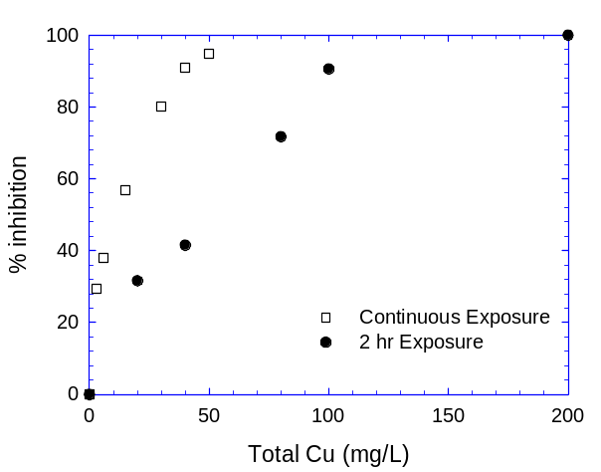
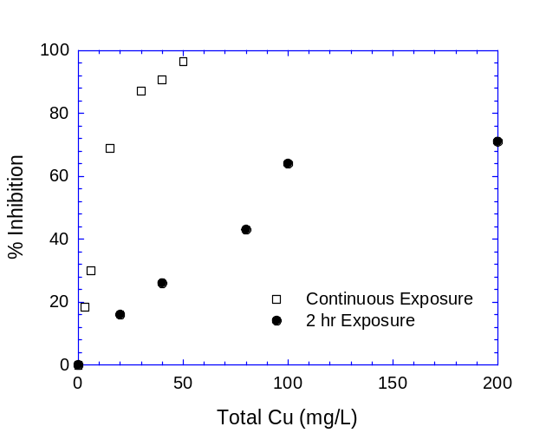
Figure 3-77 Effect of exposure time on copper inhibition of nitrifiers (graph on the left) and heterpotrophs (graph on the right).

The figures clearly show that the shorter exposure time generally employed in batch exposure studies (and also recommended by the TGD) give much lower inhibition results than the steady-state exposure data (constant exposure). This figure tend to show that the continuous exposure resulted in higher toxicity compared to short term exposure (2 h) meaning that the activated sludge amended with copper did not become acclimatized to the copper. This absence of acclimation was also reported for nitrifiers by Braam & Klapwijk (1981)
An overview of the representative EC₅₀ and NOEC values for STP micro-organisms is provided in Table 3-41 and Table 3-42.

Table 3-41 Overview of the toxicity data of copper (as total or nominal concentrations) for micro-organisms (heterotrophs and nitrifiers)
Heterotrophs |  | Nitrifiers |  | Reference
EC₅₀ (mg/l) | NOEC (mg/l) | EC₅₀ (mg/l) | NOEC (mg/l) | Reference
17 | / | / | / | Dutka et al., 1983
7 | / | / | / | Milksch & Schürmann, 1988
6 | / | / | / | Almanza et al., 1996
2.1 | <0.5-1 | 49.1 | >20 | Madoni et al., 1999
26.0 (16-40) | / | / | / | Fiebig & Noack, 2004
5.5-14.6 | 2.0-5.4 | 9.9-13.8 | 3.5-4.4 | Cha et al., 2003

Table 3-42 Overview of the toxicity data of copper (as dissolved concentrations) for micro-organisms (heterotrophs and nitrifiers)
Heterotrophs |  | Nitrifiers |  | Reference
EC₅₀ (mg/l) | NOEC (mg/l) | EC₅₀ (mg/l) | NOEC (mg/l) | Reference
0.075 | <0.02-0.04 | 3.6 | >0.92 | Madoni et al., 1999
0.51-1.15 | 0.23-0.45 | 0.74-0.91 | 0.26-0.29 | Cha et al., 2003

The bacterial studies using mixed population tests (e.g. activated sludge) representative for microbial degradation in STP, resulted in NOEC values (reported as total or nominal concentrations) ranging from <0.5-1 and 5.4 mg/l for the heterotrophs and between 3.5 and >20 mg/l for the nitrifiers. The EC₅₀ values for the micro-organisms representative for microbial degradation in STP range from 2.1 to 26 mg/l Cu (as total or nominal copper) for the heterotrophs and between 9.9 and 49.1 mg/l for the nitrifiers (as total or nominal copper). Expressed as dissolved copper concentrations, a NOEC range for heterotrophs between <0.02 and 0.45 mg/l (EC₅₀ range between 0.075 and 1.15 mg/l) was observed. For the nitrifiers, a NOEC range between 0.26 and >0.92 mg/l, as dissolved copper, was observed (EC₅₀ range between 0.74 and 3.6 mg/l).
The main difference between the Cha et al. (2003) study and the previously reported Cu inhibition study by Fiebig & Noack (2004)/ Madoni et al. (1999) is the exposure time, where in the Cha et al. (2003) study the effect of continuous exposure of Cu to activated sludge was investigated while the Fiebig & Noack (2004)/ Madoni et al. (1999) study focussed on short term batch experiments. In addition, the reliability and relevancy of the Madoni et al. (1999) batch study can be severely questioned as no statistics are reported, as a high variability in the control response is noticed (i.e. 23.5 mg O₂ (g VSS)⁻¹ h⁻¹ in the first copper experiment versus 18.5 mg O₂ (g VSS)⁻¹ h⁻¹ in the second copper experiment) and as the used batch exposure system is not ecologically relevant for the real functioning of sewage treatment plants. In addition, it was not very clear why the Madoni et al. (1999) study reported much lower NOEC values for the heterotrophic bacteria compared to the nitrifiers. Comparable sensitivity between both respiration and nitrification endpoint were found in several studies investigating the effect of copper on nitrifiers and heterotrophic bacteria in activated sludge systems (Cha et al., 2003; Braam & Klapwijk, 1981). Moreover, significant metal precipitation occurred due to the high pH and it was not clear how the dissolved fraction was determined. Analysis of the nominal and measured dissolved copper concentrations in the test media revealed that 3.9% of the copper was present as dissolved copper in the Madoni et al. (1999) study while typically ± 10% (i.e. 89% retention of copper in STP, cfr. Exposure assessment chapter; 91% retention according to the Cha et al. (2003) study) is expected. Comparison of the sensitivity (as dissolved NOEC values) revealed that the dissolved NOEC values for heterotrophs selected from the high quality studies are within the range 0.2-0.87 mg Cu/l except for the Madoni et al. (1999) study were the thresholds are one order of magnitude lower.
Table 3-43 Overview of the estimated or measured NOEC values for copper (as dissolved concentrations) - heterotrophs
Heterotrophs |  |  | Reference
EC₅₀ (mg/l) - total | NOEC (mg/l) - total | NOEC (mg/l) - dissolved | Reference
17 | 5.7* | 0.57* | Dutka et al., 1983
7 | 2.3* | 0.23* | Milksch & Schürmann, 1988
6 | 2.0* | 0.2* | Almanza et al., 1996
2.1 | <0.5-1** | <0.02-0.04** | Madoni et al., 1999
26.0 | 8.7* | 0.87* | Fiebig & Noack, 2004
5.5-14.6 | 2.0-5.4** | 0.23-0.45** | Cha et al., 2003
*: estimated values: EC₅₀ (total concentrations) to NOEC (total concentrations) conversion factor of 3 was estimated from the Cha et al. (2003) study; NOEC (total concentrations) to NOEC (dissolved concentrations) conversion factor of 10% estimated from typical retention of copper in STP.
**: measured values

The author was personally contacted but could not provide any further explanation. More (i.e. 225 individual) reliable results were obtained from a similar study performed by Fiebig & Noack (2004) (all tests follow the OECD guideline and were performed according good laboratory practices). However, the conclusions based on such short-term batch tests with the spiking addition of copper salts to mixed liquors may not necessarily be representative of its long-term effects in biological treatment processes. For example, the short-term tests may give higher inhibition results due to the presence of high bioavailable Cu levels immediately following the initial spiking. At the beginning of batch exposure study, before the equilibrium between the biomass and spiked copper were reached, organisms may be exposed to high Cu level for a short period of time. Therefore, continuous exposure of mixed culture growing at steady-state (cfr. the Cha et al., 2003 study) was deemed to more realistically mimic the actual conditions of activated sludge receiving copper discharge and seemed therefore to reflect the true representation of actual inhibition occurring in treatment plants. These values were therefore selected for the PNEC setting.

Ciliated protozoans
Protozoan tests resulted in NOEC values of 1.8 mg Cu/l (growth test with Euglena gracilis) and between 3.56 and 3.82 mg Cu/l (growth test with Tetrahymena pyriformis). A broader range in L(E)C₅₀ values ranging from 1.5 µg/l (mortality test with Blepharisma americanum) to 30 mg/l (growth test with T. pyriformis) was observed. The lowest L(E)C₅₀ values for copper were obtained from experiments carried out in laboratory tests with unfed ciliates using well water (Evian water) as test medium (Madoni et al.,1992; 1994). Higher median lethal concentrations for Cu were registered when the ciliated protozoa populations were tested under more realistic field conditions (Madoni et al., 1996), i.e. when activated sludge mixed liquour containing bacteria as food source is used as test medium. Depending on the test species used (all collected from the activated sludge mixed liquor from the aeration basin of an STP in Italy), 24 h LC₅₀ values ranging between 0.31 and >6.12 mg/l dissolved copper were estimated. It must be emphasised that these tests with individual species were performed with 1 replica/test concentration. The most sensitive species towards copper were the crawling ciliates C. uncinata and T. munita. Attached ciliates seemed to show the lowest sensitivity. According to Madoni et al. (1996), the most sensitive species seemed to account between 2.9 and 4.2% of the protozoan community in the activated sludge. However, the reliability of these toxicity results could be questioned because of the low representativity of the species (reflected in the low cell numbers) and because of the high variability in cell counting. The dominant species in the activated sludge, i.e. A. lynceus, O. minima and A. cicada, accounting for 84% of the population in the STP have sensitivity towards copper between 1.82 and >6.12 mg/l (as LC₅₀ expressed as dissolved copper). Such sensitivity is further reflected in the effect on the microbial community in the activated sludge mixed liquor (composed of 14 species of ciliated protozoa and 2 species of amoebae), with a visually estimated EC₅₀ of +/- 2 mg/l (for the endpoint survival) and +/- 6.5 mg/l (for the endpoint number of species) dissolved copper. Visually estimated EC₁₀ values were respectively 0.64 mg/l for the endpoint number of species and 0.32 mg/l (i.e. EC₂₀/2) dissolved copper. The short term tests with T. pyriformis, the species recommended by the TGD (1996, revisions 2003), resulted in NOEC and EC₅₀ (growth) values between, respectively, 3.6 - 3.8 mg/l and 8.0-10.2 mg/l nominal copper. These toxicity test results are based on short term experiments (between 2 and 4 days) performed in artificial media. The results obtained from protozoan communities were deemed to be more representative for the functioning of STPs and were therefore retained for the PNEC derivation. In addition, it is noticed that the sensitivity of the protozoan community (NOEC values) are in the same range of sensitivity compared to the bacterial populations.
An overview of the representative L(E)C₅₀ and NOEC values for STP ciliated protozoans is provided in Table 3-44.
Table 3-44 Overview of the toxicity data of copper for ciliated protozoans in STP
Species | Medium | NOEC (mg/l) | L(E)C₅₀ (mg/l) | Reference
Tetrahymena pyriformis | Artificial | 3.6-3.8 (nominal) | 8.0-30.0 (nominal) | Sauvant et al., 1997 ; Schäfer et al., 1994, Girling et al., 2000
Protozoan community | Sludge | +/- 0.32 – 0.64 (dissolved)* | +/- 2 (EC67%=3.1)-6.5 (dissolved)* | Madoni et al., 1996
Aspidisca cicada | Sludge | / | 1.82 (dissolved) | Madoni et al., 1996
Aspidisca lynceus | Sludge | / | 1.82 (dissolved) | Madoni et al., 1996
Chilodonella uncinata | Sludge | / | 0.39 (dissolved) | Madoni et al., 1996
Euplotes sp. | Sludge | / | 1.45 (dissolved) | Madoni et al., 1996
Opercularia coarctata | Sludge | / | >6.12 (dissolved) | Madoni et al., 1996
Trochilia minuta | Sludge | / | 0.31 (dissolved) | Madoni et al., 1996
Vorticella octava | Sludge | / | 2.05 (dissolved) | Madoni et al., 1996
*: visually determined

      - PNEC for aquatic micro-organisms in STP (PNEC_{micro-organisms})
It is noted that there are insufficient useful data for aquatic micro-organisms to apply statistical extrapolation. From the extracted test results, two types of tests were considered relevant for deriving the PNEC for micro-organisms in STPs: (1) tests with a mixed inoculum (e.g. activated sludge) for the endpoints respiration and nitrification, and (2) tests with ciliated protozoa (preferably Tetrahymena) for the endpoint growth.
According to the TGD (1996; revisions, 2003) the PNEC_{micro-organisms} should be derived as follows:
- the PNEC_{micro-organisms} is set equal to a NOEC from a test performed with ‘specific bacterial populations’ like nitrifying bacteria or P. putida or from a growth inhibition test performed with ciliated protozoa. An EC₅₀ from such test is divided by an assessment factor of 10,
- A NOEC from other test systems like the respiration inhibition test is divided by a factor of 10 (EC₅₀ by a factor of 100),
- The lowest value is selected as the PNEC_{micro-organisms.}

According to the TGD (1996; revisions, 2003) a higher assessment factor is applied for the heterotrophic micro-organisms compared to the nitrifying bacteria because they are exposed to a higher concentration which relates more to the influent concentration. For the nitrifying bacteria the exposure concentration is more related to the effluent concentration since nitrification is the last treatment step in a STP. The rationale for the use of a different assessment factor seemed to hold for organic substances as they are biodegraded by the heterotrophic micro-organisms in the STP. However, as metal are not biodegraded by the heterotrophic micro-organisms, similar dissolved exposure concentrations to both the heterotrophic and nitrifying bacteria are expected in the STP.
The lowest toxicity values, as NOEC value, for ciliated protozoans representative for the protozoan community of a STP was 0.32 mg/l dissolved copper (data from the protozoan community).
The lowest reliable observed NOEC value for inhibition of nitrification using activated sludge was, 3,5 mg/l as total copper and 0.26 mg/l as dissolved copper (pilot scale activated sludge simulation test) - Cha et al., 2003).The lowest reliable observed NOEC values for inhibition of respiration was 2.0 mg/l, expressed as total Cu and 0.23 mg/l expressed as dissolved copper.
Therefore, a PNEC_{micro-organisms} of 0.23 mg Cu/l (as dissolved fraction) is proposed.

Induced reductions in intra-species variability can be assessed by e.g. comparing the predicted vs. observed toxicity for the different species or by means of the max./min. ratio between toxicity thresholds.
Normalisation of toxicity data is only allowed within the boundaries of the developed/validated bioavailability model
Low (L): when the phys.-chem. in the system ≈ 10th % of abiotic factor in EU surface waters; Medium (M): when the phys.-chem. in the system ≈ 50th % of abiotic factor in EU surface waters; High (H): when the phys.-chem. in the system ≈ 90th % of abiotic factor in EU surface waters.

